College of Engineering
Electrical Engineering Department

EE497
Design and Implementation Of A Power Generation System Using Silicon Solar Cells

Students Team
RAYYAN ALBAYYALI Student ID: 436100358
TURKI ALGHWUINEM Student ID: 436107891
Supervisors
Name Signature
Dr. Mohamed Ramy
Prof. Ehab Awad

Submitted in Partial Fulfillment of the Requirement
for the B.Sc. Degree,

Rabi’II 1442
November 2020

Project Abstract

In this graduation project, we are designing a system that demands on the solar energy converting it to electricity by a solar cell then going to a DC to DC converter to control the voltage to what we need, moving to the next step the load of the system which is power bank. We collected all the equipment we need ( solar cell panel – DC to DC converter – Power Bank – wires – Variable Resistance ) and connect them & write down the readings to draw the I-V & P-V curves. We choose MAATLAB SIMULINK to draw the I-V & P-V curves and it gives automatically the other variables of solar panel such as Rs, Rsh, Id, etc. We compared between the theoretical and practical graphs of P-V & I-V curves. We gave a brief in DC to DC types.
We have so many calculations such as measuring the input & output of voltage in each terminal.

Acknowledgement

The completion of this graduation project could not have been possible without the guidance and assistance of so many people whose names may not all be enumerated. Their contributions are sincerely appreciated and gratefully acknowledged. However, we would like to express our deep appreciation and indebtedness particularly to the following: Dr. Mohamed Ramy, Dr. Ehab Awad for their endless support, kind and understanding spirit during our graduation project. To all relatives, friends and others who in one way or another shared their support, either morally, financially and physically, thank you. Above all, we are thankful to Allah for giving us the power and knowledge to complete our graduation project and complete this final report.

Table of Contents

Project Abstract ii
Acknowledgement iii
Table of Contents iv
List of Figures v
List of Tables vi
1 Introduction 1
1.1 Introduction 1
1.2 Problem Formulation 1
1.2.1 Problem Statement: 1
1.3 Project Specifications 1
2 Background 3
2.1 Silicon photovoltaics solar cell 3
2.1.1 How the PV solar cell works 3
2.1.2 I-V and P-V Curves of PV solar model: 5
2.1.3 Types of Silicon Solar Cell 7
2.1.4 Comparison between types of Silicon solar cell. 7
2.2 Dc to DC Converter 8
2.2.1 Uses of DC to DC Converter 8
2.2.2 Types of DC to DC Converters 9
2.2.3 Buck Converter 9
2.2.4 How a Buck Converter work ? 9
2.2.5 Boost Converter 10
2.2.6 How a boost converter work ? 10
2.3 Li-ion Battery 11
2.3.1 Internal Resistance 11
2.3.2 Charging Current limit and Charging Voltage 16
Summary 20
2.4 Cost of the System 21
3 Simulation & system design 21
3.1 Simulation 21
3.1.1 PV module normal characteristic: 22
3.2 Experimental Work: 24
3.2.1 Equipment 25
3.3 Calculations 29
4 Conclusions and Future Work 30
5 References 31
6 Appendix 33

List of Figures

Figure ‎1.1: Block diagram. 2
Figure ‎1.2: PV Solar Cell 3
Figure ‎1.3: Solar Cell construction and working principle. 3
Figure ‎1.4: Single-diode electrical PV module equivalent circuit 4
Figure ‎1.5: I-V Curve. 5
Figure ‎1.6: P-V curve with I-V curve 6
Figure ‎1.7: Types of Silicon Solar Cell 7
Figure ‎1.8: Our Buck Converter 8
Figure ‎1.9: Buck Converter Circuit 9
Figure ‎1.10: Buck ON-OFF state 9
Figure ‎1.11: Boost Converter 10
Figure ‎1.12: Boost On-OFF state 10
Figure ‎2.1: Discharge curve on a pulsed load with diverse internal resistance. This chart demonstrates the runtime of 3 batteries with same capacities but different internal resistance levels. 11
Figure ‎2.2: Discharge and resulting talk-time of nickel-cadmium at 1C, 2C and 3C under the GSM load schedule. The battery tested has a capacity of 113%, the internal resistance is a low 155 mOhm. 13
Figure ‎2.3: Discharge and resulting talk-time of nickel-metal-hydride at 1C, 2C and 3C under the GSM load schedule. The battery tested has a capacity of 107%, the internal resistance is a high 778 mOhm. 13
Figure ‎2.4: Discharge and resulting talk-time of a lithium-ion battery at 1C, 2C and 3C under the GSM load schedule. The battery tested has a capacity of 94%, the internal resistance is 320 mOhm 14
Figure ‎2.5: Internal resistance in nickel-metal-hydride. Note the higher readings immediately after a full discharge and full charge. Resting a battery before use produces the best results.. 15
Figure ‎2.6: Typical internal resistance readings of a lead acid wheelchair battery. The battery was discharged from full charge to 10.50V. The readings were taken at open circuit voltage (OCV).. 15
Figure ‎2.7: Charge stages of lithium-ion. 16
Figure ‎2.8: Volts/capacity vs. time when charging lithium-ion 18
Figure ‎3.1: MATLAB&SIMULINK. 21
Figure ‎3.2: PV Simulation Circuit. 22
Figure ‎3.3: I-V curve for normal state characteristic. 22
Figure ‎3.4: P-V curve for normal state characteristic 22
Figure ‎3.5: Our PV module parameters (one module) 23
Figure ‎3.6: I-V and P-V Curves for our solar panel 24
Figure ‎3.7: 20W MONO Solar Cell 25
Figure ‎3.8: 20W MONO Solar Cell Panel nameplate 25
Figure ‎3.9: Multimeters 25
Figure ‎3.10: Variable Resistance. 26
Figure ‎3.11: Connection Wires 26
Figure ‎3.12: Final Connection. 27
Figure ‎3.13: Experimental Result for I-V & P-V curves 27
Figure ‎3.14: Simulation Result for I-V & P-V curves 27

List of Tables

Table ‎1.1: Comparison between types of Silicon solar cell.. 6
Table ‎2.1: Typical charge characteristics of lithium-ion. 16
Table ‎2.2: The cost of our design. 20
Table ‎3.1: Standard Test Condition 20
Table ‎3.2: Values of the parameters in our solar cell 29

Introduction

Introduction

Considering the enormous and accelerated demand on renewable energy from governments and companies for its advantages over other energy resources based on environmental and economical level, the competition between companies gone to a completely different scale, with a goal provide and produce this energy with the highest efficiency and lowest price. And one of the most important types of renewable energy is the solar energy. Which is experiencing a huge evolution regarding improving the efficiency, methods of storing it, measuring and structuring.

Problem Formulation

Problem Statement:

The world demand for electric energy is constantly increasing, and conventional energy resources are diminishing and are even threatened to be depleted. Moreover, their prices are rising. For these reasons, the need for alternative energy sources has become indispensable, and solar energy in particular has proved to be a very promising alternative because of its availability and pollution-free nature. Due to the increasing efficiencies and decreasing cost of photovoltaic cells and improvement of the switching technology used for power conversion, our goal is to design a system that’s powered by a PV panels and could supply dc loads.

Project Specifications

The major elements of our design are Silicon photovoltaic cell, a Dc to Dc converter , a Power Bank. As it is shown In Figure ‎1.1: The Silicon Solar Cell are exposed to the sunlight to convert the solar energy into an electrical energy, moving to next stage which is the DC/DC converter which has a specific specifications according to our design ,then the Power Bank comes and it will be charging.

Block Diagram

DC to DC Converter

DC Load

Si-SC

Figure ‎1.2: Block diagram .

Background

Silicon photovoltaics solar cell

Photovoltaics is the process of converting sunlight directly into electricity using solar cells. Today it is a rapidly growing and increasingly important renewable alternative to conventional fossil fuel electricity generation, but compared to other electricity generating technologies, it is a relative newcomer, with the first practical photovoltaic devices demonstrated in the 1950s.
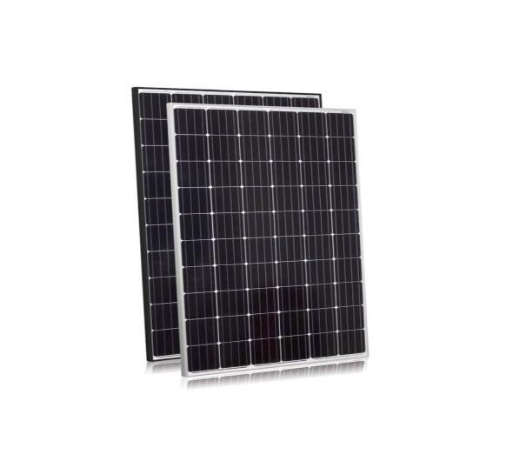

Figure1.2: PV Solar Cell.

How the PV solar cell works
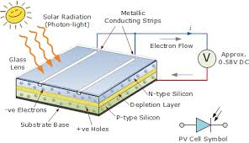

Figure1.3: Solar Cell construction and working principle.

We receive on Earth particles of solar energy called photons. When these particles hit the semiconductor material of a solar cell such as Silicon that absorbs light energy. The energy knocks electrons loose so they can flow freely and produce a difference in electric potential energy.
The flow of electrons or negative charge creates electric current. Solar cells have positive and negative contacts, like the terminals in a battery. If the contacts are connected with a conductive wire, current flows from the negative to positive contact.
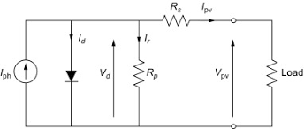

Figure1.4: Single-diode electrical PV module equivalent circuit.

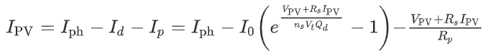
where
• V_{PV} = PV module voltage (V)
• I_{PV} = PV module current (A)
• I_{ph} = light current (A)
• I₀ = diode reverse saturation current (A)
• Q_{d} = diode ideality factor
• n_{s} = number of cells in series
• R_{s} = series resistance (Ω)
• R_{p} = shunt resistance (Ω)
• V_{t} = kT_{c}/q is the thermal voltage (V), k is Boltzmann's constant, T_{c} is the cell temperature, and q is the charge of an electron.

I-V and P-V Curves of PV solar model:

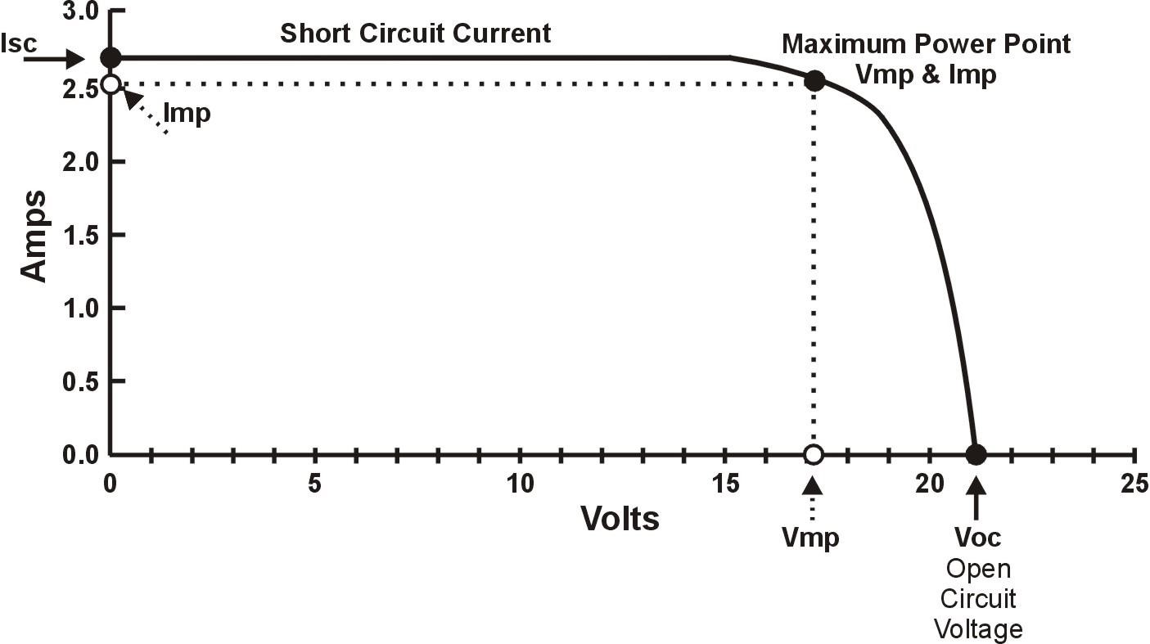

Figure1.5: IV curve.

A current-voltage (I-V) curve shown in fig.1.4 the possible combinations of current and voltage output of a photovoltaic (PV) device. A PV device, such as Solar module, produces its maximum current when there is no resistance in the circuit, i.e., when there is a short circuit between its positive and negative terminals. This maximum current is known as the short circuit current and is abbreviated (I_{sc}). When the module is shorted, the voltage in the circuit is zero.
Conversely, the maximum voltage occurs when there is a break in the circuit. This is called the open circuit voltage (V_{oc}). Under this condition the resistance is infinitely high and there is no current, since the circuit is incomplete.
there is one particular combination of current and voltage for which the power reaches its maximum value as shown in fig.1.4, at (Imp) and (Vmp). In other words, the point at which the cell generates maximum electrical power.
The maximum power point (MPP) of a solar cell is positioned near the bend in the I-V characteristics curve.
Since solar cell output voltage and current both depend on temperature, the actual output power will vary with changes in ambient temperature.
Photovoltaic panels can be wired or connected in either series or parallel combinations, or both to increase the voltage or current capacity of the solar array. If the array panels are connected in a series combination, then the voltage increases and if connected in parallel then the current
increases.
The electrical power in Watts, generated by these different photovoltaic combinations will still be the product of the voltage times the current, (P = V x I). However, the solar panels are connected, the upper right-hand corner will always be the maximum power point (MPP) of the array.

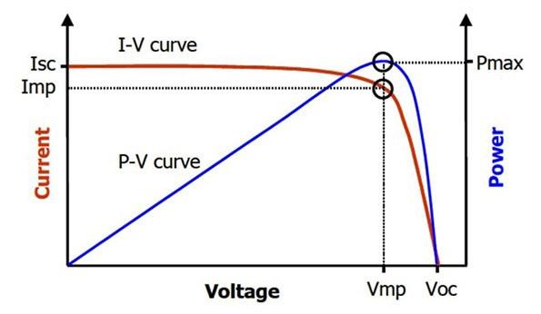
Figure1.6: P-V curve with I-V curve.

In general, I-V and P-V curves to parameters such as:
- Temperature, which affects the voltage.
- Radiation which affects the generated current.
- Resistance which affect the current and voltage hence the power.

Types of Silicon Solar Cell
Based on the types of crystal used, solar cells can be classified as,
- Monocrystalline silicon cells.
- Polycrystalline silicon cells.
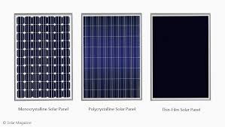
- Amorphous silicon cells.

Figure1.7: Types of Silicon Solar Cell.

- Monocrystalline silicon cell is produced from pure silicon (single crystal). Since the Monocrystalline silicon is pure and defect free, the efficiency of the cell will be higher.
- In Polycrystalline silicon cell, liquid silicon is used as raw material and Polycrystalline silicon was obtain followed by solidification process. The material contain various crystalline sizes. Hence, the efficiency of this type is less than Monocrystalline silicon cell.
- Amorphous silicon was obtained by depositing silicon film on the substrate like glass plate.

Comparison between types of Silicon solar cell.

Material | Efficiency %
Monocrystalline silicon | 14-17
Polycrystalline silicon | 13-15
Amorphous silicon | 5-7
Table1.1: Comparison between types of Silicon solar cell.

Dc to DC Converter
A DC-to-DC converter is an electronic circuit or electromechanical device that converts a source of direct current (DC) from one voltage level to another. It is a type of electric power converter. Power levels range from very low (small batteries) to very high (high-voltage power transmission).

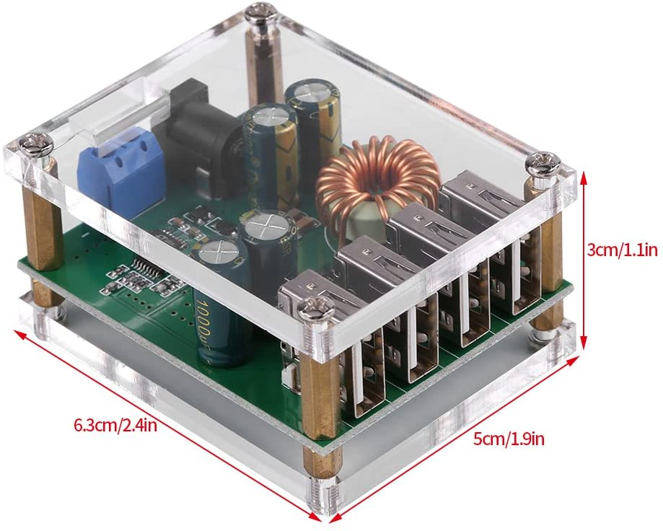
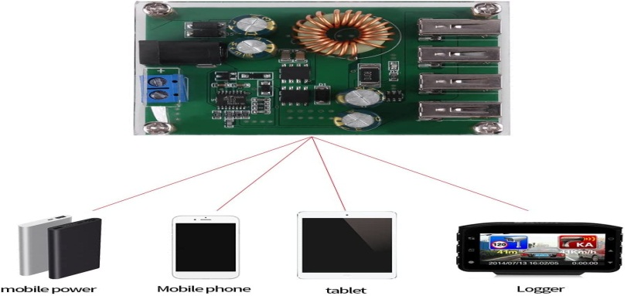

Figure1.8 : Our Buck Converter .

Uses of DC to DC Converter
DC to DC converters are used in portable electronic devices such as cellular phones and laptop computers, which are supplied with power from batteries primarily. Such electronic devices often contain several sub-circuits, each with its own voltage level requirement different from that supplied by the battery or an external supply (sometimes higher or lower than the supply voltage). Additionally, the battery voltage declines as its stored energy is drained. Switched DC to DC converters offer a method to increase voltage from a partially lowered battery voltage thereby saving space instead of using multiple batteries to accomplish the same thing. Most DC to DC converter circuits also regulate the output voltage. Some exceptions include high-efficiency LED power sources, which are a kind of DC to DC converter that regulates the current through the LEDs, and simple charge pumps which double or triple the output voltage.
DC to DC converters which are developed to maximize the energy harvest for photovoltaic systems and for wind turbines are called power optimizers.

Types of DC to DC Converters
- Buck Converter (Step Down converter)
- Boost Converter (Step Up Converter)

Buck Converter
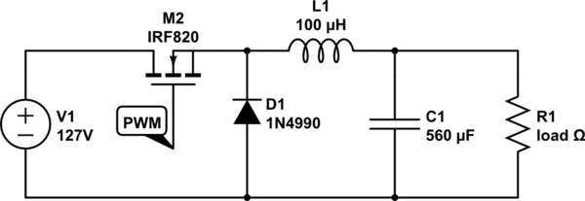
A buck converter (step down converter) is the one which converts the DC voltage level of an input source to a lower value and shift the current level of the source to a higher value at the output.

Figure1.9: Buck Converter Circuit.

How a Buck Converter work ?

  - There are two states for a buck converter, the on-state and the off-state. During the on-state, current flows towards the load from the source, while it charges up the inductor simultaneously.
  - During the off-state, the magnetic field of the inductor would collapsed and re-formed as current, and therefore discharged to the load.
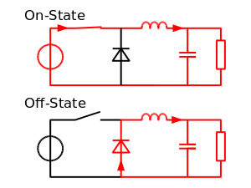

Figure1.10: Buck ON-OFF state

Boost Converter

A boost converter (step-up converter) is a DC-to-DC power converter that steps up voltage (while stepping down current) from its input (supply) to its output (load). It is a class of switched-mode power supply (SMPS) containing at least two semiconductors (a diode and a transistor) and at least one energy storage element: a capacitor, inductor, or the two in combination. To reduce voltage ripple, filters made of capacitors (sometimes in combination with inductors) are normally added to such a converter's output (load-side filter) and input (supply-side filter).
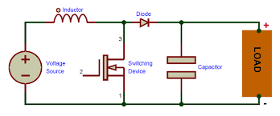

Fig1.11: Boost Converter .

How a boost converter work ?

  - Continuous Conduction Mode (CCM): The Boost Converter Continuous Switching Mode is constructed with given components that are inductor, capacitor and input voltage source and one switching device. In this inductor acts as a power storage element. The boost converter switch is controlled by the PWM (pulse width modulator). When switch is ON the energy is developed in the inductor and more energy is delivered to the output. It is possible to convert high voltage capacitors from low voltage input source. The input voltage is always greater than the output voltage. In continuous conduction mode, the current is increased with respect to input voltage.
  - Discontinuous Conduction Mode (DCM): The discontinuous conduction mode circuit is build with inductor, capacitor, switching device and input voltage source. Inductor is a power storage element same as continuous conduction mode. In discontinuous mode, when the switch is ON the energy is delivered to the inductor. And if the switch is OFF some period of time the inductor current reaches to zero when next switching cycle is on. The output capacitor is charging and discharging with respect to input voltage. The output voltage is less than compared to the continuous mode.
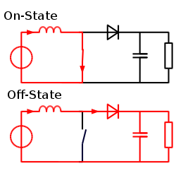

Fig1.12: Boost On-OFF state .

Li-ion Battery
We are going to talk about the most important Electric characteristics which are the internal resistance and it affect om the performance , the charging current limit , and the charging voltage .

Internal Resistance
With the move from analog to digital, new demands are placed on the battery. Unlike analog portable devices that draw a steady current, the digital equipment loads the battery with short, heavy current spikes. One of the urgent requirements of a battery for digital applications is low internal resistance. Measured in milliohms, the internal resistance is the gatekeeper that, to a large extent, determines the runtime. The lower the resistance, the less restriction the battery encounters in delivering the needed power spikes. A high mOhm reading can trigger an early 'low battery' indication on a seemingly good battery because the available energy cannot be delivered in the required manner and remains in the battery . Figure 2.1 demonstrates the voltage signature and corresponding runtime of a battery with low, medium and high internal resistance when connected to a digital load. Similar to a soft ball that easily deforms when squeezed, the voltage of a battery with high internal resistance modulates the supply voltage and leaves dips, reflecting the load pulses. These pulses push the voltage towards the end-of-discharge line, resulting in a premature cut-off. As seen in the chart, the internal resistance governs much of the runtime.
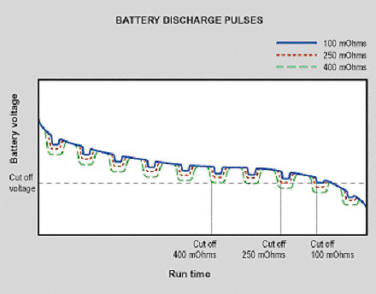 |  | Figure 2.1: Discharge curve on a pulsed load with diverse internal resistance. This chart demonstrates the runtime of 3 batteries with same capacities but different internal resistance levels.

Talk-time as a function of internal resistance

As part of ongoing research to measure the runtime of batteries with various internal resistance levels, Cadex Electronics examined several cell phone batteries that had been in service for a while. All batteries were similar in size and generated good capacity readings when checked with a battery analyzer under a steady discharge load. The nickel-cadmium pack produced a capacity of 113%, nickel-metal-hydride checked in at 107% and the lithium-ion provided 94%. The internal resistance varied widely and measured a low 155 mOhm for nickel-cadmium, a high 778 mOhm for nickel-metal-hydride and a moderate 320 mOhm for lithium-ion. These internal resistance readings are typical of aging batteries with these chemistries. Let's now check how the test batteries perform on a cell phone. The maximum pulse current of a GSM (Global System for Mobile Communications) cell phones is 2.5 amperes. This represents a large current from a relatively small battery of about 800 milliampere (mAh) hours. A current pulse of 2.4 amperes from an 800 mAh battery, for example, correspond to a C-rate of 3C. This is three times the current rating of the battery. Such high current pulses can only be delivered if the internal battery resistance is low. Figures 2.2, 2.3 and 2.4 reveal the talk time of the three batteries under a simulated GSM current of 1C, 2C and 3C. One can see a direct relationship between the battery's internal resistance and the talk time. nickel-cadmium performed best under the circumstances and provided a talk time of 120 minutes at a 3C discharge (orange line). nickel-metal-hydride performed only at 1C (blue line) and failed at 3C. lithium-ion allowed a moderate 50 minutes talk time at 3C.
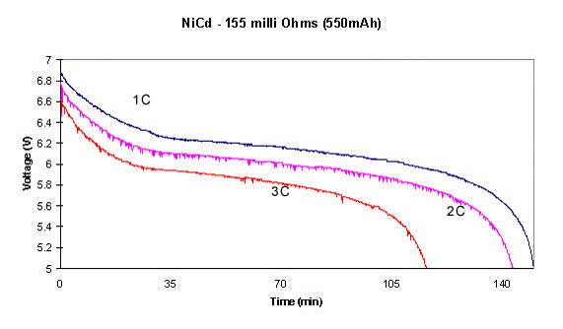
Figure 2.2: Discharge and resulting talk-time of nickel-cadmium at 1C, 2C and 3C under the GSM load schedule. The battery tested has a capacity of 113%, the internal resistance is a low 155 mOhm.
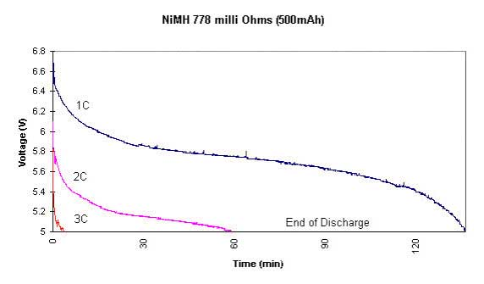

Figure 2.3: Discharge and resulting talk-time of nickel-metal-hydride at 1C, 2C and 3C under the GSM load schedule. The battery tested has a capacity of 107%, the internal resistance is a high 778 mOhm.

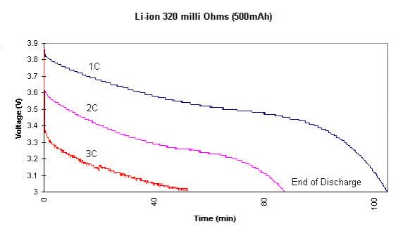
Figure 2.4: Discharge and resulting talk-time of a lithium-ion battery at 1C, 2C and 3C under the GSM load schedule. The battery tested has a capacity of 94%, the internal resistance is 320 mOhm

Internal resistance as a function of state-of-charge

The internal resistance varies with the state-of-charge of the battery. The largest changes are noticeable on nickel-based batteries. In Figure 2.5, we observe the internal resistance of nickel-metal-hydride when empty, during charge, at full charge and after a 4-hour rest period.
The resistance levels are highest at low state-of-charge and immediately after charging. Contrary to popular belief, the best battery performance is not achieved immediately after a full charge but following a rest period of a few hours. During discharge, the internal battery resistance decreases, reaches the lowest point at half charge and starts creeping up again (dotted line).
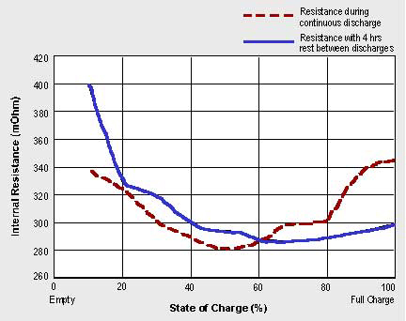 |  | Figure 2.5: Internal resistance in nickel-metal-hydride. Note the higher readings immediately after a full discharge and full charge. Resting a battery before use produces the best results.
The internal resistance of lithium-ion is fairly flat from empty to full charge. The battery decreases asymptotically from 270 mW at 0% to 250 mW at 70% state-of-charge. The largest changes occur between 0% and 30% SoC.
The resistance of lead acid goes up with discharge. This change is caused by the decrease of the specific gravity, a depletion of the electrolyte as it becomes more watery. The resistance increase is almost linear with the decrease of the specific gravity. A rest of a few hours will partially restore the battery as the sulphate ions can replenish themselves. The resistance change between full charge and discharge is about 40%. Cold temperature increases the internal resistance on all batteries and adds about 50% between +30°C and -18°C to lead acid batteries. Figure 2.6 reveals the increase of the internal resistance of a gelled lead acid battery used for wheelchairs.
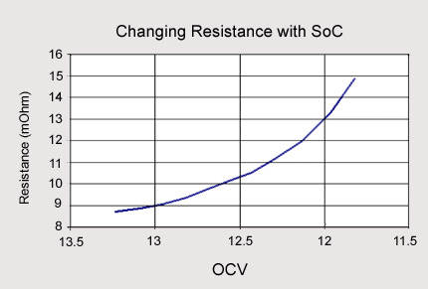 | Figure 2.6: Typical internal resistance readings of a lead acid wheelchair battery. The battery was discharged from full charge to 10.50V. The readings were taken at open circuit voltage (OCV).

2.3.2 Charging Current limit and Charging Voltage
Charging and discharging batteries is a chemical reaction, but Li-ion is claimed to be the exception. Battery scientists talk about energies flowing in and out of the battery as part of ion movement between anode and cathode. This claim carries merits but if the scientists were totally right, then the battery would live forever. They blame capacity fade on ions getting trapped, but as with all battery systems, internal corrosion and other degenerative effects also known as parasitic reactions on the electrolyte and electrodes till play a role. The Li ion charger is a voltage-limiting device that has similarities to the lead acid system. The differences with Li-ion lie in a higher voltage per cell, tighter voltage tolerances and the absence of trickle or float charge at full charge. While lead acid offers some flexibility in terms of voltage cut off, manufacturers of Li-ion cells are very strict on the correct setting because Li-ion cannot accept overcharge. The so-called miracle charger that promises to prolong battery life and gain extra capacity with pulses and other gimmicks does not exist. Li-ion is a “clean” system and only takes what it can absorb.

Charging Cobalt-blended Li-ion

Li-ion with the traditional cathode materials of cobalt, nickel, manganese and aluminum typically charge to 4.20V/cell. The tolerance is +/–50mV/cell. Some nickel-based varieties charge to 4.10V/cell; high capacity Li-ion may go to 4.30V/cell and higher. Boosting the voltage increases capacity, but going beyond specification stresses the battery and compromises safety. Protection circuits built into the pack do not allow exceeding the set voltage. Figure 2.7 shows the voltage and current signature as lithium-ion passes through the stages for constant current and topping charge. Full charge is reached when the current decreases to between 3 and 5 percent of the Ah rating.
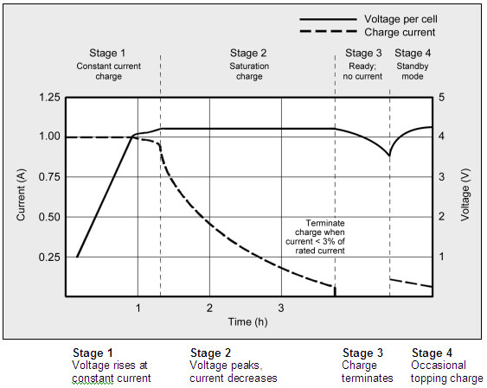
Figure 2.7: Charge stages of lithium-ion.

The advised charge rate of an Energy Cell is between 0.5C and 1C; the complete charge time is about 2–3 hours. Manufacturers of these cells recommend charging at 0.8C or less to prolong battery life; however, most Power Cells can take a higher charge C-rate with little stress. Charge efficiency is about 99 percent and the cell remains cool during charge.
Some Li-ion packs may experience a temperature rise of about 5ºC (9ºF) when reaching full charge. This could be due to the protection circuit and/or elevated internal resistance. Discontinue using the battery or charger if the temperature rises more than 10ºC (18ºF) under moderate charging speeds. Full charge occurs when the battery reaches the voltage threshold and the current drops to 3 percent of the rated current. A battery is also considered fully charged if the current levels off and cannot go down further. Elevated self-discharge might be the cause of this condition. Increasing the charge current does not hasten the full-charge state by much. Although the battery reaches the voltage peak quicker, the saturation charge will take longer accordingly. With higher current, Stage 1 is shorter but the saturation during Stage 2 will take longer. A high current charge will, however, quickly fill the battery to about 70 percent. Li-ion does not need to be fully charged as is the case with lead acid, nor is it desirable to do so. In fact, it is better not to fully charge because a high voltage stresses the battery. Choosing a lower voltage threshold or eliminating the saturation charge altogether, prolongs battery life but this reduces the runtime. Chargers for consumer products go for maximum capacity and cannot be adjusted; extended service life is perceived less important. Some lower-cost consumer chargers may use the simplified “charge-and-run” method that charges a lithium-ion battery in one hour or less without going to the Stage 2 saturation charge. “Ready” appears when the battery reaches the voltage threshold at Stage 1. State-of-charge (SoC) at this point is about 85 percent, a level that may be sufficient for many users. Certain industrial chargers set the charge voltage threshold lower on purpose to prolong battery life. Table 2 illustrates the estimated capacities when charged to different voltage thresholds with and without saturation charge.
Charge V/cell | Capacity at  cut-off voltage* | Charge time | Capacity with full saturation
3.80  3.90  4.00  4.10  4.20 | ~40%  ~60%  ~70%  ~80%  ~85% | 120 min  135 min  150 min  165 min  180 min | ~65%  ~75%  ~80%  ~90%  100%

Table 2.1: Typical charge characteristics of lithium-ion.
When the battery is first put on charge, the voltage shoots up quickly. This behavior can be compared to lifting a weight with a rubber band, causing a lag. The capacity will eventually catch up when the battery is almost fully charged (Figure 2.8). This charge characteristic is typical of all batteries. The higher the charge current is, the larger the rubber-band effect will be. Cold temperatures or charging a cell with high internal resistance amplifies the effect.
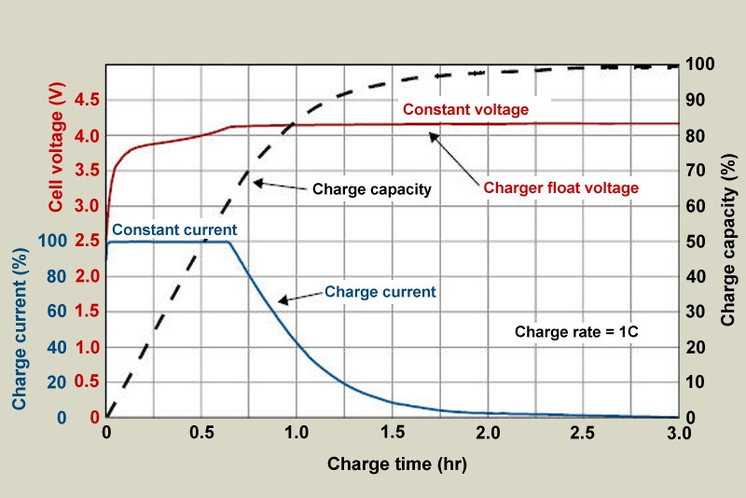
Figure 2.8: Volts/capacity vs. time when charging lithium-ion.

Estimating SoC by reading the voltage of a charging battery is impractical; measuring the open circuit voltage (OCV) after the battery has rested for a few hours is a better indicator. As with all batteries, temperature affects the OCV, so does the active material of Li-ion. SoC of smartphones, laptops and other devices is estimated by coulomb counting. Li-ion cannot absorb overcharge. When fully charged, the charge current must be cut off. A continuous trickle charge would cause plating of metallic lithium and compromise safety. To minimize stress, keep the lithium-ion battery at the peak cut-off as short as possible. Once the charge is terminated, the battery voltage begins to drop. This eases the voltage stress. Over time, the open circuit voltage will settle to between 3.70V and 3.90V/cell. Note that a Li-ion battery that has received a fully saturated charge will keep the voltage elevated for a longer than one that has not received a saturation charge.When lithium-ion batteries must be left in the charger for operational readiness, some chargers apply a brief topping charge to compensate for the small self-discharge the battery and its protective circuit consume. The charger may kick in when the open circuit voltage drops to 4.05V/cell and turn off again at 4.20V/cell. Chargers made for operational readiness, or standby mode, often let the battery voltage drop to 4.00V/cell and recharge to only 4.05V/cell instead of the full 4.20V/cell. This reduces voltage-related stress and prolongs battery life .Some portable devices sit in a charge cradle in the ON position. The current drawn through the device is called the parasitic load and can distort the charge cycle. Battery manufacturers advise against parasitic loads while charging because they induce mini-cycles. This cannot always be avoided and a laptop connected to the AC main is such a case. The battery might be charged to 4.20V/cell and then discharged by the device. The stress level on the battery is high because the cycles occur at the high-voltage threshold, often also at elevated temperature. A portable device should be turned off during charge. This allows the battery to reach the set voltage threshold and current saturation point unhindered. A parasitic load confuses the charger by depressing the battery voltage and preventing the current in the saturation stage to drop low enough by drawing a leakage current. A battery may be fully charged, but the prevailing conditions will prompt a continued charge, causing stress.

Charging Non-cobalt-blended Li-ion
While the traditional lithium-ion has a nominal cell voltage of 3.60V, Li-phosphate (LiFePO) makes an exception with a nominal cell voltage of 3.20V and charging to 3.65V. Relatively new is the Li-titanate (LTO) with a nominal cell voltage of 2.40V and charging to 2.85V. Chargers for these non cobalt-blended Li-ions are not compatible with regular 3.60-volt Li-ion. Provision must be made to identify the systems and provide the correct voltage charging. A 3.60-volt lithium battery in a charger designed for Li-phosphate would not receive sufficient charge; a Li-phosphate in a regular charger would cause overcharge.

Overcharging Lithium-ion
Lithium-ion operates safely within the designated operating voltages; however, the battery becomes unstable if inadvertently charged to a higher than specified voltage. Prolonged charging above 4.30V on a Li-ion designed for 4.20V/cell will plate metallic lithium on the anode. The cathode material becomes an oxidizing agent, loses stability and produces carbon dioxide (CO2). The cell pressure rises and if the charge is allowed to continue, the current interrupt device (CID) responsible for cell safety disconnects at 1,000–1,380kPa (145–200psi). Should the pressure rise further, the safety membrane on some Li-ion bursts open at about 3,450kPa (500psi) and the cell might eventually vent with flame. Venting with flame is connected with elevated temperature. A fully charged battery has a lower thermal runaway temperature and will vent sooner than one that is partially charged. All lithium-based batteries are safer at a lower charge, and this is why authorities will mandate air shipment of Li-ion at 30 percent state-of-charge rather than at full charge. The threshold for Li-cobalt at full charge is 130–150ºC (266–302ºF); nickel-manganese-cobalt (NMC) is 170–180ºC (338–356ºF) and Li-manganese is about 250ºC (482ºF). Li-phosphate enjoys similar and better temperature stabilities than manganese. (See also BU-304a: Safety Concerns with Li-ion and BU-304b: Making Lithium-ion Safe.).Lithium-ion is not the only battery that poses a safety hazard if overcharged. Lead- and nickel-based batteries are also known to melt down and cause fire if improperly handled. Properly designed charging equipment is paramount for all battery systems and temperature sensing is a reliable watchman.

Summary
Charging lithium-ion batteries is simpler than nickel-based systems. The charge circuit is straight forward; voltage and current limitations are easier to accommodate than analyzing complex voltage signatures, which change as the battery ages. The charge process can be intermittent, and Li-ion does not need saturation as is the case with lead acid. This offers a major advantage for renewable energy storage such as a solar panel and wind turbine, which cannot always fully charge the battery. The absence of trickle charge further simplifies the charger. Equalizing charger, as is required with lead acid, is not necessary with Li-ion. Consumer and most industrial Li-ion chargers charge the battery fully. They do not offer adjustable end-of-charge voltages that would prolong the service life of Li-ion by lowering the end charge voltage and accepting a shorter runtime. Device manufacturers fear that such an option would complicate the charger.

Cost of the System

Part | Price (SR)
Silicon solar Cell | 55
DC to DC Converter | 35
Load (charger) | 90
Table 2.2 : The cost of our design.

Total | 180

Simulation & system design

Simulation

we simulated our project using MATLAB&SIMULINK. At STC (Standard Test Conditions):
Temperature | 25º C
Air mass | 1.5
Irradiance | 1000 W/m²

Table 3.1 : Standard Test Condition.

We chose MATLAB due to our experience using it in other subjects. And its availability in the university. Also it numerous resources.
Figure 3.1: MATLAB&SIMULINK.

PV module normal characteristic:
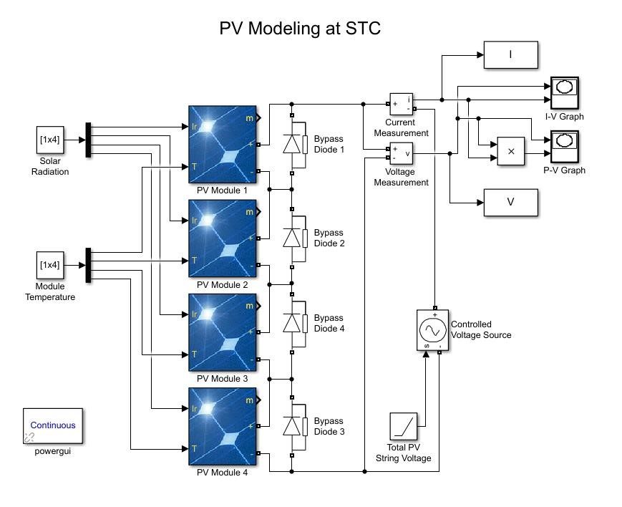
Figure 3.2: PV Simulation Circuit.

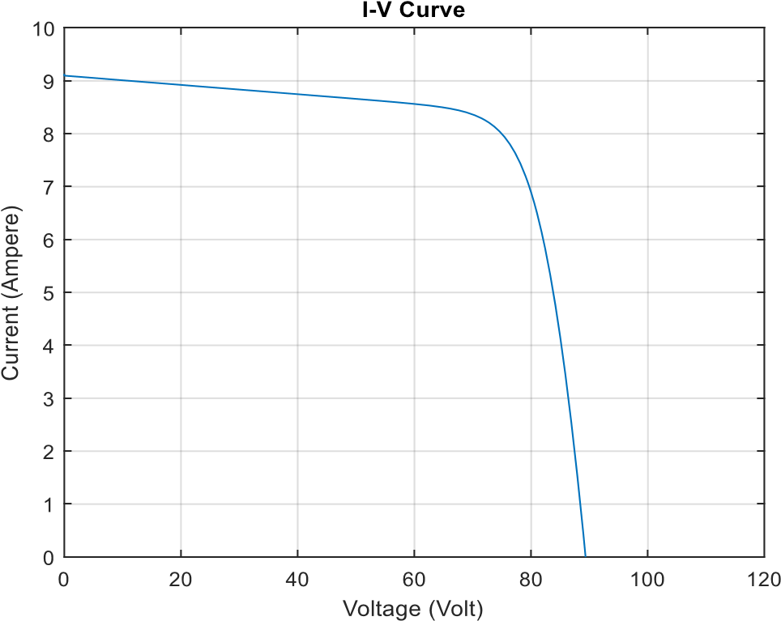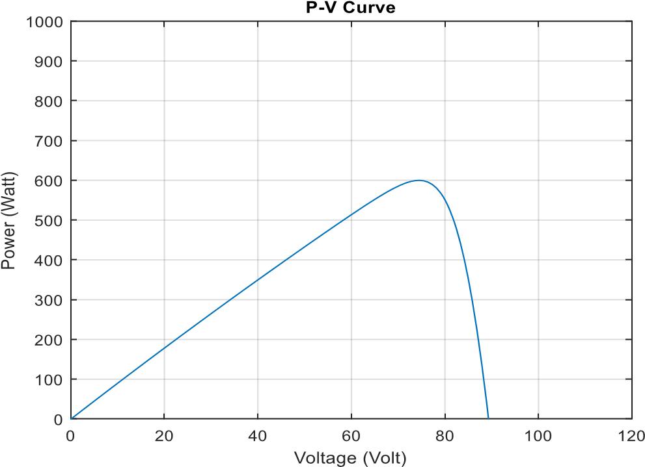
Figure 3.4: P-V curve for normal state characteristic.
Figure 3.3: I-V curve for normal state characteristic.

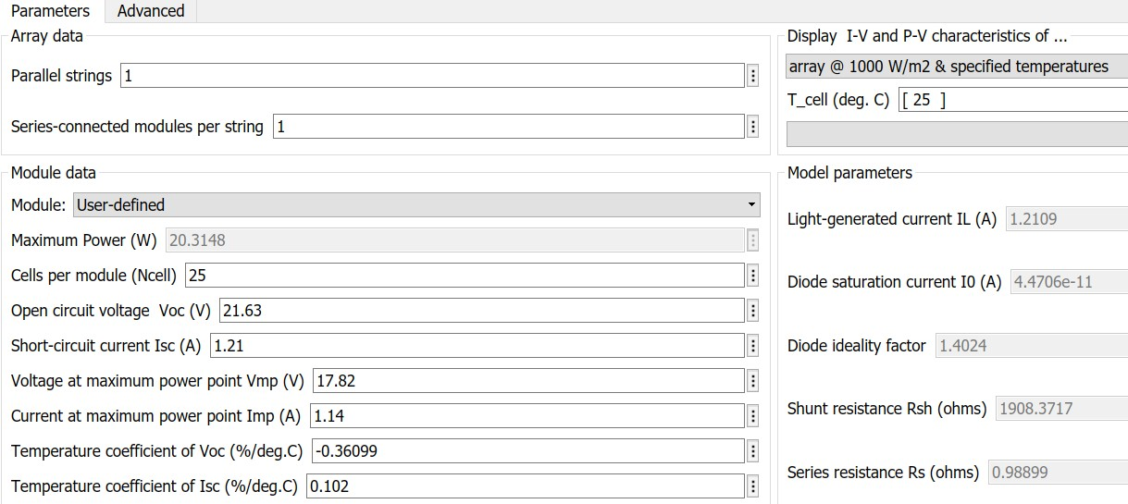

Figure 3.5: Our PV module parameters (one module).

This figure shows the model maximum power, open circuit voltage , voltage at maximum
power point , cell temperature, shunt resistance , series resistance ,short circuit current, etc. Depending on the PV module we have of the type : 20W MONO

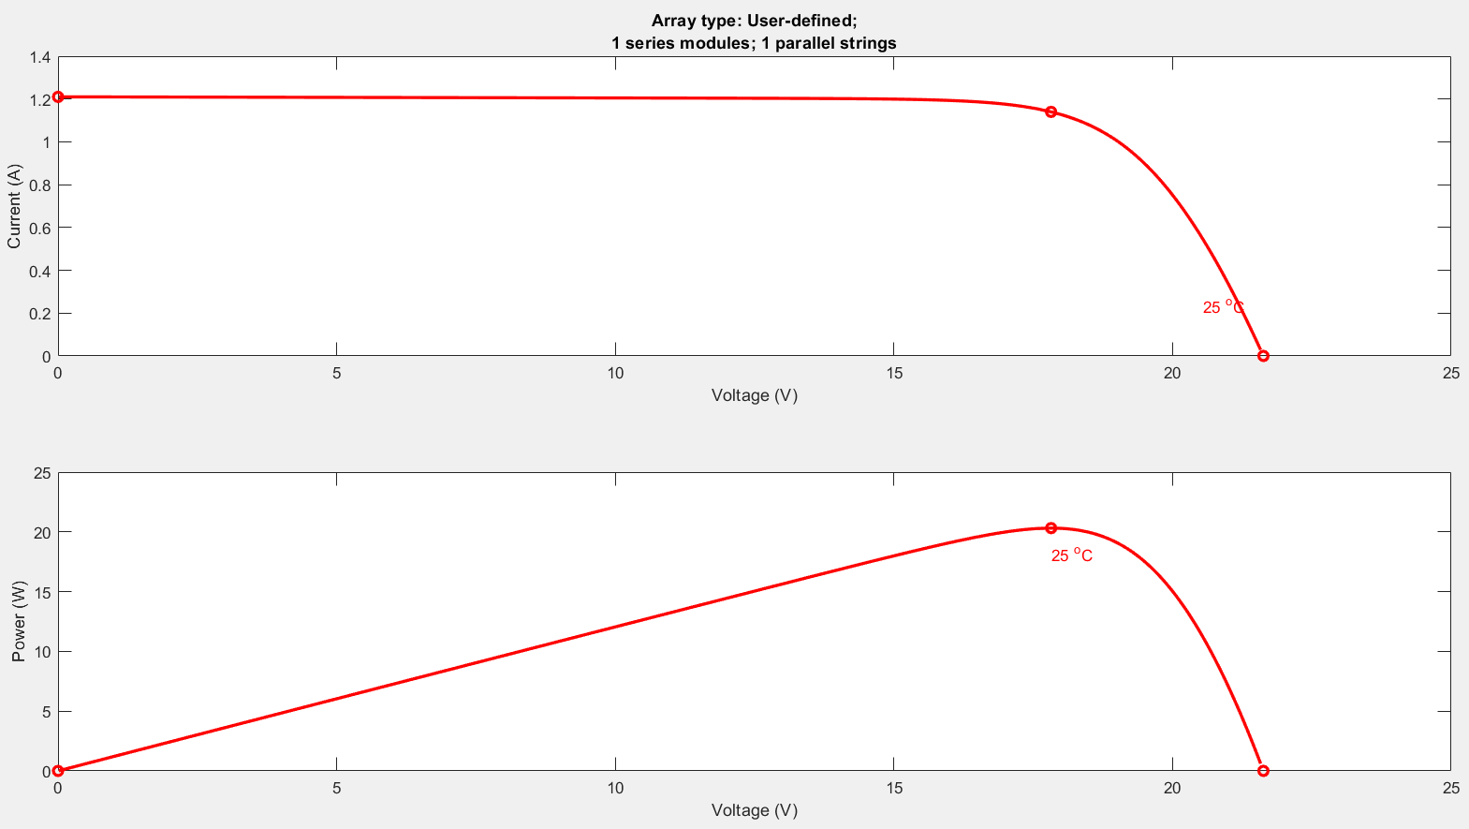

Figure 3.6: I-V and P-V Curves for our solar panel.

This figure is generated by one module, it has the P-V and I-V curve characteristics under STC for each of the four modules shown, also we can see the effect of the temperature, as we can see the voltage is decreased due to the increase in temperature, hence the power decreased also.

Experimental Work:

In this chapter we verify our work experimentally for the normal condition at Riyadh condition. Also, we gave conclusions based on the comparison between the simulation results and the experimental results.

Equipment
In the second part of the Graduation Project (Second Semester) we used some equipment to draw the I-V Curve practically.
Used equipment:
- PV solar panel:
The PV panel used in the practical work was (20W MONO) type as shown in fig3.7, also the nameplate is shown in fig3.8.
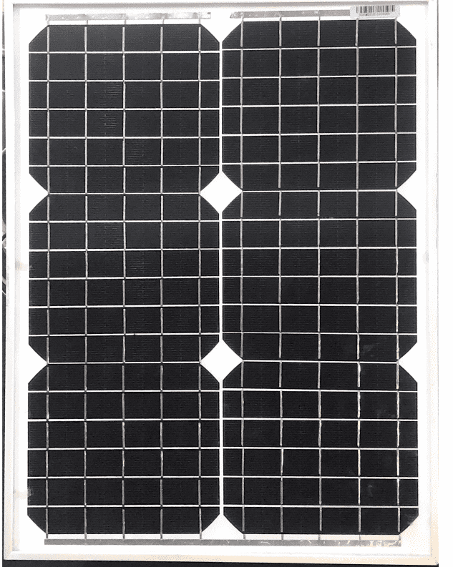
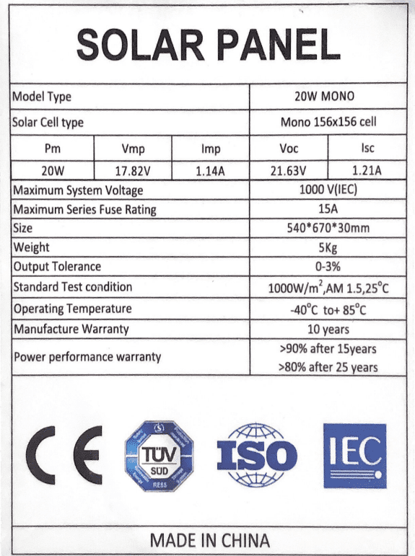

Figure 3.8: 20W MONO Solar Cell Panel nameplate.
Figure 3.7: 20W MONO Solar Cell.

- Two Multimeters:
To take the Current and the Voltage Reading at the same time we had to use Two Multimeters as shown in fig 3.9, one Multimeter is connected in series as an Ammeter, and the other one is connected in parallel as a Voltmeter.
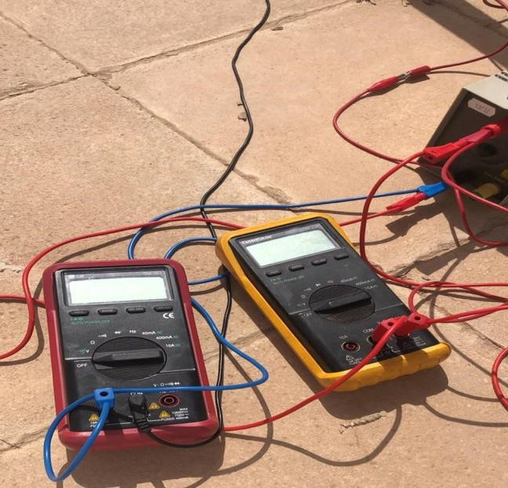
Figure 3.9: Multimeters

- Variable Resistance:
To draw the I-V Curve we had to use a Variable Resistance since it is hard to take a full day reading of Current and Voltage.
The Variable Resistance will help to simulate the changes that happen by time change.

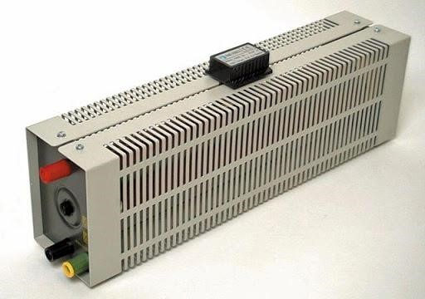
Figure 3.10: Variable Resistance.

- Connection Wires:
Also, we used some wires to connect the equipment and make the circuit.

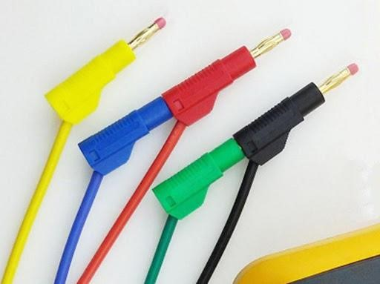

Figure 3.11: Connection Wires.

After we collect these equipment from the university labs, we start the practical work and we start to take the readings. The connection of the equipment is shown in fig3.12.
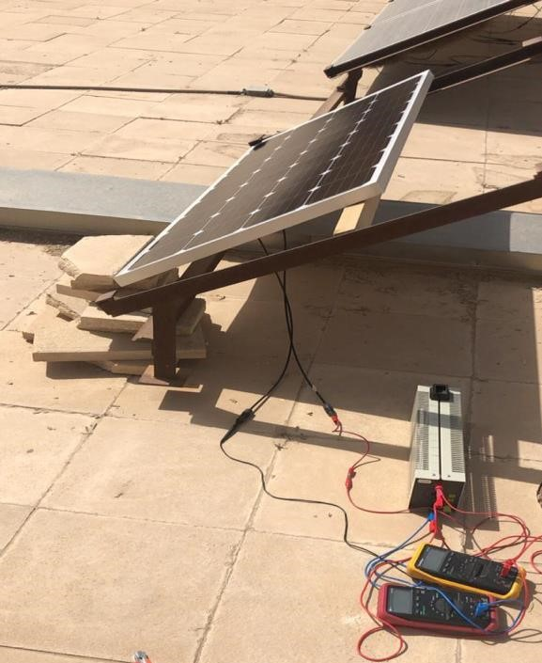
Figure 3.12: Final Connection

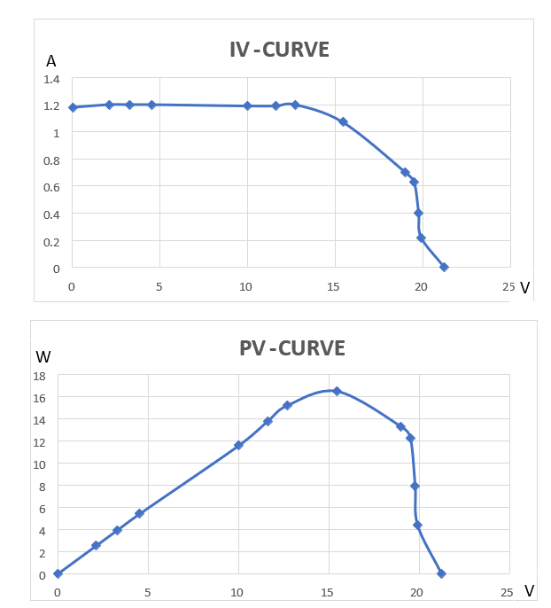

Figure 3.13: Experimental Result for I-V & P-V curves
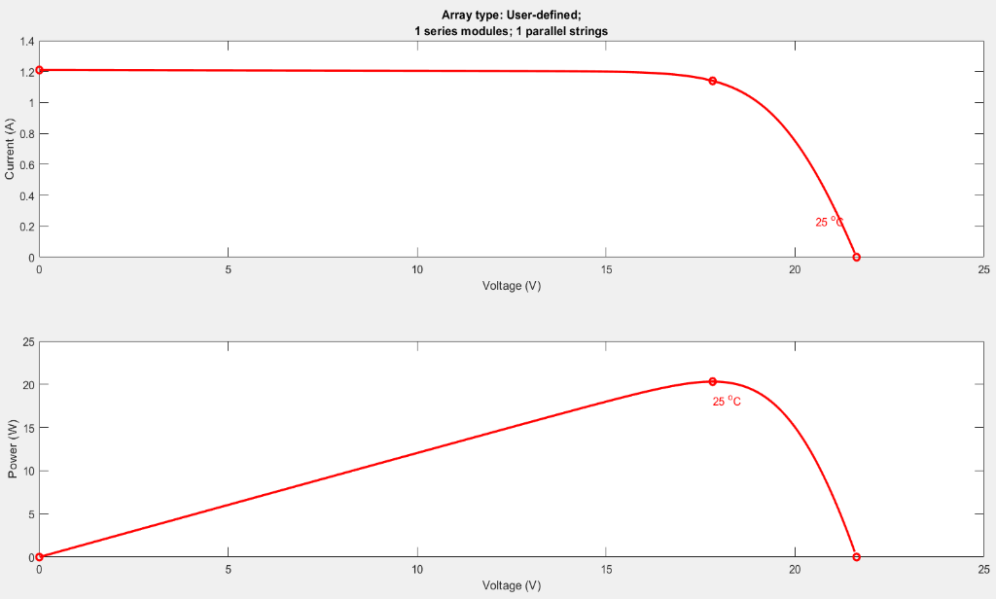

Figure 3.14: Simulation Result for I-V & P-V curves

Comments :

As we can see the experimental results are close to the simulation results. But the drop in current and voltage are due to the:

1- Drop in voltage due to the series resistance of the ammeter. Drop in current due the Parallel resistance of the voltmeter. Drop in voltage due to Connections to variable resistance.
2-Weather fluctuations. (Dusty, cloudy,etc).
3- Radiation fluctuation. (Instantaneous change in radiation)

Calculations

- Solar Cell Calculations :
Width (cm) | Length (cm) | Vmp (V) | Imp (A) | Voc (V) | Isc (A) | Po (W) | Efficiency | Area (cm²) | Pin (W/cm²)
54 cm | 67 cm | 17.82 V | 1.14 A | 21.63 V | 1.21 A | 20 W | 5.5% | 3618 cm² | 100mw/cm²
Table 3.2: Values of the parameters in our solar cell.

$$eff=\frac{Po}{Pin}×100$$

$$eff=\left(\frac{20}{0.1×3618}\right)×100=5.5\%$$

$$P=V×I$$
$$Io=\frac{P}{V}=\frac{20}{17.82}=1.122 A$$

- Converter Calculations :
$$Eff=\frac{Po}{Pin}×100$$
$$95\%=\frac{5×I}{20}×100 , Io=3.8 A$$

$$Charging time of battery=\frac{Battery in Ah}{charging current}=\frac{10Ah}{3.8}=2.63 h$$

$$We measured the charging time of battery practically=8 h$$

Conclusions and Future Work

At the end of our work we have a full understanding of our system design and we achieved the most important thing which is determining the specifications of each part , running a simulation to check our work. We have done our project successfully and it started converting the sun light into electric energy and started to charge our load which is the power bank, we also measure the charging time practically & theoretically.
We are looking forward to improve our system and try to make some improvements to sell it as a new product.

References

[1]: Sumathi, S., Kumar, L. and Surekha, P. (n.d.). Solar PV and wind energy conversion systems. pp.60-73.
[2]: Sabbaghpur Arani, M. and Hejazi, M. (2019). The Comprehensive Study of Electrical Faults in PV Arrays.” https://www.hindawi.com/journals/jece/2016/8712960/”.
[3]: C.B.Honsberg and S.G.Bowden, “Photovoltaics Education Website,” www.pveducation.org”, 20
[4]: www.statista.com. (2019). Topic: Global Solar Photovoltaics. [online] Available at: https://www.statista.com/topics/993/solar-pv/ [Accessed 18 Dec. 2019].
[5]: Energy Informative. (2019). The History of Solar Energy - Timeline. [online] Available at:
“https://energyinformative.org/the-history-of-solar-energy-timeline/”.
[6]: Das, S. (n.d.). PV Cell Working Principle | How Solar Photovoltaic Cells Work. [online] Electronics Tutorial | Best Electronics Tutorial Website. Available at: “http://www.electronicsandyou.com/pv-cell-workingprinciple-how-solar-photovoltaic-cells-work.html/ “.
[7]: Masters, G. (2013). Renewable and efficient electric power systems. Hoboken, NJ: John Wiley & Sons Inc. [8]: Darling, D. (2019). I-V curve (of a photovoltaic device). [online] Daviddarling.info. Available at:
“https://www.daviddarling.info/encyclopedia/I/AE_I-V_curve.html”.
[9]: Alternative Energy Tutorials. (2019). Solar Cell I-V Characteristic and the Solar Cell I-V Curve. [online] Av_{ailable at:”} http://www.alternative-energy-tutorials.com/energy-articles/solar-cell-i-vcharacteristic.html”.
[10]: Mathworks.com. (2019). PV String Partial Shading Model - File Exchange - MATLAB Central. [online] Available at: “ https://www.mathworks.com/matlabcentral/fileexchange/62743-pv-string-partial-shadingmodel?s_tid=srchtitle “.
[11]:Slideshare.net. (2019). Session 06 balance of system components. [online] Available at:
https://www.slideshare.net/chiragjn2007/session-06-balance-of-system-components [12]:indiamart.com. (2019). Solar Panel Batteries. [online] Available at:
https://www.indiamart.com/proddetail/solar-panel-batteries-10393056855.html
[13]:Schweizer Radio und Fernsehen (SRF). (2019). Technik - Kernspaltung: Ein Experiment veränderte die Welt.
[online] Available at: https://www.srf.ch/wissen/technik/kernspaltung-ein-experiment-veraenderte-die-welt
[14]:En.wikipedia.org. (2019). Willoughby Smith. [online] Available at: https://en.wikipedia.org/wiki/Willoughby_Smith
[15]:En.wikisource.org. (2019). Popular Science Monthly/Volume 45/July 1894/Sketch of Heinrich Hertz - Wikisource, the free online library. [online] Available at:
https://en.wikisource.org/wiki/Popular_Science_Monthly/Volume_45/July_1894/Sketch_of_Heinrich_H ertz
[16]:Millennium Academy Private, Independent, International School k-12 located in Pasco County. (2019). Albert
Einstein - Millennium Academy Private, Independent, International School k-12 located in Pasco County. [online] Available at: http://www.millenniumacademy.net/albert-einstein/
[17]:Ar.wikipedia.org. (2019). يان تشوخرالسكي. [online] Available at: https://ar.wikipedia.org/wiki/يان_تشوخرالسكي
[18]:edithlphotography, P. (2019). Solar Cell Construction Diagram and Working Principle. [online] Electrical Engineering 123. Available at: https://www.electricalengineering123.com/solar-cell-construction-workingprinciple/
[19]:Trial, M. (2019). GJU Faculty,Students get MATLAB Online - Students & Faculty - Free Trial as low as $0.00. [online] OnTheHub.com. Available at:
https://e5.onthehub.com/WebStore/OfferingDetails.aspx?o=bbd69f6a-8967-e911-8115000d3af41938&pmv=ac9673ab-a566-e911-8115-000d3af41938&ws=ca6fb172-9e50-e311-93f7b8ca3a5db7a1&vsro=8

[20]"Boost converter", En.m.wikipedia.org, 2020. [Online]. Available: https://en.m.wikipedia.org/wiki/Boost_converter. [Accessed: 22- Apr- 2020].

[21]"Basic to Advanced Battery Information from Battery University", Batteryuniversity.com, 2020. [Online]. Available: https://batteryuniversity.com. [Accessed: 22- Apr- 2020].

[22]2020. [Online]. Available: https://youtu.be/tVboddMVdWU. [Accessed: 22- Apr- 2020].

Appendix

History of PV cell:
Solar technology isn’t new. Its history spans from the 7th Century B.C. to today. We started out concentrating the sun’s heat with glass and mirrors to light fires. Today, we have everything from solar-powered buildings to solar powered vehicles.
1767 – The First Solar Oven:
in 1767, the first solar oven was invented. The credit goes to Horace de Saussure, a Swiss physicist, which probably had no idea his invention would help people prepare their dinner two and a half centuries into the future _{[5]}.
1839 – The Discovery of the Photovoltaic Effect:
Edmund Becquerel [13].
1839 marks a big year in the history because Edmund Becquerel, a French physicist, only 19 years old at the time, discovered that there is a creation of voltage when a material is exposed to light. Little did he know, that his discovery would lay the foundation of solar power _{[5]}.
1873 – Photoconductivity in Selenium:
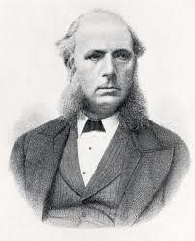
Willoughby Smith [14].
Willoughby Smith, an English engineer, discovered photoconductivity in solid selenium.
1876 – Electricity from Light [1]:
Building on Smith’s discovery three years before, professor William Grylls Adams, accompanied by his student, Richard Evans Day, were the first to observe an electrical current when a material was exposed to light. They used two electrodes onto a plate of selenium and observed a tiny amount of electricity when the plate was exposed to light _{[5]}. 1883 – The First Design of a Photovoltaic Cell [1]:
An American inventor, Charles Fritts, was the first that came up with plans for how to make solar cells. His simple designs in the late 19th century was based on selenium wafers _{[5]}.

1887 - The Photoelectric Effect is Discovered:
Heinrich Hertz [15].
Heinrich Hertz, a German physicist, observed the photoelectric effect when the light was used to free electrons from a solid metal surface to generate power. Hertz realized that this process generated more power when the surface was exposed to UV light as opposed to intense visible light. Albert Einstein joined the fun by further explaining the effect and won a Nobel Prize for his effort _{[5]}.
1905 – Albert Einstein and the Photoelectric Effect:
Albert Einstein [16].
Albert Einstein is famous for a wide variety of scientific milestones, but most people are not aware of his paper on the photoelectric effect. He formulated the photon theory of light, which describes how light can “liberate” electrons on a metal surface. In 1921, 16 years after he submitted this paper, he was awarded the Nobel Prize for the scientific breakthroughs he had discovered _{[5]}.

1918 – Single-Crystal Silicon:
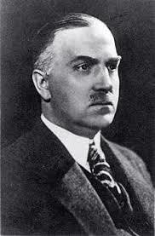
Jan Czochralski [17].
Jan Czochralski, a Polish scientist, figured out a method to grow single-crystal silicon. His discoveries laid the foundation for solar cells based on silicon _{[5].}

