Electrical Engineering Risk Management plan
This report is prepared based on college risk management plan for the entire college.

Emergency Contacts
Civil Defense Inside KSU Campus 955 or 0114673221
Civil Defense Outside KSU Campus 998
Ambulance of King Khalid Hospital 99999 or 0114699999
General Directorate of KSU Safety & Security 950 or 0114670950
Committee for the Prevention of Chemical and Biological Pollution 0114674360
Committee for the Prevention of Radioactive Pollution 0114676633

- Introduction
Laboratories and Risk Management Unit, the College of Engineering, King Saud University is consideredone of the most important committees of Vice-Rector’s Office for Development and Quality which isapproved in the organizational chart of the College of Engineering (Figure 1). The unit is supervised by college staff members who are nominated by Dean’s administrative decision. The unit consists of two main committees:
• Occupational Safety Committee • Laboratory Supervisors Committee Laboratories
and Risk Management Unit seeks to protect all users and visitors of the college’s facilities, spare them dangers in any field, and prevent loss of lives and properties as mush as possible.
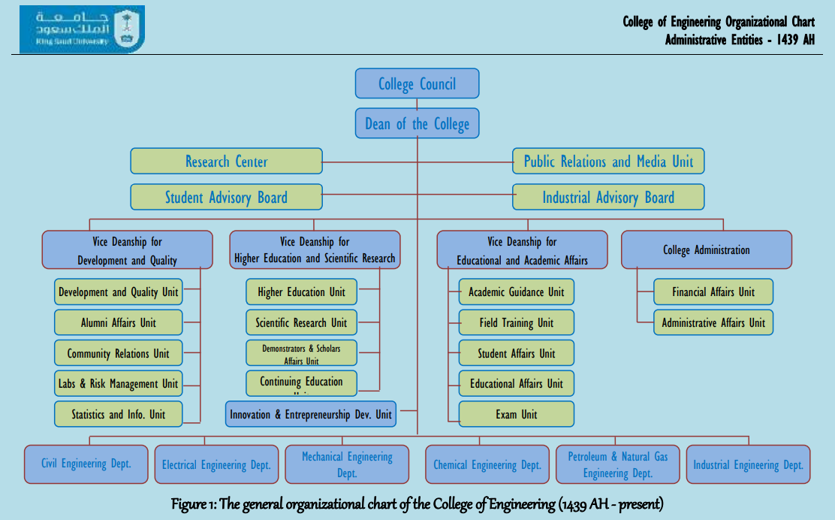

- Occupational Safety Committee : The Occupational Safety Committee at the College of Engineering is formed by an administrative decision issued by the Dean of the College. The committee includes representatives from all units, departments, centers and institutes within the college in addition to the head of the KSU risk management as a consultant. It currently includes: • Dean of the College of Engineering (Supervisor)
• Vice Dean for Development and Quality (Chair)
• Head of the College’s Development and Quality Unit (Coordinator)
• Members from all departments of the college
• Director of the college’s administration
• A member from the Prince Sultan Institute for Advanced Research
• A member from the Advanced Manufacturing Institute
• A consultant from the KSU risk assessment department
• Secretary of the Committee

The Occupational Safety Committee at the College of Engineering is concerned with assessing the risks of the work, teaching and research environment and their working conditions, studying the causes of occupational accidents and injuries, and taking the necessary measures and precautions to prevent their occurrence and non-recurrence by applying the following:
• Identifying and evaluating potential risks in the College of Engineering building and developing plans to face them.
• Designing, printing and publishing safety maps for the building indicating emergency exits and assembly areas.
• Monitoring the application of occupational safety requirements and instructions in all college sites and in laboratories.
• Following up the availability, adequacy and readiness of fire protection means.
• Periodic inspection of all college facilities to verify the implementation of safety requirements to ensure the prevention of work accidents and occupational injuries.
• Evaluating the risks of the work environment in the college and preparing and providing indicative instructions for safe work methods.
• Coordinating the training of the college employees on how to use fire protection tools and evacuation procedures in case of emergency.
• Coordinating mock evacuation plans in the event of an emergency. • Preparing reports of various accidents and taking decisions to address their causes.
• Studying the cases of abuse and violations submitted to the committee to take decisions in their regard

- Laboratory Supervisors Committee: It is an integrative committee with the Occupational Safety Committee that was established at the beginning of the first semester of this year 1439-1440 AH, after updating the organizational charts of the university units. The committee is formed by a decision from the Dean (and is reformed as needed). It includes a delegate from each academic department who has extensive knowledge of the activities of the department's laboratories, preferably the supervisor of the department's laboratories. The following are the most important tasks assigned to the Laboratory Supervisors Committee at the College of Engineering:
• Supervising and coordinating of receiving devices and equipment from the supplying companies, ensuring their compliance with the required specifications, examining them before sending the receiving, installation and operating forms to the Procurement Department through the head of the department, and keeping a copy of the forms.
• Listing the periodic needs of devices, tools and consumable materials at the end of each semester and reporting them to the head of the department.
• Returning out-of-order devices and equipment to the Warehouse Department after the approval of the head of the department.
• Instructing technicians to make laboratories available to students during work hours and as needed and following it up.
• Following up the maintenance and testing of devices periodically.
• Keeping the operating manuals and warranties of devices and equipment.
• Making a usage follow-up register for each device and place it next to them.
• Documenting the equipment, tools and materials borrowed from the laboratories as a beneficiary’s responsibility, and reporting a list of them to the head of the department at the end of each semester.
• Activating occupational safety requirements and security and safety instructions in laboratories.

- The most important activities of the unit during the last period
• Coordination with the departments regarding the safe collection and disposal of chemical waste. • Preparing a plan to confront crises and emergencies (emergency and evacuation) in building (3) of the College of Engineering.
• Preparing an emergency plan for evacuation, identifying collaborators from all units and departments of the college, creating an emergency telephone directory that contains names, mobile phones and landline numbers for all officials and collaborators in the field of security and safety in the college.
• Training the college employees on how to act in the event of an emergency in the college, through drills to evacuate the entire college building (the first drill was conducted on 3/25/1439 AH).
• Paying regular visits to all facilities to ensure that there are no violations affecting the safety of the college building and its visitors.
• Following up observations received from the University's Security and Safety Department and ensuring their being removed.
• Preparing plates with the numbers of the parties to be contacted in the event of an emergency and installing them in clear places all over the college premises
.• Counting the number of people present in the building and distributing them and locating people with special needs.
• Holding periodic meetings for the Occupational Safety Committee.
• Holding several meetings with members of the Occupational Safety Committee at the College of Engineering and representatives from the KSU's risk department, safety and security department, civil defense department, maintenance department, emergency department at King Khalid University Hospital, Committee of the Prevention of Chemical and Biological Pollution, Committee of the Prevention of Radioactive Pollution, and General Administration of Services and Facilities.
• Holding theoretical and practical workshops in cooperation with the KSU's Risk Management Department and the Safety and Security Department to educate and train all employees and students on how to act during emergencies and how to use fire extinguishers of all kinds.
• Making brochures showing emergency exits and how to act in emergency situations.
• Making panels showing emergency exits and assembly points outside the college in all parts of the college.
• Raising awareness of college employees about occupational safety precautions through banners and flyers, visiting students in lecture rooms, publishing on the college’s website, and sending instructive emails to college employees and students.
• Distributing phosphorescent vests for members of the Occupational Safety Committee with their ID cards.
• Providing some initial safety requirements for the college laboratories.
• Participation in implementing the KSU's plan for Covid-19pandemic.

- The College of Engineering plan to face Risks, Crises and Emergencies in Building (3) (Emergency and Evacuation Plan)

5.1 Definition of Evacuation It means removing the people from places at risk safely and quickly via the nearest shortcuts.
5-2 Objectives of the Plan
• It aims to evacuate the building from the college’s employees as soon as they hear the emergency alarm, by directing them to the assembly points.
• Forming and training an emergency team and defining the duties and tasks assigned to them to serve as a general framework for the implementation of evacuation plans, firefighting and rescue operations in emergency situations, and as a guide for the protection of university employees and students in coordination with the university departments of civil defense and safety.
• Educating and training the college employees about the importance and methods of evacuation.
• Monitoring the plan’s deficiencies and addressing them.

5-3 Location and Area of the College of Engineering
• The college is located in the eastern side of King Saud University (KSU) on the pathway of the scientific colleges between Building 2 (College of Agriculture) to the north and Building 4 (College of Science) to the south.
• The College of Science consists of one building with three floors. This building is divided into nine departments including EE departments.
• The building contains administrative offices, lecture rooms, chemical laboratories, workshops, as well as service rooms such as electric rooms, mechanical rooms and a communication room.
• The location of the nearest civil defense division is the Civil Defense Unit at King Saud University.
• The nearest ambulance squad is at the King Khalid University Hospital.
• There are two assembly points, one in the back of the building towards the car parks, and the other is in the front of the building. The assembly area is located at the back of the building towards the car parks.

5-4 Emergency Escape Routes
• Two main gates distributed as follows: one at the western side overlooking the pathway of the scientific colleges opposite to building (29) of Deanship of Admission and Registration; the other is at the eastern side overlooking the car parks from the first floor.
• There are six main staircases in the building overlooking the main lobby.
• Eight emergency exits (four along the northern side and four along the southern side of the building).
• Six emergency staircases (three along the northern side and three along the southern side of the building).

5-5 Elements of the Evacuation Plan
The requirements for the success of the crisis and emergency response plan depends mainly on how to detect the warning signals of the crisis, taking preventive measures, and the actual confrontation and containing the damage. It also depends on the available means and equipment and the instruction manual that regulates the method and implementation of the plan which can be classified into:

5-6 Evacuation Methods The method of evacuation depends on the type of accident. It may be partial or complete evacuation.
• Partial Evacuation (temporary evacuation) means that those in the building are able to escape from any point of the damaged part of the building and reaching a safe place from fire, often this part is in the same building.
• Full evacuation means exiting all people from the building to the assembly points outside the building. 5-7 Responsibilities and Duties of the Team’s Directors
• Determining the emergency team and being keen on training and developing them, considering making them ready and available at all times, especially at peak times, by providing and announcing a contact line service for emergencies.
• Calling the University Safety and Security Department on 4650950 (Direct 950). • Ensuring the communication with the competent authorities (Civil Defense, Operations Room at the University Safety and Security Department and Ambulance).
• Ensuring that all employees in the building are fully aware of the escape routes and have the ability to use them.
• Ensuring that all emergency exits are open and the corridors leading to them are unimpeded, that the emergency exits are not closed completely during official working hours and when the faculty employees are in the building, and that they are easy to open to the outside (the direction of the rush at the time of escape).
• Ensuring that all escape routes are clear of obstacles, and they are completely visible to those in the building using fixed indicative sings distributed properly throughout the building.
• Keeping regular maintenance records for automatic alarms and fire extinguishing devices.
• The official spokesman is in front of the officials.
• Supervising the implementation of the evacuation plan.

5-8 Duties of the Heads of Departments in the College Building
• To be knowledgeable about the number of the department’s employees (faculty members, employees, students, workers) and if anyone of them is still inside the site.
• Assigning attendance register keepers periodically, alerting faculty members to take attendance sheets with them in emergency cases, and ensuring that the hall is free of students as they take the right way out.
• Ensuring, on a regular basis, that the doors and windows are closed, except for the exits designated for evacuation, and that they have no obstacles.
• Ensuring that the electricity is switched off.
• Ensuring the communication with the competent authorities (Civil Defense, Department of Safety and Security at the site, Operations Room of the University Safety and Security Department in Dir'iya).
• Ensuring the arrival of the competent teams.
• Guiding people to the assembly point ensuring that no one is left behind.

5-9 Duties of the Employees, Students and Workers in Emergencies
• Try to be calm and not confused.
• Stopping work immediately.
• Acting upon the advice and directions of the emergency team and officials.
• Never hiding in the building.
• Heading to assembly points through escape routes and emergency exits.
• Never running or running over teammates to avoid the occurrence of any injuries.
• Never returningto the building whatsoever until it is clear by authorities.

10-5 What to do when there is a Building Fire?
• Break the fire alarm glass and switch it on.
• Call immediately KSU Department of Safety and Security’s operations room at (950) from any landline within the building or (4670950) extension (950) from outside the building.
• Report the fire to the emergency team in the building. 5-11 Safety & Emergency Teams in the Building
• The emergency team consists of college employees in the building, and their presence is mandatory during the daily busy working hours.

- Characteristics of the Emergency Team
• To be in good health and quick runner. • To be familiar with the firefighting methods in the building. • To be familiar with the types of fire extinguishers and how to use them. • To be calm and not confused. • To have a strong personality. • To be bold and witty. • To be keen on training and raising awareness.

- Tasks of the Emergency Team
• Asking everyone to stop working immediately. • Cutting off the electricity to the place if possible or asking the maintenance technicians (electricians) to do it. • Raising the spirits of the college’s employees and making them calm and reassured. • Keeping periodic maintenance records of automatic alarms and extinguishing devices, and submitting periodic reports for their status to the Safety Department every week. • Keeping lists of names, numbers and addresses of the college’s employees, and the phone numbers of their parents. • Keeping attendance sheets for counting at the assembly points to check if there are any missing persons. • Moving the injured people to the assembly area and escorting them to the hospital if necessary.

III. Teams and Responsibilities
- Evacuation Team
• Dividing the building into areas according to the map, and distributing teams over those areas. • Selecting a safe assembly point from the previously defined points, and avoiding points near to the danger. • Reporting to the operation room about the situation on a regular basis. • The team conducts a comprehensive field survey of its areas to ensure that they are empty and there are no detainees or injuries, and reports them. • Assessing whether the situation requires intervention by the civil defense. • Warning everyone not to carry belongings to avoid crowding and prevent risks caused by them, and asking everyone to leave immediately. • Warning everyone not to scream, stampede, run or bypass their colleagues, so that no injuries will occur. • Assigning someone to count the number of people present at the assembly point to ensure that there are no detainees inside the building. • Guiding those in the building to the escape routes, emergency exits and assembly points. • Evacuating those in danger and organizing their exit, especially since the building consists of several floors, so everyone should be instructed to leave through the safest and nearest exit.
B - Firefighting Team
• Identifying the location of fires through Fire Alert System signage• Dealing with the accident as soon as possible. • Making sure that the place where you stand does not pose a life risk. • Carrying out firefighting using the available firefighting equipment in the building. • Making sure that the windows are closed to prevent the spread of fire to other parts of the building. • Cooperating with the specialized teams of the civil defense by providing information about the location and type of fire, and available extinguishing equipment and means. • Reporting of the injured and detainees.

C- Rescue Team
• The medical staff goes from the first-aid clinic to the assembly area with first aid bags. • Taking information about the locations of detainees and missing persons and saving them, if possible. Assess the situation and decide whether it requires the intervention of the civil defense supporting agencies and informing them upon their arrival about the places of detainees. • Moving the injured to the assembly area, taking their personal information, providing them with first aid, and escorting them in ambulances and in hospitals until their relatives arrive.

D- Operations and Control Room
• Receiving reports and taking accurate information. • Contacting and directing the competent authorities such as the “Director of the University for Safety and Security, Civil Defense, Traffic, Police, Ambulance, Maintenance” to the emergency site. • Asking all device holders not to skip operations or cut wireless signals. What device? What operations? • Giving priority to the emergency reports, then other less urgent reports. • Reporting the received information about detainees, injured, etc.

E – The University Traffic and Parking Department
• Receiving reports from the operations and control room. • Organizing traffic within the university. • Preventing cars from entering the emergency area. • Withdrawing cars that disrupt traffic or obstruct emergency vehicles. • Controlling the entrances of the university. • Directing and guiding emergency vehicles to the emergency location.

F - Duties of the Security Unit
• Taking the organizational information from the University Safety and Security Department and the required plan for execution. • Securing the building and maintaining order. • Surrounding the area to keep the bystanders away and prevent gathering. • Preventing anyone other than the specialized personnel from entering the building. (Allowing specialized personnel only to enter the building). • Waiting for the competent teams to guide them to the emergency location.

G- Means and Equipment required in the Building
• The building assembly points must be identified by placing boards at their locations and guiding signs to their sites. • Boards of assembly points and other boards indicate them should be placed. (Repeated, same as the first point). • Emergency doors and stairs must be numbered.• Signs indicating emergency exits on the ground (phosphorescent signs) must be placed. • Ensuring that first-aid firefighting devices for all types of fires are available and suitable for immediate use. • Checking and maintaining alarms and automatic extinguishing devices and signs indicating emergency exits on a regular basis, and making a schedule for them which is kept at the office of Director of the Administration, Emergency Team and Director of University for Safety and Security. • Ensuring that first aid kits are available. • Equipping the emergency doors with handles making them open outwards. • Posting instructional signs for safe use of elevators.

H- The Responsible University Departments for Operating the Facilities
• The building maintenance technicians (electricians) disconnect the electricity supply. • The Plantation Department, in coordination with the Public Water Corporation, is responsible for providing the building with water supply in case the water or sewage network is damaged. • The Nutrition Department at the Deanship of Student Affairs, in coordination with the relevant departments, is responsible for providing shelter sites with drinking water, nutrition and accommodation requirements. • Technicians of the Operation and Maintenance Department, Safety and Security Personnel, Transportation Department and Cleaning Department are present at the site continuously as required.

- Drills After preparing the scenario for emergency cases, they are executed using Early Warning points, and monitoring the reaction of the formed teams to manage emergency cases and the behavior of the college employees. The monitoring is conducted through direct coordination between the competent agencies at the university and the relevant public agencies such as (Civil Defense, Ambulance, ... etc.).
- J- Evaluation of Outcomes Evaluating the performance level of the formed teams for emergency situations, identifying the errors occurred, and monitoring the negative points to take advantage of them in developing urgent solutions to avoid them in the future.
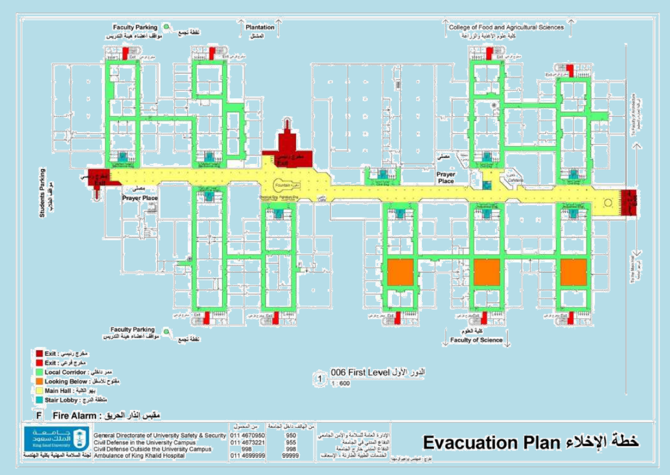
EE Department

