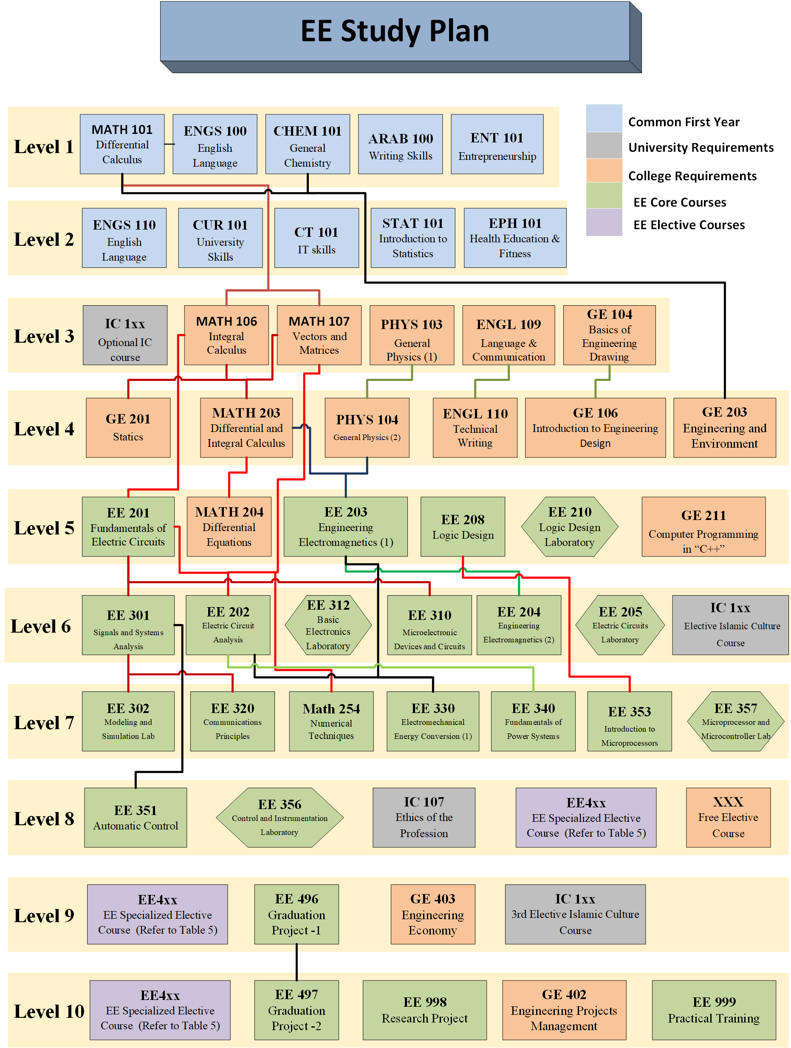
Fig. 1: Flowchart of EE Program Courses

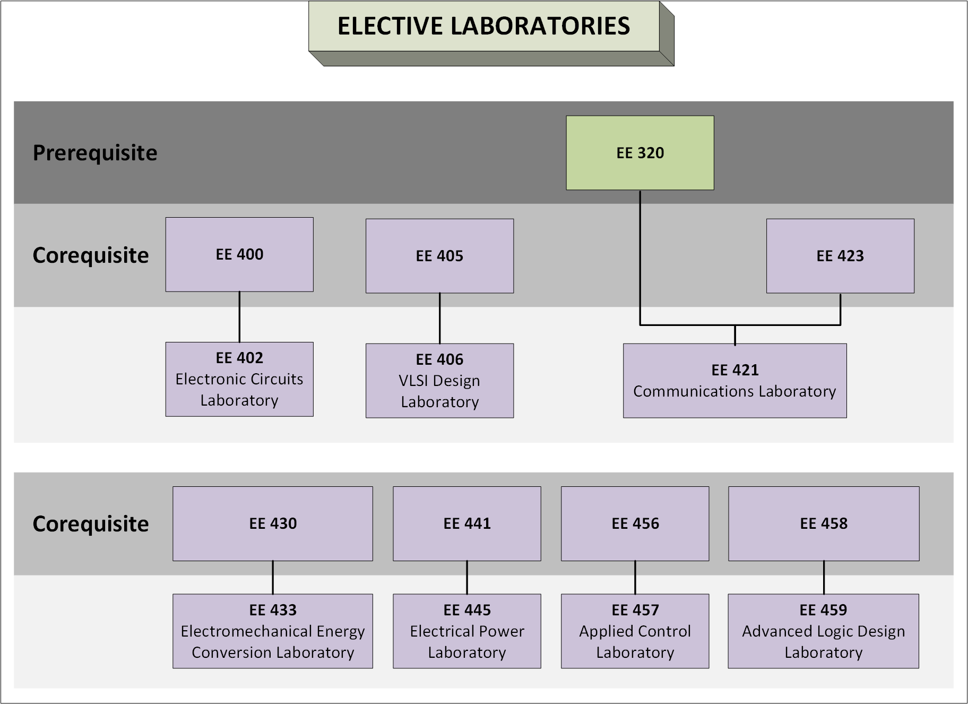
Fig. 2: Flowchart of Elective Labradorites
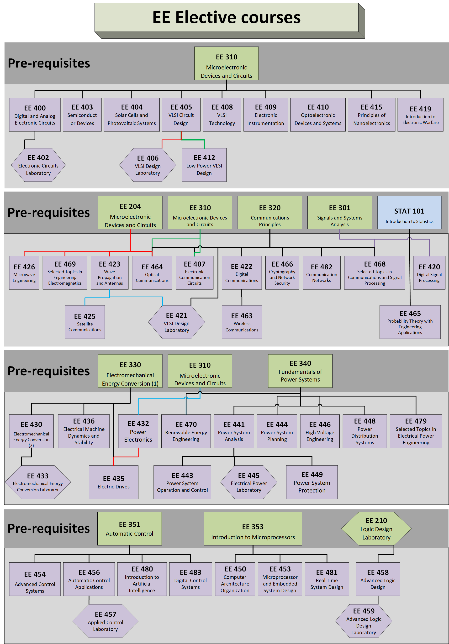
Fig. 3: Flowchart of Elective Courses

