College of Engineering
Electrical Engineering Department

EE497
Comparison of Glass-Glass and Glass-Backsheet PV Modules Using Bifacial Silicon Solar Cells.

Students Team
Yousef Aljasir Student ID: 436104419
Nawaf alduhaim Student ID: 436100944

Supervisors
Name Signature
Prof. Abdulrahman Alamoud ………………
Dr.Mohamed Al-Rashidi ………………

Submitted in Partial Fulfillment of the Requirement
for the B.Sc. Degree,

Jumada 1442
December 2020

Project Abstract

Bifacial solar cells can be encapsulated in modules with either a glass/glass or a glass/backsheet structure. A glass/backsheet structure provides additional module current under standard test conditions (STC), due to the backsheet scattering effects, whereas a glass/glass structure has the potential to generate additional energy under outdoor conditions, We want to analyze both a glass/glass and A glass/backsheet and See the difference between the two.

Acknowledgement

We would like to express our deep and sincere gratitude to our supervisor, Prof. Abdulrahman Alamoud (Professor of Microelectronics and Solar PV Energy, Dept. of Electrical Engineering) and Dr.Mohamed Al-Rashid, they was in charge of our project , for giving us the opportunity to do this project and providing invaluable guidance throughout this project. It was a great privilege and honor to work and study under his guidance.
We are also grateful for the Electrical engineering department for providing us with technical support to carry out this project, to let us utilize all the necessary facilities and institute and guidance at each step during our work on the project.

Table of Contents

Project Abstract ii
Acknowledgement iii
Table of Contents iv
List of Figures v
List of Tables vi
1 Introduction 1
1.1 Problem Formulation 1
1.1.1 Problem Statement: 1
1.1.2 Problem Formulation: 1
1.2 Project Specifications 2
2 Background 3
2.1 Literature Review: 3
2.2 Detailed Engineering Analysis and Design Presentation 4
2.2.1 Cost Analysis 5
2.2.2 Bill of Materials: 6
3 Write the Title of Your Chapter 10
3.1 Use of Styles 10
4 Citing References
5 Conclusions and Future Work
References
Appendices 9
Appendix A: Working with Endnote 10

List of Figures

Figure ‎2.1: How Do Bifacial Solar Cells Work . 3

Figure ‎2.2: bifacial solar panels . 6

Figure ‎2.3: Front Surface . 6

Figure ‎2.4: Frame . 7

Figure ‎2.5: junction box. 8

Figure ‎2.6:solar . 9

Figure ‎2.7: inverter . 9

Figure ‎3.8:design1 in Case1 . 11

Figure ‎3.9:data 1 . 11

Figure ‎3.10:SLD. 12

Figure ‎3.11: design1 energy. 12

Figure ‎3.12: design2 in Case1 . 13

Figure ‎3.13: data2 . 13

Figure ‎3.14: SLD1 CASE2 . 14

Figure ‎3.15: design2 energy case1. 14

Figure ‎3.16: design1 in Case2 . 15

Figure ‎3.17: SLD CASE1. 16

Figure ‎3.18: design1 energy case2 . 16

Figure ‎3.19: design2 in Case2. 17

Figure ‎3.20: SLD2 CASE2 . 17

Figure ‎3.21: design2 energy.case2 . 18

List of Tables

Table ‎3.1: cost Case1. 5
Table ‎3.1: cost Case 2 . 5

Introduction

Problem Formulation

Problem Statement:
Solar technologies have been increasing in popularity for many years. Whilst the primitive forms didn’t offer much in the way of efficiency, they did open a new renewable energy source. Since then, solar cells have constantly been advancing and are now one of the most widely implemented renewable energy technologies around the world. Solar PV modules have been monofacial, meaning that they use the light shining on just one side of the module to generate electricity. Bifacial modules use light shining on the front and reflecting on the rear of the module to generate electricity.

Problem Formulation:

The best in terms of price and space between Bifacial Solar Modules and Solar Panels. Bifacial solar modules offer some unique advantages over traditional solar panels Better performance and Aesthetic interest. Although bifacial modules have higher efficiency ratings, they need special equipment and additional requirements. Additionally, solar panels can only capture sunlight from one side of the panel. This means that the efficiency is also determined by the positioning of the solar panel, and the positioning affects how much sunlight is absorbed throughout the day.

Project Specifications

Solar panels
Bifacial
Regular
Mosque
Parking lot
Parking lot
Mosque
COST
Number of
Module
energy
Number of
Module
COST

energy

Background

Literature Review:
Most of the solar panels you see are Regular solar panels. Sunlight hits the top face of the panel and it generates electricity. But those aren’t the only kind of solar panel that is out there. There’s another type – bifacial PV panels. With bifacial panels, there’s an extra part of the panel that produces electricity – the back face. Bifacial panels are able to generate electricity from the sun shining directly on them and also from the sunlight reflected on the opposite side or underneath the panel. Diffused light from clouds, buildings, or other objects can also hit the back and generate electricity.

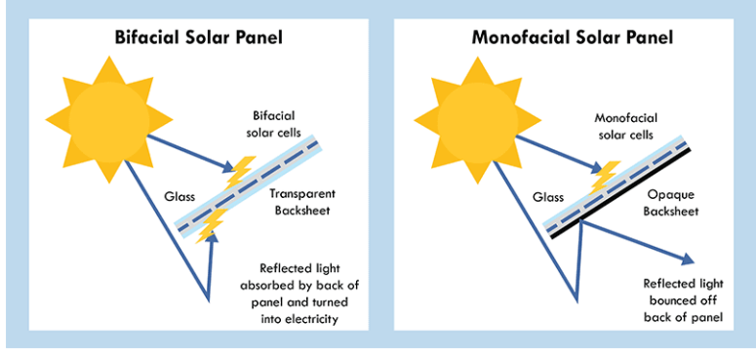
Fig(1) (Bifacial Solar Cells Work )
In order to optimize the amount of energy produced by the backside of the panel, shading caused by obstructions like the panels’ racking system needs to be minimized. In a traditional ground mount system, horizontal and vertical support bars are used to support the solar panels. However, because this traditional racking takes up valuable electricity-producing real estate on the backs of bifacial panels, these systems oftentimes have different mounting systems. The support rails across the back are thinner and there are fewer vertical support poles. Bifacial panels can be a great way to pack a big punch with less room. If you are limited on space, opting for bifacial panels can help your system produce more electricity with fewer panels. However, bifacial panels are not for everyone.

Detailed Engineering Analysis and Design Presentation
To understand the bifacial structure presented in this work it is important to know first the monofacial structure that paved the way to bifacial ones. A monofacial silicon solar cell was performed at ISC Konstanz according to the following steps: the process started with a silicon substrate (wafer), p-type with a resistivity of 0.5-3 Ωcm and about 200 µm thickness, removal of saw damage and texturing it in a chemical bath. The wafer then continued a cleaning step followed by a consecutive phosphorous diffusion. In this step, the pn+ junction was formed. The front side of the wafer was passivated using silicon nitride, and the metal contacts were screen printed, on the front side using silver metal paste and on the rear side using aluminum paste. The metal paste was dried and finally the wafer fired in a belt furnace. In this step, the metal contacts were formed and the wafer was transformed into a solar cell. In order to avoid short circuit between the emitter and the rear side metal contact of the solar cell, the edge isolation was performed using laser technology.

Cost Analysis
Case 1 small area of 10,250$m^{2}$.
We have two type of module.
1-Bifaical solar panel Design1 that has price of 445SR
1,157$\frac{SR}{W}$ price /WATT
2-Regular solar panel Design2 that has price of 335SR
1,17$\frac{SR}{W}$ price /WATT

 | Number of  Module | $$Module×price$$ | $$\frac{watt}{area }$$
Design1 | 1,075 | 478,375SR | 40.4
Design2 | 1,075 | 360,125SR | 29.9
Table(1)( cost Case1)

Case 2 is to take very Large area and specific value for watt
Area is more 45000$m^{2}$ ,the target is 4000KWp

1-Bifaical solar panel Design1 that has price of 445SR
1,157$\frac{SR}{W}$ price /WATT

2-Regular solar panel Design2 that has price of 335SR
1,17$\frac{SR}{W}$ price /WATT

 | Number of  Module | $$Module×price$$ | $$\frac{watt}{area }$$
Design1 | 10,389 | 4,654,272SR | 40.4
Design2 | 14,035 | 4,701,725SR | 29.9
Table2(cost Case1)

Bill of Materials:
bifacial solar panels:
bifacial solar cells that have photovoltaic cells that can absorb sunlight not just from the front, but the back as well. They achieve this by replacing the opaque backsheet that is standard in conventional solar panels with a transparent layer and Here’s a diagram of how a conventional panel is constructed:

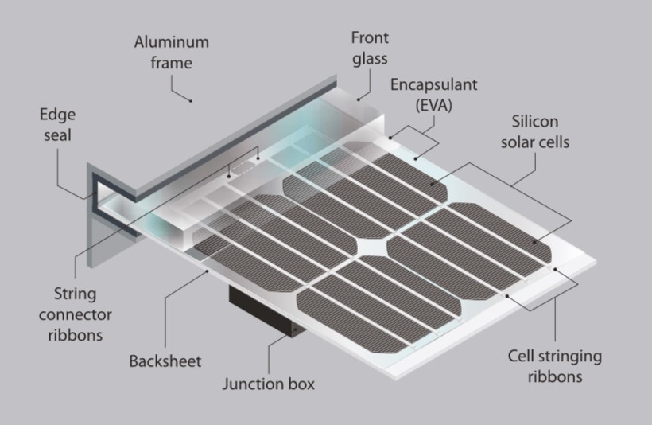

Fig(2) (diagram panel)

Front Surface Materials
The front surface of a PV module must have a high transmission in the wavelengths which can be used by the solar cells in the PV module. For silicon solar cells, the top surface must have high transmission of light in the wavelength range of 350 nm to 1200 nm. In addition, the reflection from the front surface should be low.
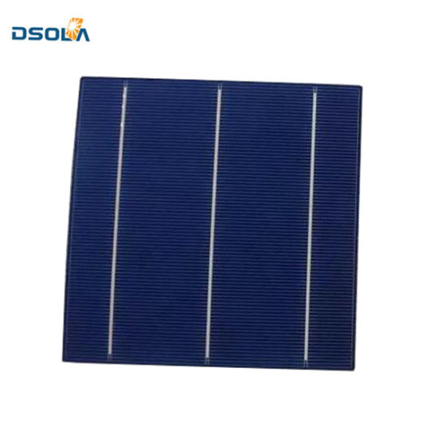
Fig(3)( Front Surface)

Rear Surface
The key characteristics of the rear surface of the PV module are that it must have low thermal resistance and that it must prevent the ingress of water or water vapour. In most modules, a thin polymer sheet, typically Tedlar, is used as the rear surface. Some PV modules, known as bifacial modules are designed to accept light from either the front or the rear of the solar cell. In bifacial modules both the front and the rear must be optically transparent.

Frame
A final structural component of the module is the edging or framing of the module. A conventional PV module frame is typically made of aluminium. The frame structure should be free of projections which could result in the lodgement of water, dust or other matter.

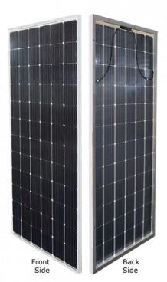

Fig(4) (Frame)

junction box:

The junction box is positioned on the module edge and does not shade any solar cell on the rear. The observed peak currents from the installed bifacial module (11.67A), which are in general to be expected from bifacial modules in installations with high albedo, are well within the tolerances of this new junction box but above the tolerances of commercial junction box.
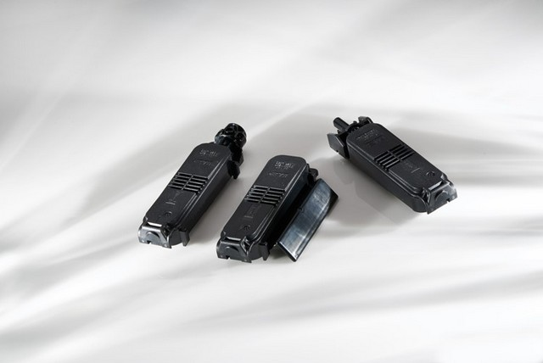
Fig(5) (junction box)

Solar Panel
The basic raw material of a solar panel is pure silicon. However, the outer frame enclosing an array of solar cells in each solar panel is made of glass. The glass must be highly transparent to allow the sunlight to penetrate the frame. Moreover, for maintenance and safety purpose, the glass used in the panels should not be brittle.
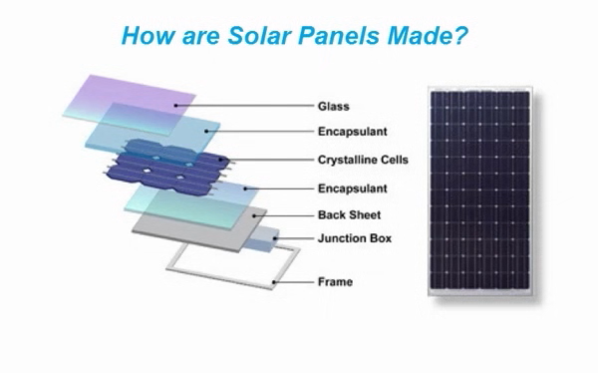
Fig(6) (solar panels made)

huawei-60kw on grid solar inverter:
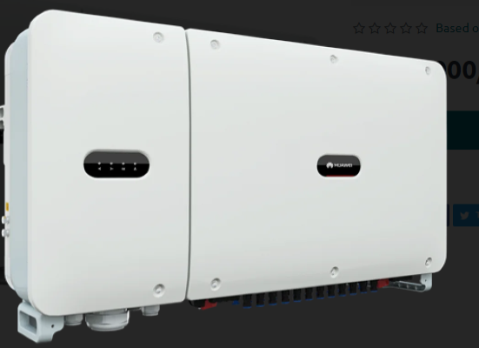
Fig(7) (inverter)

Write the Title of Your Chapter

Use of Styles
Find the best in terms of space and price. For this we have two case as a two places, every place has a two designs, one is Bifacial and the second regular solar panels, We want to compare the two, to see who is the best in terms of watt per area and cost per watt and who produces the most energy, So we have two sites, First one is a small area and the second is a large and open area, We want to see the difference between them and the importance of choosing carefully between the two types of solar panels,

First case location in King Saud University Mosque area of 10,250m^2
The area will include many distant free like : skylight, corridors, minaret, air condition, and set backs.

Design (1)
We used 1075 modules Bifacial solar panel that's give me 413.9kWp
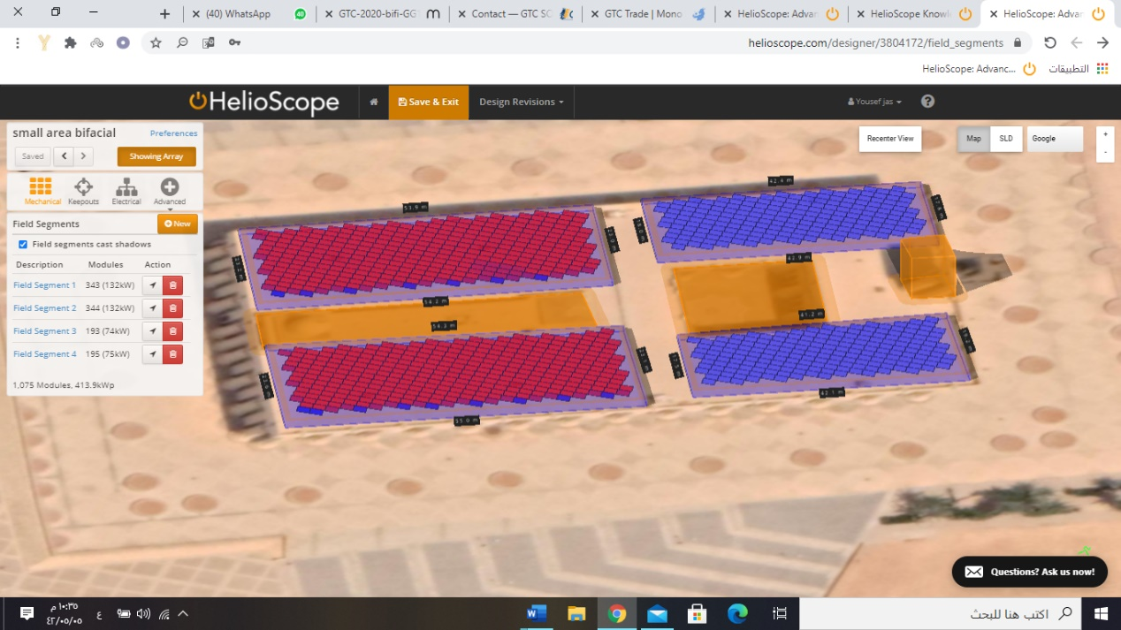

Fig(8) (design1 in Case1)

Fig(9)(DATA1)

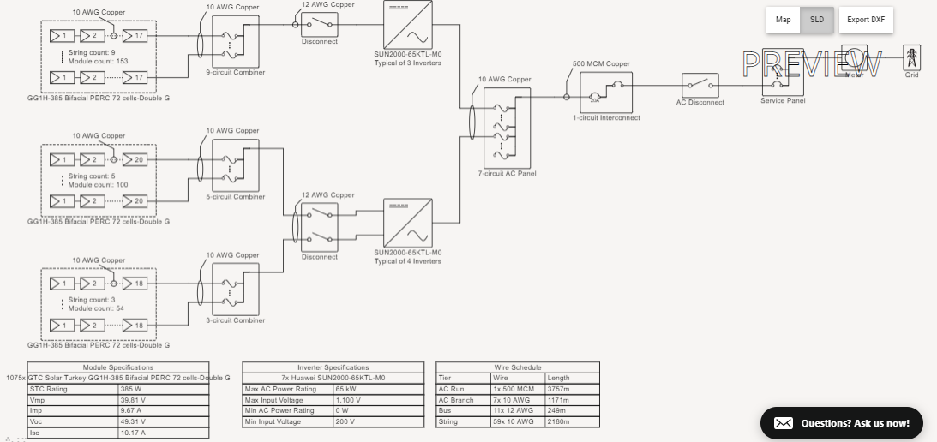
SLD

Fig(10)(SLD)
And here the result of simulation the energy = 815.6MWh
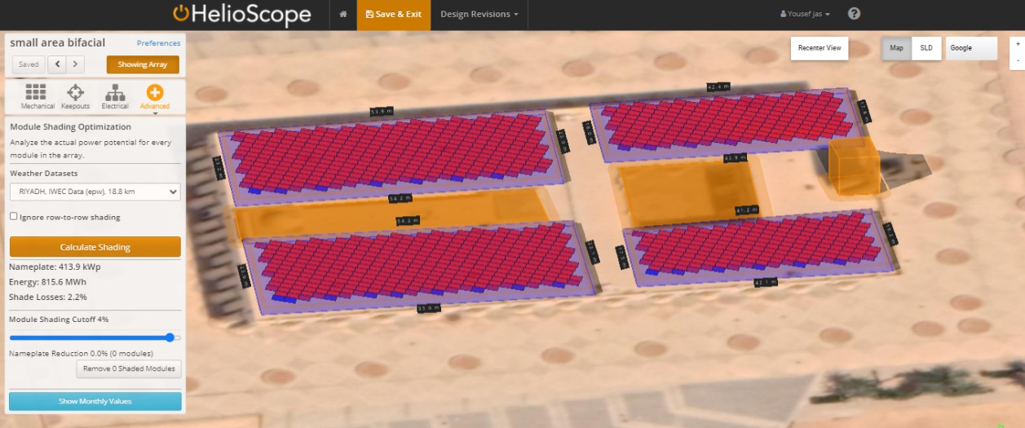

Fig(11)(design1 energy)

Design (2)
We used 1075 modules regular solar panel that's give me 306.4kWp
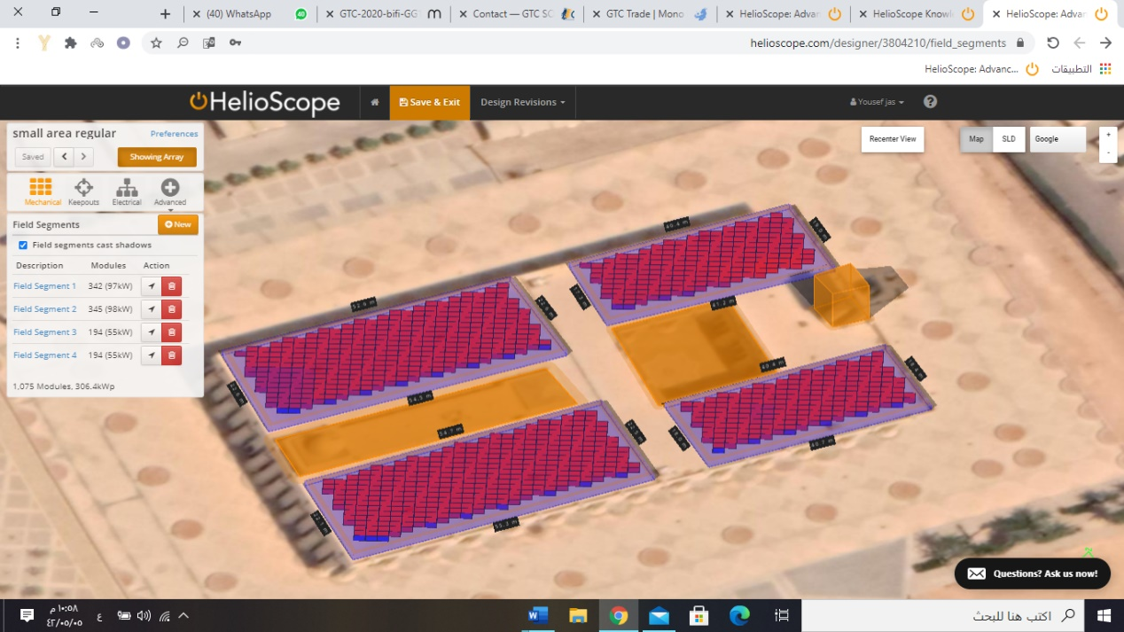

Fig(12) (design2 in Case1)

Fig(13) (DATA2)

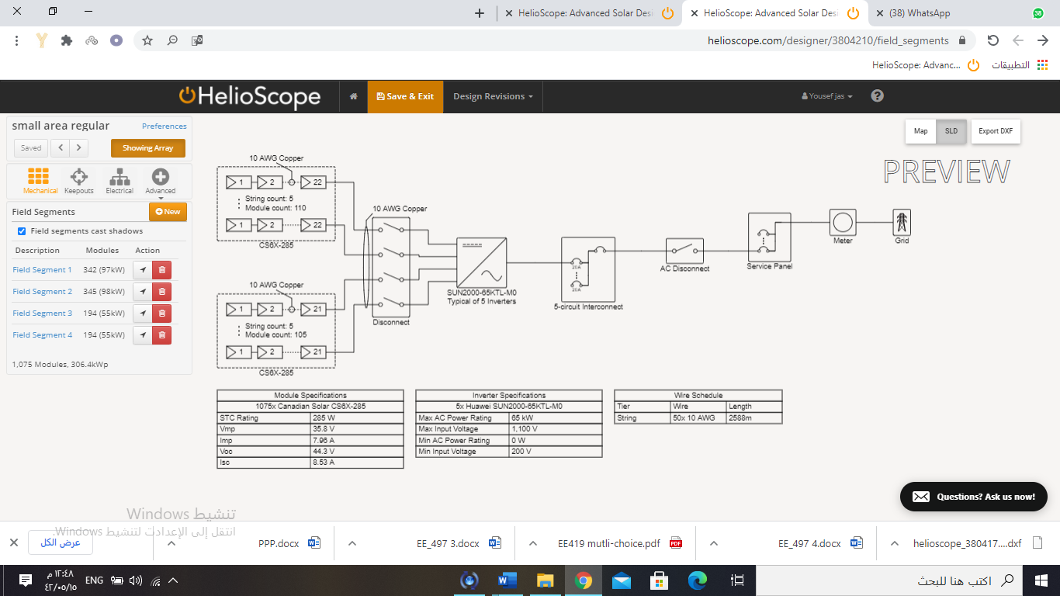
SLD

Fig(14)(SLD)
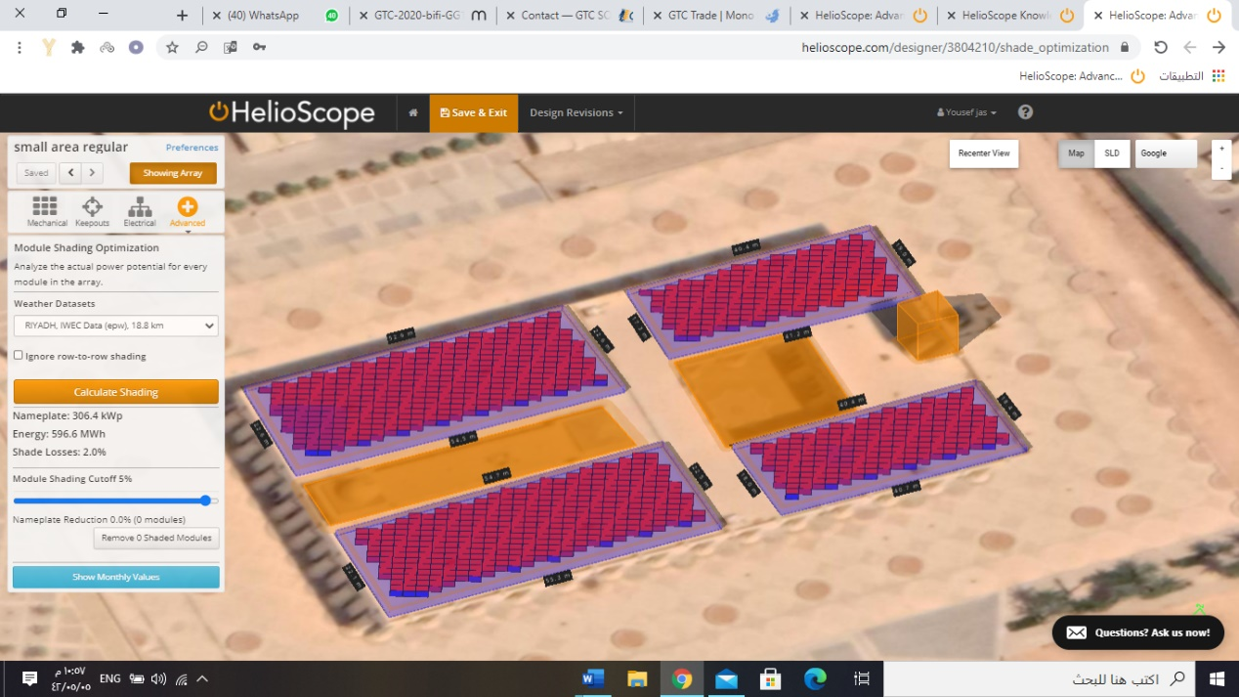
And here the result of simulation the energy = 596.6MWh

Fig(15) (design2 energy)

Second case location in King Saud University , Parking of KSU stadium and we will take a target of watts and the area is neglected , the target is 4,000 kWp and the area is +50,000 m^2

Design (1)
We used 10,389 modules Bifacial solar panel that's give me 4,000kWp
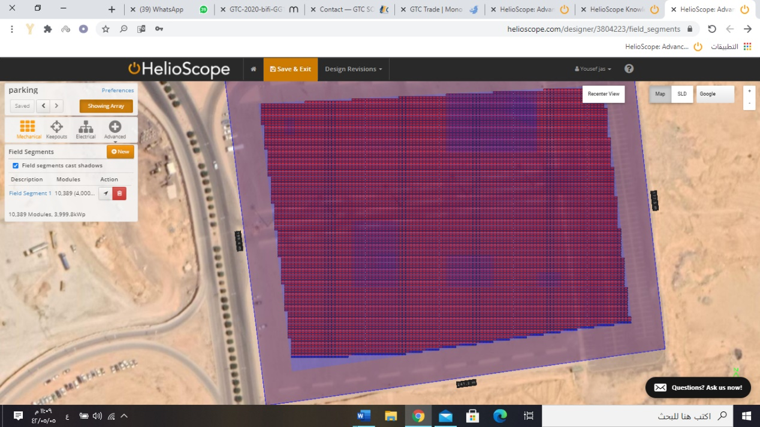

Fig(16)( design1 in Case2)

Fig(17)(SLD)

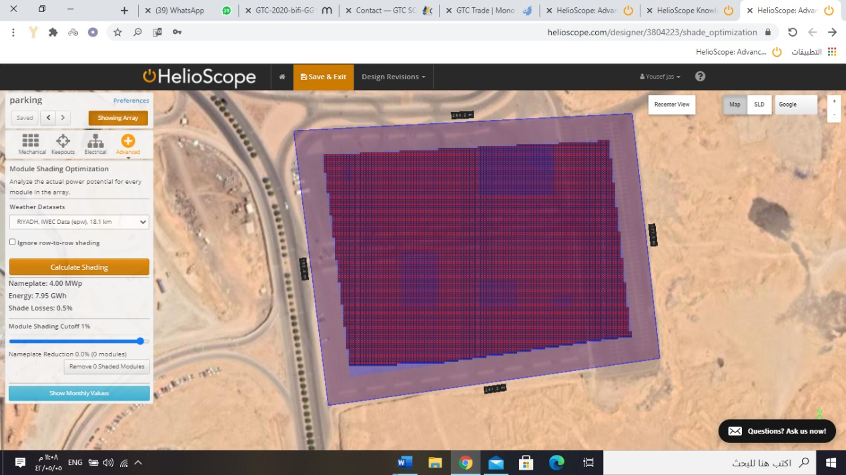
And here the result of simulation the energy = 7.59GWh

Fig(18) (design1energy case2)

Design (2)
We used 14,035 modules regular solar panel that's give me 4,000kWp
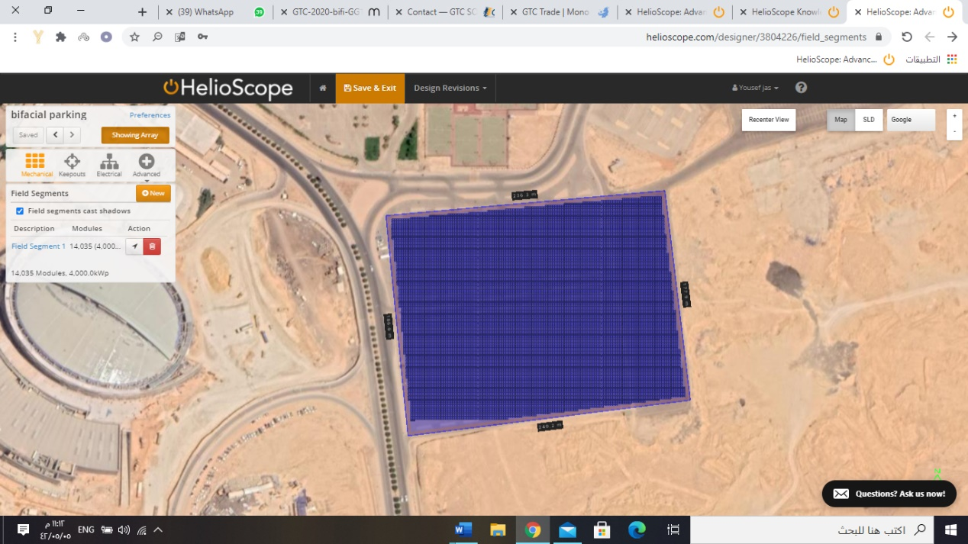

Fig(19) (design2 case2)

Fig(20)(SLD)

And here the result of simulation the energy = 7.58GWh

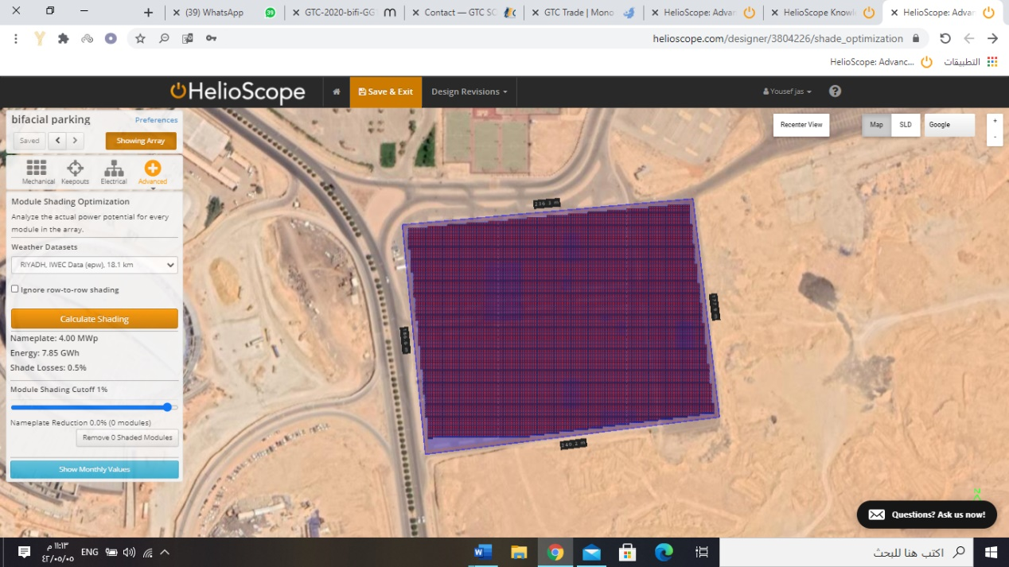

Fig(21)( design2 energy case2)

Result :

-In case(1) when the area is limited and small
 | Number of  Module | $$Module×price$$ | $$\frac{watt}{area }$$ | Power  Wp | Energy  Wh
Design1 | 1075 | 478,375SR | 40.4 | 413.9 | 815.6M
Design2 | 1075 | 360,125SR | 29.9 | 306.4 | 596.6M

The percentage for watt is 23% more in bifacial

-In case(2) when there is a target power and area is unlimited

 | Number of  Module | $$Module×price$$ | Power  Wp | Energy  GWh
Design1 | 10,389 | 4,654,272SR | 4,000 | 7.58
Design2 | 14,035 | 4,701,725SR | 4,000 | 7.58

Conclusions

In case(1) the target is to take as much as possible watts , and it's the goal of using bifacial solar panel and the different in cost is not big issue because the extra percentage in bifacial will cover by few years , also there will be extra inverter to cover the more in power but also will cover the price in few years

In case(2) when the area is very big bifacial solar panel will reduce cost by count the price of area ,metal for structure and connections , all decrease in this parameter will cover the more 20% price in bifacial and give my more efficacy And less cost

The number will change when : area and module

Finally bifacial is very good chose for this cases but need a accurate calculation

References

[1] Ooshaksaraei, P., et al. "Terrestrial applications of bifacial photovoltaic solar panels." Proceedings of the 10th WSEAS International Conference on System Science and Simulation in Engineering, Penang, Malaysia. 2011.‏
[2] DURAN, Claudia, 2012. Bifacial Solar Cells : High Efficiency Design, Characterization, Modules and Applications [Dissertation]. Konstanz: University of Konstanz
[3] Ooshaksaraei, P., et al. "Terrestrial applications of bifacial photovoltaic solar panels." Proceedings of the 10th WSEAS International Conference on System Science and Simulation in Engineering, Penang, Malaysia. 2011.‏
[4] Duran, Claudia. Bifacial solar cells: high efficiency design, characterization, modules and applications. Diss. 2012.‏
[5] Wang, Fengyou, et al. "Silicon solar cells with bifacial metal oxides carrier selective layers." Nano Energy 39 (2017): 437-443.‏

[6] Guerrero-Lemus, R., et al. "Bifacial solar photovoltaics–A technology review." Renewable and sustainable energy reviews 60 (2016): 1533-1549.‏

Appendices

Design 1 Type : file:///C:/Users/acer/Desktop/GTC-2020-bifi-GG1H-72-365-385-rev02.pdf

2- Design 2 Type: file:///C:/Users/acer/Desktop/MaxPowerCS.pdf

