College of Engineering
Electrical Engineering Department

Report of project EE (496,497)
Design of Cloud-Based Radio Access Network for Millimeter-Wave 5G Systems
Students Team
Mohammad Salem Numani Student ID: 436106973
Osamah Abdulrahamn Alyahyan Student ID: 436107967

Supervisors
Name Signature
Dr. Ibrahim Elshafiey ………………
Dr. Abdulhameed Alsanie ………………
Dr. Amr Ragheb ………………

Submitted in Partial Fulfillment of the Requirement
for the B.Sc. Degree,
Rabiʻ II 1442
December 2020

Project Abstract

5G (5th generation wireless systems) is the next major phase of mobile telecommunications standards. The scope of 5G will ultimately range from mobile broadband services to next-generation automobiles and connected devices. Millimeter-wave MMW systems are needed to solve the deficit of microwave spectrum. The propagation nature of in MMW band requires the use of compact size cells, and thus necessitates the deployment of very large number of cells. To reduce the cost and complexity, the cells should be equipped with simple and low functionality radio heads. Complex and intelligent functionality are to be carried into a central office and the obtained signal is carried through an efficient backhaul network to remote cells. This approach is recognized as cloud-based radio access network (C-RAN).

In this report we aimed to implement this idea by Designing of Cloud-Based Radio Access Network for Millimeter-Wave 5G Systems through simulation by using two master programs in this major first, MATLAB which implement the wireless communication part then second, VPI photonics which has optical fiber communication utilities the second part of the project. So, to be the nature of the project more clearly we are going to transmit and receive our digital message through our build up system by two stages. Firstly, we used Physical Downlink Shared Channel Beamforming example from MATLAB library release7 which has following specification 64 QAM, (4*1) antennas and channel with additive white noise 28dB SNR, the transmission and receiving of these data in [PDSCH Port 5 UE-Specific Beamforming] will occurs in MATLAB program interface, and this part represent wireless communication in the project of cloud-based radio access network [C-RAN].

After the transmission phase the data will move on through optical fiber backhaul network by using the program of [VPI photonics] which introduces a powerful software package capable of simulating a variety of optical systems and devices frequently used in a typical fiber optic link and presents the performance analysis of this software package in addressing primitive and complex problems arising in fiber optics. VPI photonics connect both of transmitter and receiver by centralized base station which contains base band units [BBUs]. Then, the transmitted signal will reach to the receiver from [BBUs] over optical fiber which mean we go back again to the wireless communication [MATLAB] part.

Finally, we examined the effect of some parameters on the transmitted signal such as additive noise of the channel, different optical fiber lengths, attenuation power, and dispersion strength and gain amplifier values. At the end we observed the huge effect each of gain amplifier and fiber lengths on the increasing signal performance quality. Also, we concluded according to the results we worked on put the most appropriate changes to make the performance better. We observed when we decrease the distance improved the constellation, so we investigate why many of research chose the range distance 10km-20km because in distance 40km bad concentration . Furthermore, we noticed the increasing of the gain amplifier improved the constellation.

Acknowledgement

First and foremost, we would like to thank Allah who helped and guided us to achieve this project. We also would like to express our deepest appreciation to all those who provided us the possibility to complete this project. A special gratitude we give to our final year project managers, Dr. Ibrahim Elshafiey, Dr. Abdulhameed Alsanie, and Dr. Amr Ragheb whose contribution in stimulating suggestions and encouragement , helped us to coordinate our project especially In progress this project . We are thankful to and fortunate enough to get constant encouragement, support and guidance from all Teaching staffs of college of engineering and Department of electrical engineering in King Saud university which helped us in successfully completing our project work. Also, I would like to extend our sincere esteems to all staff in laboratory for their timely support.

Table of Contents

Project Abstract ii
Acknowledgement iii
Table of Contents iv
List of Figures v
List of Tables vi
1 Introduction 1
1.1 Problem Formulation 1
1.1.1 Problem Statement: 1
1.1.2 Problem Formulation: 1
1.2 Project Specifications 1
2 Background 2
2.1 Literature Review: 2
2.2 Concept Synthesis 2
2.2.1 Concept Generation: 2
2.2.2 Concept Reduction: 2
2.3 Detailed Engineering Analysis and Design Presentation 2
2.3.1 Theoretical Background 2
2.3.2 Cost Analysis 8
3 work space and results 9
3.1 wireless communication part : 9
3.2 optical communication part : 11
4 Conclusions and Future Work 18
References 19
Appendices 20

List of Figures

Figure 2.1: RoF system for a high-capacity backhauling in heterogeneous mobile networks. 3
Figure 2.2: Edge Computing Architecture 5
Figure 2.3: the deferent between fog and mobile edge computing 6
Figure 2.4: deferent between single mode and multimode (the shape) 8
Figure ‎3.1: transmitter block diagram. 11
Figure ‎3.2: Channel between transmitter and receiver . 12
Figure ‎3.4: (a)All parameter fixed G=30 . (b): All parameter fixed G=40. 14
Figure ‎3.5:(a) All parameter fixed G=30 . (b): All parameter fixed G=40. 14
Figure ‎3.6: (a) All parameter fixed D=10km (b) All parameter fixed D=15km 15
Figure ‎3.7: All parameter fixed D=20km (b)All parameter fixed D=40km 15
Figure ‎3.8: the input electrical spectrum after uplink(a) Electrical Spectrum (b) Waveform (c) Eye Diagram 17
Figure ‎3.9: the output electrical spectrum after bandpass filter (a) Electrical Spectrum (b) Waveform (c) Eye Diagram 17

List of Tables

Table ‎1.1: Optical transmitter key specification 1
Table ‎1.2: Presents the parameters for each element used in our design 1
Table ‎2.1:The summary 3G TO 5G. 4
Table ‎3.2: power input and power output and Eff 16

Introduction

Problem Formulation

Problem Statement:
Millimeter-wave MMW systems are needed to solve the deficit of microwave spectrum. The propagation nature of in MMW band requires the use of compact size cells, and thus necessitates the deployment of very large number of cells. To reduce the cost and complexity, the cells should be equipped with simple and low functionality radio heads. Complex and intelligent functionality are to be carried into a central office and the obtained signal is carried through an efficient backhaul network to remote cells. This approach is recognized as cloud-based radio access network (C-RAN).

Problem Formulation:
The project aims at designing C-RAN system that optimizes cost, energy efficiency and spectral efficiency. The backhaul network of this system is realized through RF-over Fiber, in which MMW signal is carried over optical fiber to remote head units.

Project Specifications
The work in this project includes two types of problem design. The first is related to the performance of constellation by changing amplifier gain while the second is related how does the distance effect which is the best distant of this system.

Key Specification | Expected Value
- BitRate | 10+ Gbps
- Modulation Format | MQAM, M = 64
- Bandwidth | 200MHz
- Carrier frequency | 2e9Hz
- fiber length | 20km
Table ‎1.1: Optical transmitter key specification

Element | Electrical | Optical
- Pulse shaping filter | Roll off factor  Square root raised cosine  Raised cosine | ______________
- MZM | ______________ | Extinction ratio  Insertion loss
- Laser Source | _______________ | Line width  Average power
Table ‎1.2: Presents the parameters for each element used in our design

Background

Literature Review:
During our research about previous studies which have same idea of our project ( C-RAN ) we found several science papers such as : 5G C-RAN Architecture: A Comparison of Multiple Optical Fronthaul Networks To identify the suitability of a fronthaul technology to satisfy the unprecedented demands of future 5G wireless network in a cost-effective manner, different architecture and technologies need to be equitably compared in terms of all major requirements of 5G fronthaul network such as bandwidth requirements, delay budgets, deployment costs, complexity of radio remote head (RRH), and the ability to support advanced wireless functions by Chathurika Ranaweera[1]. According to these studies we began our research and work to get better results.

Concept Synthesis

Concept Generation:
. We start the studying by depending on two programs MATLAB and VPI transmission maker. the method of design is connecting between the MATLAB an VPI through generate the message waveform in the MATLAB then sending the waveform form transmitter which exist in MATLAB to VPI where there is an optical fiber then we receive the waveform again in MATLAB receiver .

Concept Reduction:
There are several manners to assist the process in our project such as : architecture frontal design , effect of optic fiber on performance and digital amplifier to get low latency in transmission process by experiments and analysis we recognized the best way using C-RAN architecture by using two programs MATLAB and VPI transition maker because many differences between 5G and LTE.

Detailed Engineering Analysis and Design Presentation

Theoretical Background

5G (5th generation wireless systems) is the next major phase of mobile telecommunications standards. The scope of 5G will ultimately range from mobile broadband services to next-generation automobiles and connected devices.

Two major trends are behind the race to 5G:-
1)The explosive growth in demand for wireless broadband that can carry video and other content-rich services.
2) The Internet of Things (IoT), where large numbers of smart devices communicate over the Internet.
To achieve these objectives, 5G will provide extreme broadband speed , ultralow latency , and ultra-reliable web connectivity.
The C-RAN (or Cloud RAN), also known as the Centralized RAN,. However, it’s still the early days of C-RAN development.
As the mobile telecommunications industry barrels toward the 5G future, the amount of data traffic traversing networks is exploding. One of the ways network operators are coping with the reality and the preparation for the further onslaught that will come with 5G networks is to transform the radio access network (RAN). Which in essence, means centralizing it or placing it in the cloud.

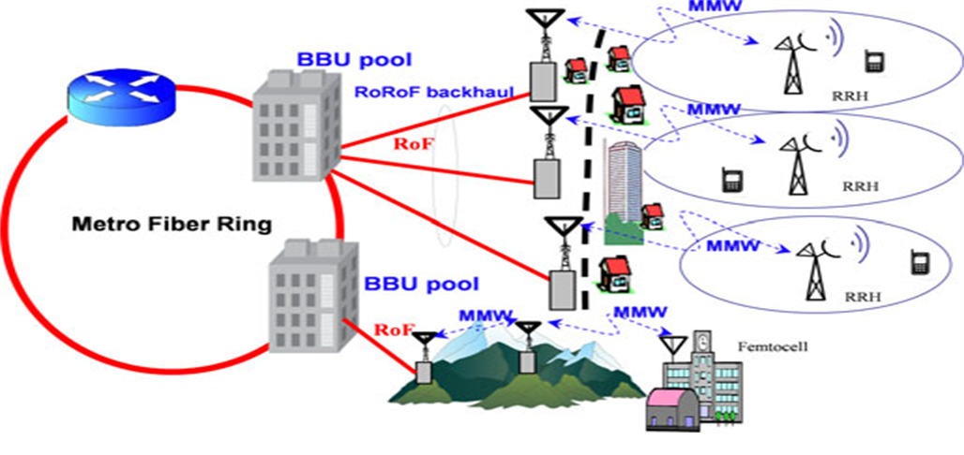

Figure 2.1: RoF system for a high-capacity backhauling in heterogeneous mobile networks[2].

C-RAN (or Cloud RAN) Architecture
A C-RAN architecture has three primary components — a centralized baseband unit (BBU) pool, remote radio unit (RRU) networks, and transport network or fronthaul:
BBU pool — The BBU pool, located at a centralized site, functions as a cloud or a data center. Its multiple BBU nodes dynamically allocate resources to RRUs based on current network needs.
RRU network — the wireless RRU network connects wireless devices similarly to access points or towers in traditional cellular networks.

Fronthaul/transport network — Using optical fiber communication, cellular communication, or millimeter wave (mmWave) communication, the fronthaul is the connection layer between a BBU and a set of RRUs, providing high-bandwidth links to handle the requirements of multiple RRUs.

Mobile Generation | Usage ID | The range of  Frequencies  Examples | User Data  Bandwidth  example | Coverage per  Antenna and  usage
3G | Mobile | 850MHz  2100MHz | 2-10 Mbps | 50-150km
4G | Mobile | 750MHz  850MHz  2.1GHz  2.3GHzand2.6GHz  (Centimeter wave) | 10-30Mbps | 150-150km
 | Fixed  Wireless |  | 50-60Mbps | 1-2km
5G | Mobile | 3.6GHz,6GHz | 80-100bMbps | 50-80km
 | Fixed  Wireless | 24-86GHz  (Milliliter wave) | 1-3Gbps | 250-300m

Table ‎2.1:The summary 3G TO 5G[3].

Motivational Topics : -
A-Edge Computing B.-Fog Computing
They are emerging technologies that enables the evolution to 5G by bringing cloud capabilities near to the end users (or user equipment, UEs) .
these are computing providing for C-RAN Architecture
1. Proximity access to information technology services.
2. Place data close to the end-user.
3. Security and privacy.
4. Network management

A-Edge Computing in 5G

Definition of Edge Computing:
Is an emerging technology that enables the evolution to 5G by bringing cloud capabilities near to the end users (or user equipment, UEs).

Edge Computing:
In order to overcome the intrinsic problems of the traditional cloud, such as high latency and the lack of security.

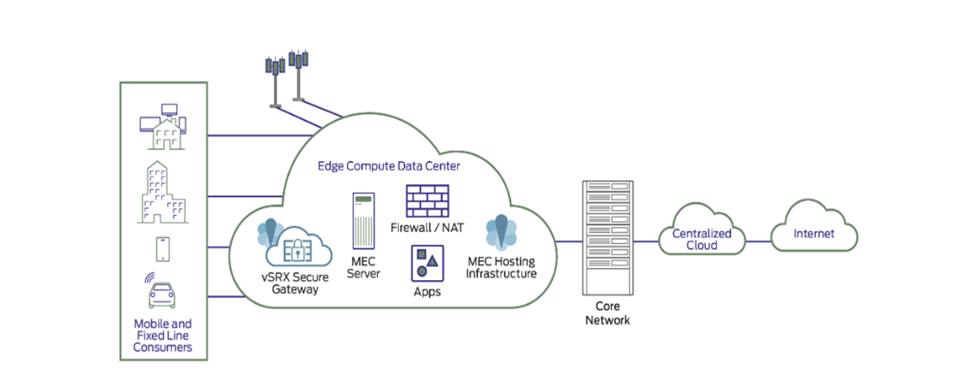

Figure 2.2: Edge Computing Architecture[3]

Objectives of Edge of Computing in C-RAN 5G:
CRAN and MEC are highly complementary technologies. Collocating these helps make the economics of each of them significantly more attractive. Collocating CRAN and MEC also helps an MNO to support (and generate revenue from) some of the key 5G applications that it would not be able to support otherwise. However, to realize these advantages, mobile operators have to overcome challenges associated with colocation, as well as maximize the return that can be made from MEC. We identify and discuss challenges in the management, security, networking and regulatory domains.

Definitions Fog Computing5G:
Fog Computing is an extension of the cloud platform from the Core to the Edge of the network– this definition is too simplistic, without noticing the key aspects of the ubiquitous nature of Fog, its enhanced networking capabilities such as providing hosting environment and improved support for interaction between devices.
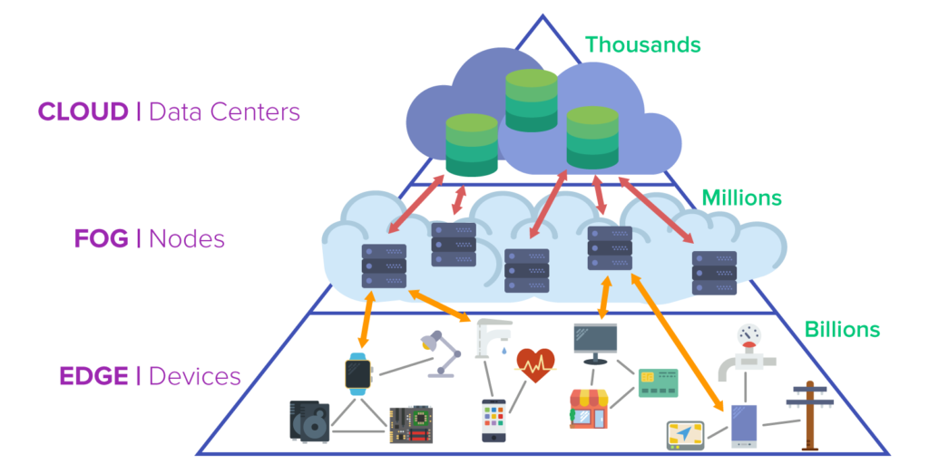
Figure 2.3: the deferent between fog and mobile edge computing[4].

Present Challenges in Designing Fog Computing Platform:
(a) Choice of virtualization technology—this will determine the efficiency speed and flexibility available in fog nodes.
(b) Latency—Latency needs to be minimized, as fog applications are necessarily expecting real-time responses.
(c) Network management: For fog functionality, network management is critical. Deploying Software-Defined Networking (SDN) or Network Function Virtualization (NFV) integrated together into Fog Computing is going to be challenging.
(d) Security and privacy: Access control and intrusion detection system is to be deployed with due support from every layer of the platform.

Optical fiber is the technology associated with data transmission using light pulses travelling along with a long fiber which is usually made of plastic or glass. Optical fibers are also unaffected by electromagnetic interference. The fiber optical cable uses the application of total internal reflection of light.
Types of Optical Fibers:
The types of optical fibers depend on the refractive index, materials used, and mode of propagation of light.
- The classification based on the refractive index is as follows:
(1) Step Index Fibers: It consists of a core surrounded by the cladding, which has a single uniform index of refraction.
(2) Graded Index Fibers: The refractive index of the optical fiber decreases as the radial distance from the fiber axis increases.

- The classification based on the materials used is as follows:
(1)Plastic Optical Fibers: The polymethylmethacrylate is used as a core material for the transmission of the light.
(2)Glass Fibers: It consists of extremely fine glass fibers.

- The classification based on the mode of propagation of light is as follows:
(1)Single-Mode Fibers: These fibers are used for long-distance transmission of signals.
(2)Multimode Fibers: These fibers are used for short-distance transmission of signals.

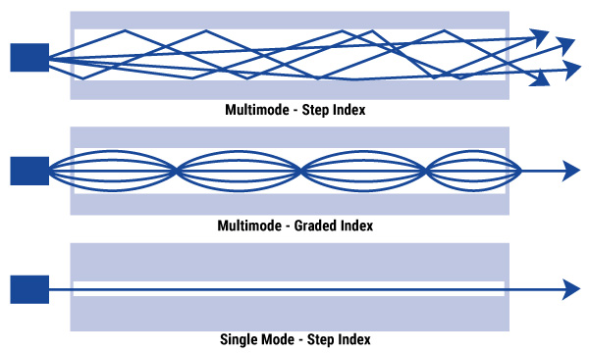

Figure 2.4: deferent between single mode and multimode (the shape)[3].

Cost Analysis

This project is depending on two simulation programs MATLAB and VPIphotonics. In the first phase of this project, we focused on the simulation by using MATLAB only, but in the second phase, we considered the simulation by using VPIphotonics. The MATLAB software is provided by MATHWORKS and it costs approx. 139SR per year for a single license. Also, the VPI photonics software is provided by RFTONICS center and it costs approx. 5500 SR per year for a single license.

work space and results

wireless communication part :

In this part of the work, we considered to build our system on typical example with strong reliability reference such as MATHWORKS name of example: Physical Downlink Shared Channel [PDSCH] UE-Specific Beamforming, Type of stander: Transmission mode7 in Release 8 of long-term evolution [LTE] toolbox: UE-specific beamforming (single antenna ).
RMC Generator Setup: In our example a Reference Measurement Channel (RMC) configuration is created using long term evolution RMC down link [lteRMCDL] .
Transmitter : the first component [block] in any communication system. Here in our project the transmitter is configured by using 4 antennas in physical down link channel [PDSCH]. This reference signal and associated transmissions that will be mapped onto the first of the 4 transmission antennas. Also, by using orthogonal frequency division modulation [OFDM] Channel estimation techniques for OFDM systems based on a pilot arrangement are investigated. Channel estimation based on a comb type pilot arrangement is studied through different algorithms for both estimating the channel at pilot frequencies and interpolating the channel. Channel estimation at pilot frequencies is based on LS and LMS methods while channel interpolation is done using linear interpolation, second order interpolation, low-pass interpolation, spline cubic interpolation, and time domain interpolation. Time-domain interpolation is obtained by passing to the time domain by means of IDFT (inverse discrete Fourier transform), zero padding and going back to the frequency domain by DFT (discrete Fourier transform). In addition, channel estimation based on a block type pilot arrangement is performed by sending pilots in every sub-channel and using this estimation for a specific number of following symbols. We have also implemented a decision feedback equalizer for all sub-channels followed by periodic block-type pilots. We have compared the performances of all schemes by measuring bit error rates with 16QAM, QPSK, DQPSK and BPSK as modulation schemes, and multipath Rayleigh fading, and AR based fading channels as channel models. 64 QAM modulate the transmit resource grid[5].
Channel: The channel estimation settings are defined using a structure of conservative 9-by-9 pilot averaging window is used to reduce the impact of noise on the channel estimate Additive noise at 28.0 dB SNR is then applied to the received signal.
Receiver: is the reverse of the transmitter work OFDM 64 QAM demodulation to recover resource grid from the perspective of the receiver, the transmission made using UE-specific beamforming is effectively from a single antenna.

The block diagram below concludes the whole project specification of MATLAB program contains the most important information. So, after building the wireless communication part by using MATLAB now the signal transmits form the transmitter which found in MATLAB through optical fiber which will be explain in detail in the next part. Then, the message is received again in MATLAB by receiver wireless communication.

Name : (PDSCH) Specific Beamforming Stander: mode7 in Release 8 of LTE

Receiver
Transmitter
Chanel

1-PDSCHTxScheme='Port5’.

2- 4 transmission antennas .
3-OFDM 64QAM modulate.

1-The channel estimation structure .
2- conservative 9-by-9 pilot.
3- Additive noise at 28.0 dB SNR

1-OFDM 64QAM demodulation
2-beamforming with single antenna

optical communication part :

[VPI photonics] which introduces a powerful software package capable of simulating a variety of optical systems and devices frequently used in a typical fiber optic link and presents the performance analysis of this software package in addressing primitive and complex problems arising in fiber optics.
In VPI photonic is considered as transmission media between base band units and remote heads. So, here we studied the effect of several parameters on optical fiber such as : different lengths , different gain amplifier values and attenuation and dispersion effects.

Pulse
Raised(filter)
Pack
Block (Processor)

Sin wave
Unpacks

Cosi Interface
(linker)

Pulse
Raised(filter)
Pack
Block(Processor)

Figure ‎3.1: transmitter block diagram.
As we see above our own system block diagram of transmitter which consists of many components, we give short brief about each one as below :
- Cosiminterface : it is an icon on VPI program to link the data in MATLAB directly and easily either the data come from transmitter or go to receiver.
- Pack Block: This module serves as an interface to the Signal Processing Modules.
- Pulse Raised : This module generates a Nyquist response from an incoming electrical impulse. This is used before an optical modulator, or as part of a receiver.
- Sin wave : This generates an electrical sine waveform superimposed on a constant bias.
Specification of transmitter:
1- Modulation=64QAM. 2-Data (Row=7680 . Columns=1)
2- SNR=28dB 3- Carrier frequency=2GHz

Photodiode
Gain
Gain
Fiber
MZM
MZM
LaserCW
LaserCW
Fiber
Photodiode
Filter
Filter
Receiver

Transmitter

Figure ‎3.2: Channel between transmitter and receiver .
As we see above our own system block diagram of channel which consists of many components, we give short brief about each one as below :
1-LaserCW: The laser has a side mode, intensity noise, wavelength drift with temperature and linewidth.
2-MZM: This module simulates a Mach-Zehnder modulator and can take into account a frequency chirp resulting from the modulator asymmetry. The module is designed for ease of use, rather than flexibility (see ModulatorDiffMZ_DSM for a flexible multiport modulator). The chirp of the modulator can be specified in two ways: by using a symmetry factor and chirp sign, or by using an alpha factor. The first method relates to the physical design of the modulator, and the second to its behavioral characteristics.
3-Photodiode: The module can handle both single-mode and multimode optical signals. It is a model of PIN and APD photodiodes. These can be simulated on the base of a predefined responsivity, avalanche multiplication, dark current, and noise. Alternatively, the voltage and temperature dependence are considered by using an equivalent RC circuit. Electric frequency response is not included and can be modeled by an external filter.
Specification for the channel:
1-LaserCW=(linewidth=10 M Hz. 2- Photodiode(thermalNoise=10.0pA/HZ^1/2)
3-Freq=193.1THz.averagepower=40mw). 4-Gain(90-60-40-30)
5-MZM(Extinction=30dB) 6- Filter(Bandpass)
7-Fiber(40km-20km-15km-10km) 8- Bandwidth channel=400MHz.

Pulse
Raised(filter)
Pack
Block(Processor)
Sin wave
channel

Unpacks
Cosi Interface
(linker)

Pack
Block(Processor)
Pulse
Raised(filter)

Figure ‎3.4: Receiver block diagram .

As we see above our own system block diagram of Receiver which consists of many components, all components same transmitter but in opposite way :

Specification of transmitter:
1-Data (Row=7680 . Columns=1)
2- SNR=28dB
3- Carrier frequency=2GHz

Result(1):
when make Distance=20km and attenuation=0.2 dB/km dispersion=16 micro s/m2 and put Gain=variable

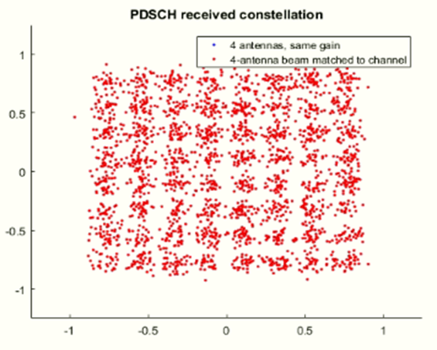
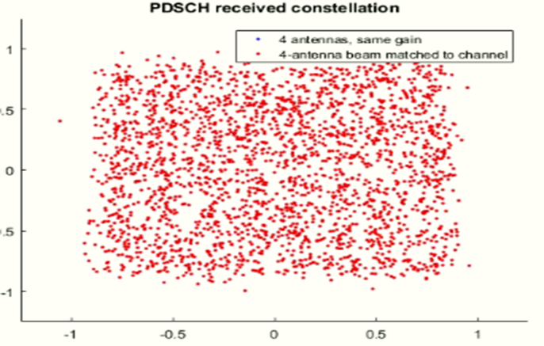
- (b)

Figure ‎3.3: (a)All parameter fixed G=30 . (b): All parameter fixed G=40.

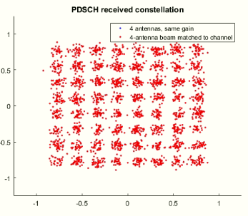
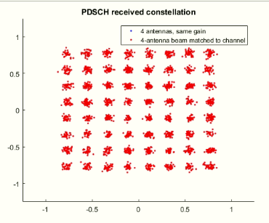

(a) (b)

Figure ‎3.4:(a) All parameter fixed G=30 . (b): All parameter fixed G=40.

Comment:
We observed when we increased the gain amplifier improved the constellation, so you need to make the suitable gain because the amplifier gains very expensive .

Result(2):

when make Gain=60 and attenuation=0.2 dB/km dispersion=16 micro s/m2 and put Distance =variable.

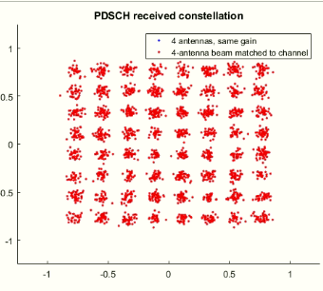
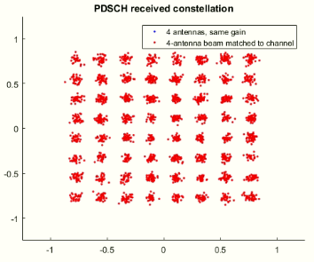

- (b)

Figure ‎3.5: (a) All parameter fixed D=10km (b) All parameter fixed D=15km
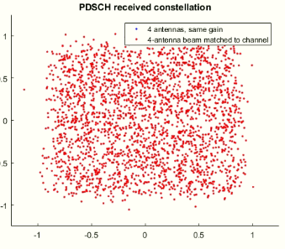
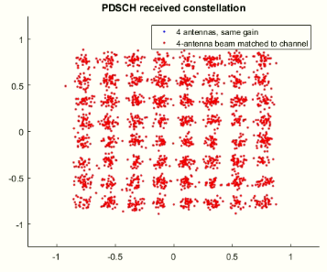

- (b)
Figure ‎3.6: All parameter fixed D=20km (b)All parameter fixed D=40km

Comment:

We observed when we decrease the distance improved the constellation, so we investigate why many of research chose the range distance 10km-20km because in distance 40km bad concentration .

Result(3) :
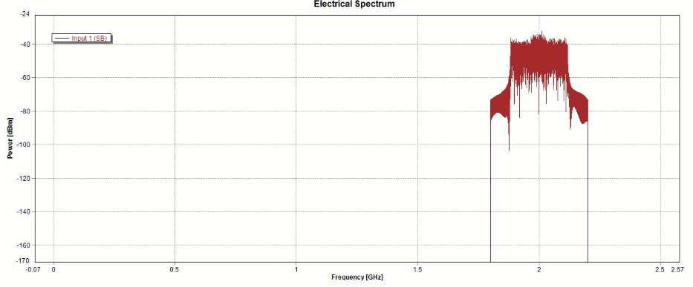
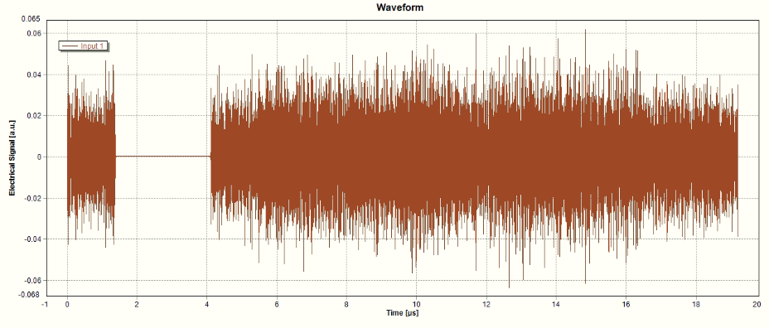
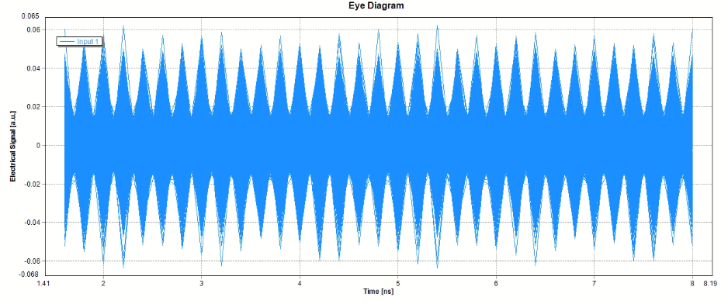

- (b) (c)
Figure ‎3.7: the input electrical spectrum after uplink(a) Electrical Spectrum (b) Waveform (c) Eye Diagram
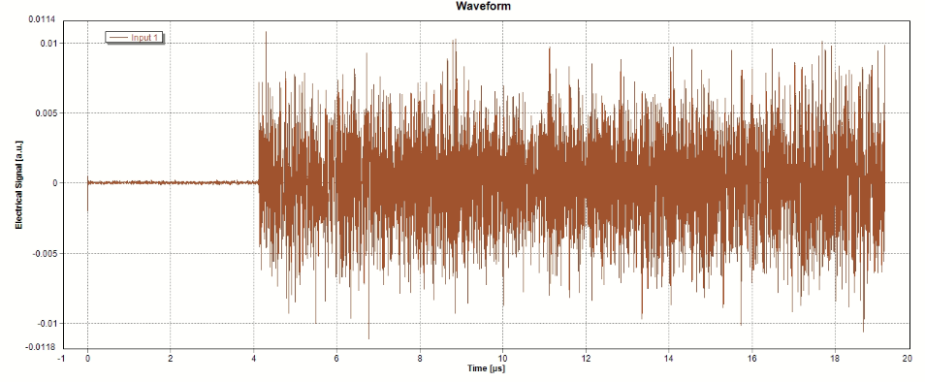
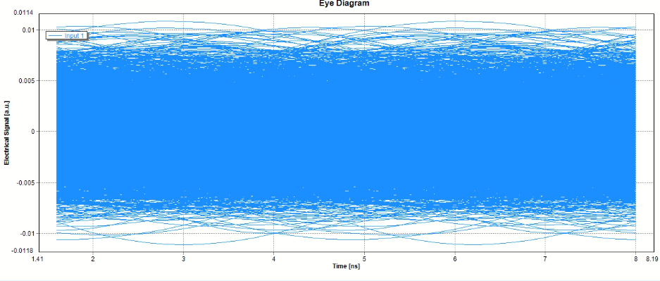
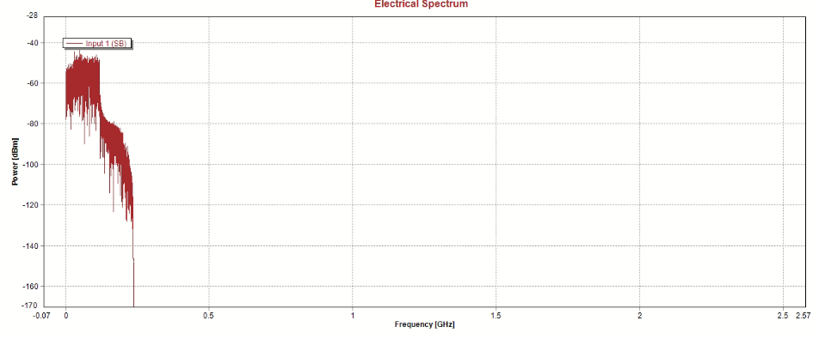

- (b) (c)
Figure ‎3.8: the output electrical spectrum after bandpass filter (a) Electrical Spectrum (b) Waveform (c) Eye Diagram
Comment:
The figures explain the effect of bandpass filter on each of input signal and output signal, where the input signal moved to 2GHz as a carrier shifting and this shows clearly too in the out when we recovered the original signal by using lowpass filter.

Conclusions and Future Work

The upcoming arrival of 5G mobile networks introduces extensive modifications to current RAN architectures. In this paper, we investigated the C-RAN concept, the enabling technologies, and their key challenges. We also presented C-RAN implementations and discussed future trends and advances.

Also, we concluded according to the results above the changing in the distances and the values of amplifier gain will effect on the quality received signals. So, we worked on put the most appropriate changes to make the performance better. And this is appearing clearly in the table when we calculate the efficiency .

The original plan of the project was to present and simulate the work by using two master programs MATLAB and VPI photonics then apply and test the perfect results which are completed by the simulation in the communication laboratory but as we know due to COVID-19 we were not able to use the lab utilities, so we focused only on the results from the simulation. So, we hope the idea complete through apply and test the results which gotten from the simulation in the lab by the next students who are considering by C-RAN project.

References

[1] Ranaweera, Chathurika, et al. "5G C-RAN architecture: A comparison of multiple optical fronthaul networks." 2017 International conference on optical network design and modeling (ONDM). IEEE, 2017.‏
[2] Dat, Pham Tien, et al. "High-capacity wireless backhaul network using seamless convergence of radio-over-fiber and 90-GHz millimeter-wave." Journal of Lightwave Technology 32.20 (2014): 3910-3923.‏
[3] S. Haykin and M. Moher, "Introduction to Analog & Digital Communications, Hoboken," ed: NJ, John Wiley & Sons Inc, 2007.
[4] G. Vivone, P. Braca, and J. Horstmann, "Knowledge-Based Multitarget Ship Tracking for Hf Surface Wave Radar Systems," Geoscience and Remote Sensing, IEEE Transactions on, vol. 53, pp. 3931-3949, 2015.
[5] J. Bucek, P. Kubalik, R. Lorencz, and T. Zahradnicky, "System on Chip Design of a Linear System Solver," in System-on-Chip (SoC), 2014 International Symposium on, 2014, pp. 1-6.
[6] Coleri, Sinem, et al. "Channel estimation techniques based on pilot arrangement in OFDM systems." IEEE Transactions on broadcasting 48.3 (2002): 223-229.‏
[7] Chih-Lin, I., Huang, J., Duan, R., Cui, C., Jiang, J., & Li, L. (2014). Recent progress on C-RAN centralization and cloudification. IEEE Access, 2, 1030-1039.‏
[8] Pan, C., Zhu, H., Gomes, N. J., & Wang, J. (2017). Joint precoding and RRH selection for user-centric green MIMO C-RAN. IEEE Transactions on wireless Communications, 16(5), 2891-2906.‏

Appendices

RMC Generator Setup

In this example a Reference Measurement Channel (RMC) configuration is created using lteRMCDL, and reconfigured to describe a UE-specific beamforming configuration. The generation is configured for R.6 and the PDSCH is configured for TxScheme='Port5', the transmission scheme associated with Release 8 UE-specific beamforming in the LTE Toolbox. The number of PDSCH transmission antennas is then set to 4 (The number of columns of the precoding matrix W indicates NTxAnts), indicating that the UE-specific beamforming will beamform onto 4 transmission antennas. Note that rmc.CellRefP=1, meaning that there is only one cell-specific reference signal; this reference signal and associated transmissions that will be mapped onto the first of the 4 transmission antennas.
rmc = lteRMCDL('R.6'); % RMC configuration
rmc.TotSubframes = 1; % Number of subframes to generate
rmc.PDSCH.TxScheme = 'Port5'; % Set UE-specific beamforming scheme
rmc.PDSCH.CSI = 'On'; % CSI scaling of soft bits

Channel Estimation Configuration

The channel estimation settings are defined using a structure cec. A conservative 9-by-9 pilot averaging window is used to reduce the impact of noise on the channel estimate. Channel estimation is performed using UE-specific reference signals as the Port5 transmission scheme is used.
cec.PilotAverage = 'UserDefined'; % Type of pilot symbol averaging
cec.FreqWindow = 9; % Frequency window size
cec.TimeWindow = 9; % Time window size
cec.InterpType = 'Cubic'; % 2D interpolation type
cec.InterpWindow = 'Centered'; % Interpolation window type
cec.InterpWinSize = 1; % Interpolation window size
cec.Reference = 'DMRS'; % Reference for channel estimation

System Processing
% Initialize storage variables for comparison
rxSymbolsStore = cell(1, 2);
WStore = zeros(2, 4);

% Loop for transmitting with and without optimal beamforming
for optimalbeamforming = 0:1

% Configure random number generators
rng('default');

% Set PDSCH beamforming vector
if (optimalbeamforming)
% Use beamforming vector matched to channel response
rmc.PDSCH.W = [17 8-15*1i -8+15*1i 15+8*1i]/34;

else
% Use equal transmission gains for each antenna
rmc.PDSCH.W = [17 17 17 17]/34;
end

% Create a resource grid without the PDSCH. PDSCH can be turned off by
% specifying the transport stream input to be empty
[~, txGrid, info] = lteRMCDLTool(rmc,[]);

% Create and map UE-specific reference signals
rmc.PDSCH.NTxAnts = size(rmc.PDSCH.W,2);
dmRsIndices = lteDMRSIndices(rmc,rmc.PDSCH);
dmRsSymbols = lteDMRS(rmc,rmc.PDSCH);
txGrid(dmRsIndices) = dmRsSymbols;

% Create and map the PDSCH reference signals
[pdschIndices, pdschIndicesDims] = ltePDSCHIndices(rmc, rmc.PDSCH, ...
rmc.PDSCH.PRBSet);
pdschSymbols = ltePDSCH(rmc, rmc.PDSCH, ...
randi([0 1], pdschIndicesDims.G, 1));
txGrid(pdschIndices) = pdschSymbols;

% OFDM modulate to create a transmit waveform
txWaveform = lteOFDMModulate(rmc, txGrid);

% Pass waveform through channel
H = [17 8+15*1i -8-15*1i 15-8*1i]/34; % Channel response
rxWaveform = (H*txWaveform.').';

% Add AWGN noise
SNRdB = 28;
SNR = 10^(SNRdB/20);
N = 1/(sqrt(2.0*double(info.Nfft))*SNR); % Scale for IFFT gain
noise = N*complex(randn(size(rxWaveform)), randn(size(rxWaveform)));
rxWaveform = rxWaveform + noise;

% Synchronization
offset = lteDLFrameOffset(rmc,rxWaveform);
rxWaveform = rxWaveform(1+offset:end,:);

% OFDM demodulation to recover resource grid
rxGrid = lteOFDMDemodulate(rmc, rxWaveform);

% Channel and noise estimation
[hest, nest] = lteDLChannelEstimate(rmc, rmc.PDSCH, cec, rxGrid);

% Perform Minimum Mean Squared Error (MMSE) equalization and decode the
% PDSCH
ind = ltePDSCHIndices(rmc, rmc.PDSCH, rmc.PDSCH.PRBSet);
ind = ind(:, 1); % Only use one receive antenna
[rxBits, rxSymbols] = ltePDSCHDecode(rmc, rmc.PDSCH, rxGrid(ind), ...
hest(ind), nest);

% Store received symbols and beamforming vector for comparison
rxSymbolsStore{optimalbeamforming+1} = rxSymbols;
WStore(optimalbeamforming+1, :) = rmc.PDSCH.W;
end

