COLLEGE OF ENGINEERING ELECTRICAL ENGINEERING DEPARTMENT

EE497
Full Scale Automotive Radar Simulation for Autonomous Guidance Applications

Students Team
Faisal Abdulaziz Alrayes Student ID: 436101269 Dahim Mohammed Alwadei Student ID: 436104642 Abdulaziz Saleh Alhammad Student ID: 436107870 Meshal bader Alshubrmi Student ID: 436102315

Supervisors
Name Signature

Dr.Saif Alsaif ………………

Dr.Ahmed Alzuhair ………………

Jum .I 1442

December
2020
Submitted in Partial Fulfillment of the Requirement for the B.Sc. Degree,

PROJECT ABSTRACT

Automotive RADAR have been increasingly used in the past few years in the manufacture of modern vehicles for safety purpose and enhance driver's abilities. This project deals with the design of a full- scale Frequency Modulated Continues Wave (FMCW) RADAR that gives the abilities for the vehicles to detect any object and goes thru all the process to avoid collisions autonomously.

ACKNOWLEDGEMENT

First and foremost, we would like to thank King Saud University especially the Electrical Engineering Department for giving us this spectacular opportunity to research and investigate up to date topics in the communication field.
Secondly, I would like to express my warmest gratitude to my supportive supervisors, Dr.Saif AlSaif and Dr.Ahmed AlZuhair , they both have provided us with continuous support and guidance towards the completion of our research project. Their remarkable ideas and suggestions helped us every step of the way.
My sincere appreciation goes to my lecturers, colleagues and everyone that participated towards making our research easier.

Thank You.

TABLE OF CONTENTS

Project Abstract ii
Acknowledgement iii Table of Contents iv List of Figures v
List of Tables vi
- Introduction 1
Problem statement _1
- Background 2
- Work progress 34
4 Conclusions 46 References 47

LIST OF FIGURES

Figure 2.1 : Major Elements of Radar 2
Figure 2.2 Average atmosphere absorption 3
Figure 2.3: Basic Radar Configuration 4
Figure 2.4 : Places of external and internal antenna 6
Figure 2.5 : Shark fin Antenna 7
Figure 2.6 : Pulsed radar waveform 8
Figure 2.7 : Pulsed radar waveform showing ADC Clock Pulses 9
Figure 2.8 : Pulsed radar range ambiguity 10
Figure 2.9 : ADAS Consists of different range radars 12
Figure 2.10 : different sizes of automotive radar systems 14
Figure 2.11 : Spherical Coordinates system 15
Figure 2.12 : Concept of resolution in range 17
Figure 2.13 : Adaptive Cruise Control 18
Figure 2.14 : Collision Avoidance System 19
Figure 2.15 : Backup warning system 19
Figure 2.16 : Ranging with FMCW system 21
Figure 2.17 : Block Diagram of an FMCW radar 27
Figure 2.18 : The FMCW-Radar ART Midrange uses separate offset antennas for transmitting and receiving 27
Figure 2.19 : The patch antenna array of a maritime FMCW navigation radar in X-Band 28
Figure 2.20 : Analogue display of a radar altimeter 29
Figure 2.21 : Transmit-and- Receive Frequency as a Function of Time with Beat Frequency. 30

Figure 3.1 : FMCW Signal and Signal spectrogram 35
Figure 3.2 : Range-Speed Response Pattern 35
Figure 3.3 : Spectrum for received and dechirped signal 36
Figure 3.4: Beat Frequency Signal 38
Figure 3.5 :The input Signal 40
Figure 3.6 : The input signal After Mixing at Transmitter 41
Figure 3.7 : The Signal After Correlation 41
Figure 3.8 : The Signal after Mixing at the Receiver 42
Figure 3.9 : The estimation of Speed using Doppler Frequency 45

LIST OF TABLES :

Table 1 : The classification of automotive radars based on range measurement capability. 13
Table 2 : Relationship between bandwidth and other parameters: 23

INTRODUCTION

- Problem statement

In real world, dangerous incidents can occur if the driver of an automotive vehicle loses the ability to control the vehicle, or lacks the attention towards potential hazardous situations. Also driving through terrible weather conditions like snow, heavy rain or fog can reduce the driver’s abilities, which might lead to poor decisions and potential danger. Research suggests that automotive radar can help in reducing the number of deaths, injuries, and economic losses linked to driving world wide.

BACKGROUND
    - RADAR

A RADAR is an electrical system that transmits radiofrequency (RF) electromagnetic (EM) waves toward a region of interest and receives and detects these EM waves when reflected from objects in that region. FMCW radar is a special type of RADAR sensor which radiates continues transmission power like a simple CW, in contrast to this CW radar FMCW radar it measures not only the speed of the target but also the distance of the target from the radar and it can change it's operating frequency during the measurements
- Major elements

The major elements of any radar should contains these subsystems: transmitter, receiver, antenna and signal processor as shown in figure 2.1.
This figure shows the process of a transmitting a radar signal, propagation of that signal through the atmosphere, reflection of the signal from the target, and receiving the reflected signal, process the signal through some calculation to show the results. The transmitter is the generator of the EM wave, these EM wave radiated from the antenna to the propagation medium (atmosphere), the receiver antenna received the reflected wave from any object and during the process of transmitting and receiving the wave the T/R switch providing a connection point so that the transmitter and receiver can both attached to the antenna simultaneously and at the same time provide isolation between them to protect the sensitive components from the high power transmit signal, the components in the receiver amplify the received signal (LNA) and it converts the RF into intermediate frequency (IF) passed by the Mixer, the signal applied to an analog-to-digital convertor (ADC) finally we get our results by signal/data process.

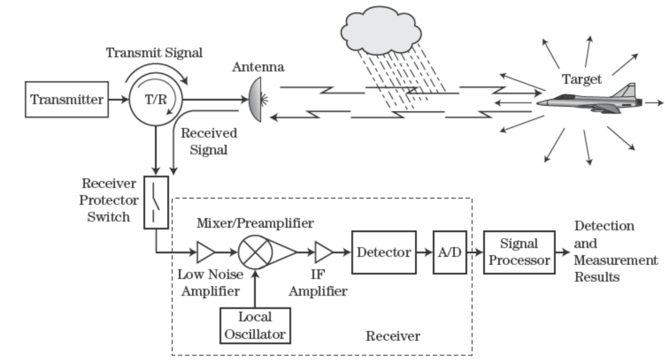
Figure 2.1 : Major Elements of Radar

- Interaction of EM waves with matter
The EM waves that radar transmits and receives interact with matter specifically in radar's antenna, we have losses between transmitter and antenna, between receiver and antenna, signal process losses and atmosphere losses. We'll focus on the atmosphere losses.

Atmospheric attenuation and absorption: The attenuation of an EM wave through an atmosphere is caused by two major components: Absorption & Scattering. Absorption occurs when the atmosphere contains gases or particulates with lossy properties like oxygen or raindrops that shows in Figure 2.2. Scattering occurs when the particulate is of sufficient size to cause some of the wave to be reflected away from antenna receiver. In addition the wave can be both scattered and absorbed like in clouds according to the particle size & lossy dielectric properties. We can calculate the one way attenuation by this equation

$$F^{2}(dB)= α×L$$

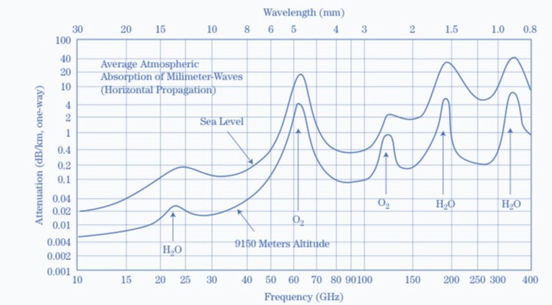
Where a is the attenuation coefficient and it's expressed in dB/Km, and L is the path length in meters (Km). if we want to calculate two way attenuation ($F^{4}$) we just multiply the one way attenuation ($F^{2}$) by 2.

Figure 2.2 Average atmosphere absorption

And we can understand from this Figure that the attenuation amount is increasing after 18GHz.

Types of antenna

There are two basic antenna configurations of radar systems: 1. monostatic and 2. bistatic (Figure 2.3). In the monostatic configuration, one antenna serves both the transmitter and receiver. In the bistatic configuration, there are separate antennas for the transmit and receive radar functions.

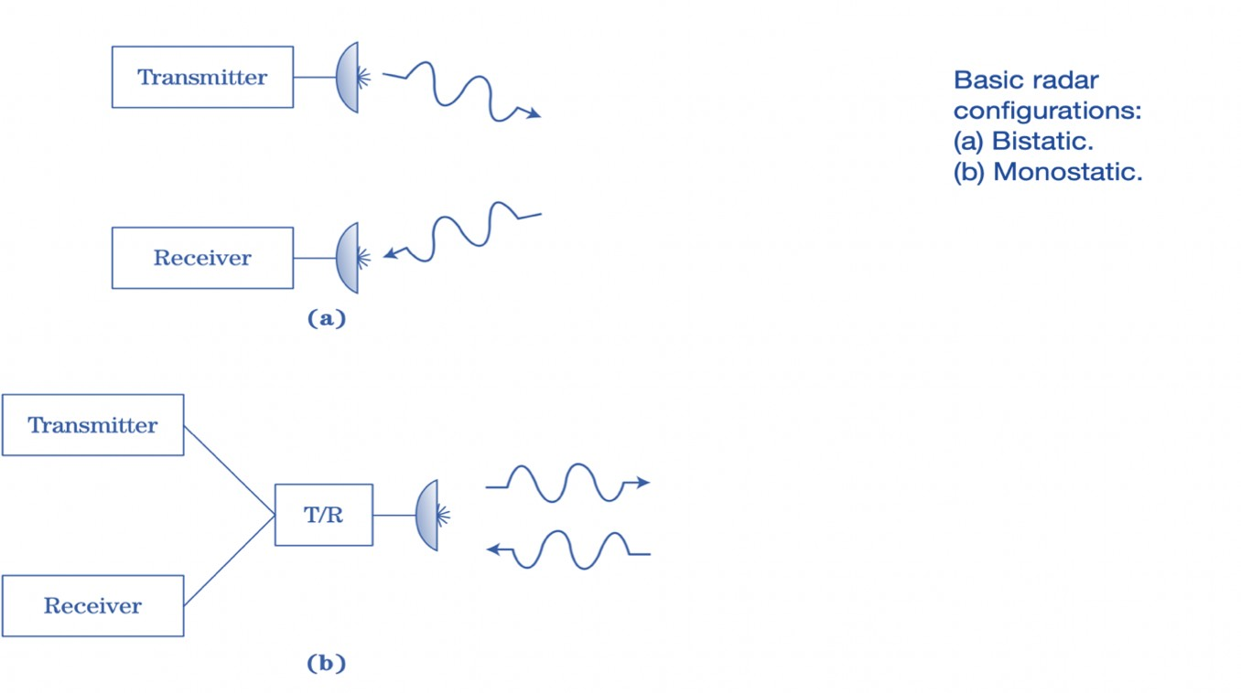
Figure 2.3: Basic Radar Configuration

Figure 2.1 : Basic Radar Configuration

The use of two antennas alone does not determine the monostatic or bistatic nature of a system. The system is considered monostatic if the two antennas are very close to each other. Only when there is sufficient separation between the two antennas such that: the angles or ranges to the target are sufficiently different is the system is considered to be bistatic. The transmitter is often a high-power device that can transmit hundreds of kilowatts, or even megawatts, of EM waves with power levels. On the other hand, the receiver is a power-sensitive device capable of responding to EM waves in the range from milliwatts to nanowatts, or less. In fact, for a radar receiver this is not uncommon to detect signals as low as −90 dBm.

If introduced directly into the receiver, high-power EM waves from the transmitter would prevent target detection (self-jamming), and could severely damage the sensitive components of the receiver. The receiver therefore needs to be isolated from the transmitter in order to protect it from high-power EM waves of the transmitter. By physically separating the transmitter and receiver antennas, the bistatic radar configuration can provide significant isolation.
There are some applications for which the transmitter and receiver are significantly separated by the bistatic system. A semi-active missile, for example, only has the receiver portion on board. On another platform the transmitter is. The transmitter "illuminates" the target while the target "homes" the missile in on the reflected signal.
Most modern radars are monostatic, since only one antenna is required, a more practical design. Isolation between transmitter and receiver is more difficult to provide since both subsystems have to be attached to the antenna. A Transmitter / Receiver device, such as a circulator or switch, provides the insulation. The transmitter and receiver do not operate at exactly the same time for a radar using a pulsed waveform. Thus, additional insulation can be achieved through the use of an additional switch in the input path of the receiver.

Car antenna:
Most antennas are made of thin steel tubes, and many are telescopic, meaning they can move up or down as needed to pick up waves. As of 2010, the three antennas used in cars include internal, external and satellite varieties

Internal Antennas
Internal car antennas sit inside the trunk, dashboard or the windshield of a car. Internal antennas receive better protection from weather and accidental damage, but their reception generally isn't as clear as external or satellite antennas. Installing the antenna inside the car or using an antenna with a built-in amplifier may help reception performance

External Antennas

External antennas, made of metal or fiberglass, are typically installed near the hood or trunk of the car. External antennas receive better reception but are more susceptible to breakage or weather damage. External antennas sometimes come with retractors that pull the antenna into the car to protect it when not in use.

Satellite Antennas

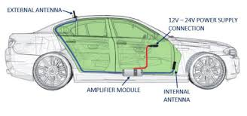
Satellite antennas are the newest type of antenna used in automobiles as of 2010. The installer mounts a radio dock in the front near the windshield or in the dashboard, then wires the radio through the back or side of the car to a small magnetic antenna on the roof of the car. Satellite radio offers superior sound quality but requires a paid subscription, unlike free terrestrial stations.
Figure 2.4 : Places of external and internal antenna

Size of car antenna

the standard antenna size on most cars, for decades, was this 1/4 wave antenna size, which comes to about 2.34 feet, or around 31 inches
modern shark-fin-style radio antennae on modern cars, you’ll actually find multiple antennae—ones for cell signals, satellite radio, and old AM/FM broadcasts
You see the “coil” of conductive copper right in there, and I expect if you were to stretch it out, it’d be about the size of a 1/4 wavelength car antenna, around 31 inches or so, or maybe some close fraction thereof
Some shark fins don’t bother with FM antennae, which are instead integrated into the rear window glass, along with the defroster, or sometimes hidden in places like rear spoilers
Most shark fin antennae actually kind of compromise FM signals—an old school 1/4 wavelength whip antenna likely will get better reception due to its better gain—but the other antennae it contains (satellite radio, etc) are now considered more important, as are the improved aesthetics, so we just deal with it, and for the most part, it’s fine
Antenna quality has been sacrificed for aesthetics before, even when AM and FM were important

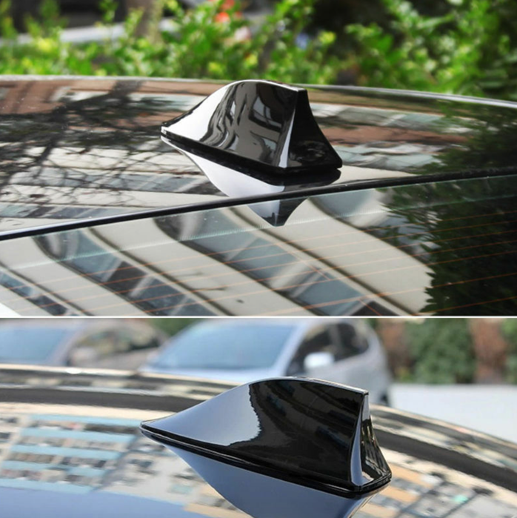
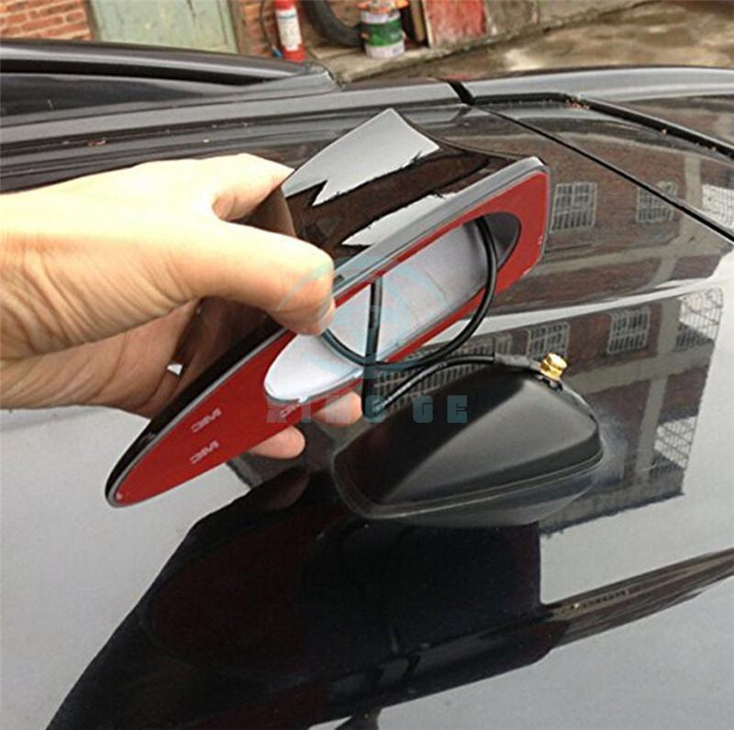

Figure 2.5 : Shark fin Antenna

Continuous Wave versus Pulsed

CW Waveform:
It is possible to divide the radar waveforms into two general classes: continuous wave (CW) and pulsed waveform. With the Continuous Waveform the transmitter transmits a signal continuously, usually without interruption, at all times during the off operation of the transmitter, the receiver also operates continuously at all times, while the pulsed waveform transmitter, on the other hand, transmits a sequence of finite duration pulses, separated by times during which the transmitter is "off". Continuous wave radars often use the bistatic configuration to effect isolation of transmitter / receiver.

Since the isolation between the transmitter and the receiver is not perfect, due to the leakage, there is some competing signal that relegates CW systems to relatively low power applications and therefore short range ones. Since a CW radar is continuously transmitting, it is necessary to determine the round-trip time of the transmitted EM wave and thus the target range by changing the characteristics of the wave, this frequency modulated (FM) technique effectively places a timing mark on the EM wave, thus allowing the determination of the target range.

Though there are relatively complex CW systems employed as illuminators in fire control systems, semi- active missiles, and trackers, CW radars tend to be simple radars and are used for such applications as police speed-timing radars, altimeters, and proximity fuses

Pulsed Waveform:
Pulsed radars transmit EM waves, typically 0.1 to 10 microseconds (μs), but sometimes in nanoseconds or as long as a millsecond, for a very short time duration, or pulse width. The receiver is isolated or blanked from the antenna during this time, thus protecting its sensitive components from the high-power EM waves of the transmitter. During this period no received signals can be detected. Apart from the isolation provided by the Trnasmitter / Reciver device (shown in Figure 2.1), the receiver protection switch offers additional protection, not shown in the figure.

The receiver is connected to the antenna during the time between transmitted pulses, typically from 1 microsecond to tens of milliseconds, allowing it to receive any EM waves (echoes) that may have been reflected from objects within the environment. This time of "listening" plus the pulse width represents one pulsed time of the radar cycle, normally called the interpulse period (IPP) or pulse repetition interval (PRI). Figure 2.6 depicts the pulsed waveform.

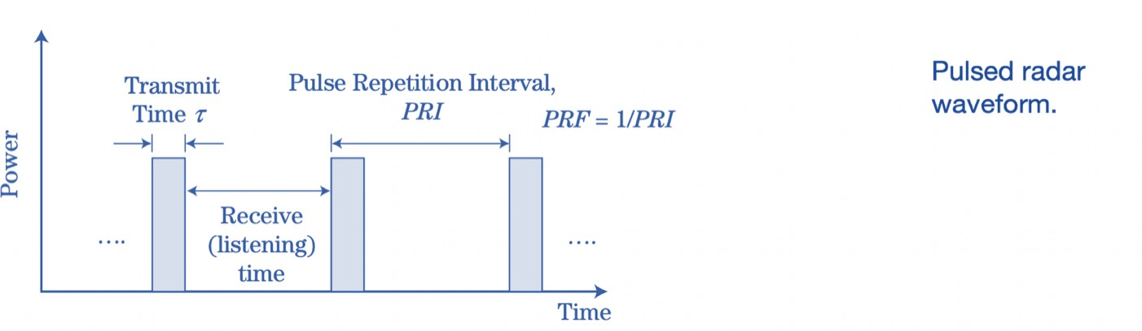
Figure 2.6 : Pulsed radar waveform

Pulse Repetition Frequency (PRF): The number of transmit/receive cycles the radar completes per second is called the pulse repetition frequency (PRF), which is properly measured in pulses per second (PPS) but is often expressed in hertz (cycles per second). The PRF and PRI are related according to :

Pulse Width and Duty Cycle: The fraction of time the transmitter is transmitting during one radar cycle is called the transmit duty factor (or duty cycle), dt , and from Figure 2.6 is given by

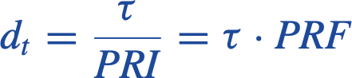

The average power, Pavg, of the transmitted EM wave is given by the product of the peak transmitted power, Pt , and the transmit duty factor:

Range Sampling: Figure 2.7 shows a sequence of two transmitting pulses and adds a hypothetical target echo. Because the time scale is continuous, with infinitesimal time resolution, a target signal can reach the radar receiver at any arbitrary time. Using an ADC, which quantizes the signal in time and amplitude, the received signal is normally sampled at discrete time intervals in a modern radar system. The time quantization corresponds to the sample times of the ADC, and the quantization of amplitude depends on the number of "bits" of the ADC and the voltage at full scale.

Usually, oversampling is used to achieve improved detection; for example, for a given pulse width, there would be two samples. A pulsing width of 1 μs would suggest a sample period of
  - μs, or a sample rate of 2 mega samples per second (Msps). Each of these time samples
represents a different range increase at a range found from $R=\frac{c ∆T}{2}$, often called a range bin.
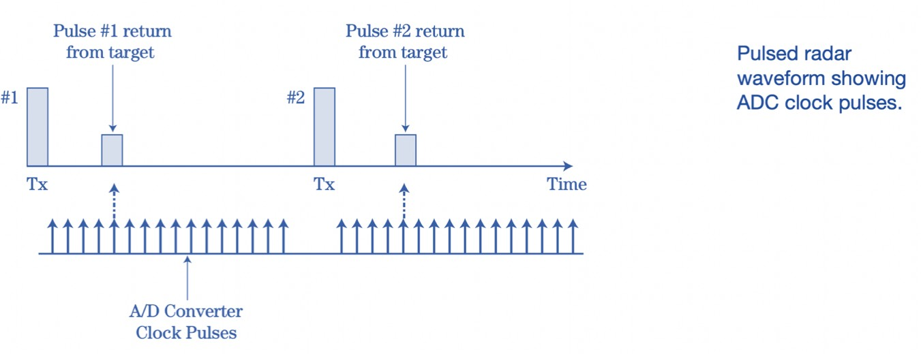
The target shown in the figure is within a range equivalent to sample number five.

Figure 2.2 : Basic Radar Configuration
Figure 2.7 : Pulsed radar waveform showing ADC Clock Pulses

Unambiguous Range Measurement: Remember that target range is determined by measuring the delay time from pulse transmission to reflected signal reception. Problems can occur in a pulsed radar when determining the target range if the travel time of the pulse round-trip is greater than the interpulse period, IPP, between the radar and the distant target. In this case, before the next pulse is transmitted, the EM wave in a given pulse will not return to the receiver of the radar resulting in time ambiguity and associated ambiguity of range. The pulse received could be a reflection of the pulse just transmitted, and thus a reflection of a close-in target, Or it could be a reflection of a previously transmitted pulse, and hence a reflection of a distant target.

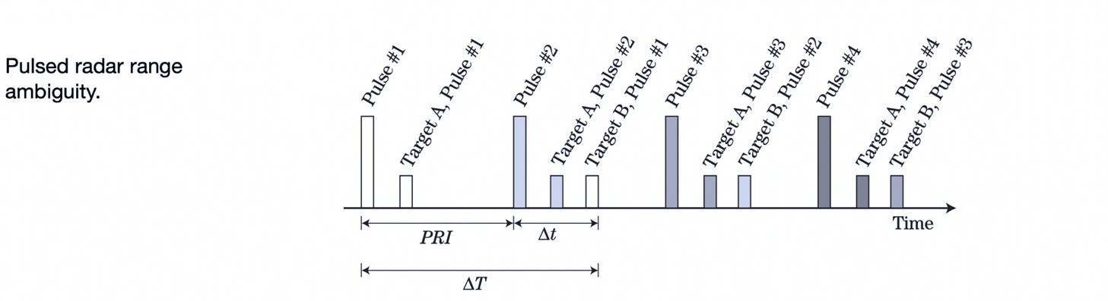
Figure 2.8 illustrates that situation. The tall rectangles represent the pulses transmitted; the shorter rectangles represent the echoes received from two targets. The shading of the target echoes corresponds with the shading of the pulse they originated from. The time delay for targeting A and back is less than the interpulse period, so that the echo from target A is received from a given pulse before the next pulse is transmitted. Specifically, assume that target B is greater than the ; ∆𝑇 = 𝑃𝑅𝐼 + ∆𝑡 Then the reflection from target B due to pulse #1 occurs ∆𝑡 seconds after pulse #2, as shown in the figure. Consequently, it is unclear if this echo is from a
Figure 2.8 : Pulsed radar range ambiguity

Range ambiguities can be avoided by ensuring that the interpulse period, PRI, is long enough or, equivalently, that the pulse repetition frequency PRF is low enough, so that before the next pulse is transmitted, all echoes of interest from a given pulse return to the radar receiver. The round trip time from equation for the radar wave is given by:

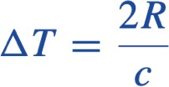

Thus, to prevent range ambiguities, the following condition must be satisfied:

where Rmax is the maximum target range of interest. Conversely, the unambiguous range, Rua, is the maximum range at which the range to a target can be measured unambiguously by the radar. It is given by

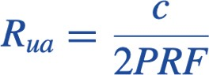

It should be noted that not all radars satisfy this condition. Some systems cannot avoid an ambiguous range condition, due to other conflicting requirements, as is seen in the following section.

- Automotive radar classification

Both autonomous and human-driven cars are increasingly using radars to improve drivers’ comfort and safety. For instance, park assist and adaptive cruise control provide comfort, while warning the driver of imminent collisions and overriding control of the vehicle to avoid accidents improve the safety. Figure 1 depicts various such radar subsystems that form ADASs. Each subsystem has unique functionality and specific requirements in terms of radar range and angular measurement capability (Table 1). The next section explains the fundamentals of location and speed estimation using the radar measurements.

- Basic automotive radar estimation problems

A radar can simultaneously transmit and receive EM waves in frequency bands ranging from 3 MHz to 300 GHz. It is designed to extract information [i.e., location, range, velocity and radar cross section (RCS)] about targets using the EM waves reflected from those targets. Automotive radar systems typically operate at bands in 24 GHz and 77 GHz portions of the EM spectrum known as mm-wave frequencies so that higher velocity and range resolution can be achieved.
Adaptive Cruise Control

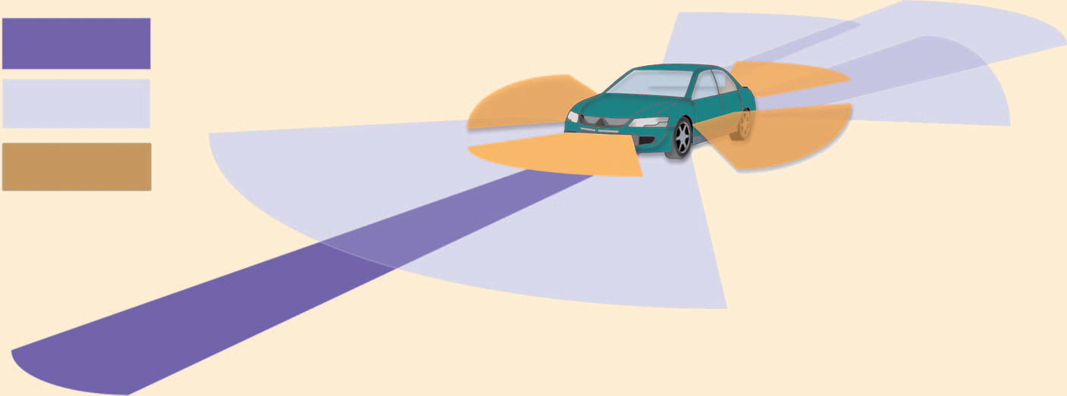
Cross Traffic Alert

Cross Traffic Alert
Cross Traffic Alert

Cross Traffic Alert
Short Range Radar

Short Range Radar
Pre Crash

Pre Crash
Rear Collision Warning
Blind Spot Detection

Rear Collision Warning
Blind Spot Detection
Pre Crash

Park Assist

Pre Crash

Park Assist
Blind Spot Detection
Park Assist

Blind Spot Detection
Park Assist
Long Range Radar
Medium Range Radar

Figure 2.9 : ADAS Consists of different range radarsLong Range Radar
Medium Range Radar
Figure 2.9 : ADAS Consists of different range radars

Table 1 : The classification of automotive radars based on range measurement capability.
Radar type | Long-Range Radars | Medium-Range Radars | Short-Range Radars
Range (m) | 10–250 | 1-100 | 0.15-30
Azimuthal field of view(deg) | ±15º | ±40º | ±80º
Elevation field of view (deg) | ±5º | ±5º | ±10º
Applications | Automotive  cruise control | Lane-change assist,  cross-traffic alert,  blind-spot detection,  rear-collision  warning | Park assist,  obstacle detection,  precrash

- Advantages of 77 GHz over 24 GHz for automotive radar systems

1. Larger Available Bandwidth & Better Resolution: The 77 GHz frequency band for automotive radar applications uses the frequency range from 76 to 81 GHz with a bandwidth of over 4 GHz as compared to a bandwidth of 200 MHz available for automotive radar applications at 24 GHz. This wide bandwidth increases range and velocity resolution of the radar, allowing it to identify objects that are closely spaced, making these radars ideal for automated parking applications.

The differences in phase between the transmitted signal and the signal at the receiver to measure the relative velocity of an object. As the wavelength decreases, the resolution and accuracy of this velocity measurement improves proportionally. Therefore, as sensors move from 24 GHz to 77 GHz, velocity measurements can improve by 3x.

This enhanced resolution also improves the detection and avoidance of big objects, like cars, and allow the avoidance of smaller ones, like pedestrians, too. It also provide drivers with better object resolution in situations with poor visibility.

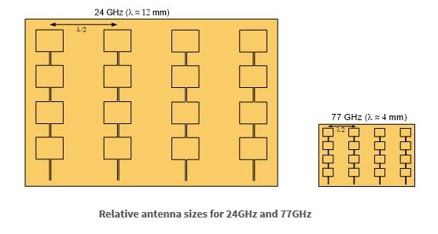
2. Smaller Size: 77 GHz radar systems are smaller in size in comparison to 24 GHz radars. As the relationship between the antenna size and the frequency is linear, the wavelength of 77 GHz signals is one-third of that of a 24 GHz system, therefore area needed for a 77 GHz radar antenna is one-ninth the size of a similar 24 GHz antenna.
Figure 2.10 : different sizes of automotive radar systems

Basic Radar Measurements

Target position:

In three dimensional space, target location must be defined. Since a radar transmits a beam in the angular direction of azimuthal and elevation, and defines the range between that angular line and a target, a radar naturally measures the location of a spherical coordinate system.
Modern radar can simultaneously detect multiple targets. ( shown in figure 2.11 )

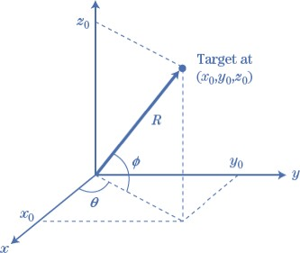
Figure 2.11 : Spherical Coordinates system

Azimuthal and Elevation angles (θ, φ):

The azimuthal and elevation angles are determined by the pointing angle of the main antenna beam, when the target detection occurs.
This antenna pointing angle can be either the actual physical pointing angle of a mechanically scanned antenna or the electronic pointing angle of an electronically sca nned antenna (phased array)

Range:

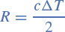
The target’s range R is determined by the round trip-time of the EM wave . We can calculate it by this equation .

R is stand for Range , c is stand for the light speed and it's equal to 3x10⁸ m/s , ∆T for the delay time

For most modern radar systems, the delay period ∆T is calculated by "counting" the number of pulses of ADC blocks that occur between the transmission period and the target time, assuming the first pulse of the clock corresponds with the transmission pulse..

Range Rate and Doppler Frequency Shift :

If there is a relative motion between the radar and the target, then the EM wave frequency reflected from the target and transmitted by the radar would be different from the radar frequency.
In modern radars the Doppler shift is a very important number
Measurement of the Doppler characteristics is used to prevent clutter returns, to determine the presence of multiple targets at the same range , and to classify and identify moving targets and targets with moving components ( e.g . trucks , tanks ,…).

Polarization:

Polarization refers to the normal gradient of the EM wave emitted by the radar antenna and received by it Different artifacts will adjust the polarization of the EM wave incident differently The polarization of the EM wave when reflected from an object brings some knowledge of the geometric shape of the object.
This information can be used to discriminate against unwanted reflected waves (e.g., rain returns) that are reflected from targets

Resolution :

The concept of resolution describes a radar’s ability to detect two or more targets that are closely spaced .

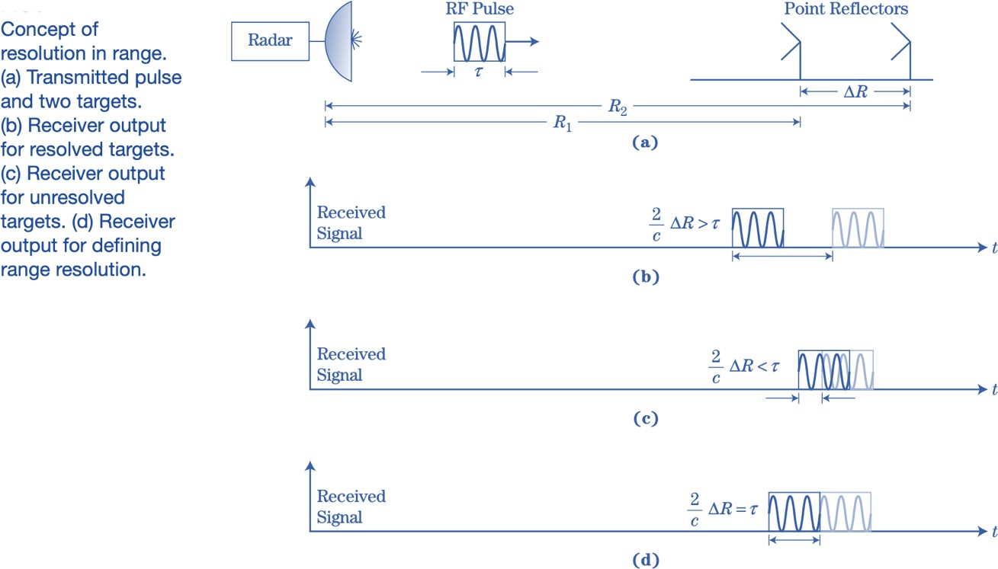
Figure 2.12 : Concept of resolution in range

The idea is explained in Figure above which imagines the receiver output for a single transmitted pulse echoed from two equal strength point scatters separated by a distance ∆R if ∆R is large enough , two distinct echoes would be observed at the receiver output as in figure (b) in this case the two scatterers are considered to be resolved in range .
In figure (c) , the scatterers are close enough that the two echoes overlap .
The dividing line between these two cases is shown in figure (d) , where the two pulses abut one another .

RADAR APPLICATIONS

Speed Measurement:

Doppler Radar : The classic Doppler phenomenon operates according to the principle of change in sound frequency according to the relative speed between the “car” source and the “radar” observer. The frequency increases as the source approaches the observer, and decreases when the audio source turns away from it.

laser speed gun : It is a laser pistol that police officers usually use to determine the speed of vehicles, and it operates according to the Time-of-flight principle

Car radar :

Adaptive Cruise Control (Belt Speed Control) Adaptive Cruise Control (ACC)

It comes under several names depending on the manufacturer such as effective belt speed control (ACC), intelligent speed control, intelligent speed control, radar speed control system, adaptive or radar, or independent belt control system from optional systems to control The vehicle, which self-adjusts the vehicle speed while maintaining a safe distance between the vehicle and the vehicle ahead. The system operates with information from a vehicle-mounted sensor. It is a radar sensor that is connected to the electronic control unit of the car, which slows down the vehicle and stops it when necessary without the intervention of the driver.

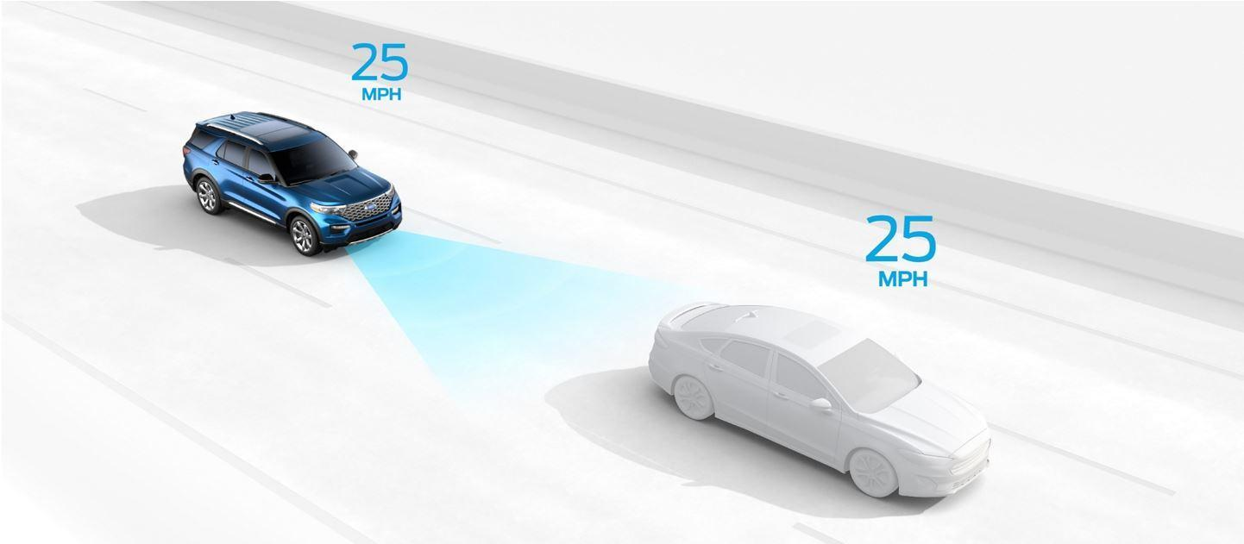
Figure 2.13 : Adaptive Cruise Control

Collision Avoidance System (CAS )
It is a vehicle safety system designed to reduce the size of an accident. It has many names and is called a pre-crash system, forward collision warning system or collision mitigating system, and it works by radar and sometimes lasers and vision sensors to avoid impending accidents. It uses ACC pre-adjustment cruise control. When sensors feel that the car is approaching the vehicle ahead, at a high rate, the system warns the driver by means of an acoustic warning or a flashing of the instrument panel. In the event that the driver does not respond and continues to approach the vehicle in front at the same rate, and upon sensing that there is an unavoidable collision case, the system activates the brakes until it reduces the force of the accident. At the same time, the system adjusts the tension of the seat belt, adjusts the headrests, closes the electric windows and the moving surface to reduce the impact of the accident upon collision.
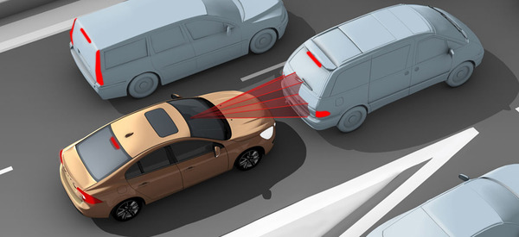
Figure 2.14 : Collision Avoidance System

Backup warning system
This system works by means of the radar transmitting and receiving system or ultrasound. Attached to the back of the car for the purpose of detecting anything in the path of moving the car again. This detection system is connected to the reflection lights and works only when the vehicle is in the rear shift. When something is detected in the vehicle’s path behind and near the vehicle, the system warns the driver, either audibly or via the instrument panel or rear view bulb.
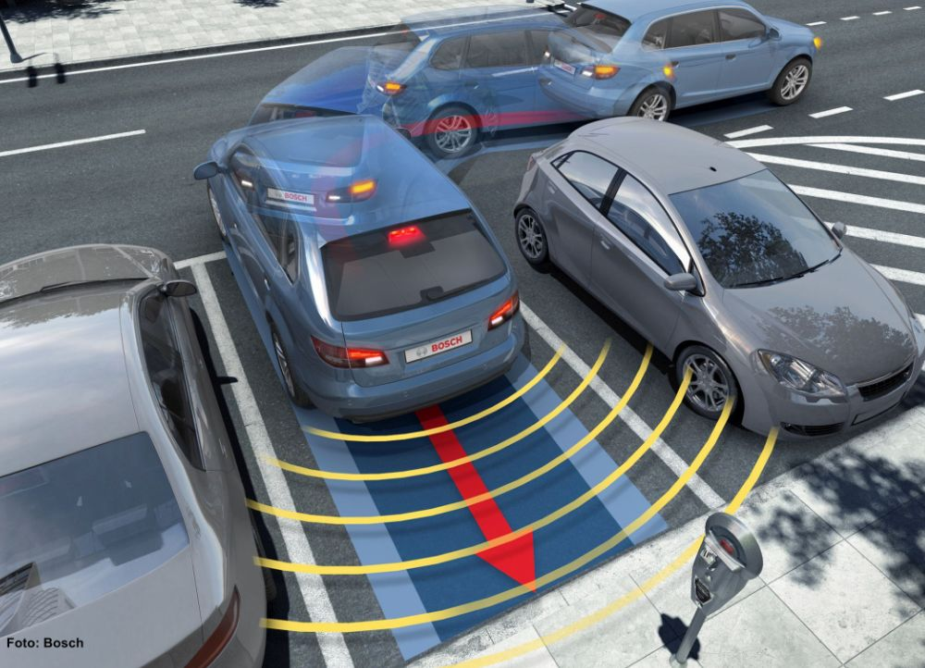
There are systems with a rear camera to identify the object behind the moving vehicle. The image appears directly on the display screen or on the rearview mirror. The system also recognizes fixed objects and moving objects.
Figure 2.15 : Backup warning system

- Frequency Modulated Continuous-Wave radar ( FMCW )

FMCW radar : is a special type of radar sensor which radiates continuous transmission power like a simple continuous wave radar (CW-Radar). In contrast to this CW radar FMCW radar can change its operating frequency during the measurement: that is, the transmission signal is modulated in frequency (or in phase). Possibilities of Radar measurements ​​through runtime measurements are only technically possible with these changes in the frequency (or phase).

Simple continuous wave radar devices without frequency modulation have the disadvantage that it cannot determine target range because it lacks the timing mark necessary to allow the system to time accurately the transmit and receive cycle and to convert this into range. Such a time reference for measuring the distance of stationary objects, but can be generated using of frequency modulation of the transmitted signal. In this method, a signal is transmitted, which increases or decreases in the frequency periodically. When an echo signal is received, that change of frequency gets a delay Δt (by runtime shift) like to as the pulse radar technique. In pulse radar, however, the runtime must be measured directly. In FMCW radar are measured the differences in phase or frequency between the actually transmitted and the received signal instead.

The basic features of FMCW radar are:

- Ability to measure very small ranges to the target (the minimal measured range is comparable to the transmitted wavelength).
- Ability to measure simultaneously the target range and its relative velocity;
- Very high accuracy of range measurement.
- Signal processing after mixing is performed at a low frequency range, considerably simplifying the realization of the processing circuits.
- Safety from the absence of the pulse radiation with a high peak power.

Principle of measurement
Characteristics of FMCW radar are:
- The distance measurement is accomplished by comparing the frequency of the received signal to a reference (usually directly the transmission signal).
- The duration of the transmitted waveform T is substantially greater than the required receiving time for the installed distance measuring range.
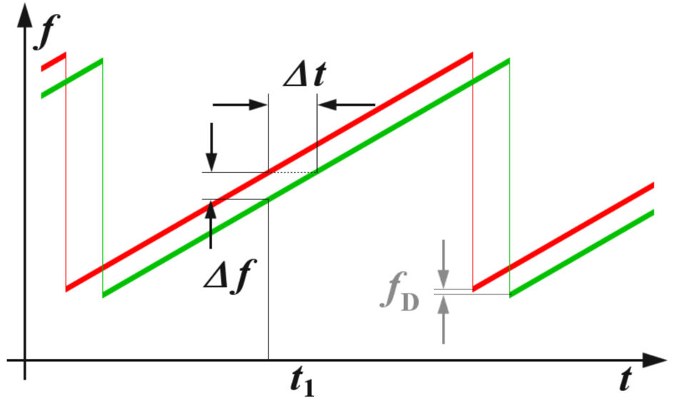
Figure 2.16 : Ranging with FMCW system

The distance R to the reflecting object can be determined by the following relations:

$$R=\frac{C × |∆t|}{2}= \frac{C × | ∆f |}{2 × \left(\frac{df}{dt}\right)}$$

Where :

$$R is the distance between antenna and the reflecting object in m$$
$$C is the speed of light=3×{10}^{8}m/s$$
$$∆t the Delay time in seconds$$
$$∆f is the measured frequency differens in Hertz$$
$$\frac{df}{dt} is the frequency shift per unit of time$$

If the change in frequency is linear over a wide range, then the radar range can be determined by a simple frequency comparison. The frequency difference Δf is proportional to the distance R. Since only the absolute amount of the difference frequency can be measured (negative numbers for frequency doesn't exist), the results are at a linearly increasing frequency equal to a frequency decreasing (in a static scenario: without Doppler effects).

If the reflecting object has a radial speed with respect to the receiving antenna, then the echo signal gets a Doppler frequency f_{D} (caused by the speed). The radar measures not only the difference frequency Δf to the current frequency (caused by the runtime), but additional a Doppler frequency f_{D} (caused by the speed). The radar then measures depending on the movement direction and the direction of the linear modulation only the sum or the difference between the difference frequency as the carrier of the distance information, and of the Doppler frequency as a carrier of the velocity information.
If the measurement is made during a falling edge of a saw tooth ,then the Doppler frequency f_{D} is subtracted of by the runtime frequency change. If the reflecting object is moving away from the radar, then the frequency of the echo signal is reduced by the Doppler frequency additionally. Now, if the measurement is performed with a sawtooth as shown in Figure 2.16, then the received echo signal (the green graph) is moved not only by the run time to the right but also by the Doppler frequency down. The measured difference frequency Δf is by the Doppler frequency f_{D} higher than according to the real run time should be.

Maximum Range and Range Resolution
By suitable choice of the frequency deviation per unit of time can be determined the radar resolution, and by choice of the duration of the increasing of the frequency , can be determined the maximum non-ambiguous range. The maximum frequency shift and steepness of the edge can be varied depending on the capabilities of the technology implemented circuit.
The maximum unambiguous range is determined by the necessary temporal overlap of the (delayed) received signal with the transmitted signal. This is usually much larger than the energetic range, i.e. the limitations by the free space loss.
For the range resolution of an FMCW radar, the bandwidth BW of the transmitted signal is decisive (as in so-called chirp radar). However, the technical possibilities of Fast Fourier Transformation are limited in time (i.e. by the duration of the sawtooth Τ ). The resolution of the FMCW radar is determined by the frequency change that occurs within this time limit.

$∆f$_{FFT} $=\frac{1}{T}= \frac{δ(f)}{δ(t)}×\frac{1}{(fup-fdwn)}$
Where :
$∆f$_{FFT} is the smallest measurable frequency difference
$\frac{δ(f)}{δ(t)}$ steepness of the frequency deviation
$f$up is the upper frequency ( end of the sawtooth )
$f$dwn is the lower frequency ( start of the sawtooth )
The reciprocal of the duration of the sawtooth pulse leads to the smallest possible detectable frequency. This can be expressed in $R=\frac{C × |∆t|}{2}= \frac{C × | ∆f |}{2 × \left(\frac{df}{dt}\right)}$ as |Δf | and results in a range resolution capability of the FMCW radar.

Bandwidth | Range  Resolution | Maximum  Range | approximately  required tx power | Example  given
400 kHz | 4,000 m | 120 km | 1,4 kW | 76N6 (“Clam Shell”)
50 … 500 kHz | 1,500 … 100 m | 15 … 250 km | 30 W | OTH oceanography radar WERA
1 MHz | 150 m | 75 km | 1.4 … 4 kW | Naval radar using a Magnetron
2 MHz | 75 m | 37.5 km
10 MHz | 5 m | 7,500 m
50 MHz | 3 m | 500 m | 4 mW | DPR-886
65 MHz | 2.5 m | 1,200 m | 100 mW | Broadband Radar™
250 MHz | 0.6 m | 500 m | 4 mW | Skyradar Basic II
8 GHz | 3.5 cm | 9 m | 4 mW | Skyradar PRO
7 GHz | 2.1 mm | 5 m | 4 mW | Omniradar RIC60A
The signal bandwidth of an FMCW radar can range from 1 MHz to several GHz. (Its upper border is mostly limited by administrative reasons. For example the mostly used for FMCW-applications European ISM-radio band is defined from 24,000 MHz to 24,250 MHz with a given band width of 250 MHz.) As the bandwidth increases, the achievable range resolution is decreasing and this means the monitored objects can be seen more accurate. The maximum detected range becomes smaller when the bandwidth increases. This can be shown in the following table:

Table 2 : Relationship between bandwidth and other parameters:
As with any radar in the FMCW radar, besides the allocated bandwidth, the antenna beam width determines the angular resolution in detecting objects.

- Modulation pattern
There are several possible modulation patterns which can be used for different measurement purposes:
- Sawtooth modulation
This modulation pattern is used in a relatively large range (maximum distance) combined with a negligible influence of Doppler frequency (for example, a maritime navigation radar).

- Triangular modulation
This modulation allows easy separation of the difference frequency $Δf$ of the Doppler frequency $fD$

- Square-wave modulation (simple frequency-shift keying, FSK)
This modulation is used for a very precise distance measurement at close range by phase comparison of the two echo signal frequencies. It has the disadvantage, that the echo signals from several targets cannot be separated from each other, and that this process enables only a small unambiguous measuring range.

- Stepped modulation (staircase voltage)
This is used for interferometric measurements and expands the unambiguous measuring range.

- Sinusoidal modulation
Sinusoidal modulation forms have been used in the past. These could be easily realized by a motor turned a capacitor plate in the resonance chamber of the transmitter oscillator. The radar then used only the relatively linear part of the sine function near the zero crossing.

- Sawtooth linear frequency changing
In a linear sawtooth frequency changing (see Figure 2.16) a delay will shift the echo signal in time (i.e. to the right in the picture). This results in a frequency difference between the actual frequency and the delayed echo signal, which is a measure of the distance of the reflecting object. This frequency difference is called “beat frequency”. An occurring Doppler frequency would now move the frequency of the entire echo signal either up (moving towards the radar) or down (moving away from the radar).
In this form of modulation, the receiver has no way to separate the two frequencies. Thus, the Doppler frequency will occur only as a measurement error in the distance calculation. In the choice of an optimum frequency sweep can be considered a priori, that the expected Doppler frequencies are as small as the resolution or at least, that the measurement error is as small as possible.
This will be the case for example in maritime navigation radar: Boats move in the coastal area at a limited speed, with respect to each other perhaps with a maximum of 10 meters per second. In this frequency band of these radar sets (X-Band mostly), the expected maximum Doppler frequency is 666 Hz. If the radar signal processing uses a resolution in the kilohertz range per meter, this Doppler frequency is negligible. Because the at an airfield occurring take-off and landing speeds of up to
200 m/s, a maritime navigation FMCW radar would have trouble at all to see these planes. The measurement error caused by the Doppler frequency can be greater than the distance to be measured. The target signs would then theoretically appear in a negative distance, i.e. before the start of the deflection on the screen.

- Block Diagram of an FMCW Radar Sensor
An FMCW radar consists essentially of the transceiver and a control unit with a microprocessor.
The transceiver is a compact module, and usually includes the patch antenna implemented as separate
transmit and receive antenna. The high frequency is generated by a voltage controlled oscillator which
directly feeds the transmitting antenna, or its power
is additionally amplified. A part of the high frequency is coupled out and fed to a mixer which down
converts the received and amplified echo signal in
the baseband.
The control board contains a microprocessor that controls the transceiver, converts the echo signals in a digital format as well (usually via USB cable) ensures the connection to a personal computer or laptop. Using a digital to analogue converter, the control voltage is provided to the frequency control. The output voltage of the mixer is digitized.
If using a single antenna, then due to the method (simultaneously transmitting and receiving) the FMCW radar needs a ferrite circulator to separate the transmitting and receiving signals. In the currently used patch antennas, however, the use of separate transmitting and receiving antennas is much cheaper. On a common substrate are placed directly above each other, a transmitting antenna array and a receiving antenna array. The polarization direction is rotated by 180 ° against each other often. Often is reduced by an additional shielding plate a direct “crosstalk” (i.e. a direct positive feedback between the two antennas). Since the measurement is performed as a frequency difference between the transmitting and receiving signal, the signal which is produced by this direct coupling can be suppressed due to the very small frequency difference.
In pure CW radar applications only the Doppler frequency must be processed. This includes frequencies only up to 16.5 kHz by using an FMCW transceiver operating in K-Band (about 24 GHz) and the expected speeds for recording are up to 360 Kilometers per hour. Therefore as microprocessor there can be used a simple stereo audio processor, which is produced in large quantities and is used for example in sound cards for home computers. Even in the FSK method (rectangular pattern modulation) such a processor can be used conditionally.
In contrast, the receiver in a FMCW radar application must be able to process the whole transmitter's frequency shift. Thus frequencies up to 250 MHz are expected in the received signal. This has a significant impact on the bandwidth of the subsequent amplifier and the necessary sampling frequency of the analogue-to-digital converter. Thus, the signal processing board of FMCW radar is considerably more expensive with respect to the CW radar.

There are currently on the market many inexpensive FMCW radar sensors or FMCW radar modules, which contain a complete transceiver with integrated patch antenna array as so-called “front-end” of FMCW radar device. These modules include as the core usually the MMIC module TRX_024_xx (see data sheet) from Silicon Radar with a power output of up to 6 dBm. This chip operates in the K-Band
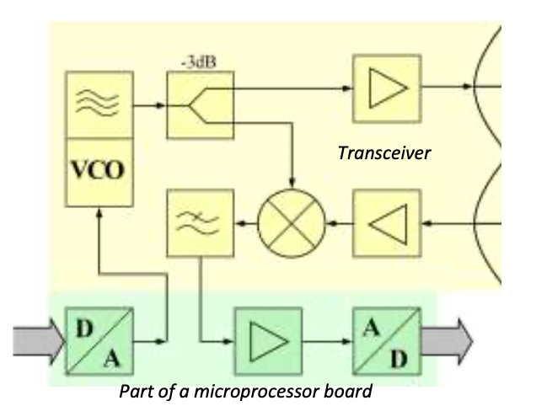
(24.0 ... 24.25 GHz) and can be used as a sensor for speed and distance measurements. The modulation or a frequency change is dependent on a control voltage and is connected to an external circuit, which is either a fixed voltage (then operates the module as a CW radar), or it is controlled by a processor and based on the output voltage of a digital-analogue converter. The output signal of the mixer is usually provided as I and Q signals, and needs to be substantially amplified before the analogue-to-digital conversion.

Figure 2.17 : Block Diagram of an FMCW radar
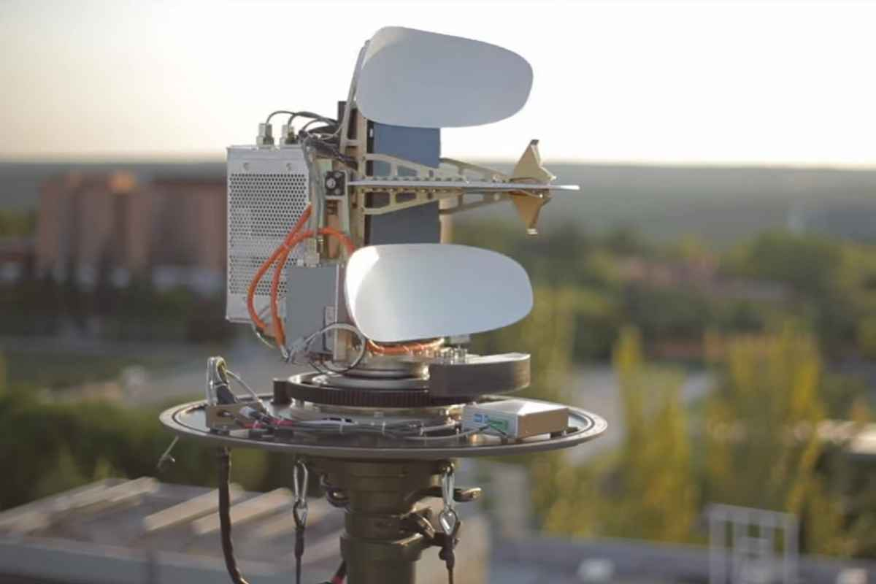
Figure 2.18 : The FMCW-Radar ART Midrange uses separate offset antennas for transmitting and receiving

- Imaging and Non-imaging FMCW radar

- Imaging FMCW radar
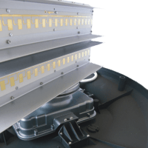
This radar method is used in the so called Broadband RadarTM as navigational radar for maritime applications. Here, the frequency sweep is stopped, however, after reaching the maximum
measurement range. Therefore, the transmission signal looks more like a signal of pulse radar using intrapulse modulation. This break has no direct influence on the maximum measuring distance here.
However, it is necessary to read the measured data from a buffer, and to transmit them lossless through narrowband line to the display unit. Due to its operation - the frequency comparison of the received echo signal with the transmitted signal, which is available across the entire distance - it remains an FMCW radar, it will only intermittently switched off for a few milliseconds, as more data are simply not needed.

Figure 2.19 : The patch antenna array of a maritime FMCW navigation radar in X-Band

An imaging radar must perform a distance measurement for each point on the monitor. A range resolution that is more dependent here on the size of a pixel of this screen and from the ability of the signal processing to provide the data in the required speed. It is required a high-resolution screen with the pixel resolution, that as a minimum for each range difference two pixels must be available, so even if the measured signal is exactly between the position of two pixels, both pixels 'light up' and upon movement of the target, the number of pixels used, and thus the relative brightness of the target character is the same.
With the above as an example mentioned Broadband-RadarTM with a frequency shift of 65 MHz per millisecond you can get good measurements.
- For an unambiguous runtime measurement with this radar are measurable only a maximum of 500 μs (see Figure 1) which corresponds to a possible maximum range of 75 km.
- The frequency deviation of 65 MHz per millisecond corresponds to a frequency changing of 65 hertz per nanosecond. If the following filters are technically able to resolve differences in frequency of 1 kHz, then herewith a measuring of time differences of 15 nanoseconds is possible, which corresponds to a range resolution of about 2 meters.
- If by the evaluation the maximum processable difference frequency is two megahertz, which accomplish an easy one-chip microcomputer, then distances of up to 4000 meters can be measured. (Without a microcontroller would then need 4000 different individual filters operating in parallel.)
- Due to the measuring method here is the accuracy of measuring approximately equal to the range resolution and is still limited by the resolution of the screen scale.
The FMCW radar can thus obtain a high spatial resolution with little technical effort. To obtain the same resolution, a pulsed radar needs capable of measuring time in region of nanoseconds. That would mean that the band width of this pulse radar transmitter must be at least 80 MHz, and for digitization the echo signal needs a sampling rate of 166 MHz.
- Non-imaging FMCW radar
The measurement result of this FMCW radar is presented either as a numeric value to a pointer instrument or digitized as alpha-numeric display on a screen. It can be measured only a single dominant object, but this one with a very high accuracy down to the centimeter range. This method of distance determination is for example as used in aircraft radio altimeter. Even an analogue pointer instrument can serve as an indicator for an FMCW radar (see Figure 8). The moving coil meter has a greater inductive impedance for higher frequencies and therefore exhibits a value dependent on the frequency, which is then, however, not linear.
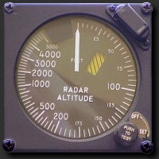

Figure 2.20 : Analogue display of a radar altimeter

- FMCW Beat Frequency
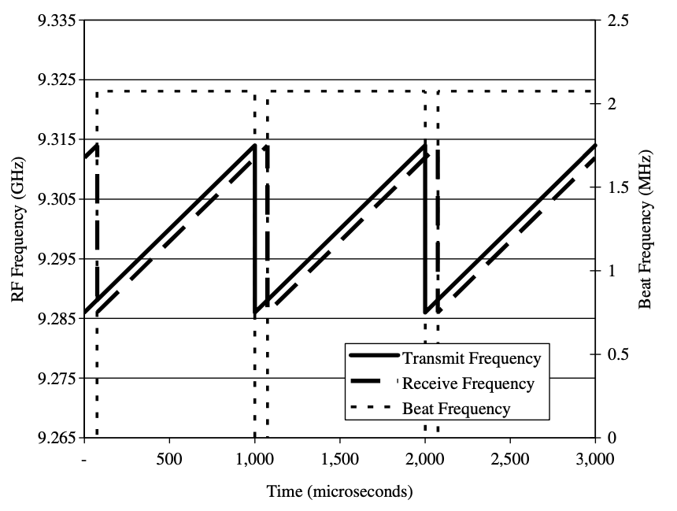

Figure 2.21 : Transmit-and- Receive Frequency as a Function of Time with Beat Frequency.

Figure 2.21 shows the transmit and receive frequency of an FMCW radar waveform as a function of time. The waveform illustrated is a sawtooth linear FMCW waveform. The receive signal comes from the echo of a target located a distance R from the transmitter. The resulting beat frequency, $f_{b}$, is the instantaneous difference in frequency between the transmit and receive waveforms. Measurement of the beat frequency allows us to determine the range to a target because it is directly related to target delay. The duration of the linear modulation is set so that it lasts longer than the round-trip transit time for the most distant target to be observed, thus avoiding ambiguities.
In Figure 2.21 the total peak-to-peak frequency deviation is $∆F$ and is termed the modulation bandwidth. The modulation period, $T_{m}$, is the time between repetitions of the sawtooth waveform. Together these two quantities (along with their repetition) form a triangle similar but offset to that formed by the beat frequency , $f_{b}$ and the transit time delay, $t_{d}$ (the time difference between the transmit and receive waveforms, that is, the range to a target.

A relation can thus be formed between the modulation bandwidth, the modulation period, the beat frequency, and the transit time that leads to the determination of range to a target:
$$\frac{f_{b}}{t_{d}}=\frac{∆F}{T_{m}}$$
$f_{b}$ : beat frequency
$t_{d}$ : round-trip propagation time delay $∆F$ : modulation bandwidth
$T_{m}$ : modulation period
The round-trip propagation time, $t_{d}$ is proportional to range and is given by :
$$t_{d}=\frac{2R}{C}$$
$R$ : Range to target
$$C : speed of light=3×{10}^{8}m/s$$

Substituting for $t_{d}$ in $$\frac{f_{b}}{t_{d}}=\frac{∆F}{Tm}$$
and rearranging terms leads to the following expression, known as the FMCW equation, which relates beat frequency and range:
$$f_{b}=\frac{∆F 2R}{Tm C }$$
The beat frequency is the product of the frequency sweep slope (i.e., the total frequency deviation divided by the modulation period) and the transit time. Thus, for the parameters shown in Figure 2.21
assuming a 28-MHz modulation bandwidth and a 1-ms modulation period, the resulting beat frequency is 2.1 MHz, which equates to a target located at a range of 11.1 km.
Other formulations of the FMCW radar equation may be constructed. For example, a sawtooth waveform modulation period, Tm, is the inverse of the modulation frequency, fm and thus the FMCW equation can be written as :
$$f_{b}\left(sawtooth\right)=∆Ff_{m}\frac{ 2R}{C }$$

- Automotive Adaptive Cruise Control using FMCW

in an ACC setup, the maximum range the radar needs to monitor is around 200 m and the system needs to be able to distinguish two targets that are 1 meter apart. From these requirements, one can compute the waveform parameters.

The sweep time can be computed based on the time needed for the signal to travel the unambiguous maximum range. In general, for an FMCW radar system, the sweep time should be at least 5 to 6 times the round trip time.

The sweep bandwidth can be determined according to the range resolution and the sweep slope is calculated using both sweep bandwidth and sweep time.

Because an FMCW signal often occupies a huge bandwidth, setting the sample rate blindly to twice the bandwidth often stresses the capability of A/D converter hardware. To address this issue, one can often choose a lower sample rate. Two things can be considered here:
- For a complex sampled signal, the sample rate can be set to the same as the bandwidth.
- FMCW radars estimate the target range using the beat frequency embedded in the dechirped signal. The maximum beat frequency the radar needs to detect is the sum of the beat frequency corresponding to the maximum range and the maximum Doppler frequency. Hence, the sample rate only needs to be twice the maximum beat frequency.

Assume X Km/h is the maximum speed of a traveling car. then the maximum Doppler shift and the maximum beat
frequency can be computed $as Vmax =\frac{X × 1000}{3600}$ , X can be any speed for ie: 80,100,120,160,230…)

Radar Signal Simulation
As briefly mentioned in above, an FMCW radar measures the range by examining the beat frequency in the dechirped signal. To extract this frequency, a dechirp operation is performed by mixing the received signal with the transmitted signal. After the mixing, the dechirped signal contains only individual frequency components that correspond to the target range.
In addition, even though it is possible to extract the Doppler information from a single sweep, the Doppler shift is often extracted among several sweeps because within one pulse, the Doppler frequency is indistinguishable from the beat frequency. To measure the range and Doppler, an FMCW radar typically performs the following operations:
- The waveform generator generates the FMCW signal.
- The transmitter and the antenna amplify the signal and radiate the signal into space.
- The signal propagates to the target, gets reflected by the target, and travels back to the radar.
- The receiving antenna collects the signal.
- The received signal is dechirped and saved in a buffer.
- Once a certain number of sweeps fill the buffer, the Fourier transform is performed in both range and Doppler to extract the beat frequency as well as the Doppler shift. One can then estimate the range and speed of the target using these results. Range and Doppler can also be shown as an image and give an intuitive indication of where the target is in the range and speed domain.

by that being said we simulate an FMCW using MATLAB

3 WORK PROGRESS

The code operates on 77 (GHz) frequency Maximum target range of 200 (m)
Range resolution of 1 (m)
Maximum target speed equal to 230 (km/h) Sweep time 7.33 (microseconds)
Sweep bandwidth is 150 (MHz) Maximum beat frequency of 27.30 (MHz) Sample rate of 150 (MHz)

The output of the code is :

rng_est = 42.9976 ( range estimated )

v_est = 1.0830 (the Doppler shift is estimated across the sweeps at the range)

deltaR = -0.0041 (the range error caused by the relative speed between the target and the radar ) it is small so we can ignore it

deltaR = -1.1118 (range Doppler coupling )

v_unambiguous = 0.4870 ( maximum unambiguous speed the radar system can detect using the traditional Doppler processing )

rng_est = 42.9658 ( range estimation Using both up sweep and down sweep beat frequencies ) v_est = 1.1114 (Doppler shift and velocity)

And the figures as shown :

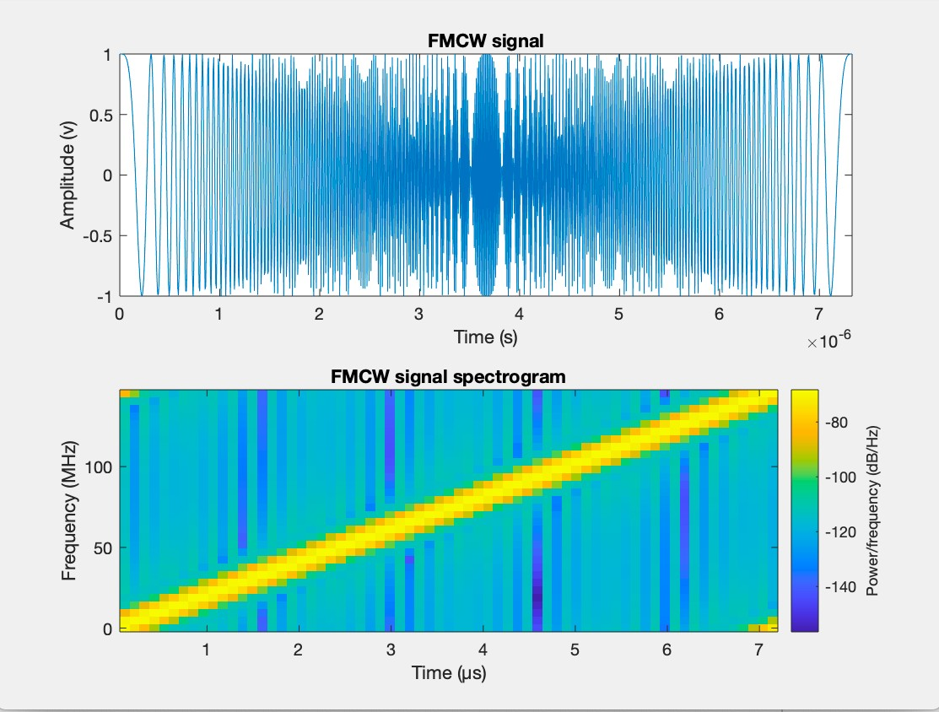
Figure 3.1 : FMCW Signal and Signal spectrogram
Pre Crash

Park Assist

Pre Crash

Park Assist
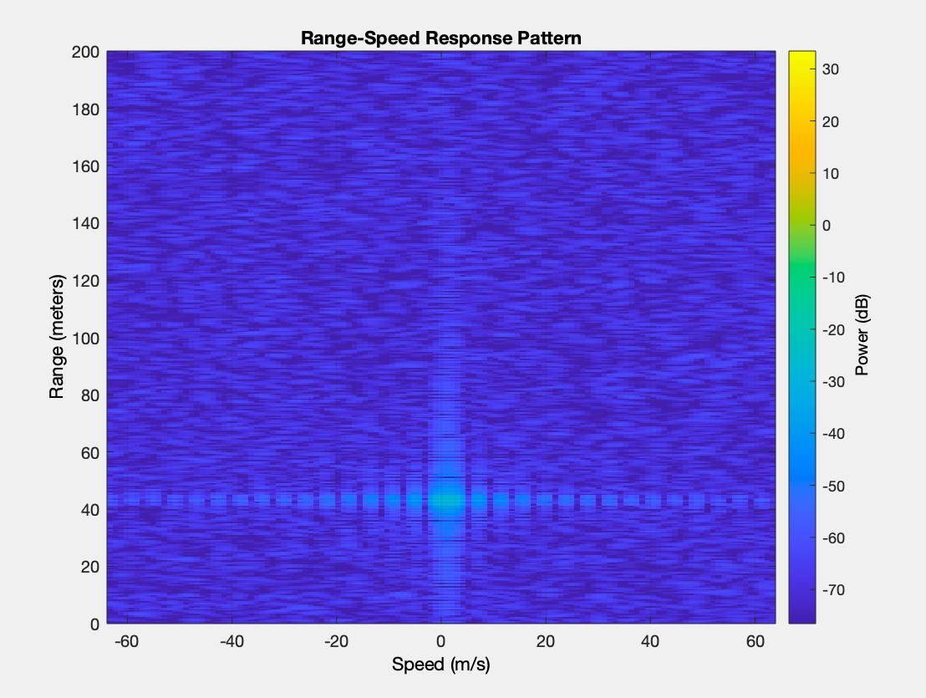
Figure 3.2 : Range-Speed Response Pattern
Blind Spot Detection
Park Assist

Blind Spot Detection
Park Assist

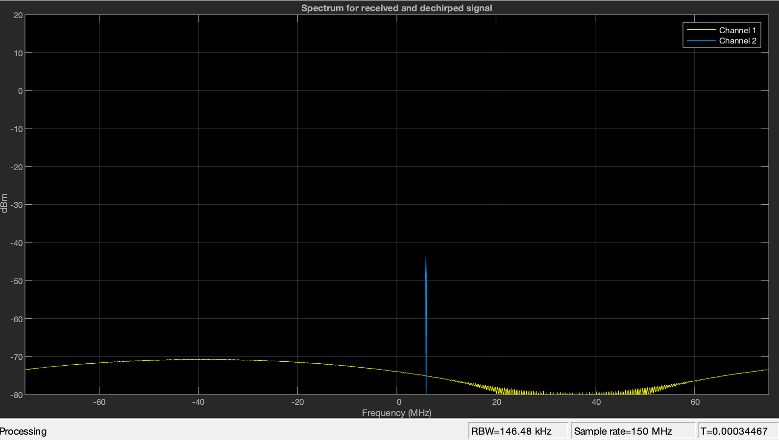

Figure 3.3 : Spectrum for received and dechirped signal

- MATLAB simulation of two objects

Code 1 :

Simulation of 2 objects ( dots ) following each other is as shown in the link below :

https://streamable.com/b6v7r7

this simulation basically is 2 objects one is circle the other is square, an initial location of both objects is randomly generated then they are trying to follow each other and the error gets smaller by the time.

Code 2 :

Simulation of 2 objects ( dots ) by entering the Speed ( Velocity ) of the two objects and the Distance Between them :

$$The Distance set to be 1000 meters$$
$$And the velocity set to 10 m/s$$

https://streamable.com/4ezrd2

- Beat Frequency using MATLAB

By using the FMCW Equation and entering the parameters as :

$$∆F=25 Khz$$
$$R=40 Km$$
$$T_{m}=100 msec$$
$$C= 3{×10}^{8} m/s$$
Apply the FMCW Equation
$$f_{b}=\frac{∆F 2R}{Tm C }=\frac{25{×10}^{3}×2×40{×10}^{3}}{0.1×3{×10}^{8}}=66.67 Hertz$$

By MATLAB (there is some error occurs due to noise )
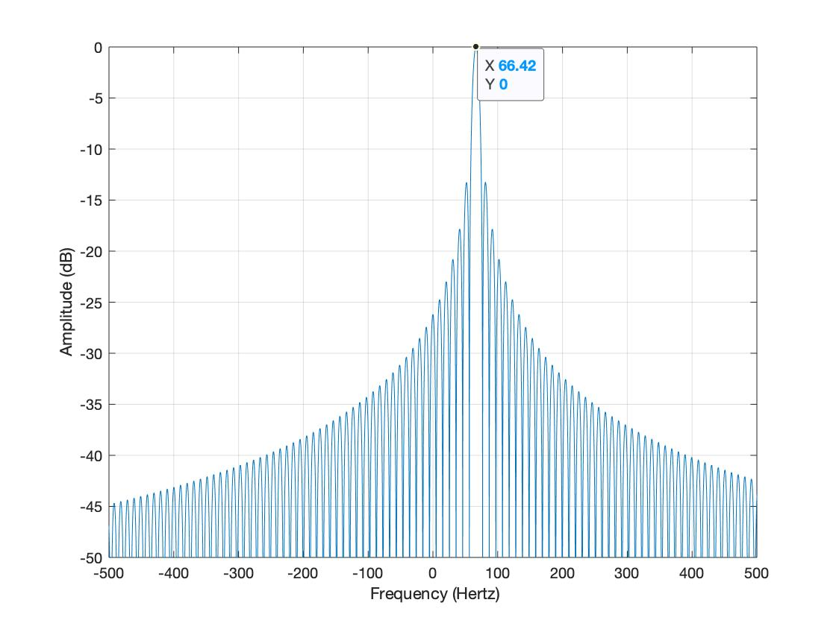
Figure 3.4: Beat Frequency Signal

Pulsed Radar Simulation

- The block diagram for the pulsed wave Radar:

The theory calculations:

First we assumed our input signal as $sinc signal$ and after that we assumed the time delay equal to $8.4632{×10}^{-5} Sec$
And the Distance is $1000m$

To calculate the delay, we use this equation:

$$∆t=\frac{2 x d}{c}= \frac{2 x 1x{10}^{3}}{3 x{10}^{8}}=6.667 μs$$

And to calculate the Distance we use this equation:

$$D= \frac{c × ∆t}{2}=\frac{3{×10}^{8}×6.667×{10}^{-6}}{2}=1000m$$

The variables that we get from our MATLAB code:

The Parameters | The values of the parameters
The time delay that we assumed | 8.4632${×10}^{-5}$S
Number of pulses | 1693
Sampling frequency | 401 MHz
Carrier frequency | 200 MHz
The time delay after we receive the signal | 6.666$×{10}^{-6}S$
The distance that we assume | 1000m
The distance after we receive the signal | 974.8m

We get a small error due to the noise from the white gaussian noise, after we calculate the distance from the time delay that we receive, and it’s approximately equal to 2.52%.

The Figures of the code :
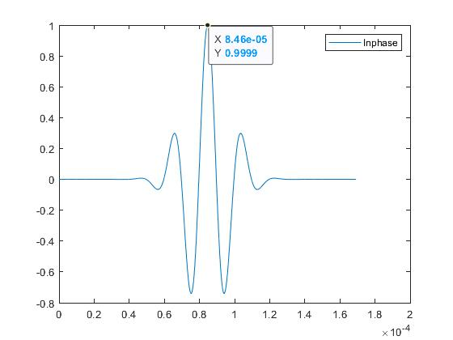
Figure 3.5 :The input Signal

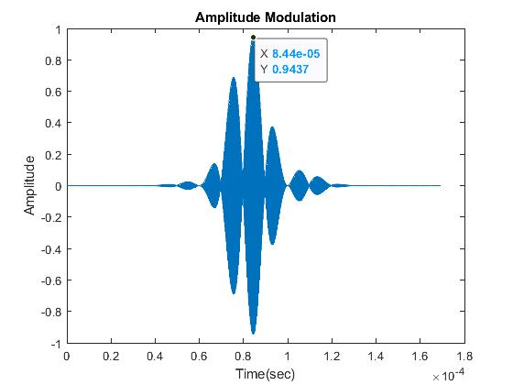
Figure 3.6 : The input signal After Mixing at Transmitter

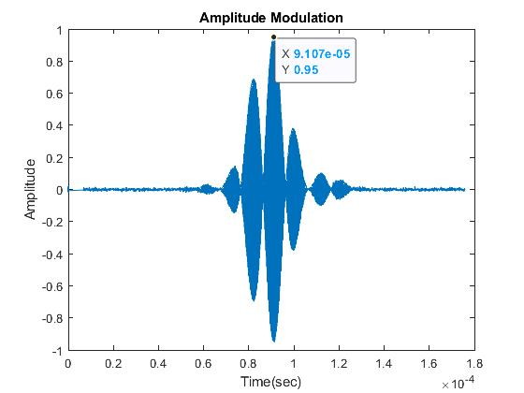
Figure 3.7 : The Signal After Correlation

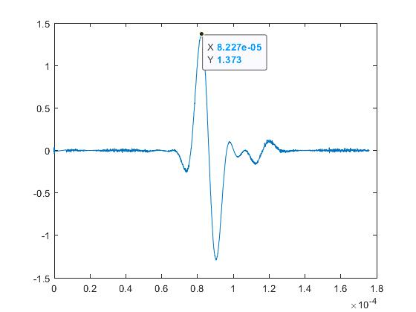
Figure 3.8 : The Signal after Mixing at the Receiver

- Speed and Doppler Shift

(theory part)

We assumed the target position in 2-Dimination is [1000,1000] m

And the velocity of the target is [10,10].m/s

So, the target position is $\sqrt{{1000}^{2}+{1000}^{2}}=1414.2m$

And the velocity is $\sqrt{{10}^{2}+{10}^{2}}=14.18m/s$

and the operation frequency is 1GHz

so, lambda is equal to $\frac{ C}{frequency}=\frac{3×{10}^{8}}{1×{10}^{9}}=0.3$

so, the Doppler shift=$≈\frac{2 Vr}{λ}$ = $\frac{2×14.18}{0.3}$ = 94.53 KHz

The assumed values for the Radar:

The values that we assumed for the rectangular waveform:

The assumed values | The parameters
5$×{10}^{6}$Hz | Sample rate
6$×{10}^{-7} Sec$ | Pulse width
1$×{10}^{4}Hz$ | PRF

The values that we assumed for the transmitter :

The assumed values | The parameters
5$×{10}^{3}$W | Peak power
20 | Gain
0m | Transmitter position
0m/s | Transmitter velocity

The values that we assumed for the receiver:

The assumed values | The parameters
0dB | Gain
0dB | Loss factor
5$×{10}^{6}$Hz | Sample rate
5dB | Noise figure

The parameters that we get from our code of the pulsed radar:

The assumed values | The parameters
5$×{10}^{6}Hz$ | Sampling frequency
10 | Number of pulses
0.2998 | Lambda
25$×{10}^{6}$Hz | Noise Bandwidth
3.1653$×{10}^{-14}w$ | Noise power
1$×{10}^{-9}$ | Probability of false alarm
1439m | Range of the target
11.7m/s | Target Speed

So, if the speed is positive that mean the target is approaching towards the Radar.

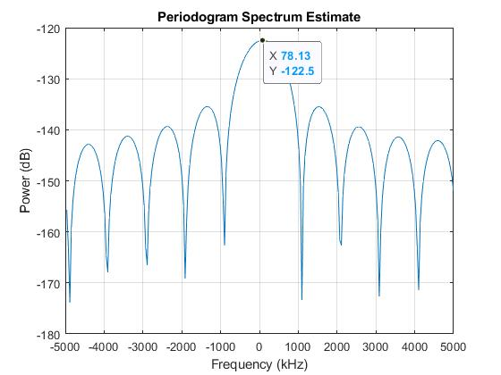
Figure 3.9 : The estimation of Speed using Doppler Frequency

So, the doppler shift as we can see from the peak of the rectangle pulse is 78.13kHz (from the figure shown above).

There is some error between the theory part and the application part and that error occurs due to the noise figure and the matched filter.

4 CONCLUSIONS

At the end of our work now we know what are the basic factors of the radar and we know how to calculate the speed and distance given a certain speed and distance in the transmitter and calculate it in the receiver so we can compare the two values and know how much is the error and how to improve our Radar. There is a lot of radar types but in our project, we use the FMCW and the pulsed radar types and we know every detail in these types. So, from our point view the pulsed radar is much simpler than the FMCW radar. Radar is something that we used all around us even though it is normally invisible. When people use radar, they are usually trying to accomplish one of three main factors, detecting the presence of an object at a distance, detect the speed of an object, or to map something. Finally, FMCW and pulsed are a special types of radar sensors so they are some kinds of an application of Radar.
REFERENCES

- Mark A Richards, James A Scheer, William A Holm , Principles of modern radar Vol. 1 Basic priciples (2010).

- Mathworks. (2019). Matlab R2020a Automotive Adaptive Cruise Control Using FMCW Technology. Available: https://www.mathworks.com/help/phased/examples/automotive-adaptive-cruise-control-using-fmcw-technology.html

- Types of Car Antenna", It Still Runs, 2020. [Online]. Available: https://itstillruns.com/types-car-antenna-7377808.html

- 3G/4G/4GX, "Telstra Cel-Fi Go Repeater Mobile Kit 3G/4G/4GX", Comnet.com.au, 2020. [Online]. Available: https://www.comnet.com.au/Repeaters-Boosters/CFGM-101

- Motors, P. Accessories, C. Parts and D. Black, "2019 Hot Shark Fin Antenna Stereo Cover Car Signal Radio AM/ FM Aerial Black | eBay", eBay, 2020. [Online]. Available: https://www.ebay.com/itm/2019-Hot-Shark-Fin-Antenna-Stereo-Cover-Car-Signal-Radio-AM-FM-Aerial-Black-/113904097215.

- Why Cars Don't Have Those Long Antennas Anymore", Jalopnik, 2020. [Online]. Available: https://jalopnik.com/why-cars-dont-have-those-long-antennas-anymore-1837879149.

- Automotive radars: A review of signal processing techniques - IEEE Journals & Magazine", Ieeexplore.ieee.org, 2020. [Online]. Available: https://ieeexplore.ieee.org/abstract/document/7870764.

- Advantages of 77 GHz Automotive Radars over 24 GHz Systems - everything RF", Everythingrf.com, 2020. [Online]. Available: https://www.everythingrf.com/community/what-are-the-advantages-of-77-ghz-automotive-radars-over-24-ghz-systems.

- Radar Basics", Radartutorial.eu, 2020. [Online]. Available: https://www.radartutorial.eu/02.basics/Frequency%20Modulated%20Continuous%20Wave%20Radar.en.html.

