College of Engineering
Electrical Engineering Department

EE497
Design of optical fiber communication link

Students Team
Meshaal Abdullah Alhassoun Student ID: 436100488
Mohammed Abdulaziz Almalki Student ID: 436100639

Supervisors
Name Signature
Prof. Ehab Awad
Prof.Mohammed Rami

Submitted in Partial Fulfillment of the Requirement
for the B.Sc. Degree,

Rabi II 1442
December 2020

Project Abstract

This project aims is how to build an optical fiber that transmit the signal from transmitter to receiver and what its components. The objective of this project:
-Understand basic concepts of communication system.
-Understand how the signal go throw the optical fiber.
-Be familiar with parts of the optical fiber.
-Understand the difference between LED and laser.
-Discuss light propagation in an optical fiber.

acknowledgment

We would like to express our sincere gratitude to our advisor Prof. Ehab Awad for the continuous support of our project study and research, for his patience, motivation, enthusiasm, and immense knowledge. His guidance helped us in all the time of research and writing of this project. We could not have imagined having a better advisor and mentor for our senior project.

Table of Contents

Project Abstract ii
acknowledgment iii
Table of Contents iv
List of Figures vii
List of Tables viii
1 introduction 9
1.1 What is communication^{]2[} 9
1.2 Components^{]2[} 9
1.3 Channels^{]14[} 10
1.3.1 Line (Conducted media) 10
1.3.2 Free space (Radiated media) 10
1.3.3 Fiber-Optic 10
1.3.4 Satellite 10
2 Optical Fiber 11
2.1 What it is^{]1 [}? 11
2.2 Component^{]1 [} 11
2.2.1 Advantages^{]15 [}: 12
2.2.2 disadvantages^{]15 [}: 12
2.3 types^{]1 [}: 13
2.3.1 multi-mode optical fibers: 13
2.3.2 single-mode optical fibers: 13
2.4 Applications^{]1 [} 15
2.5 Parts of optical fiber in communication system^{]1 [}: 16
2.5.1 Transmitter side 16
2.5.2 Receiver side 16
2.6 Total Internal Reflection (TIR) ^{]11[} ^{]7[}: 17
2.6.1 Critical Angle: 19
2.7 Numerical aperture (NA) ^{]6 [}: 20
3 Led and Laser 22
3.1 light-emitting diode (LED) ^{]4[}: 22
3.1.1 What is it? 22
3.1.2 Advantages^{]4[}: 23
3.1.3 Disadvantages^{]4[}: 23
3.1.4 wavelength and color^{]4[} 23
3.2 The laser^{]5[} 24
3.2.1 What it is? 24
3.2.2 Advantages^{]13[}: 24
3.2.3 Working of laser^{]11[} 25
3.2.4 Laser components^{]5[} 25
4 Photo-detector and Photo-transistor 27
4.1 Photo Detector 27
4.1.1 What is it? 27
4.1.2 Properties^{]9[} 27
4.1.3 Applications^{]9[} 28
4.2 Photo Transistor 28
4.2.1 What is it^{]8[} 28
4.2.2 How to work? 29
4.2.3 Advantages^{]8[} 29
4.2.4 The difference between Photo detector and Photo transistor^{]10[} 29
5 Transmitter circuit 30
5.1 About it 30
5.2 Circuit Operations 30
5.2 Microphone 31
5.3 Amplifier 31
6 Receiver circuit 32
6.1 About it 32
6.2 Circuit Operation 32
6.3 Amplifier/Driver 32
6.4 Final assembly 33
7 OP Amp and Frequency Response 34
7.1 Operational amplifier 34
7.1.1 What it can do? 34
7.1.2 Gain of the Op Amp 35
7.1.3 Common Op Amp circuits and its gain 35
7.2 Frequency response 40
8 Simulation 41
8.1 The Transmitter circuit 41
8.1.1 DC Simulation 41
8.1.2 Time domain Simulation 42
8.1.3 Frequency Response Simulation 42
8.2 The Receiver circuit 43
8.2.1 DC Simulation 43
8.2.2 Time Domain Simulation 44
8.2.3 Frequency Response Simulation 44
9 The communication kit 45
10 Experiments and Activities 47
11 Conclusion 48
12 References 49

List of Figures

Figure ‎1.2: Components of Communication systeme. 7
Figure ‎2.1: Optical fiber. 9
Figure ‎2.2: Optical fiber components. 9
Figure ‎2.3: An Optical fiber junction box 13
Figure ‎2.5: Optical fiber in communication system. 15
Figure ‎2.6: Light wave travelling in a denser medium strikes a less dense medium 16
Figure 2.6.1: Propagation of light in Optical fiber. 17
Figure ‎2.7: Numerical Aperture. 19
Figure 3.1: The work of LEDs. 22
Figure ‎3.1.2: LEDs based on wavelength. 23
Figure 3.2: The works of laser. 24
Figure 3.3: Laser components. 25
Figure 4.1: Photo detector. 26
Figure 4.2: Photo Transistor 27
Figure 4.3: Circuit of Photo transistor 28
Figure 5.1: Oscilloscope display of LM386N in the transmitter circuit 29
Figure 5.2: Transmitter circuit schematic 30
Figure 6.2: Receiver circuit schematic……………..………………………………………………...……………………….31
Figure 6.3: Block diagram of duplex voice link 32
Figure 7.1: Basic Op Amp and its elements 33
Figure 7.2: Non-inverting amplifier circuit 34
Figure 7.3: Inverting amplifier circuit 35
Figure 7.4: Voltage follower circuit 36
Figure 7.5: Differential amplifier circuit 36
Figure 7.6: Integrator amplifier circuit 37
Figure 7.7: Differentiator Op Amp circuit 38
Figure 7.8: Frequency Bandwidth 39
Figure 7.9: Frequency range of human hearing 40
Figure 8.1: The transmitter circuit 41
Figure 8.2: DC Simulation 41
Figure 8.3: Time-Domain Simulation 42
Figure 8.4: Frequency Response Simulation 42
Figure 8.5: The Receiver circuit 43
Figure 8.6: DC Simulation 43
Figure 8.7: Time-Domain Simulation 44
Figure 8.8: Frequency Response Simulation 44
Figure 9.1: Parts of the kit 45
Figure 9.2: Close look to the board 45
Figure 9.3: Complete look to the board with the Optical Fiber 46

List of Tables

Table 2.3: Comparison of fiber grades 11

introduction

What is communication^{]2[}

It’s the method of transfer of information from one place to another by using components to accomplish this goal

Components^{]2[}
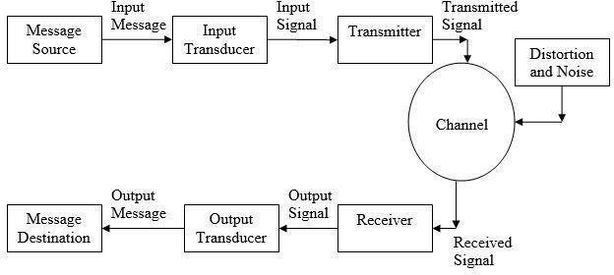

Figure 1.2: Components of Communication system.
- Message Source: The place where the message came from
- Input Message: The message we want to send
- Input Transducer: Converts the input message into its electrical form
- Input Signal: The data in electrical form
- Transmitter: Modifies the signal for transmission
- Channel: The medium over which the transmitted signal is sent (e.g., wire, air, optical fiber, free space)
- Distortion/Noise: External signals that affect the signal
- Receiver: Modifies the received signal, undoing the modifications done by the transmitter
- Output Transducer: Converts message from its electrical form back into its original form
- Output Message: The message that has been communicated
Message Destination: The place was the message intended for.

Channels^{]14[}

The two main channels are used:

Line (Conducted media)
It's the channel made using metallic cables such as:
- Coaxial cable
- Twisted pair
- Parallel wires

Free space (Radiated media)
It’s the channel where the transmission of signal is carried out by the propagation of electromagnetic wave.

Fiber-Optic
Fiber-optic communication is a method that we can transmitting information by sending pulses that carry information through an optical fiber, when we faced high bandwidth and long distance the best method can we used is optical fiber.
By optical fiber communication we can transmit voice, video through local area networks, computer networks, or across long distances.
It is also used by many telecommunications companies to transmit for
example:
      - telephone signals.
      - Internet communication.
      - cable television signals.

Satellite
A communications satellite is a satellite that relays and amplifies radio telecommunications signals through a transponder, it creates a communication channel between a transmitter and a receiver.
Communications satellites has many uses, for example:
    - Television
    - Telephone
    - Radio
    - Internet

Optical Fiber

2.1 What it is^{]1 [}?

An optical fiber is a flexible, thin fiber made of plastic or glass that carry light from one end to another, it is used mostly as a method to transmit light between the two ends of the fiber, one of the most advantages is transmitting the signal longer distances and at high than electrical cables.
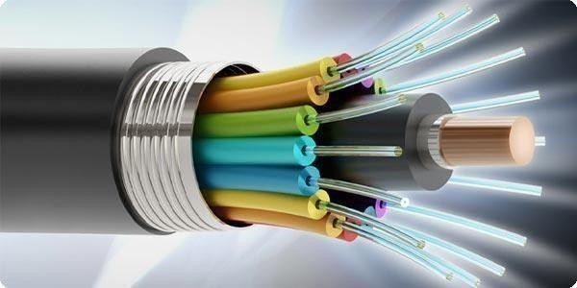
Fibers are used instead of metal wires because signals travel along them with less loss.

Figure 2.1: Optical Fiber.

2.2 Component^{]1 [}

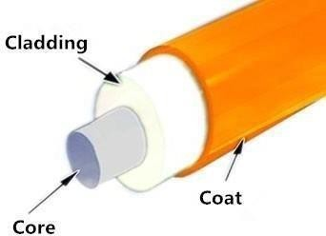

Figure 2.2: fiber structure

2.2: Optical Fiber components

- Core: The core is a cylindrical rod of dielectric material it’s made mostly of glass or can be sometimes of plastic, light propagates mainly along the core of the fiber.

- Cladding: The cladding surrounds the core and has lower refractive index to make the optical fiber work. Also it’s made from glass or plastic.

- Coat: The coating is a layer of material used to protect an optical fiber from physical damage. The material used for a coat is a type of plastic.

Advantages^{]15 [}:

- High/wide bandwidth and low transmission loss.
- Optical Fiber has a small size and low weight Immunity to interference.
- Electrical isolation.
- Immunity to interference.
- Signal security.

Disadvantages^{]15 [}:

- Distance: The distance between the transmitter and receiver should keep short or repeaters are needed to boost the signal.
- Inelastic: it’s not easy to bend fiber optic cable. And if you bend them too much, they will break
- Fragility: Optical fiber is rather fragile and more vulnerable to damage compared to copper wires. It’s better not to twist or bend fiber optic cables.

Types^{]1 [}:
Two main types of optical fiber used in optic communications are:

multi-mode optical fibers:

A multi-mode optical fiber has a larger core, more than or equal 50 micrometers, allowing less precise, cheaper transmitters and receivers to connect to it as well as cheaper connectors.

single-mode optical fibers:

The core of a single-mode fiber is smaller than 10 micrometers and requires more expensive components and interconnection methods, but allows much longer, higher-performance links.
Both single- and multi-mode fiber is offered in different grades:
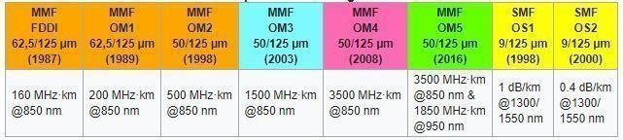
Table2.3: Comparison of fiber grades

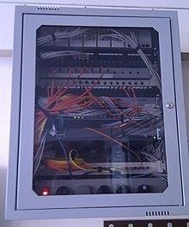

Figure 2.3: An Optical fiber junction box

In fig2.3 above, the yellow cables are single mode fibers and the orange and blue cables are multimode fiber.

Applications^{]1 [}

- Medical

Can be used as lasers for surgeries and light guides.

- Defense/Government

Used as hydrophones for seismic waves and SONAR, as wiring in aircraft, submarines and other vehicles.
- Data storage
Used for data transmission
- Telecommunications
Fiber is laid and used for transmitting and receiving messages
- Networking
Used to help increase the speed and accuracy of data transmission.
- Industrial
Used for imaging in hard to reach areas, as wiring where EMI is an issue, as sensory devices to make temperature, pressure and other measurements.

- Broadcast
Broadcast/cable companies are using fiber optic cables for HDTV, internet, video on-demand and other applications

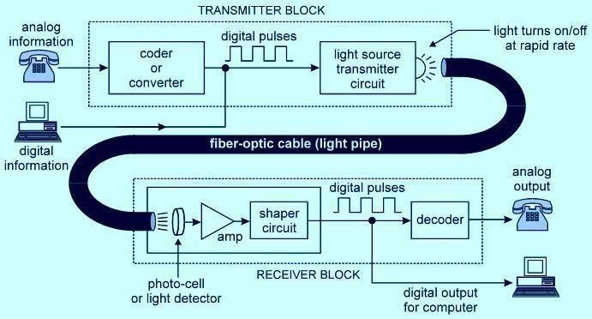
Parts of optical fiber in communication system^{]1 [}:
Figure 2.5: Optical fiber in communication system

Transmitter side
when the data is analog, we will send it to a coder or converter circuit as we see in fig2.5 which converts the analog signal into digital pulses and goes through a light source transmitter circuit to convert it to light waves. if it digital signal will sent directly into light source transmitter light and it will be propagated throw the fiber cable.

Receiver side
finally, on the receiver side the photocell, receives the light waves from the transmitter throw the optical fiber cable, amplifies it using the amplifier and converts it into the digital signal.

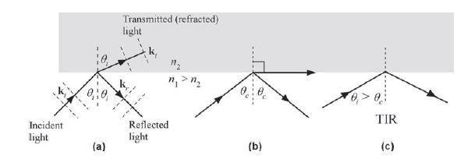
Total Internal Reflection (TIR) ^{]11[} ^{]7[}:

Figure 2.6: Light wave travelling in a denser medium strikes a less dense medium

When the incidence angle θi exceeds θc (Critical Angle) then there is no transmitted wave but only a reflected wave.
The effect of increasing the incidence angle is shown in Figure 2.6 Above.

Depending on the incidence angle with respect to θc, which is determined by the
Ratio of the refractive indices, the wave may be transmitted or reflected.
(a) θi < θc
(b) θi = θc
(c) θi > θc

TIR occurs when waves in one medium reach the boundary with another medium at
a sufficiently slanting angle, provided that the external medium is transparent to the waves and allows them to travel faster than in the internal medium.
This effect is used in optical fibers to confine light in the core. Light travels through the fiber core, bouncing back and forth off the boundary between the core and cladding.
Because the light must strike the boundary with an angle greater than the critical angle, only light that enters the fiber within a certain range of angles can travel down the fiber without leaking out.

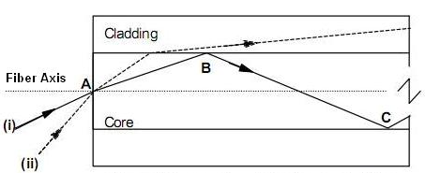

Figure2.6.1: Propagation of light in an optical fiber

In Figure 2.6.1 consider a light ray (i) entering the core at a point A, travelling through the core until it reaches the core cladding boundary at point B. As long as the light ray intersects the core-cladding boundary at a small angles, the ray will be reflected back into the core to travel on to point C where the process of reflection is repeated ie,
total internal reflection takes place.
If a ray enters an optic fiber at a steep angle(ii), when this ray intersects the core-cladding boundary, the angle of intersection is too large. So, reflection back into the core does not take place and the light ray is lost in the cladding.
This means that to be guided through an optic fiber, a light ray must enter the core with an angle less than a particular angle called the acceptance angle of the fiber. A ray which enters the fiber with an angle greater than the acceptance angle will be lost in the cladding.

Critical Angle:
The critical angle is the smallest angle of incidence that yields total reflection.
the critical angle is given by θc = Arcsin(n₂ / n₁), where n₂ ≤ n₁.

Numerical aperture (NA) ^{]6 [}:
is a dimensionless number that characterizes the range of angles over which the system can accept or emit light.

Consider an optical fiber having a core of refractive index n₁ and cladding of refractive index n₂. let the incident light makes an angle i with the core axis as shown in Figure 4.7.
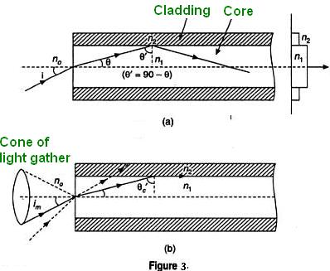

Figure2.7: Numerical Aperture

Then the light gets refracted at an angle θ and fall on the core-cladding interface at
an angle where,

By Snell’s law at the point of entrance of light into the optical fiber we get,

Where n₀ is refractive index of medium outside the fiber. For air n₀ =1.

When light travels from core to cladding it moves from denser to rarer medium and
so it may be totally reflected back to the core medium if θ' exceeds the critical
angle θ'_{c}. The critical angle is that angle of incidence in denser medium (n1) for
which angle of refraction become 90°. Using Snell’s laws at core cladding interface,

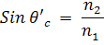

for light to be propagated within the core of optical fiber as guided wave, the angle of incidence at core-cladding interface should be greater than θ'_{c}. As i increases,
θ increases and so θ' decreases. Therefore, there is maximum value of angle of incidence beyond which, it does not propagate rather it is refracted in to cladding medium. This maximum value of i_{m} is called maximum angle of acceptance and
n₀ sin i_{m} is termed as the numerical aperture (NA).

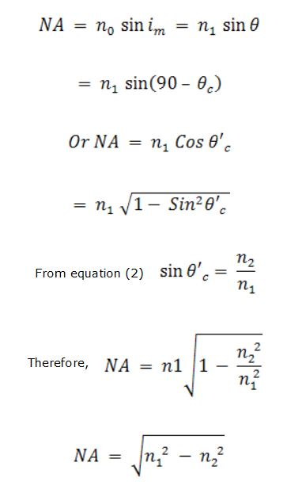

Led and Laser

light-emitting diode (LED) ^{]4[}:

What is it?

LEDs are a type of semiconductor called Light Emitting Diode. are semiconductor light sources that combine a P-type semiconductor with an N-type semiconductor. Applying an enough forward voltage will cause the electrons and holes to recombine at the P-N junction, releasing energy in the form of light.
Regular light sources usually first convert electrical energy into heat and then into light.
But LEDs convert electrical energy directly into light, delivering efficient light generation with little-wasted electricity.

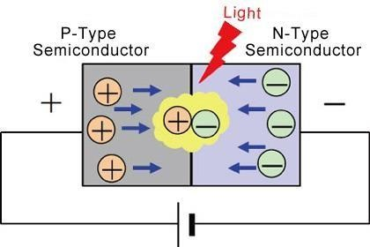

Figure 3.1: The work of LEDs

Advantages^{]4[}:
  - Efficiency: LEDs emit more lumens per watt than incandescent light bulbs. The efficiency of LED lighting fixtures is not affected by shape and size

  - On/Off time: LEDs light up very quickly. A typical LED will achieve full brightness in under 1µs. LEDs have faster response times in communications devices.

- Size: LEDs can be very small (smaller than 2 mm²) and are easily attached to printed circuit boards.

3.1.3 Disadvantages^{]4[}:
- Price: LED lighting is more expensive investment than a traditional light source.

- Temperature sensitivity: Quality of diodes’ lighting is highly dependent on the ambient operating temperature.

Wavelength and color^{]4[}
There are two specifications for wavelength are used to indicate color: λP (Peak Wavelength) and λD (Dominant Wavelength), with λD corresponding to the color actually seen by the human eye.
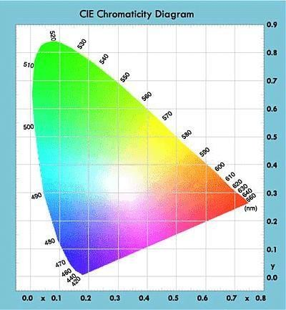

Figure 3.1.2: LEDs based on wavelength

The laser^{]5[}

3.2.1 What it is?
A laser is a device that emits light through a process of optical
amplification based on the stimulated emission of electromagnetic radiation. The term "laser" it’s a shortcut of "light amplification by stimulated emission of radiation, laser has single wavelength. Spatial coherence allows a laser to be focused to a tight spot, enabling applications such as laser
cutting and lithography. Spatial coherence also allows a laser beam to stay narrow over great distances.

Advantages^{]13[}:
  - has high information carrying capacity.
  - Laser based fiber optic cables are very light in weight and hence are used in fiber optic communication system.
  - High intensity

Working of laser^{]11[}
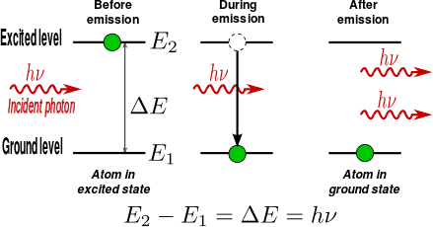
A laser is created when the electrons in atoms in special glasses, crystals, or gases absorb energy from an electrical current or another laser and become excited as shown in figure 3.2 Below. The excited electrons move from a lower energy side to a higher energy side around the atom’s nucleus. When they return to their normal or “ground” state, the electrons emit photons
Figure3.2: The works of laser

Laser components^{]5[}
As we see in figure 3.3 below, laser consists of a gain medium, the gain medium is a material with properties that allow it to amplify light by way of stimulated emission. Light of a specific wavelength that goes through the gain medium is amplified and it will be increases in power.
For the gain medium to amplify light, it needs to be supplied with energy in a process
called pumping. The energy is typically supplied as an electric current or as light at a different wavelength. Pump light could be provided by a flash lamp or by another laser.

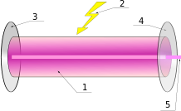
Figure3.3: Laser components.

- Gain medium
- Laser pumping energy
- High reflector
- Output coupler
- Laser beam

Photo-detector and Photo-transistor

Photo Detector

4.1.1 What is it?
^{]10[}Photo detectors as we see in figure4.1convert an incident radiation as light to an electrical signal such as a voltage or current because it's has a p-n junction. In many photodetectors like photoconductors and photodiodes this conversion is usually happened by the creation of free electron hole pairs by the absorption of photons or heating.

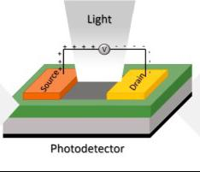

Figure4.1: Photo detector.

4.1.2 Properties^{]9[}

- It must be sensitive in some given spectral region. In some cases, the responsivity should be constant or defined within some wavelength range.
- The bandwidth of detection may start at zero hertz or finite frequency and ends at some frequency we limited.
- high quantum efficiency is important, or will be there additional quantum noise is introduced.
- Noise equivalent power is a measure of the sensitivity of a photodetector or detector system.
- Small size.

Applications^{]9[}
- Audio CD player.
- DVD players.
- Optical communication system.

Photo Transistor

4.2.1 What is it^{]8[}
It's a bipolar junction transistor (BJT) that operates as a photodetector with a photocurrent gain, it's able to sense the light and change the current according to the received light, also it's more sensitive than photodiode because it's BJT.

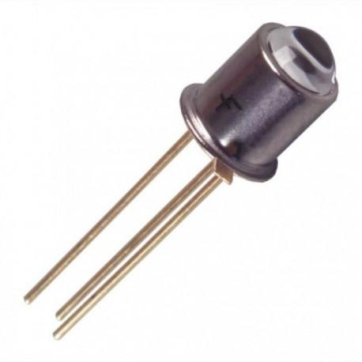

Figure4.2: Photo Transistor

4.2.2 How to work?
^{]11[}As we see in Figure 4.3 Below. In an ideal device, only the depletion regions, or the space charge layers, contain an electric field. The base terminal is normally open and there is a voltage applied between the collector and emitter. An incident photon is absorbed in the SCL between the base and collector to generate an electron–hole pair. The field in the SCL separates the electron hole pair and drifts them in opposite directions.
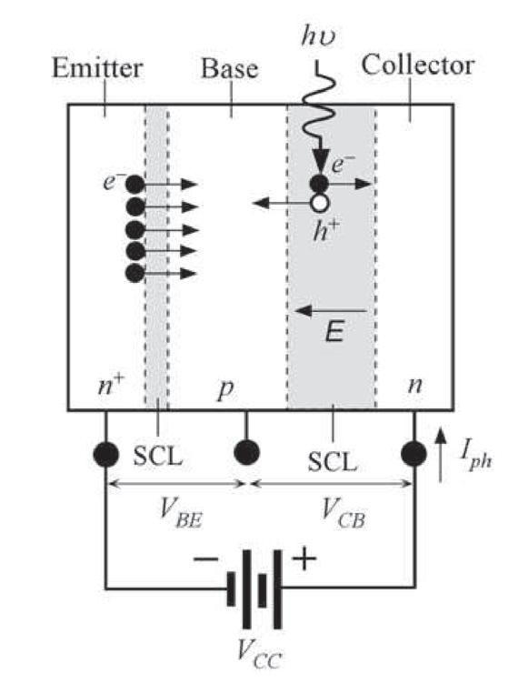

Figure4.3: Circuit of Photo transistor

4.2.3 Advantages^{]8[}
- Phototransistor Produce higher current than photodiode
- It's not expansive
- Its response is very fast

4.2.4 The difference between Photo detector and Photo transistor^{]10[}
The most important difference between the photodiode and the phototransistor is that the photodiode uses PN-junction diode which converts the light energy into an electric current, whereas the phototransistor uses the BJT for the conversion of light into current.

Transmitter circuit

About it
The simplest fiber optic transmitters are typically composed of a buffer, driver, and optical
source. The buffer electronics provide both an electrical connection and isolation between the driver electronics and the electrical system supplying the data. The driver electronics provide electrical power to the optical source in a way that duplicates the pattern of data being fed to the transmitter. Finally, the optical source (LED in this kit) converts the electrical power to light energy with the same pattern.

Circuit Operations
^{]12[}The transmitter in this kit also has an acoustic microphone for converting sound waves to an electrical signal, and it receives power from the voltage regulator in the receiver portion of the circuit board.
Figure 5.2 below shows the schematic of the circuit contained on the transmitter printed wiring board of this kit.

the momentary-close switch, SW1, activates the transmitter portion of the optical voice link by applying 8-volt power to the indicator light (LED), microphone, audio circuits and fiber optic LED. The switch must be held closed for the transmitter to operate by generating light to carry audio signals.

Tracing a signal through the transmitter circuit starts with the microphone. Here any acoustic vibrations near the microphone are sensed and produce an electrical AC signal proportional in strength and frequency to that of the acoustic signal. This AC signal is coupled through the blocking capacitor (C2) to the LM386N audio amplifier.
The LM386N amplifies the signal and drives the fiber optic LED(D2).
The output of the LED is red light with a DC component and AC signal superimposed upon it from LM386N. A typical output signal from LM386N is shown in Figure 7.1 below.
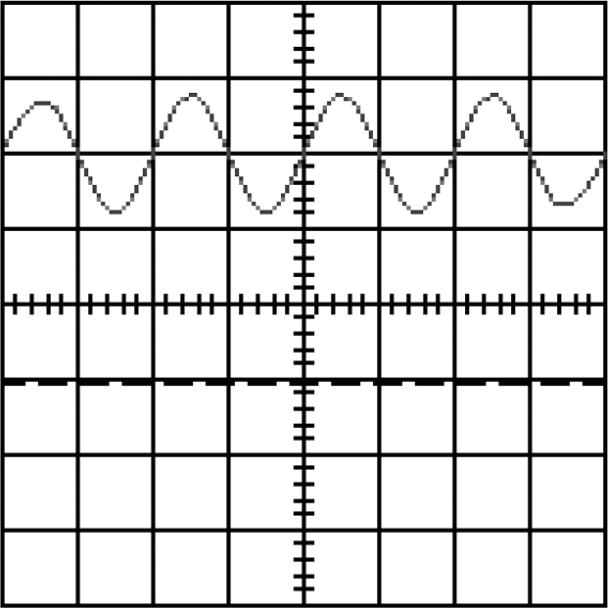

Figure5.1: Oscilloscope display of LM386N in the transmitter circuit.

5.2 Microphone
^{]12[}Your voice produces acoustic vibrations, which are picked up by a microphone (MIC1) containing a sensitive membrane and an FET (Field effect transistor). The microphone and R2 form a voltage divider. With no voice input.
The microphone acts as a passive resistor, resulting in a voltage across the microphone of about seven volts. When sound is sensed by the microphone, its resistance (and voltage across it) will vary according to the loudness and the frequency.

Amplifier
^{]12[}LM386N is a power audio amplifier designed for use in low-voltage consumer applications.
It has an input impedance (pin 2) of 50 k ohms. This input impedance combined with the .047 µf capacitor (C2) produces a 3 dB high-pass-frequency point of 70 Hz for the
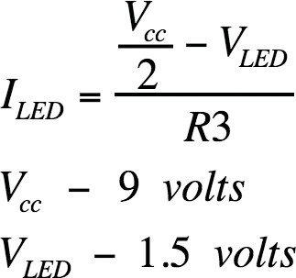
microphone signals. The gain of LM386N as shown in the circuit schematic is 20. Inputs to the amplifier are ground-referenced and the output is internally automatically biased at one- half the supply voltage. The output of LM386N, being at one-half supply voltage, causes a DC current to flow through the infrared LED equal to:

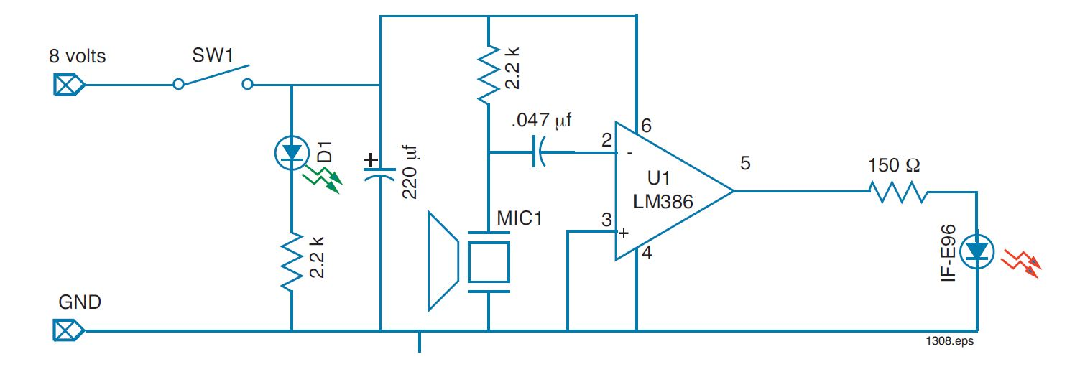
Figure 5.2: Transmitter circuit schematic.

Receiver circuit

About it

The receiver circuit is one of the most important component in the communication system spatially in the optical fiber, when light energy come from transmitter to the receiver it must be converted to the original form that mean the same information pattern that was fed to the transmitter by source, analog fiber optical received the massage by three elements are photodetector, amplifier and sometimes buffer.

Circuit Operation

^{]12[}A schematic diagram of this fiber optic receiver is shown in Figure 6.2 below. In the diagram
the receiver circuit consists of three elements are photodetector, amplifier, adjustable volume control and miscellaneous electronics. the signal as it exits from the optical fiber as light form, the signal go throws the NPN phototransistor (IF-D92) that converts the light photons to a current. The phototransistor current flows through the potentiometer (R2) which produces a voltage with the voltage amplitude depends on the amount of light exiting from the fiber. The voltage across the potentiometer is AC-coupled through C1 into an amplifier (U1) that increases the AC voltage portion of the input signal. The output of the amplifier is AC-coupled to an 8-ohm speaker which converts the electrical signal to acoustic waves that we can heard it by our ears. The printed wiring board also contains an 8-volt regulator that adapts the input voltage, and an indicator LED (D1) to warn us if there is a problem in an operation.

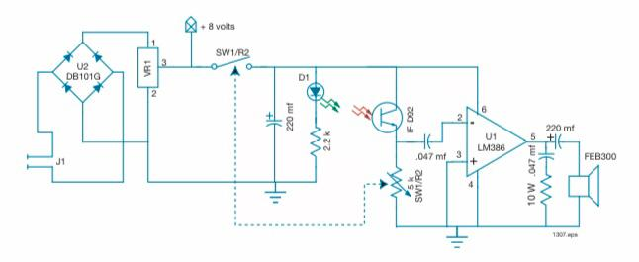
Figure 6.2: Receiver circuit schematic.

Amplifier/Driver

^{]12[} The ampliﬁer in this circuit is LM386N (U1). LM386N is a power audio ampliﬁer designed for use in low-voltage. It has an input impedance (pin 2) of 50 k ohms. This input impedance combined with the 0.047 µf capacitor (C1) produces a 3 dB high-pass-frequency point of 70 Hz. The gain of LM386N is 20. Components C4 and R3 provide capacitive load compensation to the inductive speaker load for LM386N.The 8-ohm speaker is capacitively coupled through C3, a 220 µf electrolytic capacitor.

we can calculate the 3dB frequency by this equation below:

$$f_{3dB}=\frac{1}{\begin{aligned}2πRC \\ \end{aligned}}$$

Final assembly
^{]12[}This kit when assembled will functionally look like the block diagram shown in Figure 6.3.
The transmitter on the left will be optically coupled to the receiver on the right. The transmitter on the right will be optically connected to the receiver on the left. Optically coupling the left and right sides will be a 3-meter length of jacketed duplex optical fiber with a 1000 µm core.

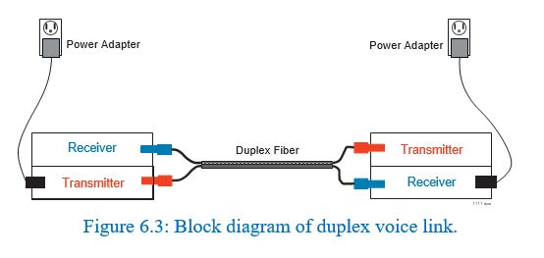

OP Amp and Frequency Response

Operational amplifier
An operational amplifier is an integrated circuit that can amplify weak electric signals. An operational amplifier has two input pins and one output pin. Its basic role is to amplify and output the voltage difference between the two input pins.[16]
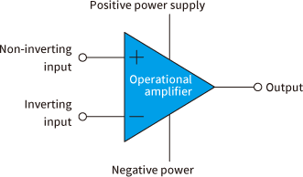
Figure 7.1: Basic Op Amp and its elements

What it can do?
An operational amplifier is not used alone but is designed to be connected to other circuits to perform a great variety of operations. This article provides some typical examples of usage of circuits with operational amplifiers:
  - Enables elimination of noise from an input signal.
  - Enables substantial amplification of an input signal.

Gain of the Op Amp
It is the factor by which the input signal is multiplied by to produce the amplified output voltage. The gain of an op amp signifies how much greater in magnitude the output voltage will be than the input, Which is given by the Formula:
G =
𝑣𝑜
𝑣𝑖

Common Op Amp circuits and its gain

  - Non-inverting amplifier circuit

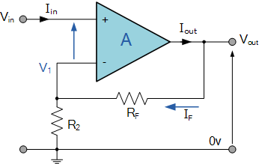
$$G=1+\frac{RF}{R2}$$
Figure 7.2: Non-inverting amplifier circuit

  - Inverting amplifier circuit
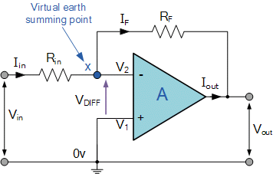
$$G=\frac{RF}{Rin}$$

Figure 7.3: Inverting amplifier circuit

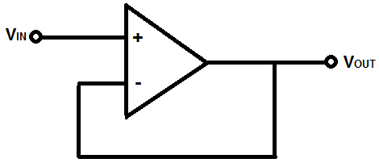
  - Voltage follower circuit
Figure 7.4: Voltage follower circuit

  - Differential amplifier circuit
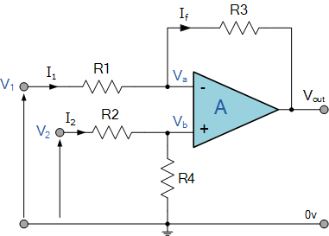
$$G =\frac{R3}{R1}\left( V2 – V1 \right)$$
Figure 7.5: Differential amplifier circuit

  - Integrator amplifier circuit

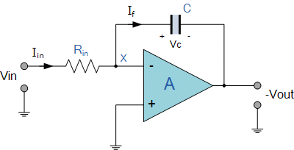

Figure 7.6: Integrator amplifier circuit
Rin = R1
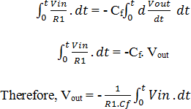

  - Differentiator Op Amp circuit

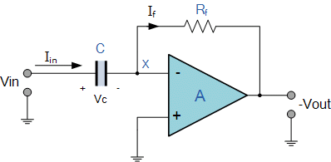
Figure 7.7: Differentiator Op Amp circuit

𝑉𝑜𝑢𝑡 = −𝐶. 𝑅𝑓 {𝑑(𝑉𝑖𝑛)/𝑑𝑡}

Frequency response

Amplifiers is used electronic circuits that have the properties of amplification.[17]
Amplifiers produce gain while filters alter the amplitude and/or phase characteristics of an electrical signal with respect to its frequency. As these amplifiers use resistors, inductors, or capacitor networks (RLC) within their design, there is an important relationship between the use of these reactive components and the circuits frequency response characteristics.
When dealing with AC circuits it is assumed that they operate at a fixed frequency, for example either 50 Hz or 60 Hz. But the response of a linear AC circuit can also be examined with an AC or sinusoidal input signal of a constant magnitude but with a varying frequency such as those found in amplifier.
Frequency Response of an electric or electronics circuit allows us to see exactly how the output gain and the phase changes at a particular single frequency, or over a whole range of different frequencies from 0Hz to thousands of mega-hertz,
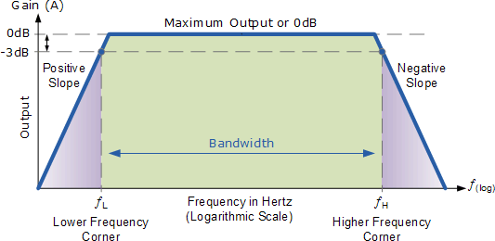
Generally, the frequency response analysis of a circuit or system is shown by plotting its gain, that is the size of its output signal to its input signal, Output/Input against a frequency scale over which the circuit or system is expected to operate. Then by knowing the circuits gain, at each frequency point helps us to understand how well the circuit can distinguish between signals of different frequencies.
Figure 7.8: Frequency Bandwidth

Then we can see that the frequency response of any given circuit is the variation in its behavior with changes in the input signal frequency as it shows the band of frequencies over which the output (and the gain) remains fairly constant.
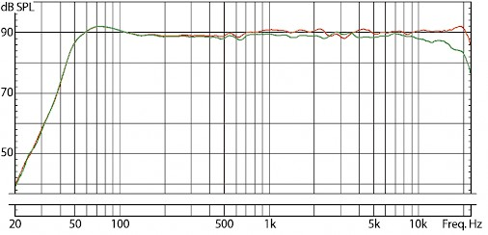
The range of frequencies either big or small between ƒL and ƒH is called the circuits bandwidth. So from this we are able to determine at a glance the voltage gain (in dB) for any sinusoidal input within a given frequency range.
Figure 7.9: Frequency range of human hearing

The frequency response is used to describe the audible frequency range that a loudspeaker can reproduce. Audio frequencies are measured in Hertz (Hz) and the theoretical range of human hearing is generally regarded as being from about 20 Hz (the very lowest bass tones) through 20 kHz.

Simulation

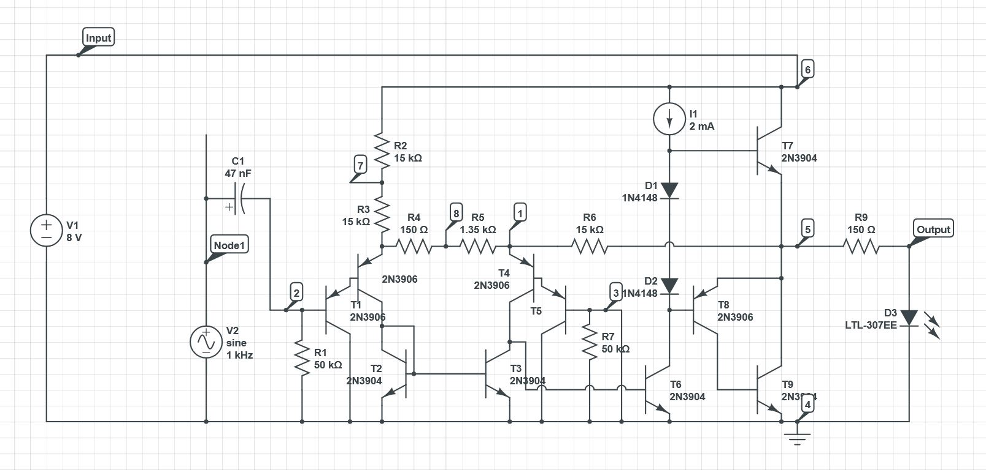
8.1 The Transmitter circuit
Figure 8.1: The transmitter Circuit

DC Simulation
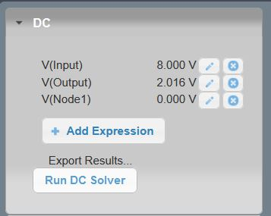

Figure 8.2: DC Simulation

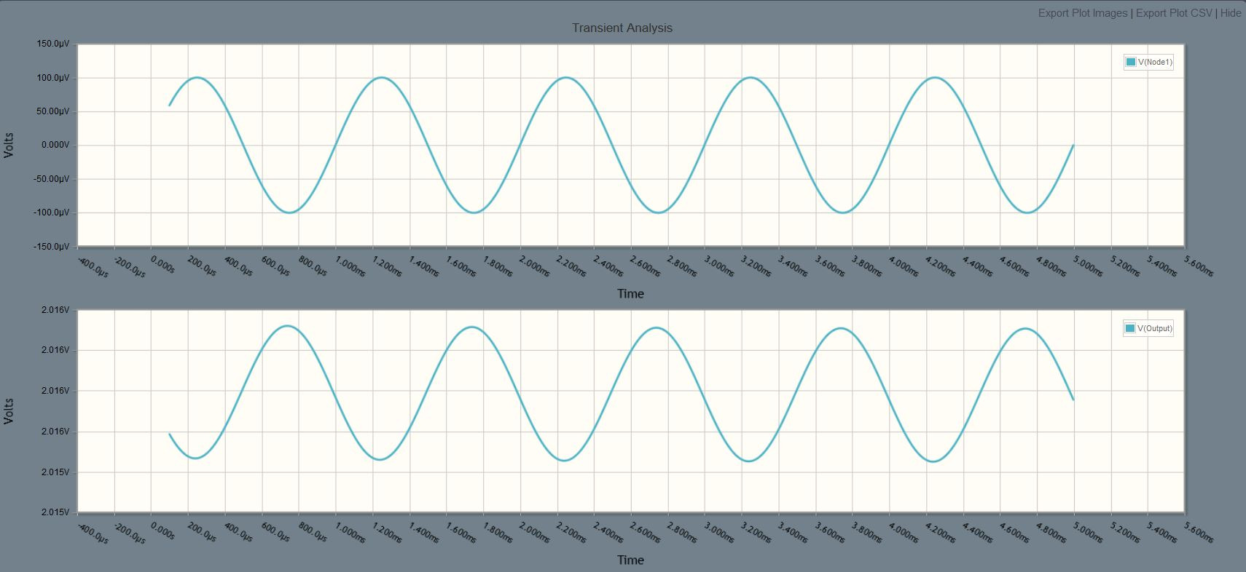
Time domain Simulation
Figure 8.3: Time domain Simulation

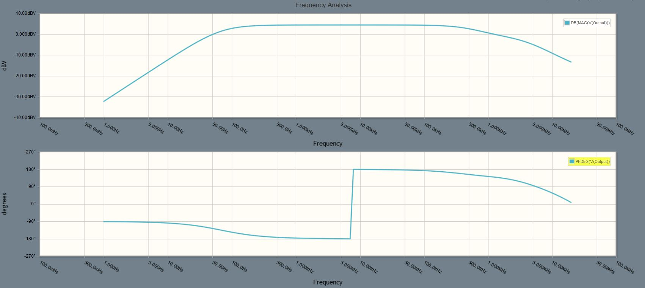
Frequency Response Simulation
Figure 8.4: Frequency Response Simulation

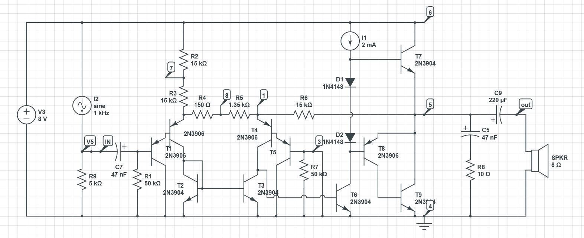
The Receiver circuit
Figure 8.5: The receiver circuit

DC Simulation
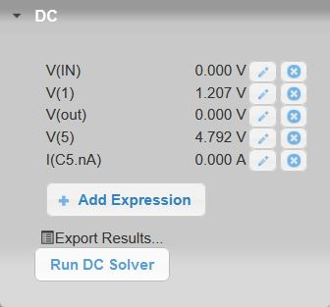
Figure 8.6: DC Simulation

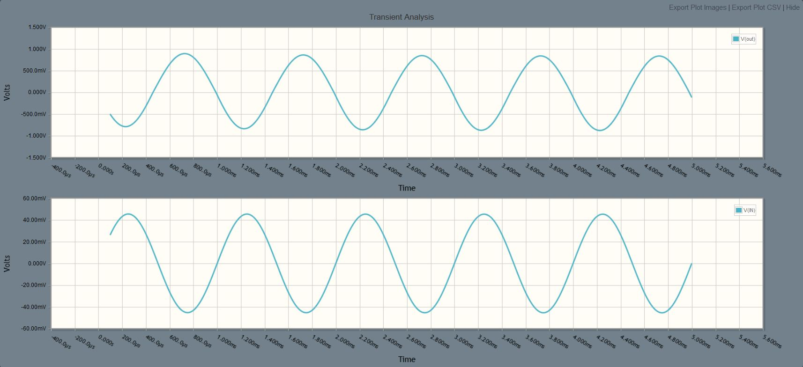
Time Domain Simulation

Figure 8.7: Time domain simulation

Frequency Response Simulation
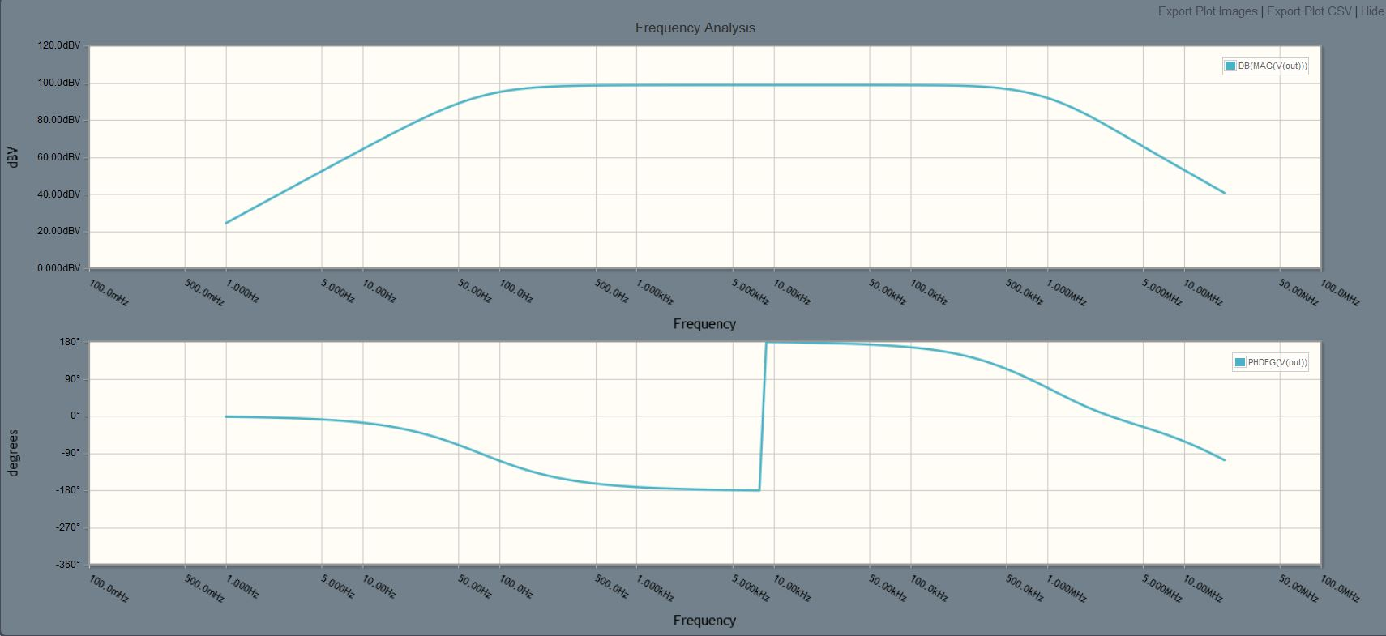
Figure 8.8: Frequency response simulation

the communication kit
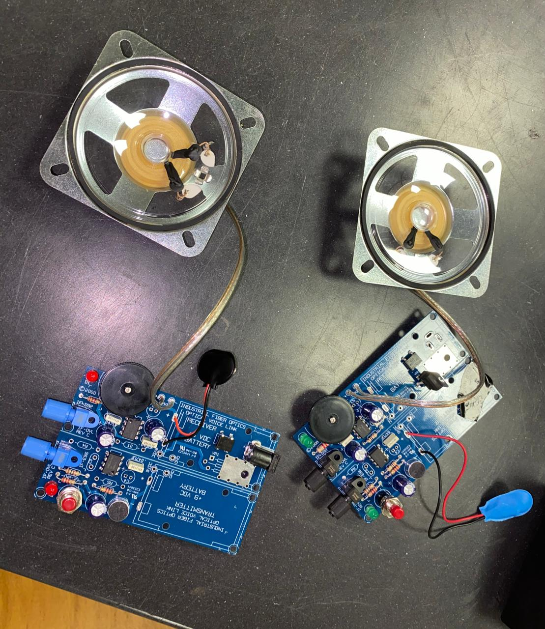
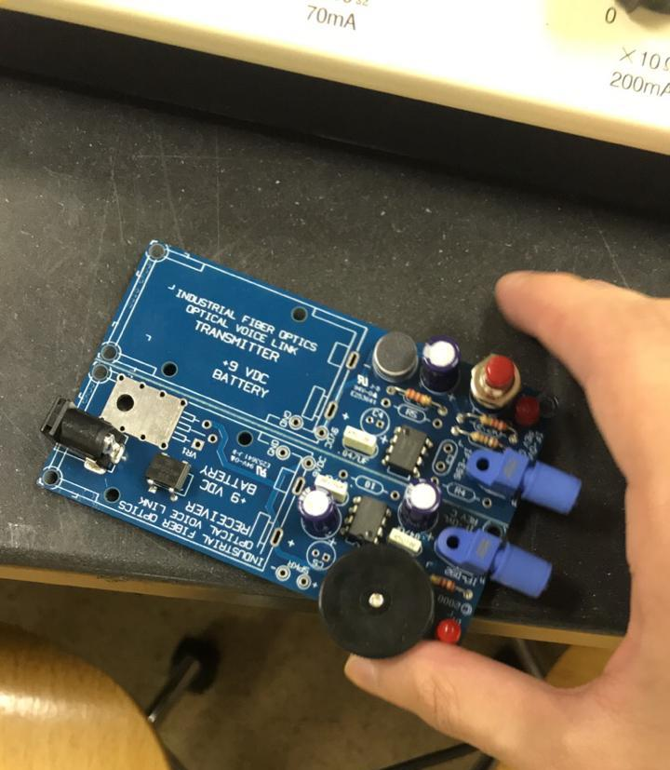
Figure 9.2: Close look to the board
Figure 9.1: Parts of the kit
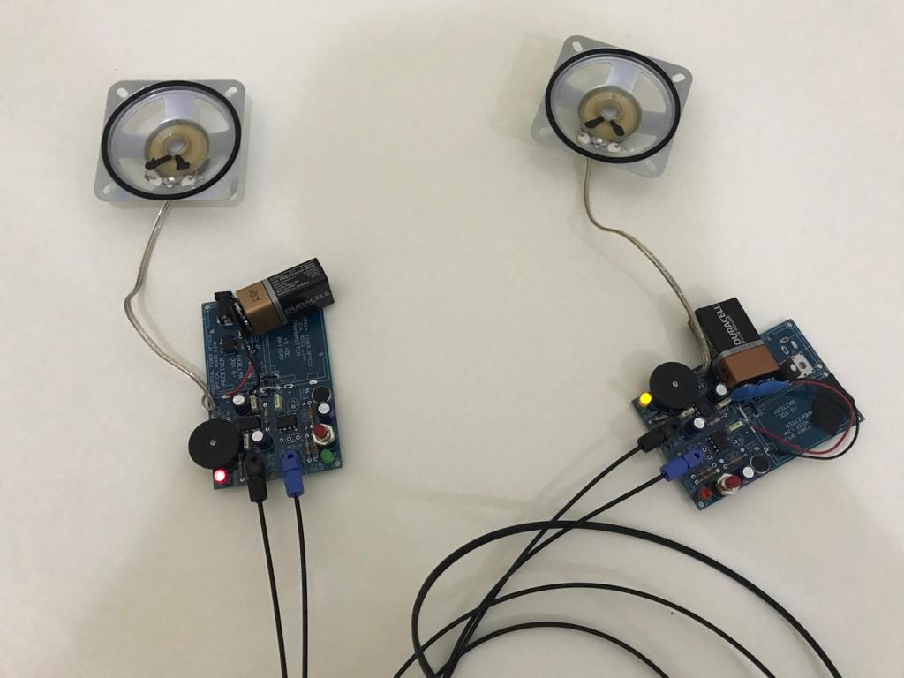
Figure 9.3: Complete look to the kit with the Optical Fiber

Experiments and Activities

Grasp the optical fibers near their tips between your thumb and forefinger. Point them toward a light source and observe the other end of the fiber. Note the changes in brightness on both fiber ends as you move the other end around, or cover its tip with a finger. Do any colors seem to transmit better than others?
Ans: No, they’re almost the same

Ensure that both receivers are off by turning the receiver switch counterclockwise until it rests in a détente position. Plug the 110-VAC-to-12-VDC power adapters into 110-VAC wall outlets. Plug the 2.1 mm power plug on the end of each power adapter cord into the 2.1 power jack located on each printed wiring board.
Ans: DONE

Turn the receiver switch clockwise ¼ of a turn on both boards. The green LEDs (D1) on both boards should light. If not, check to see if the power adapters are plugged in, that there is power to the wall outlet, and that assembly of the printed wiring board (including installation of R1 and orientation of D1) has been done properly.
Ans: all of the LEDs on(light)

Push the momentary switch on both boards to energize the transmitter circuitry. The red LED (D1) on each board should light. If not, check the assembly of the printed wiring board including installation of R1 and orientation of D1.
Ans: all of the LEDs on(light)

Determine if both of the transmitter fiber optic LEDs (IF-E96) are on by measuring the voltage across them with a multimeter or oscilloscope when the momentary switch is closed. The proper operating voltage for this LED is approximately 1.7 volts. If the LED does not have any voltage across it, double-check the installation of U1 and R2.
Ans: the voltage across the two (IF-E96) is 1.924v.

Press the momentary switch on one of the transmitter circuits and speak into the microphone. You and your partner should hear your voice from the receiver’s speaker at the other end. Adjust the receiver’s volume as required.
Ans: DONE.

Locate yourself at one of the assembled printed wiring boards and a partner at the other. Have your partner press the momentary switch on his/her transmitter and speak into the microphone. Describe below their voice sounds when reproduced by the fiber optic receiver, compared to traveling through air.
Ans: Its louder with using the kit than through air and I can control the volume of the voice in the kit.

Conclusion

Optical fiber used in many areas of telecommunication, medical and engineering. It has attracted many researchers due to its performance, low loss, no interference, higher bandwidth and high data-carrying capacity. Also, optical fibers have many advantages, there still exist some disadvantages associated with the optical fiber technology. In this project optical fiber communication link is implemented and simulated.

References

[1] https://en.wikipedia.org/wiki/Optical_fiber
[2] https://www.elen.ca/education/communications/introduction-communication-systems/
[3] https://circuitdigest.com/article/how-optical-fiber- communication- works-and-why-it-is-used-in-high-speed-communication
[4] https://www.rohm.com/electronicsbasics/leds/what-are-leds
[5] https://en.wikipedia.org/wiki/Laser
[6] https://vlab.amrita.edu/?sub=1&brch=189&sim=343&cnt=1
[7] https://en.wikipedia.org/wiki/Total_internal_reflection
[8] https://www.elprocus.com/phototransistor-basics-circuit-diagram-advantages-applications/
[9] https://en.m.wikipedia.org/wiki/Photodetector
[10] https://www.sciencedirect.com/topics/engineering/photodetector
[11] Optoelectronics and photonics, principles and practices, second edition, S.O. Kasap
[12] The duplex optical fiber voice link
]13[ https://www.rfwireless-world.com/Terminology/Advantages-and-Disadvantages-of-Laser.html
]14[ https://en.m.wikipedia.org/wiki/Communications_system
]15[ https://community.fs.com/blog/the-advantages-and-disadvantages-of-optical-fibers.html
[16] https://www.electronics-tutorials.ws/opamp/opamp_8.html
[17] https://www.electronics-tutorials.ws/amplifier/frequency-response.html

