College of Engineering Electrical Engineering Department

EE497
Design of energy management system for King Saud University

Students Team
Khalid Abdulaziz Al-Shuaibi Student ID: 436101538 Faisal Atallah Al-Enzi Student ID: 436104051

Supervisors

Name Signature

Abdullah M. Al-Shaalan ………………

Submitted in Partial Fulfillment of the Requirement for the B.Sc. Degree,
Jumada′I 1442
December 2020

PROJECT ABSTRACT
This paper aims to minimize the consumption bill while maintaining the efficiency and reliability in order to help the University to achieve its goals that were set last year as a part of their objectives in the future , the project is set to tackle the problems of consumption by diversifying the approach to maintain reliability and to discuss the efficiencies generated by simulations, comparisons, and equations. The first approach is Solar power which will be done by utilizing the area of the rooftop of the University grand mosque and assuming the load consumed by the mosque which will provide valuable information for the simulation done in PVsyst, The second approach is to discuss the chillers located in the Agency of projects and how to improve the load consumption., the third approach is changing all the fluorescent lamps to LED and see the effects of how a simple solution could achieve a very desirable result.

ACKNOWLEDGEMENT

Throughout the project we have received tremendous amount of support by providing us valuable knowledge, resources and contacts from our supervisor Dr. Abdullah Al-Shalaan, we sincerely express our gratitude for his guidance which helped us greatly during this journey.

We also would like to thank Dr. Hasan Farrah for his advices on writing the report.

We would like to express our gratitude to Eng. Ibrahim Al-Nami and Eng. Rashid Al-Wadi for their hospitality and permission to visit the chillers in the agency of projects and provided us with a tour to discuss and explore the site.

TABLE OF CONTENTS

Project Abstract ii Acknowledgement iii Table of Contents iv List of Figures vi List of Tables vii
- Introduction 1
  - Problem Formulation 1
    - Problem Statement: 1
    - Problem Formulation: 1
  - Project Specifications 1

Background 2
  - Literature Review: 2
  - Concept Synthesis 2
    - Concept Generation: 2
    - Concept Reduction: 3

METHDOLOGY 4
  - Building Solar System in The University's Grand Mosque 4
    - University Grand Mosque Monthly Electricity Production 4
    - Site inspection 4
    - Solar Radiation and Solar irradiance 4
    - Selecting the PV module 6
    - Inverter selection 7
    - Combiner box selection 8
    - Installation of Solar Panel 8
    - Project sizing 9
    - Number of module selection 9
    - PV array project in 9
    - Number of inverter calculation 10
    - Total of box selection 10
    - Electricity SOLAR system supply project 11
    - Project simulation 12
    - Simulation Results 13
    - Normalized productions 14
    - Performance ratio 14
    - balances and main results 14
    - Arrow loss diagram 15
    - Results from theoretical calculation 16
    - Comprehension of results 16
    - Price Calculation 16
    - Per part electricity Price 18
  - Studying the Effect of Chillers on Energy Consumption 18
    - Chillers and Its Effect in Energy Conservations 18

    - Types of Chillers: 20
    - Actions to Increase Efficiency of Chiller Systems: 21
    - Chillers & Energy Conservation 22
    - Chillers in King Saud university 22
  - Lighting in King Saud University 30
    - Compact fluorescent lamp 30
    - Light emitting diode 30
    - Comparisons between LED and CFL 30

Conclusions and Future Work 33
- References 34

LIST OF FIGURES
Figure 2.2-1 stand-alone SOLAR PV project with battery 3
Figure 2.2-2 : is grid coupled SOLAR 3
Figure 3.1-1 :. Front look of University Grand Mosque 4
Figure 3.1-2: Samsung LPC250S SOLAR 7
Figure 3.1-3: ZONZEN ZZ-ZB 100kW grid tie inverter 8
Figure 3.1-4: The SMA SCCB-10 combiner box 8
Figure 3.1-5: SOLAR PV project 11
Figure 3.1-6: Project schema 12
Figure 3.1-7: . Monthly nominal power graph for 100 kW project 13
Figure 3.1-8: Arrow loss diagram 15
Figure 3.2-1: Chiller working principle 20
Figure 3.2-2: A Chiller 23
Figure 3.2-3: Monitoring system 24
Figure 3.2-4: Overall design of the heaters and boilers 25
Figure 3.2-5: Boilers 26
Figure 3.2-6: Close up picture of the boiler 27
Figure 3.2-7: Compressor alarm and fault points 28
Figure 3.2-8: water storage 29
Figure 3.2-9 Total Daily load Variation curve 29

LIST OF TABLES

Table 1: Monthly global SOLAR intercalation in Riyadh city 5
Table 2: Daily normal sunny sunshine hours in Riyadh city 6
Table 3: Possible number of modules consuming roof top and faced area 9
Table 4 balances and main results abbreviations 14
Table 5: The Total Cost of the Project 17
Table 6: Per Part Electricity Price 18
Table 7: Comparisons between CFL and LED 30
Table 8: Lifetime comparison 31
Table 9: Cost differences 31

- INTRODUCTION

  - Problem Formulation

    - Problem Statement:
Energy Management means ways, methods, and strategies for better energy utilization, optimization, and conservation. Energy Management constitute a serious concern for large consumers, big buildings and wide infrastructures who depend heavily on a continuous and reliable flow of large quantities of energy supply. This project provides measures and recommendations for the design and sound management strategies for optimizing and efficient utilization of electric energy at King Saud University (KSU) campus. It introduces requirements and recommendations for the design of an electrical energy consumption within the framework of an energy efficiency management approach to achieve the best permanent functionally of electric service based on the lowest electrical energy tariff, acceptable energy availability and economic saving. These requirements and recommendations apply, to all facilities in the KSU comprising colleges, laboratories, mosques, libraries, housing, hospital, and recreational areas, etc.

Problem Formulation:
The study will cover the grand mosque using solar power, LED lightings in all facilities and buildings that have fluorescent lamps, chillers will tackle the air conditioning of all facilities and buildings.

Project Specifications

The project is distinguished by the diverse approach, as the study deals with different facilities and many of them have their own unique solutions with different simulations and equations, it is a large scale project that will aid the university in the foreseeable future and will boost their efforts and increase the speed of the schedule of electricity consumption mitigation.
There are several objectives that can be achieved from this project and can be summarized as follows:
- Reduction of energy consumption at the KSU based on optimal and efficient and economic management strategies.
- Keeping good quality, efficient and reliable performance for the electric energy in all the KSU campus buildings and facilities.
- Mitigating the losses and costs imposed by energy waste and non-efficient appliances and equipment operated in the KSU. Technical Approach and Expected.

- BACKGROUND

  - Literature Review:
“Performance analysis of 100 kWp grid connected Si-poly photovoltaic system using PVsyst simulation tool (2017) ” This paper was conducted to evaluate the feasibility of installing a photovoltaic system for supplying the electric load of an educational institute it utilizes the performance and pre-feasibility analysis of a solar power plants that were carried out using PVsyst software tool, for this analysis a grid connected photovoltaic system is modelled and simulated using PVsyst software. The main aim of this analysis is to determine annual energy yield and performance ratio of the PV system that is designed. For analyzing the performance analysis, different parameters are assessed.

“Chillers energy consumption, energy savings and emission analysis in an institutional buildings (2011)” In this paper, energy consumption by chillers and chilled water pumps, condenser pumps and fan motors has been estimated using data collected by a walkthrough energy audit for the 16 faculties of the University of Malaya. It has been estimated that chillers and motors and pumps used in chillers consume 10,737 MWh (i.e. 51% of total energy consumption) of electric energy for different percentage of loadings. As chillers are major energy users, variable speed drives are applied in chillers to reduce their energy consumption. It has been estimated that about 8368 MWh annual energy can be saved by using efficient chillers at different loadings. It has also been found that about 23,532 MWh annual energy can be saved for chilled water supply pumps, condenser pumps and cooling tower fan motors by matching required speeds using variable speed drives for 60% of speed reduction.

Concept Synthesis

Concept Generation:

There are some possible formations of SOLAR PV project. Each of these formations has its own advantages and disadvantages. Conditional on the project requirements appropriate project formation must be chosen.
In our project at first, we considered two possible formations for Mosque, the first one is grid coupled SOLAR PV project without battery as shown in Fig 2.2-2, and the second one is stand-alone SOLAR PV project with battery as shown in Figure 2.2-1. [7]

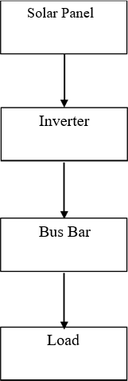

Figure 2.2-2 : is grid coupled SOLAR PV project without battery

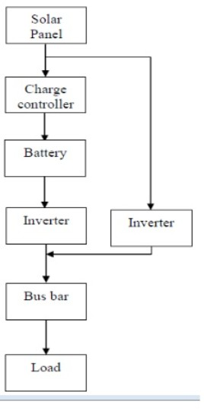
Figure 2.2-1 stand-alone SOLAR PV project with battery

Concept Reduction:
Figure 2.2.2: The block diagram shows the project formation where the SOLAR panels will be coupled to inverters then from the inverter current will be carried to the Mosque bus bar then to the load.

Figure 2.2.1: The block diagram shows a project formation that can collected supply and store electricity. When the demand is high the then the scheme will deliver electricity same as the block diagram (a) as described. But when the mandate is low or in an off day the battery can store drive by SOLAR panel through charge controller. This kept drive can be used as backup for gloomy day or at night. But we need large full of electricity to run the Mosque. Monthly normal electricity production of University Grand Mosque is 238,573.33 kWh and we can theoretically generate 19335.607 kWh per month. At 694.04 W/m² intercalation the specific PV module can generate = 173.51W. Daily normal sunny sunshine hour = 7.55, Full no. of modules = 492
Hence, the monthly electricity production = 173.51*7.55*492*30 = 19335.607 kwh/month
As this is a large difference with the Mosque’s monthly electricity production, we cannot store extra electricity.
Therefore. we choose the block diagram from figure 2.2-2 for our proposed project.

- METHDOLOGY

Building Solar System in The University's Grand Mosque

University Grand Mosque Monthly Electricity Production

By learning the details of the monthly electricity bill of University Grand Mosque we can estimate the and normal electricity production of the Grand Mosque.

      - Peak-hour: peak hour is from 6pm to 11pm
      - Off-peak hour: off-peak hour is from 6am to 10pm
      - Load inspection of Mosque Grand Mosque is estimated to be between 100-140 KW

Site inspection
Figure 3.1-1 :. Front look of University Grand Mosque

Solar Radiation and Solar irradiance
Solar radiation, often called the solar resource or just sunlight, is a general term for the electromagnetic radiation emitted by the sun. Solar radiation can be captured and turned into useful forms of energy, such as heat and electricity, using a variety of technologies. However, the technical feasibility and economical operation of these technologies at a specific location depends on the available solar resource.

Solar irradiance
radiance is the amount of light energy from one thing hitting a square meter of another each second. Photons that carry this energy have wavelengths from energetic X-rays and gamma rays to visible light to the infrared and radio. It can be measured for any glowing object, including stars, the Moon, and the overly bright high beams of an oncoming car. Human beings radiate primarily infrared light; an infrared image of a human shows a very active heart and mind!

The solar irradiance is the output of light energy from the entire disk of the Sun, measured at the Earth. It is looking at the Sun as we would a star rather than as a image.

The solar spectral irradiance is a measure of the brightness of the entire Sun at a wavelength of light. Important spectral irradiance variations are seen in many wavelengths, from the visible and IR, through the UV, to EUV and X-ray. As we look at the solar irradiance, we should remember that space weather is related to ionization, while climate is related to absorption of heat.

Measuring the spectral irradiance is important because different wavelengths (or colors) of sunlight are absorbed in different parts of our atmosphere. We feel warm because of the visible and infrared radiation that reaches the surface. Ultraviolet light creates the ozone layer and is then absorbed by that ozone. Higher still ultraviolet light creates the thermosphere, which is ionized by light at the short wavelengths of the extreme ultraviolet (EUV). Because radio communications are affected by the created ions, changes in the solar EUV output are a primary Space Weather concern.

Energy from other sources also enters our atmosphere. A table of some of them is shown below. Note that the energy input from Joule heating, a coupling of the ionosphere to the magnetosphere, can be about the same as from solar EUV [1]

Irradiance of a site is given by the following relation:

 | Normal Intercalation
Irradiance | / kWh / m2
= | Normal daily sunny sunshine hours
Eq. (1.1)
It is very important to know the irradiation and intercalation of a site when anyone is going to project a SOLAR PV project for that site. Conditional on the sunshine irradiance and intercalation varies from place to place
The irradiance of the Riyadh city can be calculated from Tables 1 and 2.

Table 1: Monthly global SOLAR intercalation in Riyadh city

Month |  | SOLAR
Intercalation kWh/m2
January |  | 5.47
February |  | 5.91
March |  | 6.00
April |  | 5.85
May |  | 5.23
June |  | 4.55

July |  | 4.18
August |  | 4.60
September |  | 4.94
October |  | 5.44
November |  | 5.34
December |  | 5.38
Normal |  | 5.24

Table 2: Daily normal sunny sunshine hours in Riyadh city

Month | Daily Mean | Minimum | Full
January | 8.7 | 7.5 | 9.9
February | 9.1 | 7.7 | 10.7
March | 8.8 | 7.5 | 10.1
April | 8.9 | 7.8 | 10.2
May | 8.2 | 5.7 | 9.7
June | 4.9 | 3.8 | 7.3
July | 5.1 | 2.6 | 6.7
August | 5.8 | 4.1 | 7.1
September | 6.0 | 4.8 | 8.5
October | 7.6 | 6.5 | 9.2
November | 8.6 | 7.0 | 9.9
December | 8.9 | 7.4 | 10.2
Normal | 7.55 | 6.03 | 9.13

The daily normal sunny sunshine hours in Riyadh city is 7.55 hours and the normal SOLAR intercalation is 5.24 kWh/ m².
From Eq. (1.1) the irradiance of Riyadh city can be found, and the value is equal to 694.04 watt/m². This value will be used for MOSQUE SOLAR PV project. [2] [3]

Selecting the PV module
As we need large power supply and we do not have large area. Hence, we specific mono crystalline silicon module. Our module selection depends on Price and productivity.
The capital asset of SOLAR PV panel is very high. Normally 60% of the full project Price is the price of module Price. We should consider the Price in order to get the flawless output of the money spent. Price varies on productivity of panel and the material has been used to make the PV panel. The Price of silicon SOLAR cell is very high. In our project we used mono crystalline silicon cell.
Productivity of SOLAR cell depends on the expertise used. Silicon SOLAR cell has the highest productivity. Thin film has low productivity, but they can be ideal for some applications. Another important consideration is temperature. Module productivity decreases as the module temperature increases. When modules working on roof it heats up substantially. Cell inner temperature reaches to 50-70 degree Celsius. In high temperature areas it is good to choose a panel with low temperature co- efficient.
Considering the above factors, we have specific a module of Samsung brand.

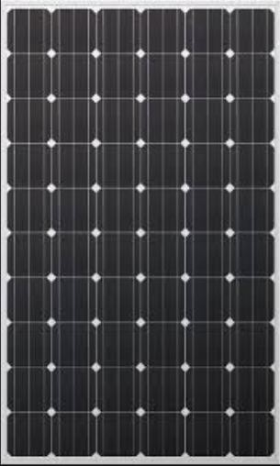
Figure 3.1-2: Samsung LPC250S SOLAR

Fig 3.1-2 shows the Samsung SOLAR module, and the model is LPC250S. Its full output power is 250 watts. If irradiance is 1000 watts per meter square, then the module’s nominal power output is 200 watts if irradiance is 800 watts per meter square. The irradiance of Riyadh City is
694.04 watts per meter square. Hence, we will get power less than 200 watts/ normally 173.51 watts. 35 years power output warranty is 80%. The panel productivity is 15.62%. Short circuit current of the panel is 8.66A at standard test condition and 6.90A at nominal condition. [4]

Inverter selection
We specific a PV grid tied inverter. The model is ZZ-ZB100kW as shown in Fig 3.1-3 It is a product of ZONZEN [21].
      - The MPPT voltage range: 100-500 V
      - Output power: 100kW
      - Connection: 60Hz grid frequency and 3 phase 4 wire connection
      - The productivity of this inverter: 97%.
      - AC voltage: 230 Volt.

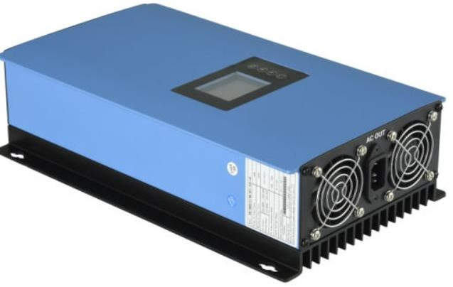
Figure 3.1-3: ZONZEN ZZ-ZB 100kW grid tie inverter

Combiner box selection
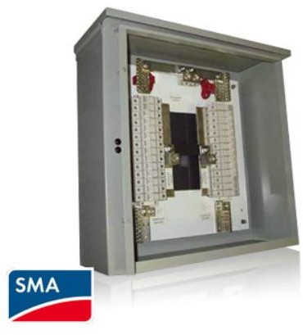
We have chosen the model of specific combiner box is SMA SCCB-10 as shown in Fig 3.1-4 [22]
- The number of input circuit: 12
- Full input fuse rating: 20 A/ 600V DC
- Full output current: 240 A DC

Installation of Solar Panel

- Solar Panel Pole Mounts: Side & Top of Pole Mounting
Figure 3.1-4: The SMA SCCB-10 combiner box

There are a wide variety of installation methods for MAPPS® solar power systems. Systems from 10 Watts to 480 Watts using pole-mount solar panels can easily be mounted on vertical poles ranging from 2" to telephone poles. Many versions are shown below from single module mounting structures to multiple modules mounting structures on larger poles. Large solar generator systems can be skid mounted, ground mounted, mounted on the side of a steel tower, mounted on the top of poles, mounted on cross arms with dual vertical poles, or mounted on trailers. Examples of these installations are shown below. We can design virtually any size system for a fixed or portable application anywhere in the world. [5]

There are 3 forms Solar Panel Pole Mounts
- The Top-of-Pole Mount (TPM) is designed to install quickly and provide a secure mounting structure for PV modules on a single pole. The module specific c design reduces the number of components and provides for an easier assembly.
- Side of pole: Generally small PV modules are placed be side of electricity or telephone pole
- Tracking pole: it is a special type of installation. This is done to maximize the output of the PV module by tracking with the sun path. [6]

Project sizing

In this section we will select the number of PV module can be fit in the specific area. The number of inverters, combiner box and other equipment’s is needed to complete the whole project in.

Number of module selection
The number of modules can be accommodated on collected roof top and facade can be calculated by the following formula:

No. of module accommodation = 𝐹𝑢𝑙𝑙 𝑢𝑠𝑎𝑏𝑙𝑒 𝑎𝑟𝑒𝑎
𝑎𝑟𝑒𝑎 𝑜𝑓 𝑎 𝑠𝑝𝑒𝑐𝑖𝑓𝑖𝑐 𝑃𝑉 𝑚𝑜𝑑𝑢𝑙𝑒
Eq. (2)

by utilizing this formula, we get

Table 3: Possible number of modules consuming roof top and faced area

Panel project  location | Usable area(m2) | No. of modules
Roof top | 408 | 252
Facade | 380.50 | 240
Full | 788.50 | 492

PV array project in

To implement the array there are some parameter to check. The most important thing to choose proper inverter and combiner box. Hence, it can withstand the PV modules’ voltage and current.
- ZONZEN ZZ-ZB 100kW inverter’s MPPT voltage range = 100-500 V SAMSUNG LPC250S module’s open circuit voltage =37.6 V
- 12 modules in series = 37.6* 12 = 451.2 V
This is within the inverter’s MPPT voltage range. We didn’t put more module due to safety.
- Module’s full power voltage = 30.9 V
- Inverter MPPT voltage range: 100-500V.

- (100-500V)/12 = 8.33-41.66 (module full power voltage = 30.9)
- Hence, power full power voltage is in the inverter’s voltage range.
- Inverter’s Full current: = 27.77A
- At 694.04 W/m2 full short circuit current = 6.15A
- If we put 3 parallel string (1 string consist of 12 series module) = 3*6.15 = 18.45A
We cannot put more string because if there is a rise in weather condition with low temperature and high intercalation excessive current can flow.
For safety considering 35% excessive current = 24.9 A
SMA SCCB-10 combiner box full input fuse rating = 600 V/ 20A this is can withstand 3 parallel string each consist of 12 series modules
Therefore, our chosen PV array project is 3 parallel string each consist of 12 series modules for 1 combiner box and 1 inverter.
As we need to arrange 492 modules, we need 14 formation [8][9]

Number of inverter calculation
No of inverter =Full no of module/ (no. of module in series in a string * no. of parallel string) = 492 / (12*3) =13.66 =14

Total of box selection
We will need combiner box is equal to the number of inverters. Hence, we will need 14 combiner boxes.

Electricity SOLAR system supply project
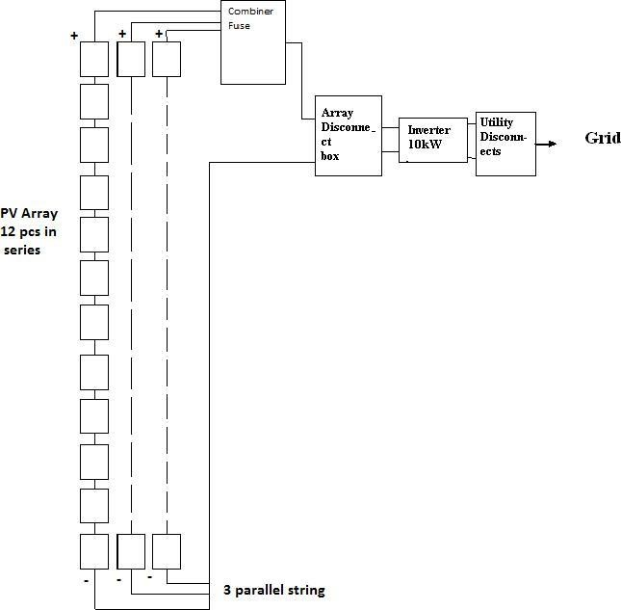

Figure 3.1-5: SOLAR PV project

Fig 3.1-5 shows the SOLAR project of Mosque Grand Mosque. This formation showing that there is one combiner coupled with 36 PV module. 12 PV modules in series in a string and there are 3 strings in parallel. For our project there would such 14 formation.
The SOLAR irradiance in Riyadh is 694.04 watt/day the electricity supplied by the SOLAR PV project in a year can be found by the following formula.
Full electricity supply = Full Power at defined irradiance of a SOLAR panel * Normal sunny sunshine hour * 365 days * full no. of SOLAR panels
= 173.51 * 7.55 * 365 * 492 = 235.249 MWh/year
Considering 80% of panel’s output productivity the full electricity supply = 188.39 MWh/year [10][11]

Project simulation

For the PV project for University Grand Mosque. we have chosen PVSYST software for simulation. PVSYST has built-in mathematical models for component such as photovoltaic module inverter and other tools. PVSYST gives two forms of project in options as preliminary project and project. utilizing these options there are various kinds of project can be developed.

For preliminary project:
Grid coupled project stand alone and pumping – these three forms of project can be project ed. this is used to get a primary idea for users. There are three steps to project a project like have to define location and project sizing (select PV module type, expertise, ventilation. Then PVSYST will show users a result for that project.
For project:
This is more elaborate than preliminary project. There are options to define parameters for project in a project of different forms of project is like grid coupled, standalone, dc grid coupled, pumping.

In this section we will show the results of simulation of the Solar project by PVSYST software.

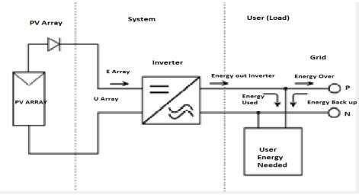

Figure 3.1-6: Project schema

Simulation Results
In this section we will show the results of simulation of the Solar project by PVSYST software

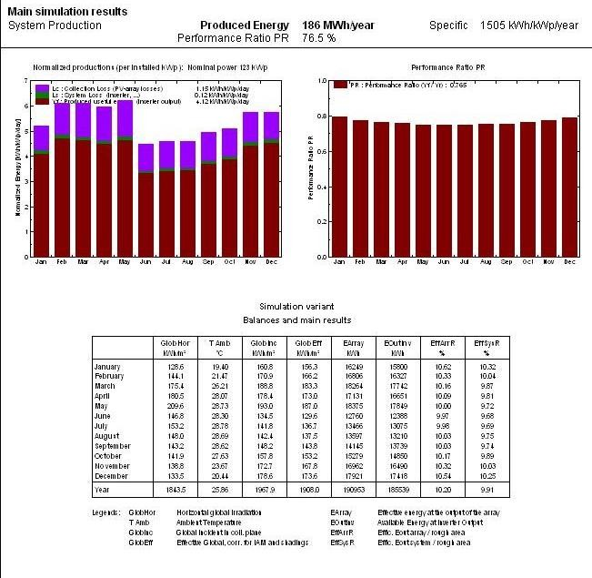
Figure 3.1-7: . Monthly nominal power graph for 100 kW project

Fig 3.1-7 demonstrates the produced energy which is 186 MWh/year with specific 1505 kWh/kWp/year and the performance ratio PR is 76.5% which will be discussed below, there are two curves, the curve on the left shows the normalized productions per installed kWp with nominal power 123 kWp as discussed in the Fig 3.1-7,, and the curve on the right is the performance ratio PR, while the table is about balances and main results of the photovoltaic systems

Normalized productions
Normalized productions such as collection losses, system losses and produced useful energy per installed kWp/day were evaluated from the simulation study, these normalized productions are defined by the IEC norms and are standardized variables for assessing the PV system performance. Lc is the Collection losses or the PV array capture losses i.e. 1.15 kWh/kWp/day. Ls is the system loss i.e. 0.12 kWh/kWp/day and the Yf is the produced useful energy i.e. 4.12 kWh/kWp/day

Performance ratio
The performance ratio is a measure of the quality of a PV plant that is independent of location and it therefore often described as a quality factor. The performance ratio (PR) is stated as percent and describes the relationship between the actual and theoretical energy outputs of the PV plant which is equal to 0.765 in this simulation.

balances and main results
Balances and main includes the variables like global irradiance on horizontal plane, ambient average temperature, global irradiance on collector plane without any optical corrections, effective global irradiance considering soiling losses and shading losses. Apart from these variables, energy injected into the grid considering the losses in electrical components, photovoltaic array and system efficiency also computed. The computed values of each variable mentioned in balances and main results were obtained in terms of monthly and yearly values. Yearly values of the variables are possible as averages for temperature, efficiency and summation for irradiance and energy.

Table 4 balances and main results abbreviations.
GlobHor: horizontal global irradiation in kWh/Sq. m T Amb: ambient temperature in °C
GlobInc: global incident in collector plane

GlobEff: effective global, correction for shadings in kWh/Sq. m

EArray: effective energy at the output of the array in MWh

EOutInv; Available Energy at Inverter Output EffArrR: efficiency of the array in percentage

EffSysR : efficiency of the system in percentage

Our PV project’s nominal power output is 100KW. Due to various factors such as site location, weather condition, intercalation, irradiance, performances of PV modules and inverters and project losses, the power capacity of the project is reduced. [13][14]

Arrow loss diagram
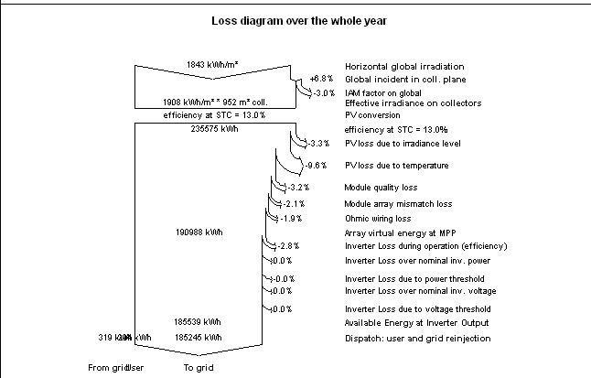
Figure 3.1-8: Arrow loss diagram

Arrow loss diagram is obtained from the simulated studies, which help in analyzing the various losses that are to be encountered while installing PV plant or constraints to be considered. Arrow loss diagram is seen in Fig. 3.1-8. Which represents the various losses in the system. Global irradiance on horizontal plane is 1843 kWh/m². But the effective irradiance on collector is 1908 kWh/m². When this effective irradiance falls on the surface of a photovoltaic module or array, electricity or electrical energy is produced. After the PV conversion, array nominal energy at standard testing conditions (STC) is
235.575 MWh. The efficiency of the PV array at STC is 13 %. Annual array virtual energy at MPP is 190.988 MWh. The various losses occur in this stage are 13% losses due to temperature, 2.1 % loss due to module array mismatch and 1.9 % is the Ohmic writing losses. Available energy on annual basis at the inverter output facility is 185.539 MWh and 185.425 MWh is injected to the grid. Here one loss was possible which is inverter loss during inverter operation that equals 2.8 %

Results from theoretical calculation

Considering these factors above.

The Working Power Output =
Full No. of Solar Panels ∗ Full Power At Defined Irradiance of a Solare Panel
Eq (2)
The Working Power Output = 492 ∗ 173,51 = 86𝐾𝑊
Hence, the full effective power output of PV project is 86 kW.

Comprehension of results
From our previous calculation,
Our theoretically calculated electricity production is 188MWh/year and the electricity production using PVSYST software is 186 MWh/year for electricity production per year the theoretical worth is nearly same to the simulation result.

Price Calculation
To implement the proposed SOLAR PV project for MOSQUE. we need to have a clear concept on the implementation Price. In these consequences we have calculated the approximation Price in USD. Table6 shows all components that we have required implementing a SOLAR PV project. These components are:
      - PV Modules
      - Inverters
      - Combiner Boxes
      - Surge Arrestors
      - Lightning Rod
      - Meters
      - Wiring
- We must consider the transport and maintenance Prices. We have considered this as the 40% of all components Prices. After doing calculation the full Price stands around 608,670.476 USD.

Table 5: The Total Cost of the Project

Component | Description | Quantity | Price
PV Module | Samsung LPC250S | 492 | 350,116.056 USD
Inverter | ZONZEN ZZ ZB10kW | 14 | 42,000 USD
Combiner Box | SAM SCCB-10 | 14 | 6790 USD
Surge Arrester |  | 14 | 1,200 USD
Lightning Rod |  | 2 | 200 USD
PV Structure |  |  | 31,428.57 USD
Meters |  |  | 30 USD
Wiring |  |  | 3000 USD
Transport and Maintenance | 40% of Total Price |  | 173,905.85 USD
Total Cost | 608,670.476 USD = 2,283,230.12 Saudi Riyal (2.28M)

Per part electricity Price
consider our proposed PV project life is 35 years. Hence, the Price per part of electricity by the project will be shown in table 6.

Table 6: Per Part Electricity Price

Total Cost of the project | 608,670.476 USD
Normal daily sunny sunshine hours | 7.55 Hours
Estimated capacity of project | 86 KW
electricity made per day | 86 * 7.55 = 649.3 kWh
Electricity made in 35 years in kWh | 649.3*35*365 = 8,294,807.5
Price per part of electricity in USD Electricity made in 35 years | (608670.476 /8,294,807.5) =  0.073 USD / kWh

Price per part of electricity in USD Electricity made in 35 years is 0.073 USD / kWh and that equals to
0.275 SR / kWh
Note that, currently in Saudi Arabia if the power consumption is more then 6kWh, the per price is 0.32 SR/kWh [15][16]

Studying the Effect of Chillers on Energy Consumption

Chillers and Its Effect in Energy Conservations
What are Chiller Systems?
Commercial buildings use Heating, Ventilation and Air Conditioning (HVAC) systems to dehumidify and to cool the building. Modern commercial buildings seek efficient HVAC systems and components as part of broader initiatives centered on building performance and sustainability. Building occupants similarly carry great expectations, that the HVAC system will function as intended to create a comfortable interior environment regardless of the conditions external to the building.

Chillers have become an essential HVAC component of a wide variety of commercial facilities, including hotels, restaurants, hospitals, sporting arenas, industrial and manufacturing plants, etc. The industry has long recognized that chiller systems represent the single largest consumer of electrical usage in most facilities. They can easily consume more than 50% of the total electrical usage during seasonal periods. According to the US Department of Energy (DOE), chillers can combine to use approximately 20% of the total electric power generated in North America. Moreover, the DOE estimates that chillers can expend up to 30% in additional energy usage due to various operational inefficiencies. These acknowledged inefficiencies cost companies and building facilities billions of dollars annually.

In general, a chiller facilitates the transfer of heat from an internal environment to an external environment. This heat-transfer device relies on the physical state of a refrigerant as it circulates through the chiller system. Certainly, chillers can function as the heart of any central HVAC system.

How Does a Chiller Work?
A chiller works on the principle of vapor compression or vapor absorption. Chillers provide a continuous flow of coolant to the cold side of a process water system at a desired temperature of about 50°F (10°C). The coolant is then pumped through the process, extracting heat out of one area of a facility (e.g., machinery, process equipment, etc.) as it flows back to the return side of the process water system.

A chiller uses a vapor compression mechanical refrigeration system that connects to the process water system through a device called an evaporator. Refrigerant circulates through an evaporator, compressor, condenser and expansion device of a chiller. A thermodynamic process occurs in each of above components of a chiller. The evaporator functions as a heat exchanger such that heat captured by the process coolant flow transfers to the refrigerant. As the heat-transfer takes place, the refrigerant evaporates, changing from a low-pressure liquid into vapor, while the temperature of the process coolant reduces.

The refrigerant then flows to a compressor, which performs multiple functions. First, it removes refrigerant from the evaporator and ensures that the pressure in the evaporator remains low enough to absorb heat at the correct rate. Second, it raises the pressure in outgoing refrigerant vapor to ensure that its temperature remains high enough to release heat when it reaches the condenser. The refrigerant returns to a liquid state at the condenser. The latent heat given up as the refrigerant changes from vapor to liquid is carried away from the environment by a cooling medium (air or water).[17][18]

Types of Chillers:
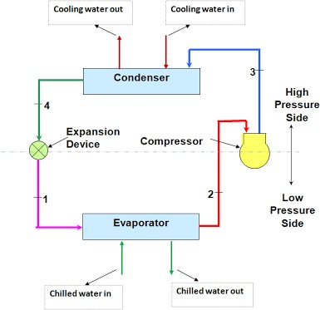
Figure 3.2-1: Chiller working principle

As described, two different cooling mediums (air or water) can facilitate the transfer of the latent heat given up as the refrigerant changes from vapor to liquid. Thus, chillers can use two different types of condensers, air-cooled and water-cooled.

Air-cooled condensers resemble the “radiators” that cool automobile engines. They use a motorized blower to force air across a grid of refrigerant lines. Unless they are specially designed for high- ambient conditions, air-cooled condensers require ambient temperatures of 95°F (35°C) or below to operate effectively.
Water-cooled condensers perform the same function as air-cooled condensers but require two steps to complete the heat transfer. First, heat moves from refrigerant vapor into the condenser water. Then, the warm condenser water is pumped to a cooling tower where the process heat is ultimately discharged to the atmosphere. [19][20]
.

Water-Cooled Chillers:
Water-cooled chillers feature a water-cooled condenser connected with a cooling tower. They have commonly been used for medium and large installations that have a sufficient water supply. Water- cooled chillers can produce more constant performance for commercial and industrial air conditioning because of the relative independence to fluctuations of the ambient temperature. Water-cooled chillers range in size from small 20-ton capacity models to several thousand-ton models that cool the world’s largest facilities such as airports, shopping malls and other facilities.

A typical water-cooled chiller uses recirculating condenser water from a cooling tower to condense the refrigerant. A water-cooled chiller contains a refrigerant dependent on the entering condenser water temperature (and flow rate), which functions in relation to the ambient wet-bulb temperature. Since the wet-bulb temperature is always lower than the dry-bulb temperature, the refrigerant condensing temperature (and pressure) in a water-cooled chiller can often operate significantly lower than an air- cooled chiller. Thus, water-cooled chillers can operate more efficiently.

Water-cooled chillers typically reside indoors in an environment protected from the elements. Hence, water-cooled chiller can offer a longer lifespan. Water-cooled chillers typically represent the only option for larger installations. The additional cooling tower system will require additional installation expense and maintenance as compared to air-cooled chillers. [20][21]

Actions to Increase Efficiency of Chiller Systems:
Chiller costs consume a substantial part of a building’s utility bills. The measures one should take to obtain energy savings through maximal efficiency of the chiller system is as follows.
      - Ongoing Maintenance
Chiller systems will operate more efficiently through proper ongoing maintenance. Most organizations recognize this value and have taken steps as part of their day-to-day facility management best practices. Some common best practices for chiller systems include:
Inspect and clean condenser coils. Heat transfer has a large effect on chiller systems and remains fundamental to producing efficient chiller operation. Routine maintenance should inspect condenser coils for clogging and free air passage.
Maintain refrigerant charge. A chiller’s cooling quotient depends on proper refrigerant levels in the system. Maintaining proper refrigerant charge can greatly impact energy efficiency by reducing cooling costs by nearly 5-10%.
Maintain condenser water: Condenser water loops used with cooling towers must maintain proper water flow as designed. Any debris like sand, erosive solids and contamination materials can affect the condenser water loop. Fouling or scaling can inhibit water flow and greatly impact the chiller operating efficiency.

Predictive Maintenance
Artificial Intelligence (AI) continues to advance in everyday practical applications. Machinery such as chiller systems will benefit from AI algorithms that can detect potential failures before they occur.
Predictive maintenance leverages the collection and analysis of chiller system operational data to determine when maintenance actions should be taken prior to catastrophic failure. As chillers systems represent the heart of most modern HVAC systems, the prevention of catastrophic failures that produce significant “downtime” will save on emergency repair costs as well as reputation. The critical role played by a chiller system warrants the increased scrutiny. Big Data and AI will minimize downtime and maximize productivity. [22]

The Internet of Things (IoT) provides the data collection tool that can enable AI applications such as predictive maintenance. In fact, the future of HVAC is AI and IoT. IoT enables the collection of real- time data from a chiller to enable continual analysis of its operation. The granular IoT data collected from a chiller will go far beyond that obtained by visual inspection. IoT connects building engineers to real-time visibility of critical HVAC assets, thereby enabling informed monitoring of actual operating conditions.

Optimization
Chillers operate as part of a complex HVAC system. Water-cooled chillers have greater complexity due to the connection to a cooling tower system. Evaluating overall chiller plant performance will therefore involve an analysis of total power consumption of the compressor, pumps, cooling tower fans, etc. to evaluate comprehensive efficiency measures such as kW/ton.
Optimization of the overall chiller plant must be performed holistically. Various adjustments focusing on optimal chilled water set points, chiller sequencing and load balancing, peak demand management, cooling tower water management, etc. can only be performed with operational data. IoT can provide the tools for such optimization by providing real-time monitoring of power consumption from each part of the chiller plant, supply/return temperatures from the chiller and cooling tower, water flow rates from the condenser water loop, etc. IoT has found practical application in HVAC to facilitate true optimization. [23]

Conclusion:
Chiller operational efficiency will greatly impact the building operating costs. Ongoing routine maintenance represents the minimum from the perspective of facility management. Predictive maintenance and optimization of the chiller system requires real-time operational data. IoT has opened the door to new forms of chiller efficiencies. [24][25]

Chillers & Energy Conservation
Chillers consume more than 40% of the total energy used in the commercial and industrial buildings for space conditioning. In this paper, energy consumption by chillers and chilled water pumps, condenser pumps and fan motors has been estimated using data collected by a walkthrough energy audit for the 16 faculties of the University of Malaya. It has been estimated that chillers and motors and pumps used in chillers consume 10,737 MWh (i.e. 51% of total energy consumption) of electric energy for different percentage of loadings. As chillers are major energy users, variable speed drives are applied in chillers to reduce their energy consumption. It has been estimated that about 8368 MWh annual energy can be saved by using efficient chillers at different loadings. It has also been found that about 23,532 MWh annual energy can be saved for chilled water supply pumps, condenser pumps and cooling tower fan motors by matching required speeds using variable speed drives for 60% of speed reduction. About 1,274,692 kg of CO2 emission could be avoided for using energy efficient chillers at 50% load. It has been also found that about 2,426,769 kg CO2 emission can be reduced by using variable speed drives for 60% speed reductions. Payback periods found to be only few months for using variable speed drives in chilled water pumps, condensers and fan motors. [26]

Chillers in King Saud university
The chillers in King Saud university are located near the agency of projects, it responsible for 40-50% of the consumption of electricity and it feeds the entire buildings in all the campus including King Khalid’s hospital.
A trip was conducted after communicating with the employees of the agency of projects and the information that will be shown are given after a long discussion with the engineers at the site.
King Saud University currently have 7 chillers, 4 chillers work in the summer, while only 2 are needed during the winter, and one is used completely for backup, all chillers are water cooled instead of air cooled.

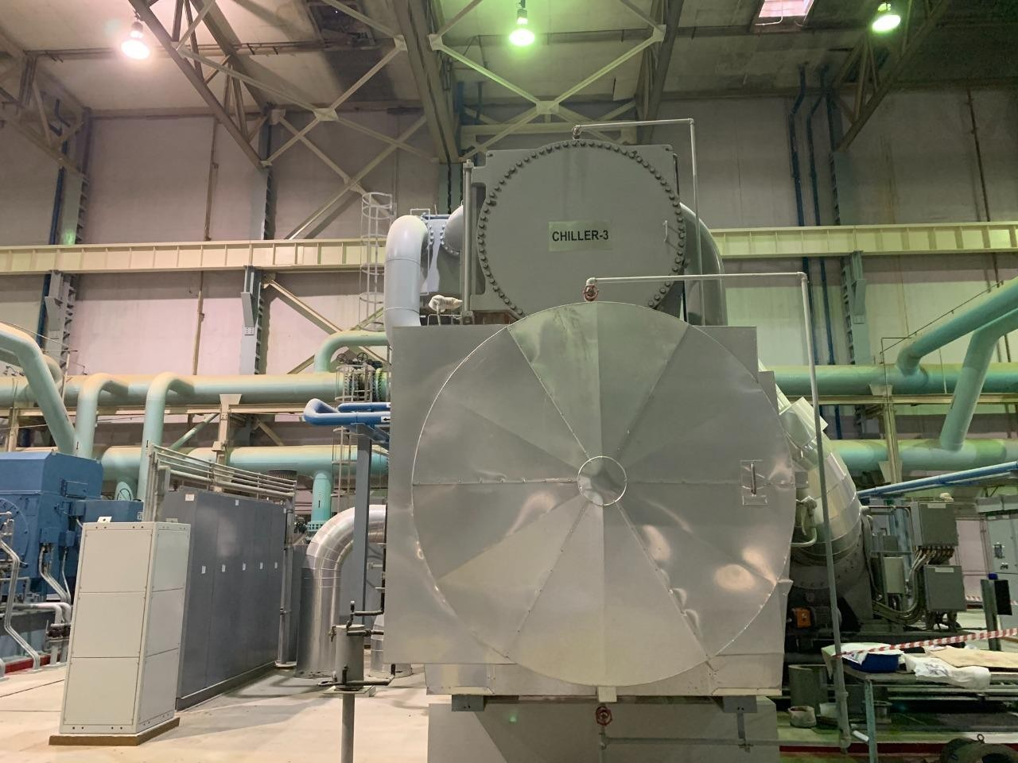
Figure 3.2-2: A Chiller.

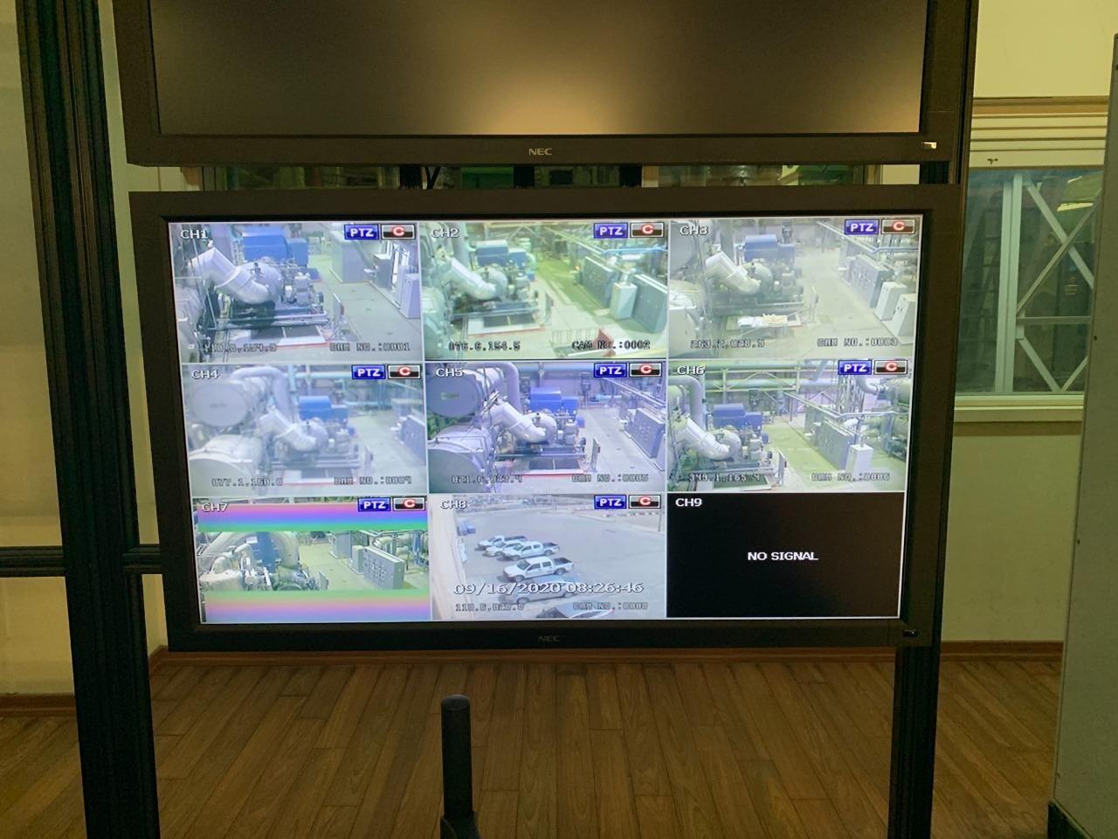
Figure 3.2-3: Monitoring system.
In fig 3.2-3: there are cameras in different angles covering the site.

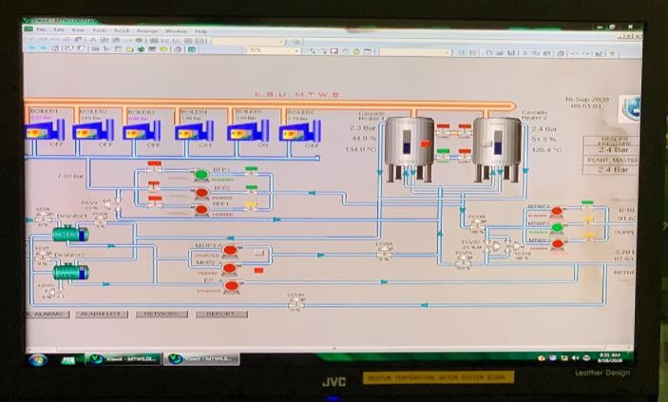
Figure 3.2-4: Overall design of the heaters and boilers.

In figure 3.2-4, the heaters are shown in cascaded manner, the first heater has 2.3 bar pressure and 134 C heat, while the second heater has 2.4 Bar and 126.4 C heat, all six boilers are off because they were not needed in the summer.

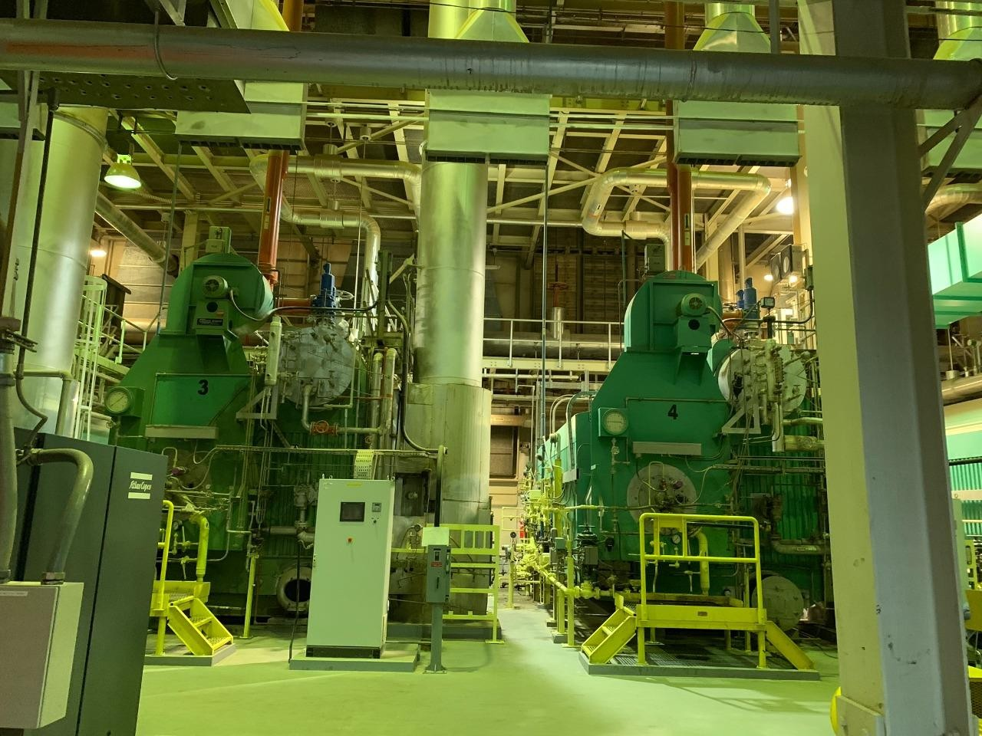
Figure 3.2-5: Boilers.
In figure 3.2-5: two boilers out of six are shown.

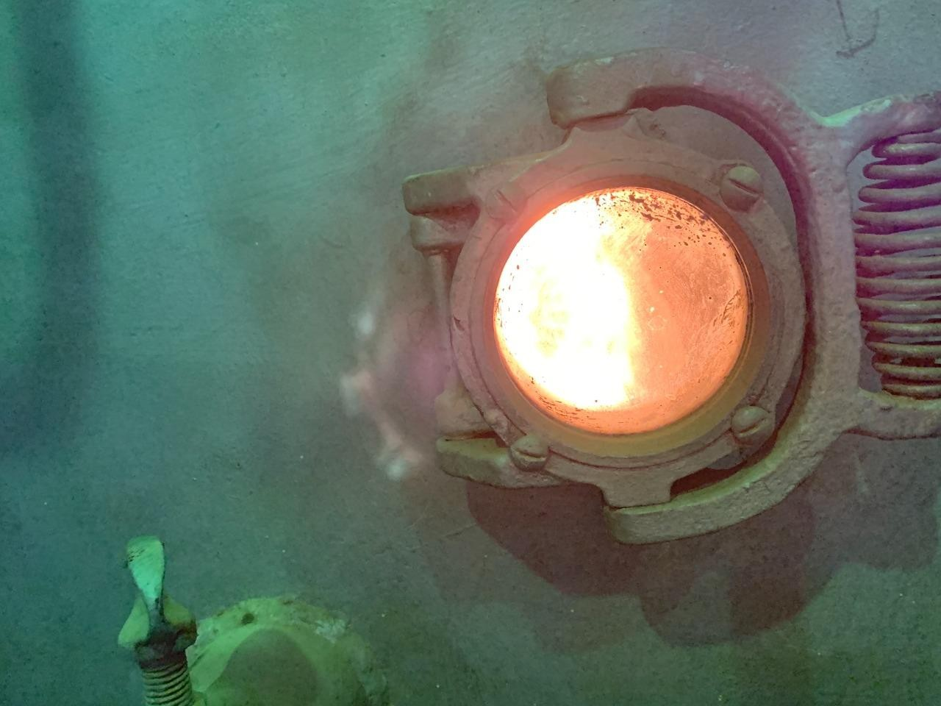
Figure 3.2-6: Close up picture of the boiler.
The boiler primary pump shall be operated at least 10 min before and after boiler is energized. A high limit temperature sensor will operate the circulating pumps until the boiler internal temperature is at or below its set point. The boiler discharge temperature control is integral to the boiler and is provided by the manufacturer.

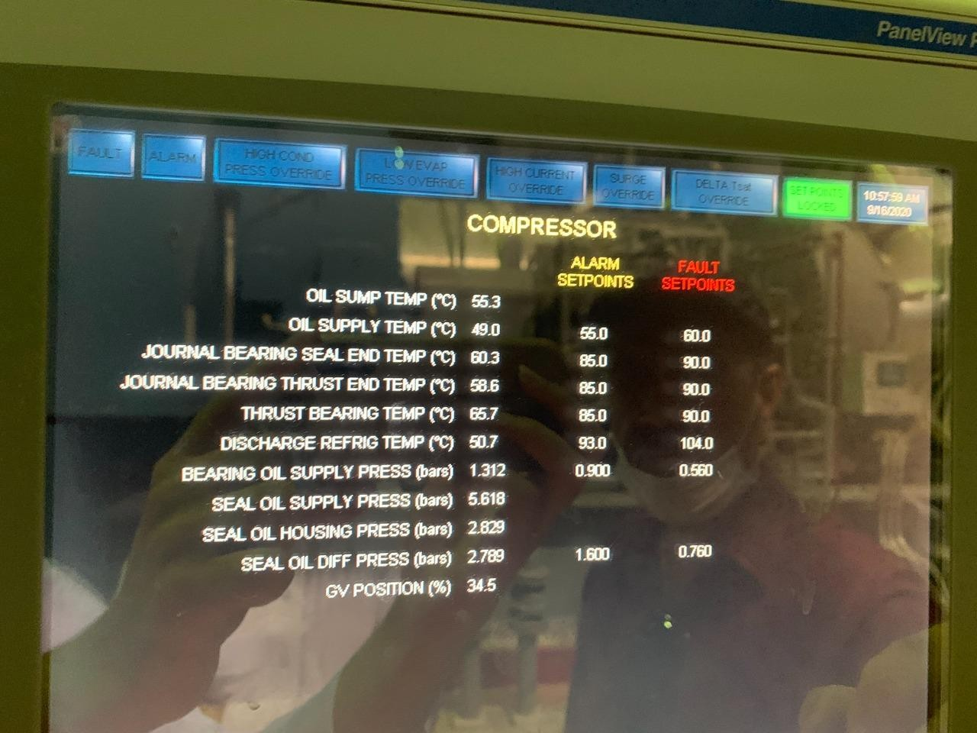
Figure 3.2-7: Compressor alarm and fault points

The refrigeration cycle begins with the compressor. The compressor takes low-pressure low- temperature refrigerant in gas form and compresses it into a high-pressure high-temperature gas, the picture in figure 3.2-7 illustrates that there are certain points where the compressor’s temperatures and pressures may reach a certain alarming points in value

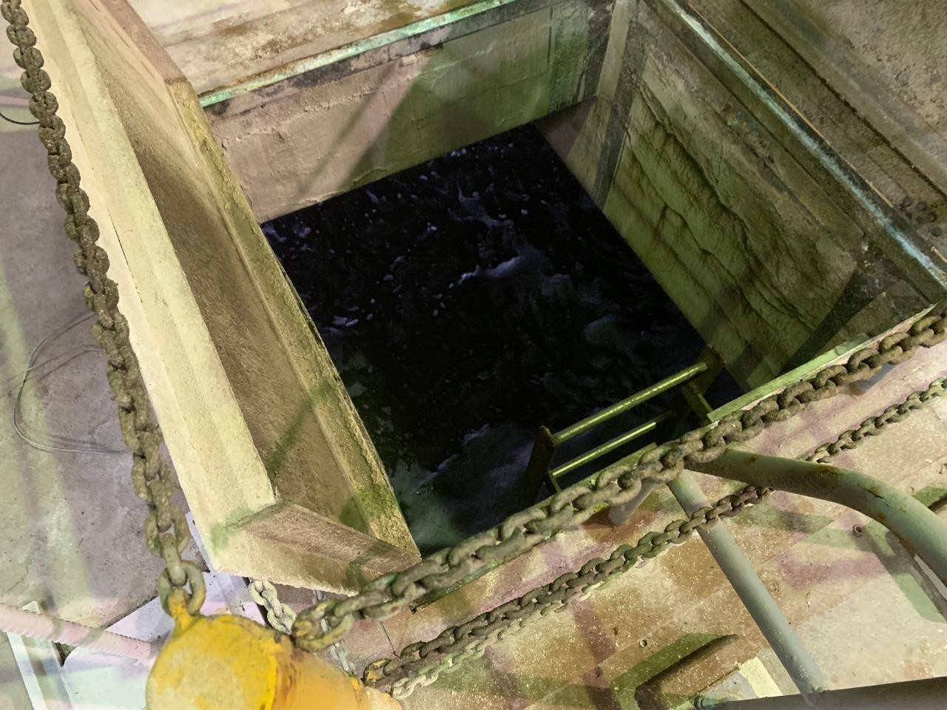
Figure 3.2-8: water storage.
Since the chillers are water cooled, they consume 5000 Liters of water daily.

In general, the load in king Saud university can be estimated as shown in the following graph.
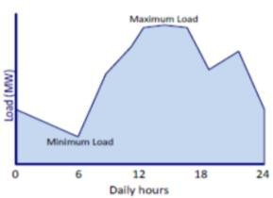

Figure 3.2-9 Total Daily load Variation curve

Lighting in King Saud University

Compact fluorescent lamp
Currently most facilities in KSU are using compact fluorescent lamp (CFL) , CFL are driven by an electric current through a tube that contains argon and mercury vapor. This process creates ultraviolet light that quickly translates into visible light, unlike incandescent lights which put off a warm glow, less than 10 percent of the energy used by the bulb produces light; the rest escapes as heat. So, it takes a lot of energy to create the incandescing's warm glow which is the main issue that must be solved in order to reduce unnecessary electricity consumption.

Light emitting diode
Light emitting diode (LED) is It is a PN junction diode which produces light when current passes through it in the forward direction, the charge carrier emits light when they combine with each other. The led emits light only in one direction because of which the bulb has good brightness. The objective is to change all lightings in KSU facilities to LED and the reason will be discussed in the next subsection.

Comparisons between LED and CFL
The differences can be shown in the table below
Table 7: Comparisons between CFL and LED

Basis for comparison | CFL | LED
Power Consumption | More | Less
Lifespan | Up to 10,000 hours | Up to 50,000 hours
Turn on intensity | Slower | Faster
Emission of heat | More | Less
Brightness | Less | More
Effect of switch on/off | Reduces life span | No effect
Recyclable | No | Yes

Table 6 illustrates the main differences between LED and CFL, the power consumption in CFL is more as compared to LED. Because CFL uses mercury, which requires more power for ionization. Also, the turn-on intensity of the CFL is less as compared to LED because CFL contained mercury vapor which takes time for ionization.

The CFL emits most of their energy in the form of heat as compared to the LED. The CFL uses mercury as a filament which emits visible light when their ions are ionized. The ionization occurs in high-voltage and this high voltage increases their temperature, the brightness of a CFL is less as compared to LED because LED emits light only in the one direction. The LED has a PN junction diode which operates only in the forward biasing. Whereas the CFL emits light in all the direction.

The frequent on/off of CFL reduces their capacity because CFL requires lots of energy for turning on. Thus, continuously switching reduces the ionization property of the mercury vapor. Whereas the LED is unaffected by constantly switching, the recycling of CFL is difficult as compared to LED because LED does not have any toxic substance. The LED has semiconductor which is easily recycled by adding impurities through doping. Therefore, it is possible to conclude that LEDs are better than CFLs in every aspect.

Now if the comparisons cover the lifetime aspect, it can be shown in the table below

Table 8: Lifetime comparison.

Lifetime in years | LED 25,000 hours | CFL 10,000 hours
Hours per day | Years | Years
3 | 22.8 | 9.1
6 | 11.4 | 4.5
9 | 7.6 | 3
12 | 5.7 | 2.2
24 | 2.9 | 1.1

.

If we take 3 hours per day and 25,000 hours as a sample, then the following table will demonstrate the results.
Table 9: Cost differences.

Basis for comparison | LED | CFL
Approximate cost per bulb | 8$ | 2$

Watts used | 10W | 14W
Number of bulbs for 25,000 hours of consumption | 1 | 3
Total purchase price | 8$ | 6$
Total cost of electricity  used (25,000 hours at $0.12 per kWh) | 30$ | 42$
Total operational cost over 23 years | 38$ | 48$

Sample calculations:

Total cost of electricity for LED = (25,000/1000)*10*0.12 =30$ Total cost of electricity for CFL = (25,000/1000)*14*0.12 =42$ Total operation cost = Total cost of electricity + Total purchase price Total operation cost for LED = 30$ + 8$ = 38$
Total operation cost for CFL = 6$ +42$ = 48$

This is 10$ difference is only for a single LED bulb which is equivalent to 3 CFL bulbs in the same lifetime, if we change every single lamb in KSU facilities the savings will be significantly higher.

- CONCLUSIONS AND FUTURE WORK
The simulation and theoretical values gained from utilizing the rooftops of the grand university mosque to apply PV solar power results were discussed in this paper to combat the energy consumption, the overall cost of the project is approximately 608,670.476 USD which is equivalent to 2,283,230.12 Saudi Riyals (2.28M), the estimated capacity of the project is 86 KW and the price per part of electricity made in 35 years is 0.073 USD / kWh and that equals to 0.275 SR / kWh .It is important to note that, currently in Saudi Arabia if the power consumption is more then 6kWh, the per price is 0.32 SR/kWh.
Chillers were discussed in this paper and it is essential to improve the efficiency because it covers up to 40-50% of the consumption in any large building. The methods to enhance the efficiency are ongoing maintenance, predictive maintenance and optimization.
The paper also studied the differences between LED and compact fluorescent, it is found that there is a 10$ difference in cost for a single LED bulb which is equivalent to 3 CFL bulbs in the same lifetime.

For future work we recommend studying the payback period of the solar PV system and to study the effect and cost mitigation when the methods of efficiency enhancements are applied to the chillers, and to design special cases of LED to accommodate the needs of KSU buildings and facilities.

- REFERENCES

- NASA. (2008). Solar Dynamics Observatory. Available NASA.COM

- Global Horizontal Irradiation-Saudi Arabia. Solargis, Bratislava, Slovakia. 2013. Available online: http: //solargis.com/products/maps-and-gis-data/free/download/saudi-arabia
- General Authority for Statistics Indicators of Renewable Energy in Saudi Arabia 2017. Available online: https://www.stats.gov.sa/sites/default/files/indicators_of_renewable_energy_in_saudi_arabia_2017_en_2.pdf

- International Energy Agency (IEA). 2018. World Energy Outlook 2018. Paris: International Energy Agency.

- Photovoltaics in Buildings, A Design Handbook for Architects and Engineers. Editors Friedrich Sick and Thomas Erge,
Fraunhofer Institute for Solar Energy Systems ISE Freiburg, Germany

- : Solar Pole Mount Installation. Available online: https://ironedison.com

- Taleb, H.M.; Sharples, S. Developing sustainable residential buildings in Saudi Arabia: A case study. Appl. Energy 2011
- Adinoyi, M.J.; Said, S.A.M. Effect of dust accumulation on the power outputs of solar photovoltaic modules. Renew. Energy 2013,
- Top 10—Solar Projects Saudi Arabia. Desert Solar Saudi Arabia. 2016.
- Alrashed, F.; Asif, M. Prospects of Renewable Energy to Promote Zero-Energy Residential Buildings in the KSA.
Energy Procedia 2012, 18, 1096–1105
- Sidawi, B. Hindrances to the financing of affordable housing in Kingsdom of Saudi Arabia. Emirates J. Eng. Res. 2009
- Alrashed, F.; Asif, M. Analysis of critical climate related factors for the application of Zero-Energy Homes in the Saudi Arabia. Renew. Sustain. Energy Rev
- Asif, M. Urban Scale Application of Solar PV to Improve Sustainability in the Building and the Energy Sectors of KSA. Sustainability 2016
- Huraib, F.S.; Hasnain, S.M.; Alawaji, S.H. Lessons learned from solar energy projects in Saudi Arabia. Renew. Energy 1996
- SEEC (2014), Saudi Energy Efficiency Centre. 2013. Available online: http://www.seec.gov.sa/ar/buildings

- 24. Housing the Growing Population of the Kingdom of Saudi Arabia; KCORP: Košice, Slovakia, 2013.
- Yu FW, Chan KT. Environmental performance and economic analysis of allvariable speed chiller systems with load- based speed control. Applied Thermal Engineering 2009.
- Yu FW, Chan KT. Part load performance of air-cooled centrifugal chillers with variable speed condenser fan control. Building and Environment 2007.
- Flake, B.A., Parameter estimation and optimal supervisory control of chilled plants. PhD thesis, Department of mechanical Engineering, University of Wisconsin-Madison. 1988.
- The Ultimate Guide to Chiller Systems. Everything You Need to Know. Available here: https://www.sciencedirect.com
- Saidpur, Rahman, et al. "Chillers energy consumption, energy savings and emission analysis in an institutional building." Energy 36.8 (2011): 5233-5238.
- Crowther H, Furlong J. Optimizing chillers and towers. ASHRAE Journal 2004;
- Mahlia TMI. Emissions from electricity generation in Malaysia. Renewable Energy 2002
- Tolvanen J. LCC approach for big motor-driven systems savings. World Pumps; November, 2008
- Jayamaha L. Energy efficient building systems. McGraw Hill Publisher; 2008
- Oxford: Butterworth-Heinemann; 2002. pp. 117e147.

