College of Engineering
Electrical Engineering Department

EE497
Faults Assessment in Solar PV array By Simulation and Experiment.

Students Team
Mutaz Helal Alsayali Student ID: 436106539
Abdullah Abdulaziz Aldhawyan Student ID: 436103975

Supervisors
Name Signature
Dr. Wonsuk Ko ………………
Dr. Essam Al-Ammar ………………

Rabi Al-Akhir 1442
December 2020

Project Abstract
This project investigates a fault diagnosis technique for a photovoltaic string, based on the I-V characteristic analysis. Simulated data (I-V characteristics) will be used to validate the fault diagnosis technique. In this project, various fault cases will be considered and classified. The objective of proposed project is to study modelling PV array and understand fault signal analysis. By simulation using Matlab/Simulink. Later in this project we verify our work experimentally for the partial shading fault without bypass diode only since other faults can’t be verified with the available resources, after the experimental work we gave conclusions based on the comparison between the simulation results and the experimental results.

Acknowledgement
First and foremost, we would like to thank Allah who helped and guided us to achieve this project successfully.
We also offer our sincerest gratitude to our supervisors Dr.Wonsuk Ko and Dr.Essam Al-Ammar for their invaluable and patient assistance and supervision, natural kindness, and continuous encouragement that helped us in all the times of creating and analyzing the project in the whole research period. However, this semester we faced the pandemic of Coronavirus that affects all life aspects world widely. we ask Allah to help us get through this as soonest.
Lastly, we thank our families and friends for their understanding and support.

Table of Contents:

Project Abstract 2
Acknowledgement 3
Table of Contents 4
List of Figures 5
List of Tables 7
1 Introduction 8
1.1 Problem Statement 8
1.2 Problem Formulation 8
2 Background 9
2.1 Basics of Solar PV 9
2.2 PV Module Performance Measurements 11
2.2.1 Balance of System and Applicable Standards 11
2.3 Types of PV Systems 14
2.4 PV array 15
2.4.1 Modeling and Simulation of PV array 15
2.4.2 SIMULINK Model of PV Module 19
3 Fault 22
3.1 Fault Diagnosis Simulation 23
4. Experimental Work 36
4.1 Equipment 36
4.2 Circuit and Connection 39
4.3 Experimental Results for Normal Condition 40
4.4 Experimental Result for Partial Shading Condition 43
4.5 Experimental Result for Total Shading Condition 46 5 Conclusions 49
References 50

List of Figures:
Figure 2. 1: UL standards used for the BOS components 12
Figure 2. 2: Grid-Connected Solar PV System 14
Figure 2. 3: Stand-Alone Solar PV System: 14
Figure 2. 4: PV array 15
Figure 2. 5: electrically equivalent circuit of PV array 15
Figure 2. 6: MPP of a PV module 17
Figure 2. 7: MPP of a PV string ……………………………………………….. 18 Figure 2. 8: MPP of n parallel PV modules 18
Figure 2. 9 MPP of a PV array of n x m modules 18
Figure 2. 10: Power-voltage curve (P-V curve) 19
Figure 2. 11: PV array in SIMULINK 20
Figure 2. 12: I-V curve 21
Figure 2. 13: P-V curve 21

Figure 3. 1: [F1] I-V Curve 23
Figure 3. 2: [F1] P-V Curve 23
Figure 3. 3: [F2] I-V Curve 24
Figure 3. 4: [F2] P-V Curve 24
Figure 3. 6: [F3] P-V Curve 25
Figure 3. 5: [F3] I-V Curve 25
Figure 3. 7: [F4] I-V Curve 26
Figure 3. 8: [F4] P-V Curve 26
Figure 3. 9: [F5] I-V Curve 27
Figure 3. 10: [F5] P-V Curve 27
Figure 3. 11: [F7] I-V Curve 29
Figure 3. 12: [F7] P-V Curve 29
Figure 3. 13: [F8] I-V Curve 30
Figure 3. 14: [F8] P-V Curve 30
Figure 3. 15: [F9] P-V Curve 31
Figure 3. 16: [F9] I-V Curve 31
Figure 3. 17: [F10] I-V Curve 32
Figure 3. 18: [F10] P-V Curve 32
Figure 3. 19: [F11] I-V Curve 33
Figure 3. 20: [F11] P-V Curve 33
Figure 3. 21: [F12] I-V Curve 34
Figure 3. 22: [F12] P-V Curve 34
Figure 3. 24: [F13] P-V Curve 35
Figure 3. 23: [F13] I-V Curve 35
Figure 4. 1: 150W MONO Solar Panel 36
Figure 4. 2: Solar Panel nameplate 36
Figure 4. 3: Variable Resistance 37
Figure 4. 4: Multimeters 37
Figure 4. 5: Connection Wires 38
Figure 4. 6: Solar power meter 38
Figure 4. 7: Carton board 39
Figure 4. 8: Circuit and Connection 39
Figure 4. 9: I-V Curves for simulation and experimental results 40
Figure 4. 10: P-V Curves for simulation and experimental results 41
Figure 4. 11: Partial shading practically 43
Figure 4. 12: I-V Curves for simulation and experimental results 43
Figure 4. 13: P-V Curves for simulation and experimental results 45
Figure 4. 14: Total shading practically 46
Figure 4. 12: I-V Curves for simulation and experimental results 47
Figure 4. 13: P-V Curves for simulation and experimental results 48

List of Tables:
Table2. 1: Photovoltaic (PV) module speciﬁcations 20
Table3. 1: The typical faults in a PV array and their descriptions. 22

Tables3. 2: Tables of [F1] cases 23
Tables3. 3: Tables of [F2] cases 24
Tables3. 4: Tables of [F3] cases 25
Tables3. 5: Tables of [F4] cases 26
Tables3. 6: Tables of [F5] cases 27
Tables3. 7: Tables of [F7] cases 29
Tables3. 8: Tables of [F8] cases 30
Tables3. 9: Tables of [F9] cases 31
Tables3. 10: Tables of [F10] cases 32
Tables3. 11: Tables of [F11] cases 33
Tables3. 12: Tables of [F12] cases 34
Tables3. 13: Tables of [F13] cases 35
Table 4. 1: I-V simulation and experimental results 41
Table 4. 2: P-V simulation and experimental results 42
Table 4. 3: I-V simulation and experimental results 44
Table 4. 4: P-V simulation and experimental results 45
Table 4. 5: I-V simulation and experimental results 47
Table 4. 6: P-V simulation and experimental results 48
Table 5. 1: Conclusion of assessment results 49

Introduction

1.1 Problem Statement:
Due to the advantages of this source of energy, and the increase of the electricity demand, Photovoltaic (PV) system capacity has been increased. But there are faults in the PV field such as short circuiting of a module, a disconnection with open circuiting of a module, short circuiting of a bypass diode, an increased contact serial resistance. For these reasons, fault detection and localization methods in PV systems are needed to increase reliability, efficiency and safety in PV systems.
1.2 Problem Formulation:
Numerous diagnosis techniques are proposed and vary in complexity, precision, and cost. For these techniques, a simple method is based on the power losses analysis; two indicators are analyzed to identify the fault type, without the requirement of using climate information. The designed technique is based on the analysis of the anomalies in the I-V characteristic.

2. Background

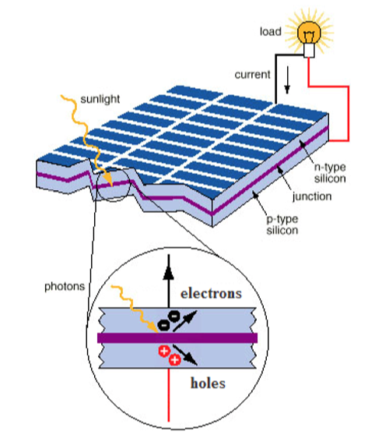
2.1 Basics of Solar PV:
PV cell is capable of generating about 1 or 2 W of power approximately depends of the type of material used. the entire system performance is based on the efﬁciency or the performance of the individual components. Apart from the solar PV module the system components comprises a battery charge controller, an inverter, MPPT controller and some of the low voltage switchgear components. Presently in the market, power conditioning unit consists of charge controller, inverter and MPPT controller. A Balance-of-System (BoS) includes components and equipments that convert DC supply from the solar PV module to AC grid supply. In general, BOS of the solar PV system includes all the components of the system except the Solar PV modules. In addition to inverters, this includes the cables/wires, switches, enclosures, fuses, ground fault detectors, surge protectors, etc. the cost of BOS equipment can equal or exceed the cost of the PV modules. the Solar PV module world market is steadily growing at the rate of 30 % per year. The reasons behind this growth are that the reliable production of electricity without fuel consumption anywhere there is light and the ﬂexibility of PV systems. the efﬁciency of the solar PV cell, in the commercial market a cell efﬁciency of up to 18.3 % is currently obtained, depending on the technology that is used. When it is related to the module efﬁciency, it is slightly lower than the cell efﬁciency. This is due to the blank spaces between the arrays of solar cells in the module. The overall system efﬁciency includes the efﬁciency and the performance of the entire components in the system and also depends on the solar installation. Here there is another numerical drop in value when compared to the module efﬁciency, this being due to conductance losses, e.g., in cables. In the case of inverter, it converts the DC output from the Solar PV module to the AC grid voltage with a certain degree of efﬁciency. It depends upon conversion efﬁciency and the precision and quickness of the MPP tracking called tracking efﬁciency. MPP tracking which is having an efﬁciency of 98–99 % is available in the market, each and every MPPT is based on a particular tracking algorithm. the maximum efﬁciency of crystalline silicon is only 28 %. Efﬁciency of existing laboratory cells has already achieved efﬁciency values of over 25 %. PV Modules with BOS components known as an entire PV system. This system is usually sufﬁcient to meet a particular energy demand, such as powering a water pump, the appliances and lights in a home, and electrical requirements of a community. In the cost of PV systems and in consumer acceptance, reliability of PV arrays is a crucial factor. With the help of fault-tolerant circuit design, reliability can be improved using various redundant features in the circuit to control the effect of partial failure on overall module yield and array power degradation. Degradation can be limited by dividing the modules into a number of parallel solar cell networks. This type of design can also improve module losses caused by broken cells. The hot-spots in the Solar PV module can be avoided by having diodes across each cell and that is called as bypass diodes. Practically a solar PV module consists of one bypass diode for 18 cells to mitigate the effects of local cell hot-spots.

2.2 PV Module Performance Measurements:
The peak watt (W_{p}) rating is determined by measuring the maximum power of a PV module under laboratory Standard Test Conditions (STC). Another method is to consider the whole day rather than “peak” sunshine hours and it is based on some of the factors like light levels, ambient temperature, and air mass and also based on a particular application. Solar arrays can provide speciﬁc amount of electricity under certain conditions. In order to determine array performance, following factors to be considered: (i) characterization of solar cell electrical performance (ii) degradation factors related to array design (iii) assembly, conversion of environmental considerations into solar cell operating temperatures and (iv) array power output capability. The following performance criteria determines the amount of PV output.
Power Output: Power output is represented in watts and it is the power available at the charge controller/regulator speciﬁed either as peak power or average power produced during one day.
Energy Output: Energy Output indicates the amount of energy produced during a certain period of time and it is represented in Wh/m2.
Conversion Efﬁciency: It is deﬁned as energy output from array to the energy input from sun. It is also referred as power efﬁciency and it is equal to power output from array to the power input from sun. Power is typically given in units of watts (W), and energy is typical in units of watt-hours (Wh).

2.2.1 Balance of System and Applicable Standards:
UL is a global leader in energy product testing and certiﬁcation. The focus of the UL standards is in providing requirements for materials, construction and the evaluation of the potential electrical shock, ﬁre safety hazard and also testing and certiﬁcation according to the appropriate energy standard. UL certiﬁes that PV equipment complies with the safety, environmental and other performance requirements of the appropriate standards. IEC focus on the requirements in terms and symbols, testing, design qualiﬁcation and type approval. UL supports manufacturers with the compliance to both the UL and the IEC requirements. In addition, UL provides balance of systems equipment certiﬁcation to the standards identiﬁed in the diagram. Even though the design of solar PV system.

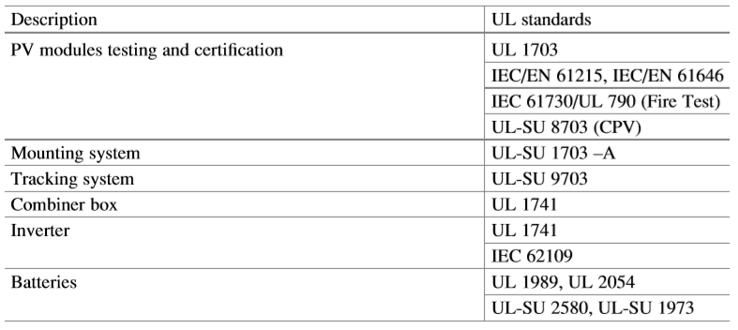
Figure 2. 1: UL standards used for the BOS components

The UL standards used for the corresponding BOS components of the Solar PV system are as shown in Table above. As these issues might seem insigniﬁcant during the installation, they affect the system performance, efﬁciency, reliability, maintenance cost and aesthetics in the long run. The BOS components can be divided into the following categories based on their basic functions: (i) Mounting Structure (ii) Power Conditioning Units (iii) Cables/Protection devices and (iv) Storage devices.

2.2.1.1 Mounting Structure:
(i) Durability of the design (ii) Tilt angle (iii) Orientation and (iv) PV array shading. Tilting angle optimally varies the efﬁciency of the solar PV module so, the mounting structure also serves as a PV module tilting structure which tilts the PV arrays at an angle determined by the latitude of the site location, to maximize the solar insolation falling on the panels. The optimum tilt angle required to maximize the solar insolation changes as the position of the sun varies every month. shading has a signiﬁcant effect on PV generation. Partial shading can reduce the system production up to 90 %. To identify the shading levels at any location, software and online tools are available. Some of commonly used tools are – Sun path, Eco tech, Celeste lite etc.

2.2.1.2 Power Conditioners:
A high self-consumption inverter, continuously drains the battery which results in lower back up and decrease the battery life cycle due to increased discharge. Further, as the efﬁciency of the inverter changes with respect to the load, it is good practice to design the load on average efﬁciency rather than the peak efﬁciency. In a typical inverter, the peak efﬁciency is mostly between 20 % and 30 % of the total capacity.

2.2.1.3 Cables and Protection Devices:
The commonly found mistakes in installation sites are the undersized or inappropriate selection of cables.

2.2.1.4 Storage:
Presently researches are going on in the ﬁeld of Li-ion batteries and to implement the concept of fuel cells in Solar PV Systems. One of the most expensive components in the PV system is the battery. Under sizing the batteries will become more costly as the battery life cycle is signiﬁcantly reduced at higher Depth of Discharge (DOD%). With good selection and installation practice the overall losses from BOS can be limited to 15.5 % at STC.

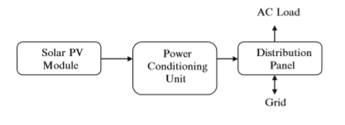
2.3 Types of PV Systems:

Figure 2. 2: Grid-Connected Solar PV System
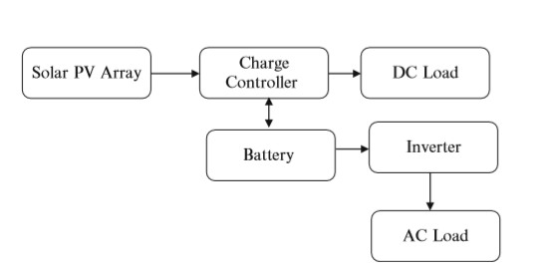

Figure 2. 3: Stand-Alone Solar PV System:

2.4 PV array:
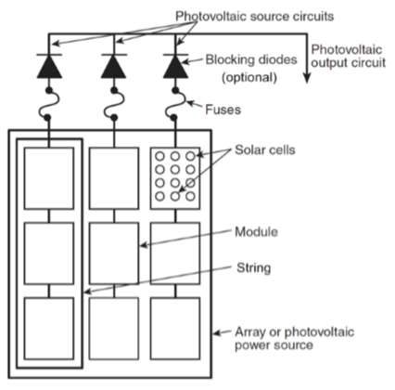
In a PV array, PV modules are connected in series, in parallel or their combination to produce the desired current and voltage.
The series connection increases the output voltage, a parallel connection can augment the supplied current: the terminal current is the sum of the current of each PV string.

Figure 2. 4: PV array
2.4.1 Modeling and Simulation of PV array:
Models for solar cells:
Because of the non-linear I-V characteristics of solar cells, it is not appropriate to simply model them as a constant voltage source or a constant current source.
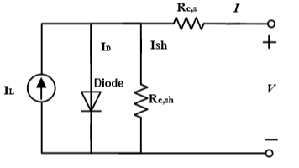
To understand the electronic behavior of a solar cell, it is useful to represent it as electrically equivalent circuit. An ideal solar cell may be modeled by a current source in parallel with a diode. In practice no solar cell is ideal, so a shunt resistance and
Figure 2. 5: electrically equivalent circuit of PV array
a series resistance component are added to the model, as shown in figure2.5
Where:
I = solar cell current (A)
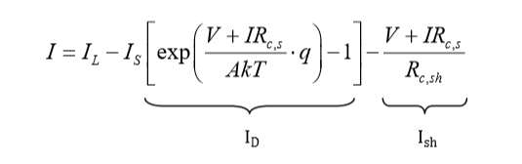
V = solar cell voltage (V)
I_{L} = light-generated current (A)
I_{D} = diode current (A)
I_{sh} = shunt resistance current (A)
I_{S} = saturation current of the diode (A)
Rc,s = solar cell series resistance (ohms)
Rc,sh = solar cell shunt resistance (ohms)
q = electron charge = 1.6×10-19 C
k = Boltzmann’s constant = 1.38×10-23 J/K
A = diode ideal factor (12 A ≤≤ )
T = ambient temperature (K)

All PV array datasheets bring basically the nominal open-circuit voltage (V_{oc,n}), the nominal short-circuit current (I_{sc,n}), the voltage at the MPP (V_{mp}), the current at the MPP (I_{mp}), the open-circuit voltage/temperature coefﬁcient (K_{V}), the short circuit current/temperature coefﬁcient (K_{I}), and the maximum experimental peak output power (P_{max,e}). This information is always provided with reference to the nominal condition or standard test conditions (STC’s) of temperature and solar irradiation.
To model a PV array, it is unrealistic to simulate every solar cell in the array. Moreover, PV manufacturers usually only provide end users with complete and environmentally protected modules rather than solar cells in bulk. In addition, in real working conditions, solar cells packaged in the same module usually have almost the same irradiance conditions. For these reasons, we can simply assume that all the solar cells in each PV module have identical characteristics and working conditions. Thus, a PV module can be viewed as a basic unit consisting of identical solar cells. Therefore, modeling and simulation of PV modules become key steps for PV system normal and fault analysis.
Open-circuit voltage and short-circuit current:
The practical PV device has a series resistance R_{c,s} whose inﬂuence is stronger when the device operates in the open circuit condition and when a parallel resistance R_{c,sh} with a stronger inﬂuence it operates in the short circuit condition. The assumption I_{sc}= I_{L} is generally used in the modeling of PV devices because in practical devices the series resistance is low and the parallel resistance is high.

Current-voltage curve (I-V curve):
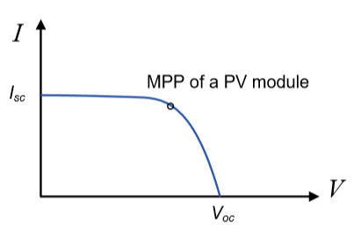
There are three important points on the I-V curve, named short-circuit current (Isc), open-circuit voltage (Voc) and maximum power point (MPP), which represent the maximum possible current, maximum possible voltage and maximum possible power
Figure 2. 6: MPP of a PV module

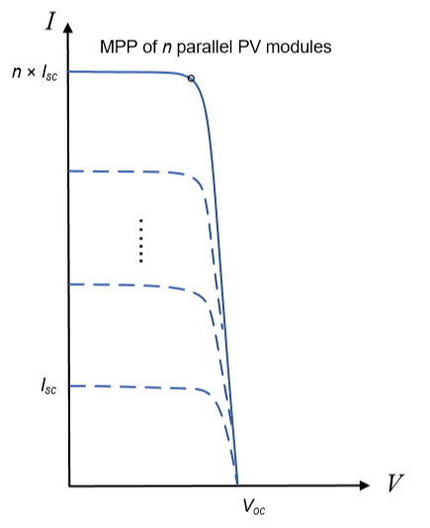
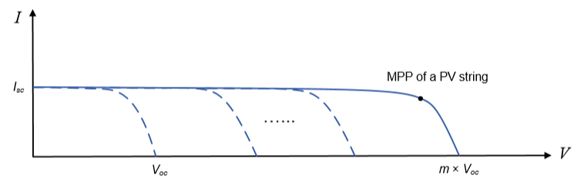
connecting m modules in series will yield a PV string with a higher open-circuit voltage (m×Voc). In figures, putting n strings in parallel will create a PV array with a larger short-circuit current (n×Isc)
Figure 2. 7: MPP of a PV string Figure 2. 8: MPP of n parallel PV modules
A large PV array can be developed. If a string has m identical modules, n identical PV strings can be in parallel to build a PV array containing (n × m) PV modules
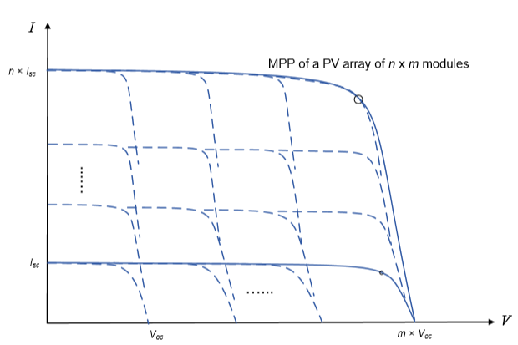
Figure 2. 9 MPP of a PV array of n x m modules
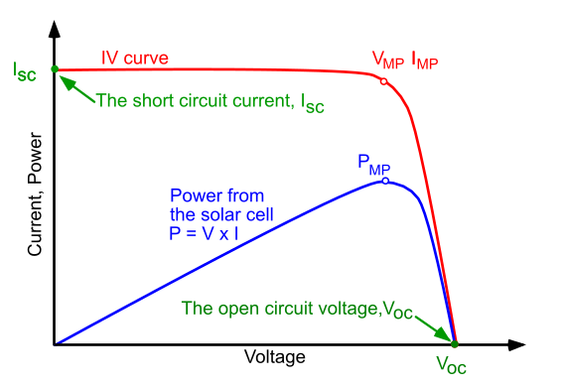
Figure 2. 10: Power-voltage curve (P-V curve)

2.4.2 SIMULINK Model of PV Module:
Overview:
The Matlab/Simulink software is used to represent PV array. By use the block as shown in fig, and we can change the date of PV array when we open the block.
Then we can show the current-voltage (I-V), and power-voltage (P-V) characteristics.

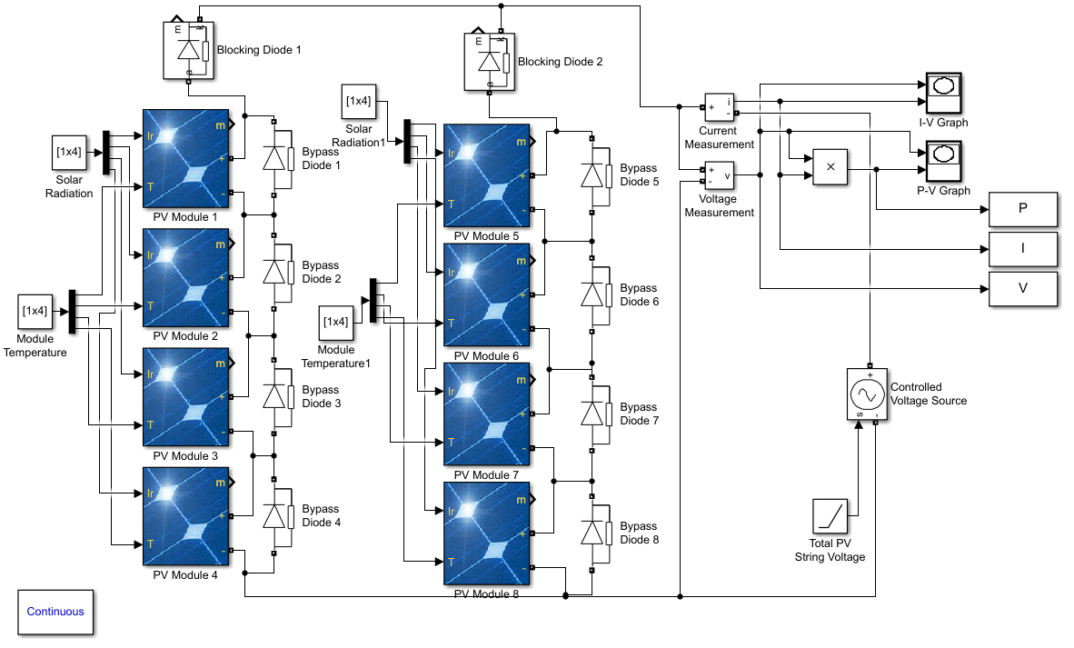
In our Simulation in Matlab/Simulink we will simulate PV array of 4x2 modules as shown in fig. the type of each module is SunPower SPR-X20-250-BLK, and the speciﬁcations of each module as mentioned in the table.
Figure 2. 11: PV array in SIMULINK

Parameters | Value
Maximum power | 294.952 W
Voltage at open circuit | 50.93 V
Current at short circuit | 6.2 A
Voltage at the MPP (maximum power point) | 42.8 V
Current at the MPP | 5.84 A
Cell per module | 72

At normal operation the solar irradiance and temperature are fixed 1000 W/m² and 25º respectively.

Table2. 1: Photovoltaic (PV) module speciﬁcations
Normal Operation:
As we mentioned earlier, theoretically when we connecting 4 modules in series the V_{oc} will be 4×50.93= 203.72V, and when we connecting 2 strings in parallel I_{sc} will be 2×6.2= 12.4A. But practically in our PV array: V_{oc}=202.9V, I_{sc}=12.413A, V_{mpp}= 169.7V, I_{mpp}= 11.73A, and the Maximum power will be 169.7×11.73= 1990W
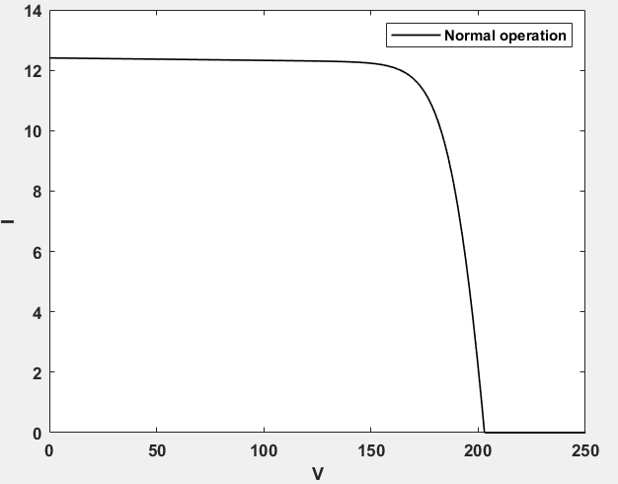

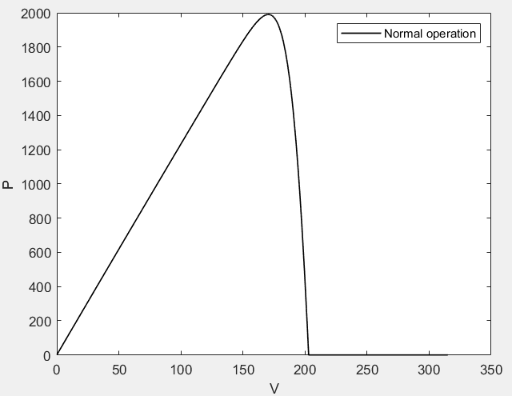

Figure 2. 12: I-V curve

Figure 2. 13: P-V curve
3. Faults
As the amount of PV energy mainly depends on the environmental conditions and failures in PV generators, the last decades have been witnessed a great deal of research effort devoted to maximizing the output power of the PV generators. Their diagnosis is very important as it can provide users with a warning of the system failure risks. The electrical faults are the main source of failures in a PV generator. The short circuit, open circuit, impedance, reversed polarity and partial shading faults are the major faults known in the field of the PV diagnosis. These faults can occur at the basic components, at the PV modules and at the PV strings. The electrical behavior of a photovoltaic generator can be described by its I-V and P-V characteristics.
Our main objective in this report is to investigates a faults diagnosis of the PV array, and what is the impact will be on the PV array. The impact of these faults will appear in the I-V and P-V characteristics of the PV array. the typical faults which mentioned in the table below will be considered in the project.

Types of faults | Description | Symbol
Blocking diode | Short circuit | F1
 | Open circuit | F2
 | Impedance | F3
 | Reverse polarity | F4
Bypass diode | Short circuit | F5
 | Open circuit | F6
 | Impedance | F7
 | Reverse polarity | F8
Shading | Total shadow on the modules | F9
 | Partial shadow on the modules | F10
PV modules | Short circuit in any module | F11
 | Disconnection | F12
Connectivity | Two modules connected by a resistance | F13
Table3. 1: The typical faults in a PV array and their descriptions.

3.1 Fault Diagnosis Simulation:
- Blocking diode faults:
Short circuit [F1]: This fault can be classified among the most danger faults than can occur in a PV array. As shown in figure the faulty I-V and P-V characteristics are similar to the normal operation, but there is change in values as shown in table.
Parameters | Value
P_{m} | 1990 W
V_{oc} | 202.9 V
I_{sc} | 12.413 A
V_{mpp} | 169.7 V
I_{mpp} | 11.73 A
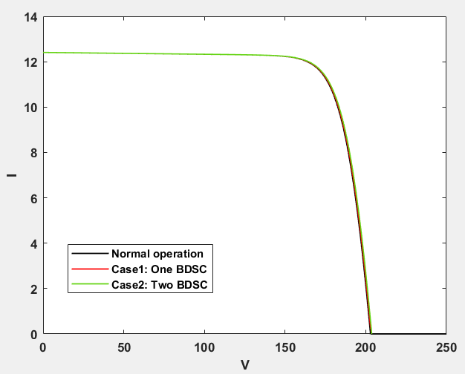
Normal operation
Parameters | Value
P_{m} | 1995 W
V_{oc} | 203.72 V
I_{sc} | 12.414 A
V_{mpp} | 170.5 V
I_{mpp} | 11.70 A
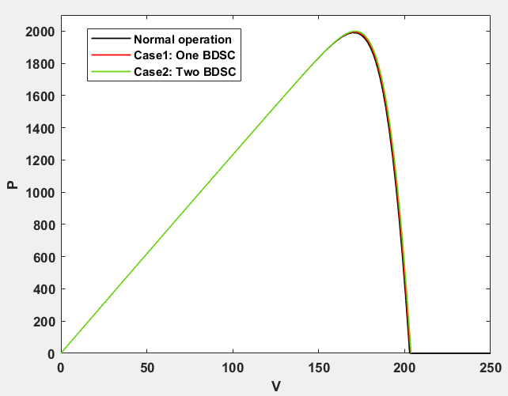
Case1: Short circuit in one blocking diode
Figure 3. 1: [F1] I-V Curve

Case2: Short circuit in two blocking diodes
Figure 3. 2: [F1] P-V Curve

Parameters | Value
P_{m} | 2000 W
V_{oc} | 203.71 V
I_{sc} | 12.414 A
V_{mpp} | 171.1 V
I_{mpp} | 11.68 A
Tables3. 2: Tables of [F1] cases
Open circuit [F2]: In this case, when there is an open circuit fault in blocking diode, one faulty blocking diode cancels the current flowing by the faulty string, then a decrease of 1/2 total short circuit current Isc is observed, causing power degradation and decrease it 50%.
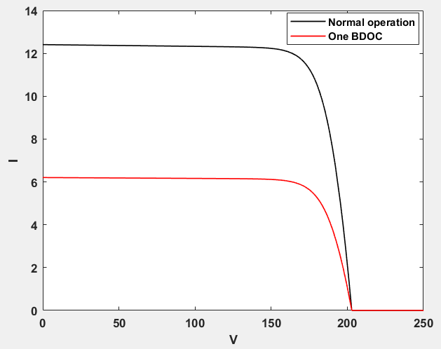

Parameters | Value
P_{m} | 1990 W
V_{oc} | 202.9 V
I_{sc} | 12.413 A
V_{mpp} | 169.7 V
I_{mpp} | 11.73 A
Normal operation

Figure 3. 3: [F2] I-V Curve
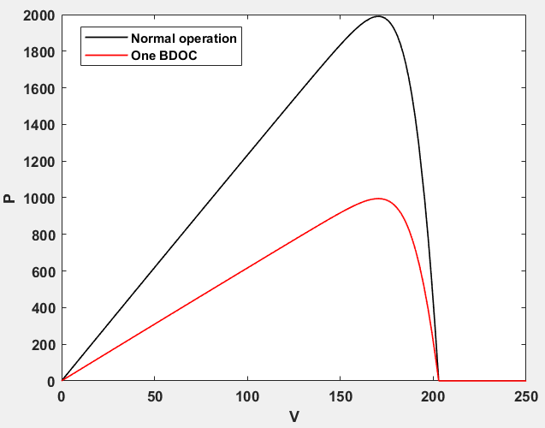

Open circuit in one blocking diode
Tables3. 3: Tables of [F2] cases

Parameters | Value
P_{m} | 995 W
V_{oc} | 202.9 V
I_{sc} | 6.207 A
V_{mpp} | 169.7 V
I_{mpp} | 5.865 A

Figure 3. 4: [F2] P-V Curve

Impedance [F3]: When a blocking diode submits to the impedance fault, it allows the current flow in both directions and causes a significant degradation in the maximum produced power P_{max}. Figure shows that the slope of the I-V curve changes proportionally to the impedance value. We notice that this type of fault behaves as an open circuit fault for higher values of the impedance, as it reduces the I_{sc} value.
Parameters | Value
P_{m} | 1757 W
V_{oc} | 203.71 V
I_{sc} | 12.40 A
V_{mpp} | 155.2 V
I_{mpp} | 11.32 A
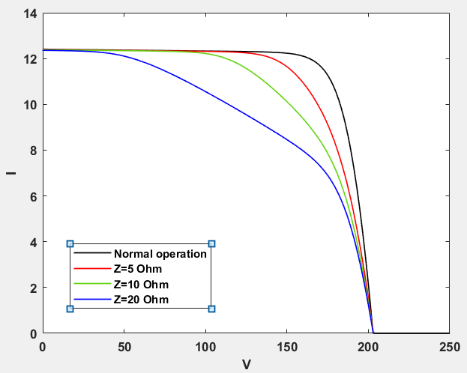
Case3: Z=20 Ohm
Case2: Z=10 Ohm
Case1: Z=5 Ohm
Parameters | Value
P_{m} | 1518 W
V_{oc} | 203.71 V
I_{sc} | 12.38 A
V_{mpp} | 149.8 V
I_{mpp} | 10.14 A
Parameters | Value
P_{m} | 1275 W
V_{oc} | 203.71 V
I_{sc} | 12.35 A
V_{mpp} | 158.1 V
I_{mpp} | 8.07 A
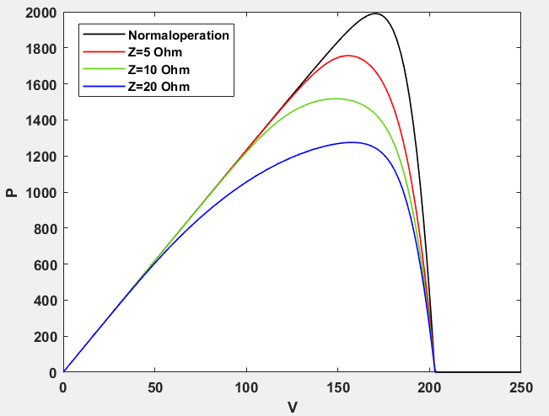
Tables3. 4: Tables of [F3] cases
Figure 3. 6: [F3] P-V Curve
Figure 3. 5: [F3] I-V Curve

Reverse polarity [F4]: The reversed polarity fault of a blocking diode has the same influence when this component is submitted to the open circuit fault.

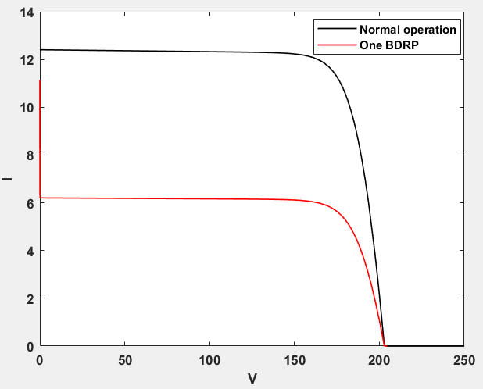
Parameters | Value
P_{m} | 1990 W
V_{oc} | 202.9 V
I_{sc} | 12.413 A
V_{mpp} | 169.7 V
I_{mpp} | 11.73 A
Parameters | Value
P_{m} | 995 W
V_{oc} | 202.9 V
I_{sc} | 6.207 A
V_{mpp} | 169.7 V
I_{mpp} | 5.865 A
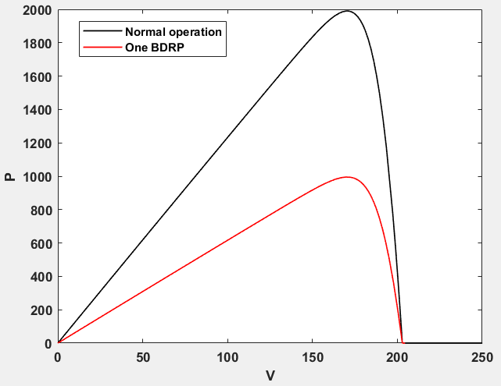
Normal operation
Figure 3. 7: [F4] I-V Curve

Reverse polarity in one blocking diode

Tables3. 5: Tables of [F4] cases
Figure 3. 8: [F4] P-V Curve
- Bypass diode faults:
Short circuit [F5]: When there is short circuit in one bypass diode in one string the maximum power will reduce by 22%, and when there is short circuit in two bypass diode in same string the maximum power will reduce by 45%. But when occurs one short circuit bypass diode in other string the change is slight.
One short circuit bypass diode in one string
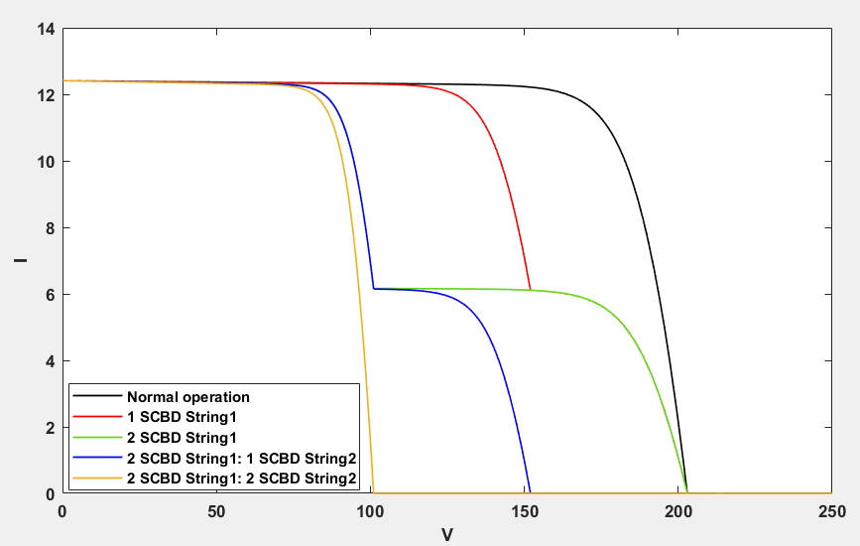
Parameters | Value
P_{m} | 1546 W
V_{oc} | 202.9 V
I_{sc} | 12.413 A
V_{mpp} | 132.2 V
I_{mpp} | 11.69 A  Two short circuit bypass diodes in one string  Parameters Value  P_{m} 1029 W  V_{oc} 202.9 V  I_{sc} 12.413 A  V_{mpp} 87.85 V  I_{mpp} 11.72 A  Two short circuit bypass diodes in one string

Parameters | Value
P_{m} | 1029 W
V_{oc} | 202.9 V
I_{sc} | 12.413 A
V_{mpp} | 87.85 V
I_{mpp} | 11.72 A

Parameters | Value
P_{m} | 990.4 W
V_{oc} | 101.1 V
I_{sc} | 12.413 A
V_{mpp} | 84.75 V
I_{mpp} | 11.69 A
Figure 3. 9: [F5] I-V Curve

Two short circuit bypass diodes in one string and one in other string

Two short circuit bypass diodes in one string and one in other string
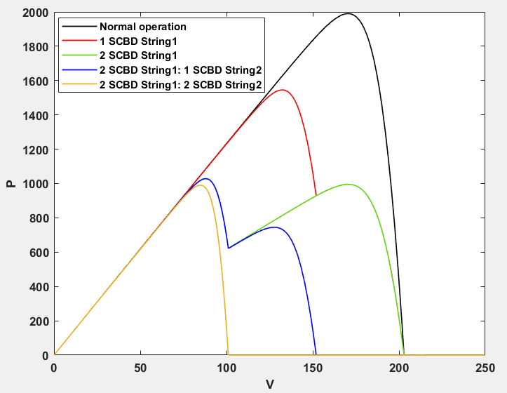
Parameters | Value
P_{m} | 1028 W
V_{oc} | 152 V
I_{sc} | 12.413 A
V_{mpp} | 87.63 V
I_{mpp} | 11.73 A

Two short circuit bypass diodes in one string and two in other string

Two short circuit bypass diodes in one string and two in other string

Figure 3. 10: [F5] P-V Curve

Tables3. 6: Tables of [F5] cases

Open circuit [F6]: The open circuit fault has no impact on the I-V and P-V curves. So, this fault is not considered in these simulations.

Impedance [F7]: In this fault, bypass diode it will be impedance fixed value Z=20 Ohm, as shown in figure the greater impact in maximum power and V_{oc} will occurs when there is impedance bypass diode in each string. However, when one string has all impedance bypass diode the I_{sc} will decrease.
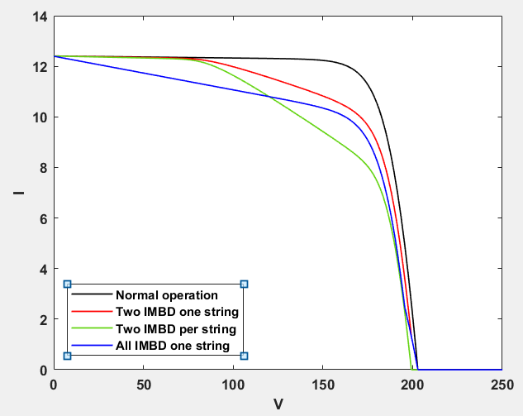
Two impedance bypass diodes in one string

Two impedance bypass diodes in one string
Two impedance bypass diodes in each string

Two impedance bypass diodes in each string

Figure 1: [F7] I-V Curve
Parameters | Value
P_{m} | 1433 W
V_{oc} | 199.3 V
I_{sc} | 12.413 A
V_{mpp} | 165.5 V
I_{mpp} | 8.656 A
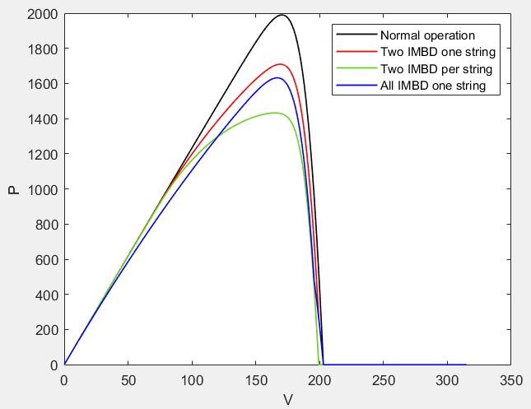
Figure 3. 11: [F7] I-V Curve

All impedance bypass diodes in one string

All impedance bypass diodes in one string
Parameters | Value
P_{m} | 1709 W
V_{oc} | 202.9 V
I_{sc} | 12.413 A
V_{mpp} | 169.3 V
I_{mpp} | 10.1 A
Tables3. 7: Tables of [F7] cases

Parameters | Value
P_{m} | 1632 W
V_{oc} | 202.9 V
I_{sc} | 12.40 A
V_{mpp} | 166 V
I_{mpp} | 9.83 A
Figure 3. 12: [F7] P-V Curve
Reverse polarity [F8]: As shown in figure when reversed polarity fault of a bypass diode its behaves as short circuit

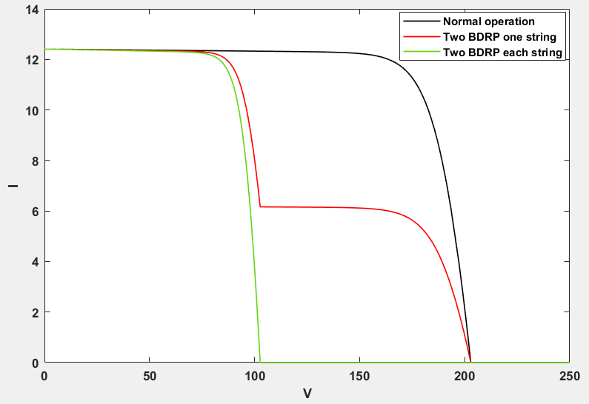
Reverse polarity in two bypass diodes in one string

Reverse polarity in two bypass diodes in one string
Parameters | Value
P_{m} | 1029 W
V_{oc} | 202.9 V
I_{sc} | 12.413 A
V_{mpp} | 87.85 V
I_{mpp} | 11.72 A
Reverse polarity in two bypass diodes in each string

Reverse polarity in two bypass diodes in each string
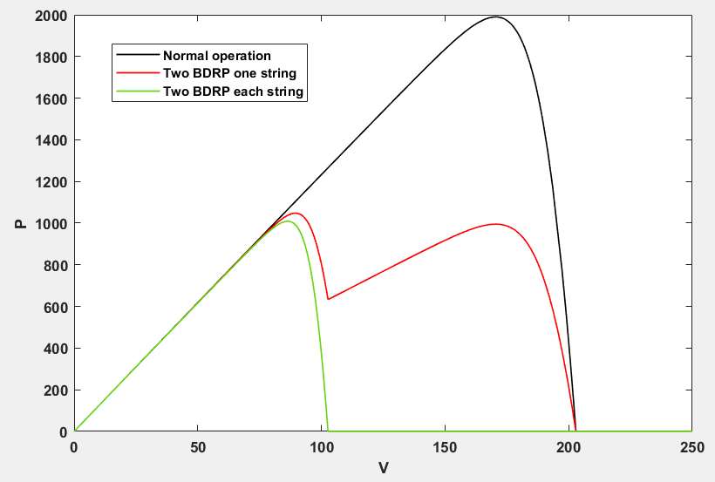
Figure 3. 13: [F8] I-V Curve

Figure 3. 14: [F8] P-V Curve
Parameters | Value
P_{m} | 990.4 W
V_{oc} | 101.1 V
I_{sc} | 12.413 A
V_{mpp} | 84.75 V
I_{mpp} | 11.69 A
Tables3. 8: Tables of [F8] cases

- Shading faults:
Total shadow on the modules [F9]: In this fault, all modules under shadow. We represent this by change irradiance to 500W/m² in first case and 250W/m² in second case. As shown in figures I-V and P-V curves changes proportionally to the irradiance value.
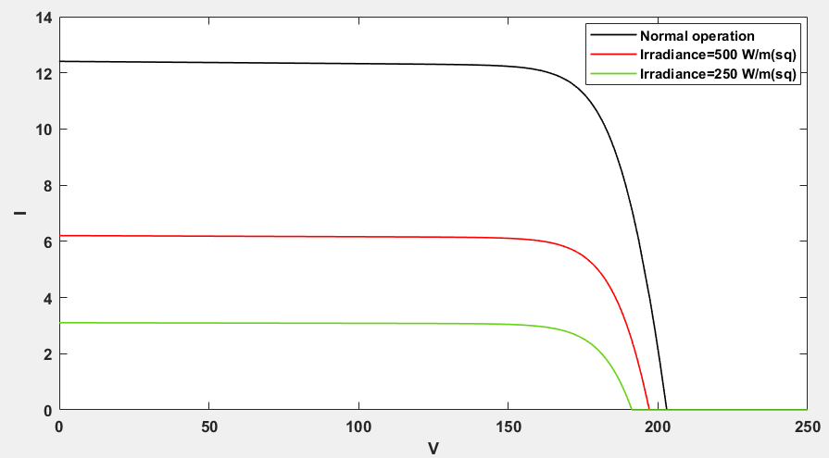
Figure 3. 15: [F9] P-V Curve
Figure 3. 16: [F9] I-V Curve
All modules under shadow, irradiance=500W/m²

All modules under shadow, irradiance=500W/m²
Normal operation

Normal operation
Parameters | Value
P_{m} | 981.6 W
V_{oc} | 197.1 V
I_{sc} | 6.206 A
V_{mpp} | 168.6 V
I_{mpp} | 5.822 A
Parameters | Value
P_{m} | 479.3 W
V_{oc} | 191.3 V
I_{sc} | 3.103 A
V_{mpp} | 164.2 V
I_{mpp} | 2.919 A
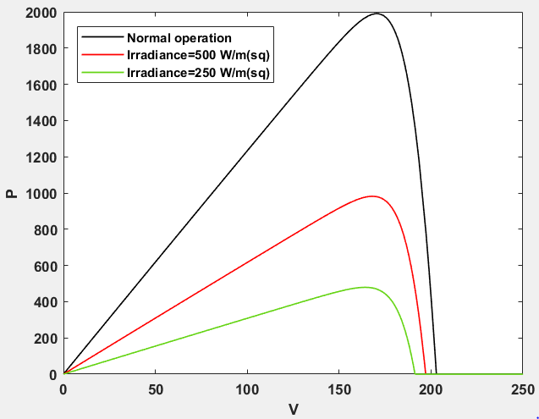
Tables3. 9: Tables of [F9] cases
All modules under shadow, irradiance=250W/m²

All modules under shadow, irradiance=250W/m²

Figure 2:[F9] I-V Curve
Parameters | Value
P_{m} | 1990 W
V_{oc} | 202.9 V
I_{sc} | 12.413 A
V_{mpp} | 169.7 V
I_{mpp} | 11.73 A

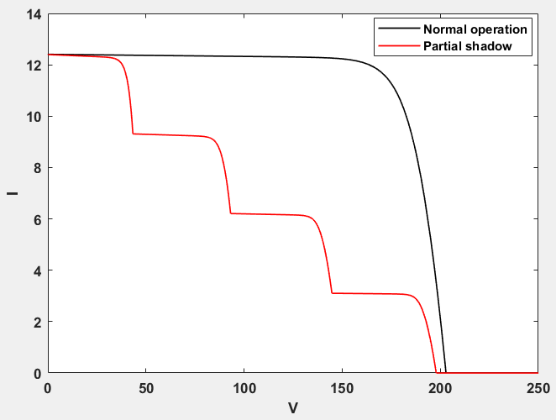
Partial shadow on the modules [F10]: We represent partial shadow by change irradiance to 1000W/m², 750W/m², 500W/m², 250W/m² respectively. The maximum power reduced 59%, and local maximum powers appeared.
Normal operation

Normal operation

Parameters | Value
P_{m} | 1990 W
V_{oc} | 202.9 V
I_{sc} | 12.413 A
V_{mpp} | 169.7 V
I_{mpp} | 11.73 A
Normal operation

Normal operation

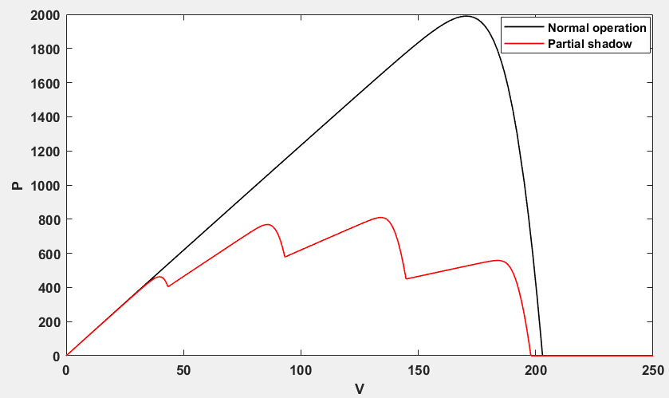
Figure 3. 17: [F10] I-V Curve
Partial shadow

Partial shadow

Partial shadow

Partial shadow
Parameters | Value
P_{m} | 1990 W
V_{oc} | 202.9 V
I_{sc} | 12.413 A
V_{mpp} | 169.7 V
I_{mpp} | 11.73 A
Tables3. 10: Tables of [F10] cases

Parameters | Value
P_{m} | 810 W
V_{oc} | 197.9 V
I_{sc} | 12.40 A
V_{mpp} | 133.9 V
I_{mpp} | 6.048 A
Figure 3. 18: [F10] P-V Curve
- PV modules faults:
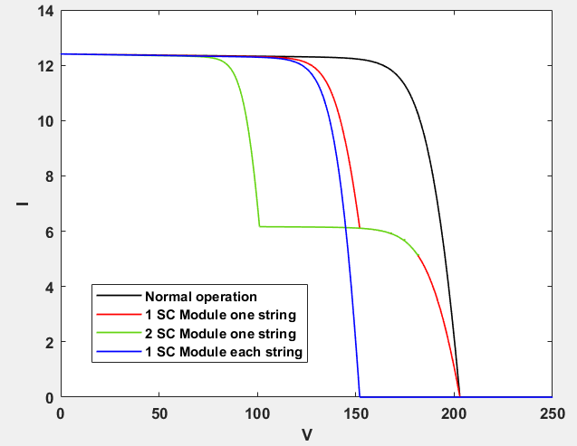
Short circuit in any module [11]: To represent this fault, we replaced module by short circuit. The most dangerous case when there are two modules in series are shorted, results in overcurrent in the faulty string and could be high enough to damage PV array, as shown in green curve in figure.
One short circuit module in one string

One short circuit module in one string

One short circuit module in one string

One short circuit module in one string

Parameters | Value
P_{m} | 1546 W
V_{oc} | 202.9 V
I_{sc} | 12.413 A
V_{mpp} | 132.6 V
I_{mpp} | 11.66 A

One short circuit module in each string

One short circuit module in each string

One short circuit module in each string

One short circuit module in each string

Figure 3:[F11] I-V Curve

Figure 4:[F11] I-V Curve

Figure 5:[F11] I-V Curve
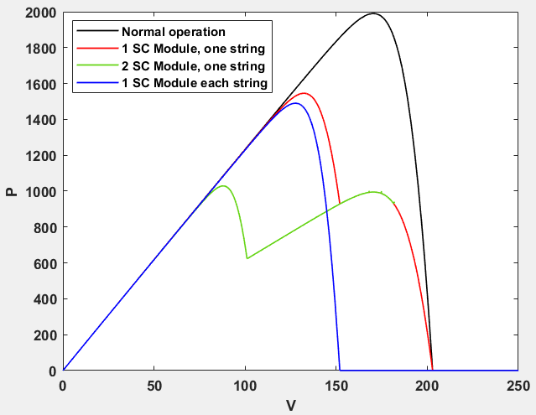
Figure 3. 19: [F11] I-V Curve
Parameters | Value
P_{m} | 1490 W
V_{oc} | 152 V
I_{sc} | 12.413 A
V_{mpp} | 127.7 V
I_{mpp} | 11.67 A
Tables3. 11: Tables of [F11] cases

Figure 3. 20: [F11] P-V Curve

Disconnection [12]: As shown in figure. The open voltage of these cases remains almost the same, while the maximum power decrease linearly with the increase in the number of disconnected strings.
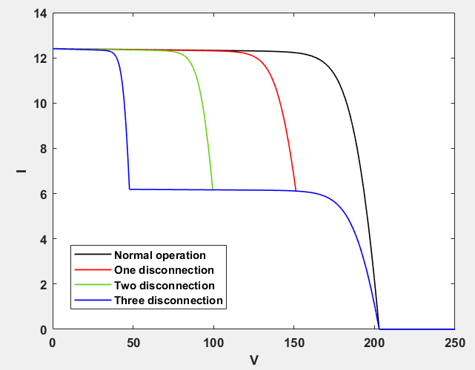

One disconnection

One disconnection

One disconnection

One disconnection
Parameters | Value
P_{m} | 1536 W
V_{oc} | 202.9 V
I_{sc} | 12.413 A
V_{mpp} | 131.9 V
I_{mpp} | 11.65 A
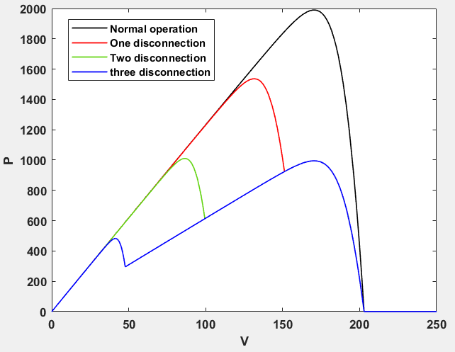
Figure 3. 21: [F12] I-V Curve
Two disconnection

Two disconnection

Two disconnection

Two disconnection
Parameters | Value
P_{m} | 1010 W
V_{oc} | 202.9 V
I_{sc} | 12.411 A
V_{mpp} | 86.5 V
I_{mpp} | 11.68 A

Three disconnection

Three disconnection

Three disconnection

Three disconnection
Tables3. 12: Tables of [F12] cases
Parameters | Value
P_{m} | 995 W
V_{oc} | 202.9 V
I_{sc} | 12.40 A
V_{mpp} | 171 V
I_{mpp} | 5.82 A

Figure 3. 22: [F12] P-V Curve

- Connectivity fault:
Two modules connected by a resistance [F13]: This fault represent by make resistance between modules in one string. Occurs degradation in maximum power proportionally to the resistance value.
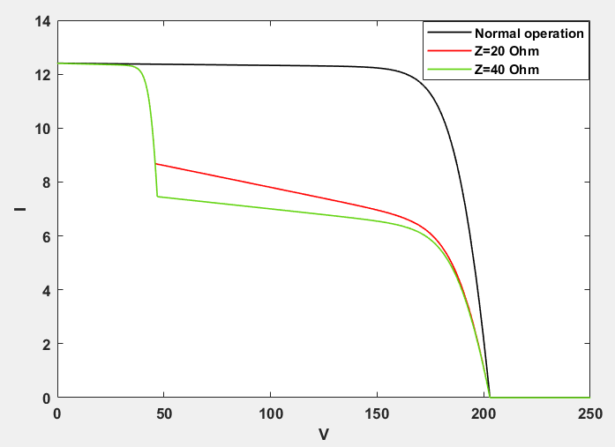
Z=20 Ohm

Z=20 Ohm

Z=20 Ohm

Z=20 Ohm

Parameters | Value
P_{m} | 1087 W
V_{oc} | 202.9 V
I_{sc} | 12.40 A
V_{mpp} | 166.2 V
I_{mpp} | 6.54 A
Parameters | Value
P_{m} | 1041 W
V_{oc} | 202.9 V
I_{sc} | 12.40 A
V_{mpp} | 168.3 V
I_{mpp} | 6.186 A
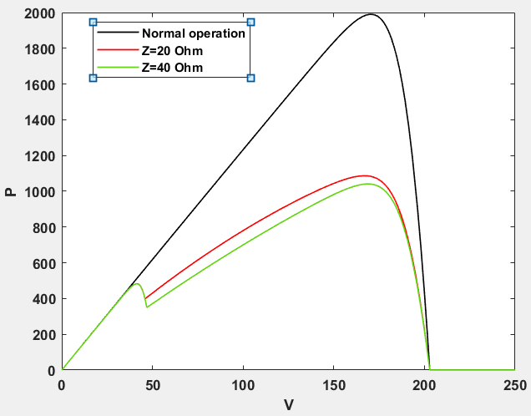
Figure 3. 24: [F13] P-V Curve
Figure 3. 23: [F13] I-V Curve
Z=40 Ohm

Z=40 Ohm

Z=40 Ohm

Z=40 Ohm

Tables3. 13: Tables of [F13] cases

4. Experimental Work
In this chapter we verify our work experimentally for the normal condition at Riyadh condition and the partial shading fault without bypass diode only since other faults cannot be verified with the available resources.

4.1 Equipment
Module measurement method uses the variable of resistance to determine the I-V and P-V curves practically. By changing the resistance of the module load and measuring voltage and current.
- PV solar panel:
The PV panel used in the practical work is (150W MONO) type as shown in fig1, also the nameplate is shown in fig2
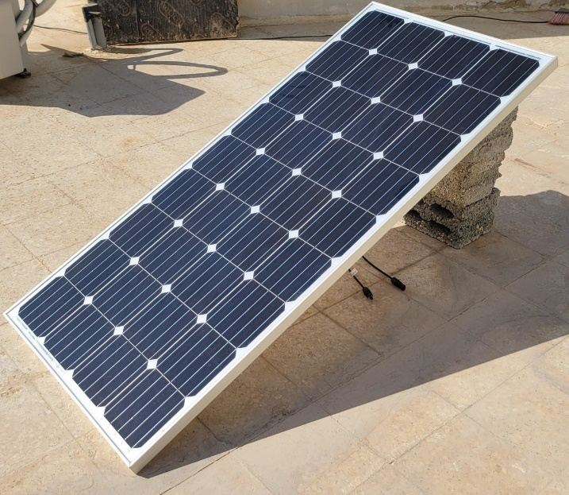
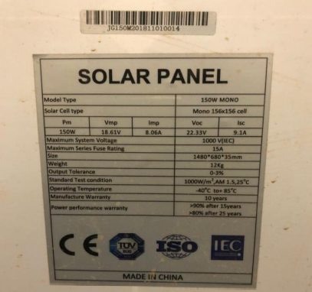
Fig 4. 2: Solar Panel nameplate.
Fig 4. 1: 150W MONO Solar Panel.

- Variable Resistance:
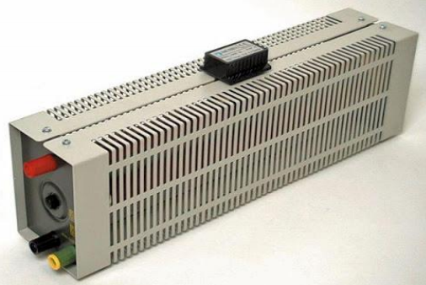
To draw the I-V Curve we had to use a Variable Resistance since it is hard to take a full day reading of Current and Voltage.
Fig 4. 3: Variable Resistance.

- Two Multimeters:
To take the Current and the Voltage Reading at the same time we had to use Two Multimeters as shown in fig4.
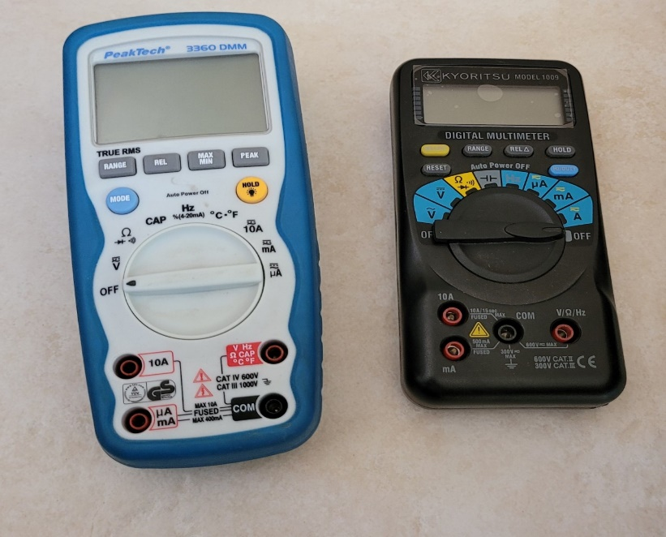
Fig 4. 4: Multimeters.

- Connection Wires:
To connect the equipment and make the circuit uses some wires.
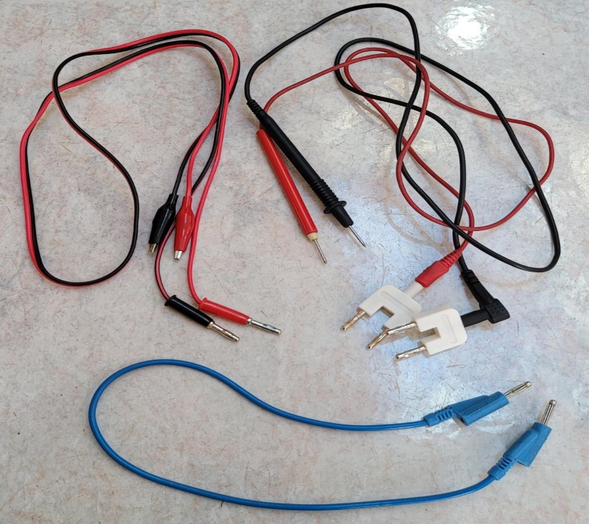
Fig 4. 5: Connection Wires

- Solar Power Meter:
To measure solar irradiance, solar power meter will be needed. It should be fixed at the same level as the solar panel
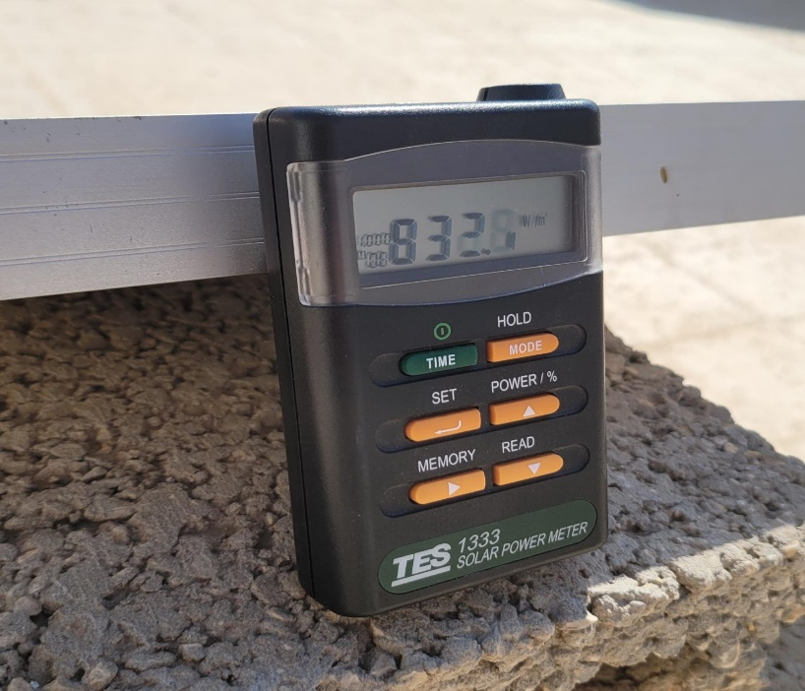
Fig4. 6: Solar power meter

- Carton Board:
Use carton board to apply the shading cases:
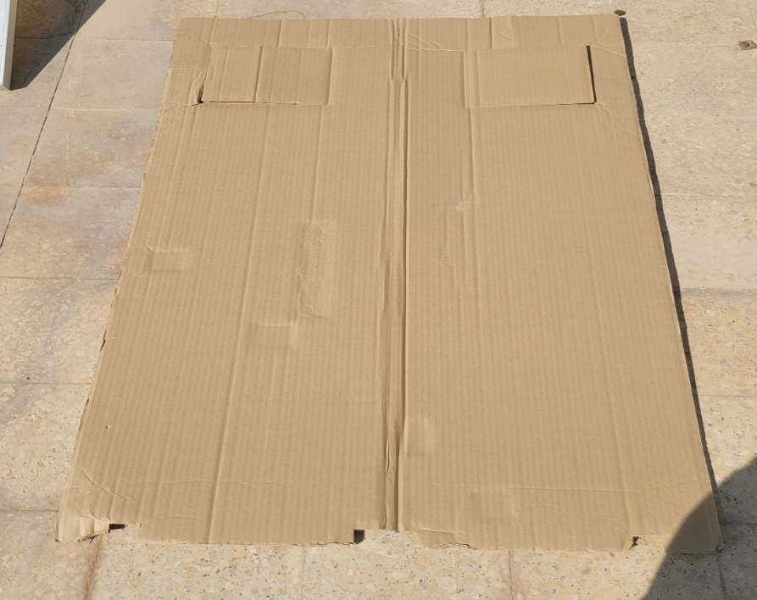
Fig4. 7: Carton board

4.2 Circuit and Connection
Variable resistance connected in series with module. black multimeter is connected in series as an ammeter, and the blue one is connected in parallel as a voltmeter. The angle of the panel is fixed at latitude of Riyadh about 24 degree.
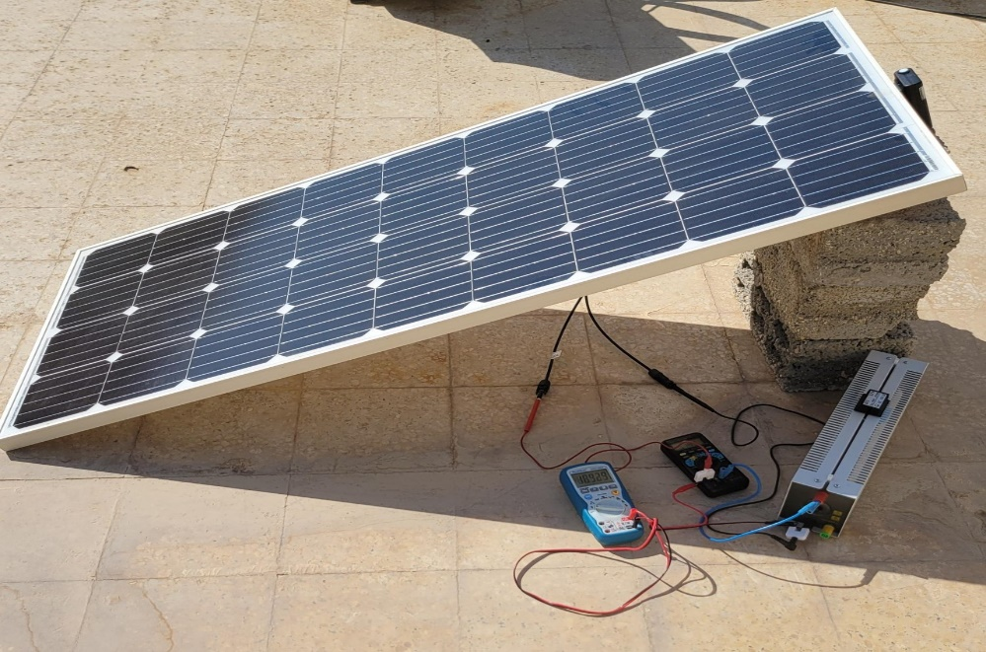
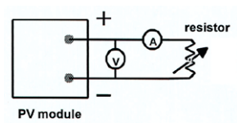

Fig4. 8: Circuit and Connection

4.3 Experimental Results for Normal Condition:
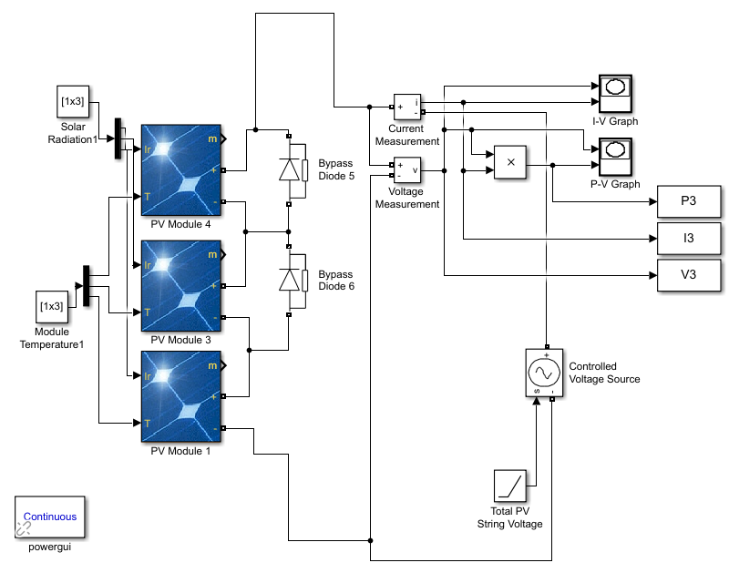
First, the simulation results with specifications of PV solar panel (STC) by using the circuit as shown below, then the experimental results on different days and times at Riyadh conditions.

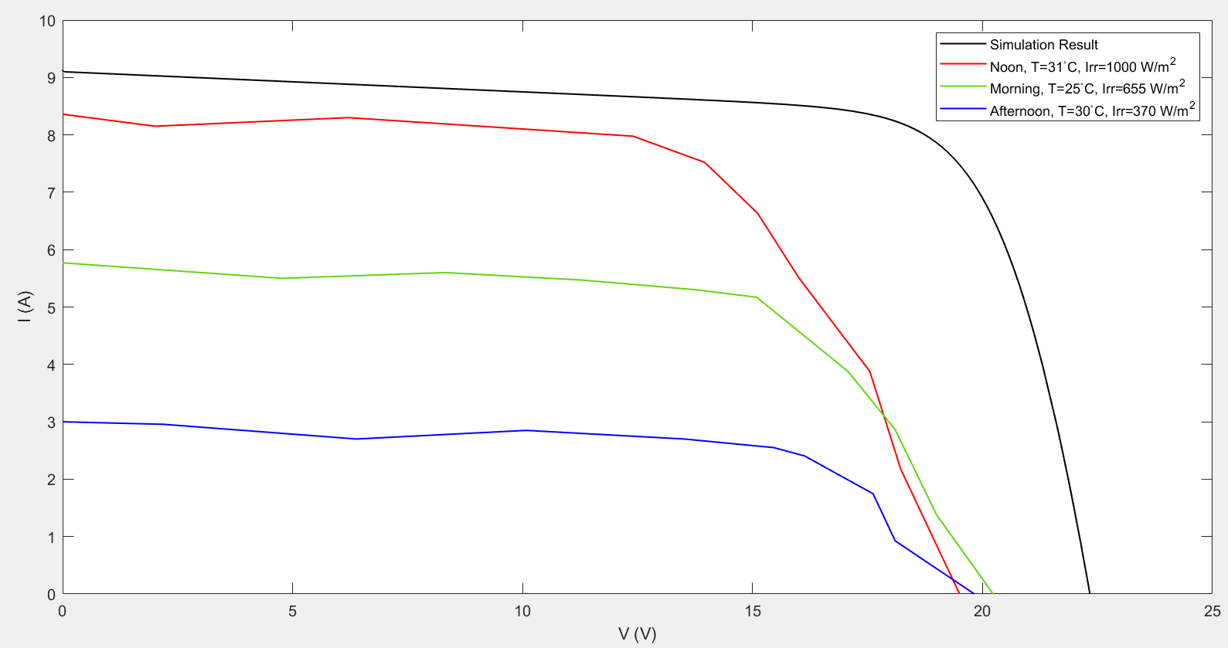
Current-Voltage Curves:
Figure 4. 9: I-V Curves for simulation and experimental results

Table 4. 2: I-V simulation and experimental results
Results:
T (ºC) | Irr (W/m2) | V_{oc} (V) | I_{sc} (A)
25 | 1000 | 22.33 | 9.1 | Simulation Results
31 | 1050 | 19.5 | 8.36 | Noon | Experimental Results
25 | 655 | 20.23 | 5.77 | Morning
30 | 370 | 19.82 | 3 | Afternoon

Comments:
- I_{sc} is directly proportional to the irradiance, so as shown above at noon I_{sc} is close to the simulation result by 92%, at morning and at afternoon it is become lower because the irradiance is lower.

- Increasing in temperature causes a decreasing in V_{oc} , So it is lower at noon, and higher at morning because the temperature practically equal to temperature in simulation results.

- Afternoon is the worst time, because the irradiance is lower and the temperature is higher, which affects the I_{sc} and V_{oc}

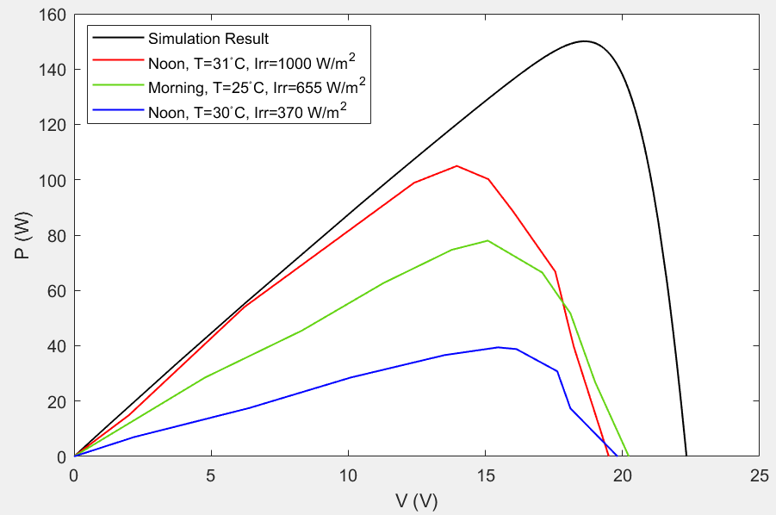
Power-Voltage curves:
Figure 4. 10: P-V Curves for simulation and experimental results

Results:
Table 4. 2: P-V simulation and experimental results
η (%) | P_{max} (W) | V_{max} (V) | I_{max} (A)
15 | 150 | 18.61 | 8.06 | Simulation Results
10.5 | 105 | 13.96 | 7.52 | Noon | Experimental Results
7.8 | 78 | 15.09 | 5.17 | Morning
3.9 | 39.42 | 15.46 | 2.55 | Afternoon

Comments:
- The best efficiency of PV solar panel at noon, where it was equal to 70% from efficiency in simulation results (STC), then at morning 52%, and the worst time is afternoon where it was 26%.

- Resistance of cables, voltmeter and ammeter causes drop in current, voltage and power losses. In addition to the test conditions in terms of weather and radiation fluctuations.

- Maximum power obtains when the resistance equal to:
R_{(noon)}= 2 Ohm R_{(morning)}= 3.25 Ohm R_{(afternoon)}= 6.5 Ohm

- Decreasing in irradiance means needed to higher resistance to obtains maximum power, because an increase in the resistance leads to an increase in the voltage, while the current changes slightly under a slight irradiance.

4.4 Experimental Result for Partial Shading Condition:
The simulation of partial shading by change the irradiance to 130 W/m² (as appeared to us in experiment) at the last module as shown below.
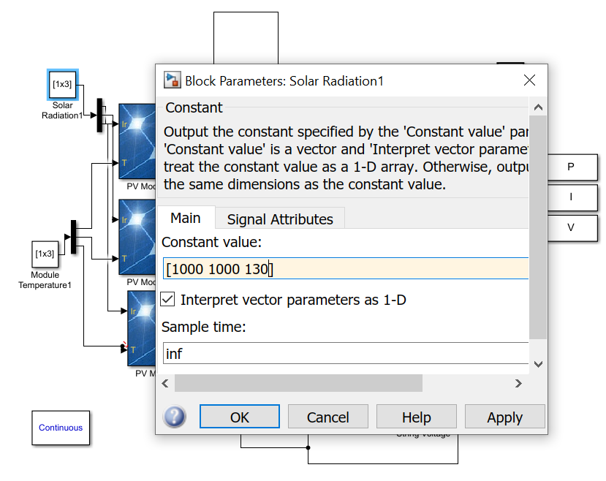
Experimentally, use carton board to apply the partial shading on 33% of a PV solar panel as shown in fig11.
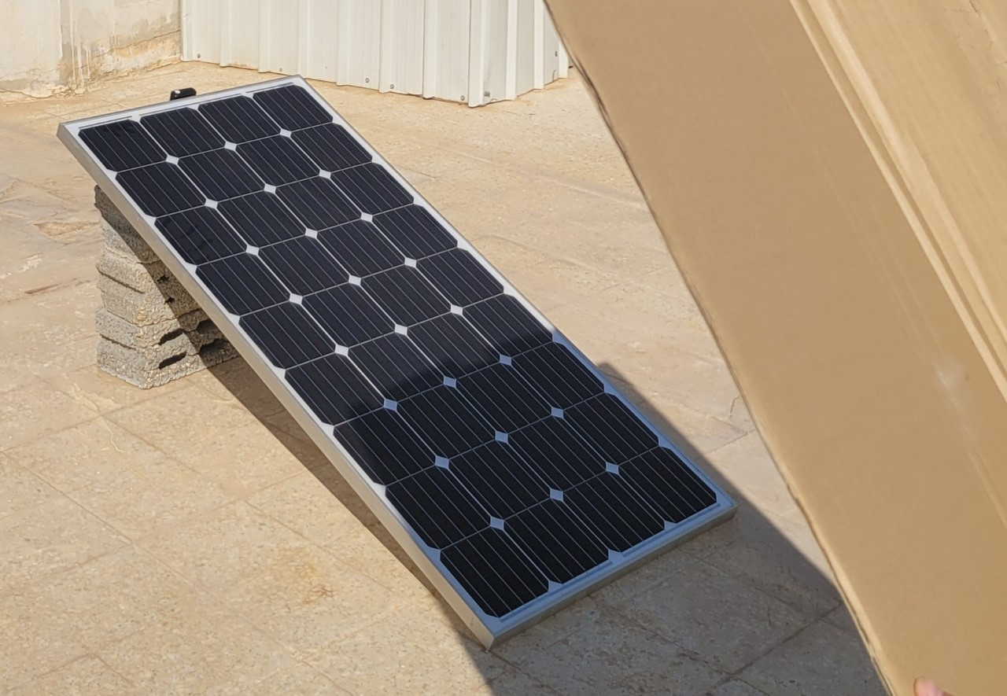

Figure 4. 11: Partial shading practically
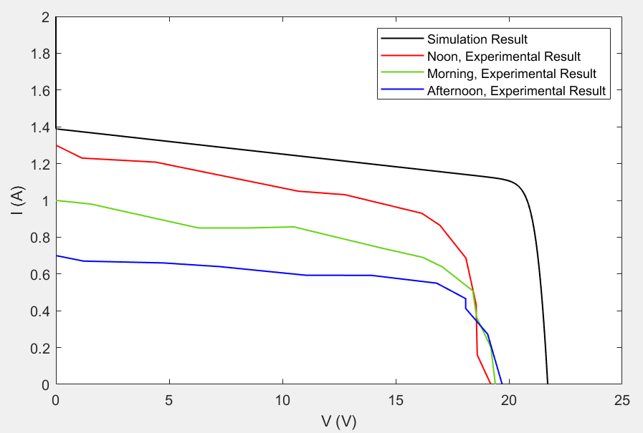
Current-Voltage curves:

Figure 4. 12: I-V Curves for simulation and experimental results

Table 4. 3: I-V simulation and experimental results
Results:
T (ºC) | Irr (W/m2) | V_{oc} (V) | I_{sc} (A)
25 | 1000 | 21.71 | 1.39 | Simulation Results
29 | 1000 | 19.2 | 1.3 | Noon | Experimental Results
27 | 700 | 19.4 | 1 | Morning
29 | 340 | 19.7 | 0.7 | Afternoon

- The main effect of partial shading is on the current, in simulation results I_{sc} decreasing by 84% from the normal condition (STC).

- At noon, I_{sc} experimentally equal to 93.5% from the simulation results, 72% at morning and 50% at afternoon.

- The worst effect at afternoon, because the irradiance on cells that were not exposed to partial shading is lower than other times.

- Effect of partial shading on the voltage is slight.

- Drop in voltage due to the series resistance of the ammeter. drop in current due the Parallel resistance of the voltmeter.
Comments:

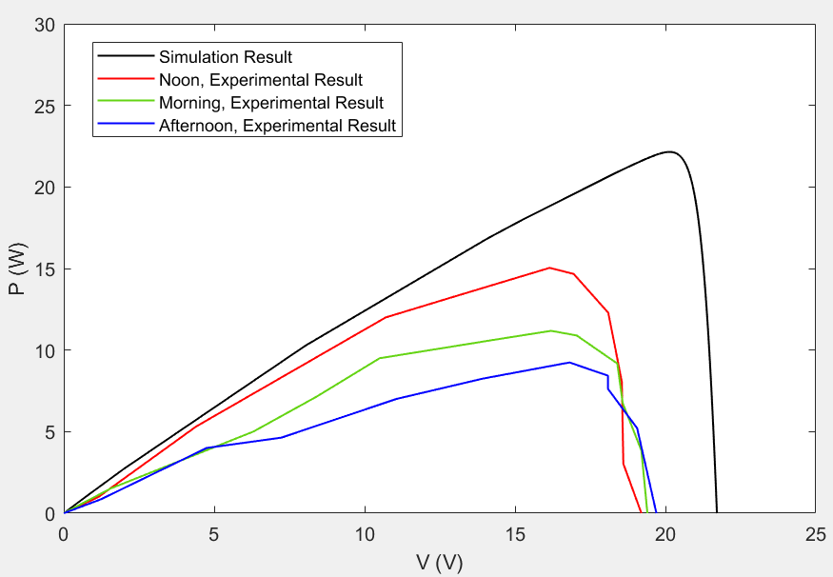
Power-Voltage curves:

Figure 4. 13: P-V Curves for simulation and experimental results

η (%) | P_{max} (W) | V_{max} (V) | I_{max} (A)
2.2 | 22.15 | 20.11 | 1.1 | Simulation Results
1.5 | 15.04 | 16.15 | 0.93 | Noon | Experimental Results
1.1 | 11.18 | 16.2 | 0.69 | Morning
0.9 | 9.24 | 16.81 | 0.55 | Afternoon
Table 4. 4: P-V simulation and experimental results
Results:

Comments:
- Partial shading caused decreasing in efficiency from 15% to 2.2% under STC in simulation results.

- At noon, P_{max} experimentally equal to 68% from the simulation results, 50% at morning and 41% at afternoon.

- To improve efficiency, bypass diodes can be used in PV module to bypass the shaded modules during partial shading.

- Shading inconsistency because it is difficult to apply the shading accurately with 33.3% percent of the module.

4.5 Experimental Result for Total Shading Condition:
The simulation of total shading by change the irradiance to 130 W/m² (as appeared to us in experiment) at all modules as shown below.
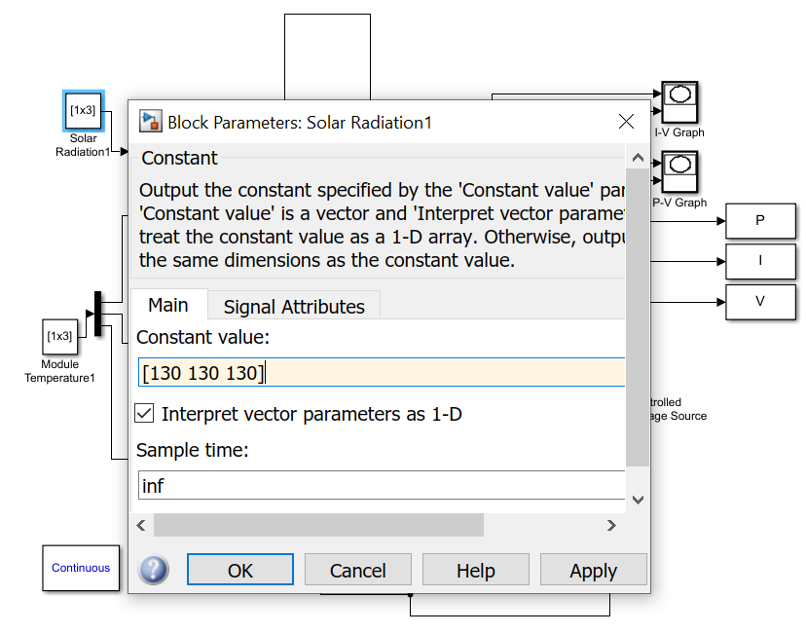

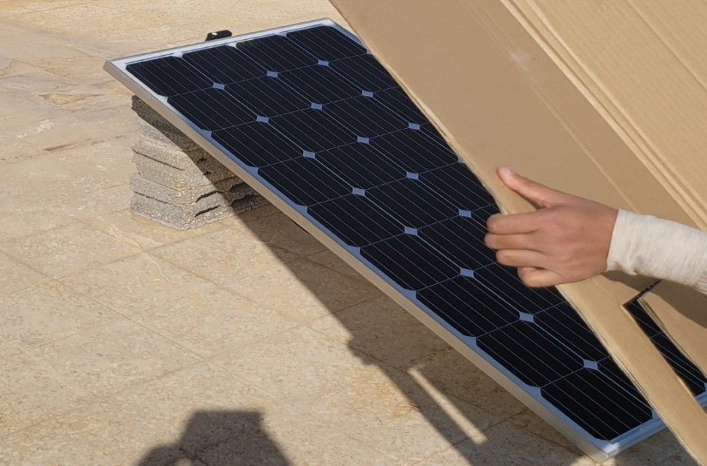
Experimentally, use carton board to apply the total shading on all a PV solar panel as shown in fig14.

Figure 4. 14: Total shading practically
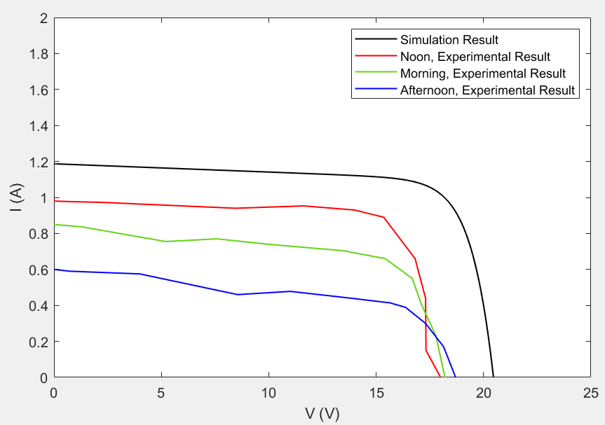
Current-Voltage curves:

Figure 4. 15: I-V Curves for simulation and experimental results

T (ºC) | Irr (W/m2) | V_{oc} (V) | I_{sc} (A)
25 | 130 | 20.45 | 1.19 | Simulation Results
30 | 130 | 18 | 0.98 | Noon | Experimental Results
28 | 110 | 18.2 | 0.85 | Morning
29 | 95 | 18.7 | 0.6 | Afternoon
Table 4. 5: I-V simulation and experimental results
Results:

Comments:
- Isc decreasing by 87% from normal condition (STC) in simulation results.

- At noon, the difference between Isc in simulation and experimentally is equal to 0.21 A

- Effect of total shading on the voltage is slight, but it is more than effect under partial shading

- Drop in voltage due to the series resistance of the ammeter. drop in current due the Parallel resistance of the voltmeter.

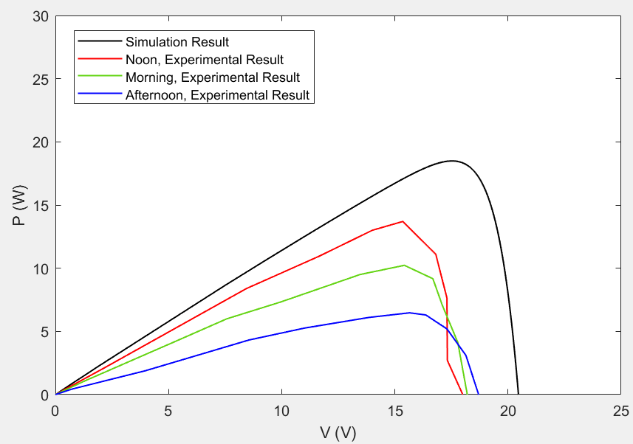
Power-Voltage curves:

Figure 4. 16: P-V Curves for simulation and experimental results

η (%) | P_{max} (W) | V_{max} (V) | I_{max} (A)
1.85 | 18.5 | 17.51 | 1.056 | Simulation Results
1.37 | 13.7 | 15.35 | 0.89 | Noon | Experimental Results
1 | 10.23 | 15.42 | 0.66 | Morning
0.65 | 6.47 | 15.65 | 0.414 | Afternoon
Table 4. 6: P-V simulation and experimental results
Results:

Comments:
- Total shading caused degradation in power greater than partial shading

- Total shading caused decreasing in efficiency by 87.6% from normal condition (STC) in simulation results.

- The efficiency of panel is inversely proportional to the irradiance under total shading

- When the power input drops from 1050W to 130W at noon, the power output drops from 105W to 13.7W which is roughly the same percentage 87%

5. Conclusions
In conclusion, to understand PV array, we presented overview about basics of solar PV. Then, we considered various fault cases such as short circuit, open circuit, impedance, reversed polarity and partial shading faults, are the major faults known in the field of the PV diagnosis. We investigated a fault diagnosis technique for a photovoltaic string based on its I-V and P-V characteristics by Matlab/Simulink. This study was overall constructed to learn about each of these faults.
After establishing a clear view of how the results might be, verifying it using the experimental work was the next step. As mentioned before faults such as impedance, reversed polarity and short circuit can’t be done experimentally. So, the verification procedure focused on the shading faults without bypass diode.
Conclusion | η (%)
The best efficiency of PV solar panel at noon, where it was equal to 70% from efficiency in simulation results (STC), then at morning 52%, and the worst time is afternoon where it was 26%. | 15 | Simulation Results |  | Normal Condition
 | 10.5 | Noon | Experimental Results
 | 7.8 | Morning
 | 3.9 | Afternoon
The main effect of partial shading is on the current, in simulation results I_{sc} decreasing by 84% from the normal condition (STC). At noon, I_{sc} experimentally equal to 93.5% from the simulation results, 72% at morning and 50% at afternoon. | 2.2 | Simulation Results |  | Partial shading
 | 1.5 | Noon | Experimental Results
 | 1.1 | Morning
 | 0.9 | Afternoon
Total shading caused degradation in power greater than partial shading. And decreasing in efficiency by 87.6% from normal condition (STC) in simulation results. | 1.85 | Simulation Results |  | Total shading
 | 1.37 | Noon | Experimental Results
 | 1 | Morning
 | 0.65 | Afternoon
Table 5. 1: Conclusion of assessment results
From simulation and experimental results, we can conclude the following:

References

- S. Sumathi et al., "Solar PV and Wind Energy Conversion Systems - An Introduction to Theory, Modeling with MATLAB/SIMULINK, and the Role of Soft Computing Techniques", 2015
- SOUMEN PAL, "Modeling, Simulation And Misdiagnosis Of A Photovoltaic Array Using Genetic Algorithms", 2007
- Siwar Fadhel et al., "Faults Effects Analysis In A Photovoltaic Array Based On Current-Voltage And Power-Voltage Characteristics", 2019
- David Nilsson, "Fault Detection in Photovoltaic Systems", 2014.
- M.Sabbaghpur Arani and M.A.Hejazi, "The Comprehensive Study of Electrical Faults in PV Arrays", 2016
- Ye Zhao, "Fault Analysis in Solar Photovoltaic Arrays", 2010
- Tingting Pei and Xiaohong Hao, "A Fault Detection Method for Photovoltaic Systems Based on Voltage and Current Observation and Evaluation", 2019
- Dong Ji et al., "Photovoltaic Array Fault Detection by Automatic Reconﬁguration", 2017

