Experimental and Numerical Study on Structural behavior of Tree-Like Steel Columns

Abstract
Tree-like steel columns have been used throughout the world in many structures, especially in large halls and pools. Few researchers studied the structural behavior of tree-like steel columns experimentally, and they do not focus on its geometry parameters. The research aimed to study the effect of the ratio of branch’s height to total height, the ratio of specimen’s width to the overall width, number of branches, number of branching levels, and the ratio of section non-prismatic on the structural behavior of the tree-like steel column experimentally. Furthermore, developing a 3D finite element model to simulate the tree-like column with different parameters. Experimental work was carried out on thirteen specimens. All specimens were tested under a static compressive load and evaluated for failure load, vertical failure displacement, and failure mode. The ratio of the branch’s height to total height and specimen’s width to overall width was varied from 25 to 50, 75, and 100 %, respectively. Moreover, the number of branches varied from one to two and three, respectively. The branching levels changed from one to two, and the ratio of section non-prismatic was varied from 100 to 75, 50, and 25 %, respectively. The results showed that when the ratio of the branch’s height to total height increased, failure load increased between (11.2 – 50.4) %, but when the ratio of specimen’s width to overall width increased, the failure load decreased between (6.4 - 25.6) %. Also, the failure load increased when increasing the number of branches, and it decreased when changed the branching levels from one to two. The failure load significantly decreased when decreasing the ratio of section non-prismatic. All specimens failed with the buckling mode. The finite element model was calibrated and validated by using the experimental results. Another parameter was studied by using the FE model.
Keywords: Tree-like column, branching structure, column, lightweight structure, dendriform structures.

Introduction
Many designers have preferred forms that combine with wilderness, and it has a strong structure like trees and forests. One of the benefits of using tree-like columns is that they cover a large surface area with near bearing points. There are three methods of the form-finding of tree-like columns: experimental, geometric, and numerical. Experimental methods have a technique of wet thread, dry thread, beaded thread, etc. Its results influenced by the scale of the model. Frei Otto (Glaeser, Otto, and Art 1972) was one of the first engineers to take an interest in the lightweight tree-like systems with the experimental method. Kolodziejczyk (von Buelow 2007) used the waterish logging thread model to carry out the form-finding of branching structures.
Geometrical methods introduce fractal theory to produce tree-like geometric shapes. Gawell produced geometric tree-like forms based on L-system fractal theory and applicate it in Tote Restaurant in Mumbai (Gawell 2013). The tree-like shapes produced by the fractal method only focus on the forms of trees. By using the structure optimizing technology, they can improve
∗Corresponding author.
Email address: ali-almalki@utq.edu.iq (Ali Abdulmohsin Khamees*)
their geometrical configuration in order to take into account the mechanical features of the trees (Li 2014). Buelow (Von Buelow 2006) used the genetic algorithm (GA) to study the tree-like structure. Hunt (Hunt, Haase, and Sobek 2009) proposed to use a numerical method where tree structures are supposed to be connected to hinge, and pseudo supports are added to maintain a positive stiffness matrix in a vertical direction. Numerical methods used to generate tree-like forms, and use of this aspect became hotspot (Peng 2016). Zhang studied tree-like form-finding using the sliding element cable (Zhang et al. 2015). Using the skeleton structure optimization method, Changyu implemented the tree-like sensitivity form-finding method (Cui, Jiang, and Cui 2013). Meanwhile improved the evolutionary method of structural optimization (ESO) to generate the optimal topology of tree-like as a topological optimization method of continuum structures (Hui 2006). For designing the Qatar Convention Center, the enhanced ESO method was applied by Sasaki (Sasaki, Itō, and Isozaki 2007). Wu (Wu, Zhang, and Cao 2011) proposed a recursive reverse hang method for optimizing the branching structure form. Ahmeti (Ahmeti 2007) researched a group of branching column structures and compared them in order to learn about each column type’s structural behavior. The new method for the strengthening (bracing) of seismically loaded steel building using branch columns that look similar to trees, used by R. Black and A (Black and Astaneh-Asl 2014). No single method can efficiently solve the problems in the development of tree-like structures of topological nature, shape analysis, and mechanical optimization. Tree-like columns are located in a number of buildings around the world, as shown in Fig. 1.
The objectives of the research were to study the effect of the ratio of branch’s height to total height, ratio of specimen’s width to the overall width, number of branches, number of branching levels, and the ratio of section non-prismatic on the structural behavior of the tree-like steel column. Furthermore, developing a 3D finite element model to simulate the tree-like column with different parameters. The model’s calibration and validation were done with the experimental work depending on the failure load and load-displacement response.
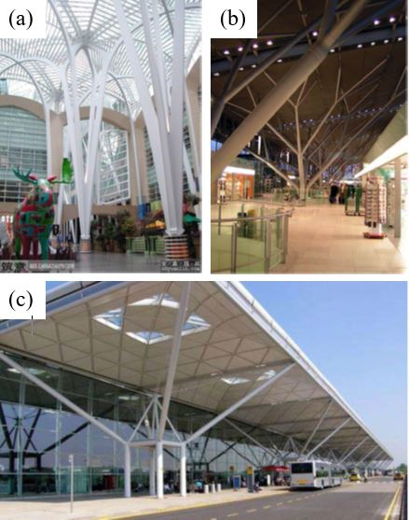
Fig. 1, Some Buildings that have Tree-like Steel Column; (a) BCE Culture Square Building (b) Stuttgart Airport Waiting Hall (c) Stansted Airport, London.

Experimental investigation

Description and Manufacturing of Specimens’
Thirteen tree-like steel column specimens were used in this research program; each specimen covers volume with dimensions: 350 mm width, 350 mm height, and 350 mm thickness, as shown in Fig.2. The details of the specimens were summarized in Table 1. Six codes labeled all specimens. For instance, in the T-1-2-100-25-25 label, where the first symbol refers to the plane tree-like column, the second symbol refers to the number of branching level (BL), the third symbol refers to the number of branches (BN), the fourth symbol refers to the ratio of section non-prismatic (NP), the fifth refers to the ratio of branch’s height to the total height (HB/HT) and the sixth symbol refers to the ratio of specimen’s width to overall width (W/WT). All specimens were made from steel plate gauge 6 mm. and they were cut by using Computer Numerical Control (CNC) machine. Specimens were provided with steel bases that fixed to the specimen by using welding. The steel bases contained holes for fixe the specimen to the testing machine by 17 mm diameter steel screws. The welding method was an electric arc covered electrode J38.12 / E6013. During the manufacture of the specimens, the horizontal and vertical straightness of all were checked. All specimens were dyed by spraying device; Fig. 3 showing the manufacturing of specimens.
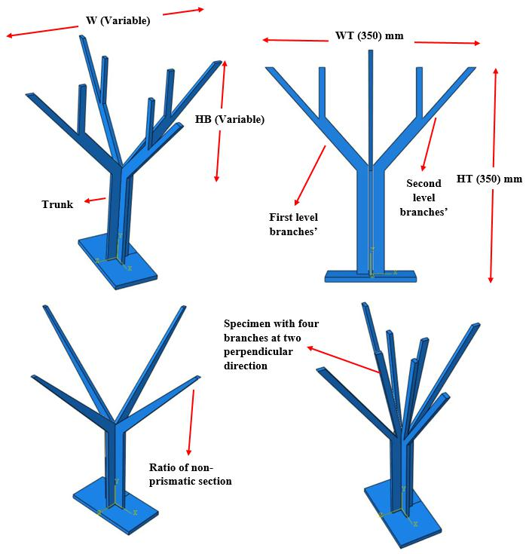
Fig. 2, Specimen Parameters Details.

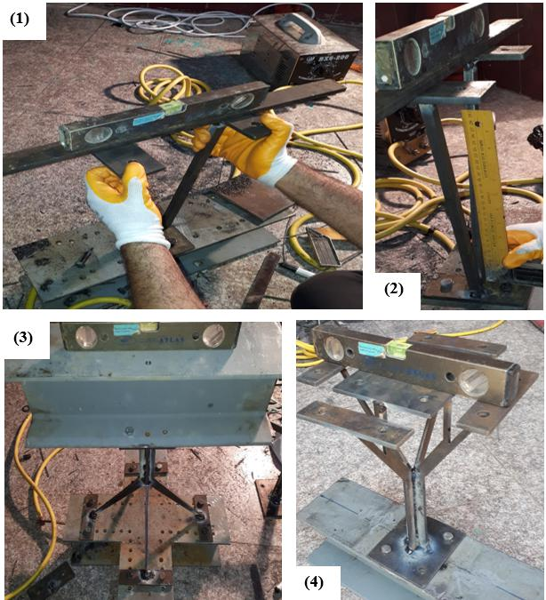

Fig. 3, Tree-Like Specimens’ Manufacturing Steps.

Materials
The steel plate that used in research is compliant with the specifications of ASTM A 605 [15] for the physical and chemical limitations, and the test results were summarized in Table 2 and Table 3. Steel plate tensile testing was performed using the method described in ASTM A370 (ASTM-A370A 2019), ASTM A36 (ASTM-A36M 2019), and chemical testing was performed using the method described in BS 4449. As for welding, the welding electrodes J38.12/E6013 was used in compliance with AWS A5.1 E6013. The welding was carried out according to the requirements of the AWS structural welding process. Destructive welding tests NDT was conducted to ensure the highest quality of welding and its suitability for concept fixation. To ensure its consistency, Visual test VT and penetrating test PT were carried out on welding.

Table 1, Specimens Dimensions.

Specimen Designations | HB (mm) | W (mm) | Trunk length (mm) | BN | BL | NP % | Parameter Studied
T-1-2-100-25-100 | 87.5 | 350 | 262.5 | 2 | 1 | 100 | The Parameter that Studied by these specimens is the ratio of the branch’s height to the total height.
T-1-2-100-50-100 | 175 | 350 | 175 | 2 | 1 | 100
T-1-2-100-75-100 | 262.5 | 350 | 87.5 | 2 | 1 | 100
T-1-2-100-100-100 | 350 | 350 | Non | 2 | 1 | 100
T-1-2-100-50-50 | 175 | 175 | 175 | 2 | 1 | 100 | The Parameter that Studied by these specimens is the ratio of the specimen’s width to the overall width.
T-1-2-100-50-75 | 175 | 262.5 | 175 | 2 | 1 | 100
T-1-2-100-50-100 | 175 | 350 | 175 | 2 | 1 | 100
T-1-3-100-50-100 | 175 | 350 | 175 | 3 | 1 | 100 | The Parameter that Studied by these specimens with specimen T- 1-2-100-50-100 is the number of branches.
T-1-4-100-50-100 | 175 | 350 | 175 | 4 | 1 | 100
T-2-4-100-50-100 | 175 | 350 | 175 | 4 | 2 | 100 | The Parameter that Studied by this specimen with specimen T- 1-2-100-50-100 is the number of branching levels.
T-1-2-75-50-100 | 175 | 350 | 175 | 2 | 1 | 75 | The Parameter that Studied by these specimens with specimen T- 1-2-100-50-100 is the ratio of non-prismatic section.
T-1-2-50-50-100 | 175 | 350 | 175 | 2 | 1 | 50
T-1-2-25-50-100 | 175 | 350 | 175 | 2 | 1 | 25
HB: Height of branch.
W: Specimen’s width.
BN: Number of branches.
BL: Number of branching levels.
NP: Ratio of non-prismatic section.

Table 2, Physical Results of Steel Test.
Test name | Plat 6 Mm thickness | ASTM A36/A36 M limits (Min.)
Yield point, min, Mpa | 276 | 250
Tensile strength, min, Mpa | 422 | 400 for (6 Mm)
Elongation, min, % | 25 | 20

Table 3, Chemical Results of Steel Test.
Test name | Sample | ASTM A36/A36 M limits
Carbon, max, % | 0.210 | 0.25
Manganese, % | --- | ---
Phosphorus, max, % | 0.040 | 0.04
Sulfur, max, % | 0.043 | 0.05
Silicon, max, % | 0.341 | 0.40
Copper, min, % | 0.432 | 0.20

Testing Procedure
The static load test was carried out in the structural laboratory / Babylon university by using a hydraulic compressive device with a capacity of about 400 kN, as shown in Fig. 4. It has an LCD screen to read of the results correctly and all necessary sensors. The testing device was calibrated by Iraq’s Central Organization for Standardization and Quality Control (COSQC). To achieve the fixing support at the top and bottom of the specimens, they were linked to the device’s frame by using 17 mm screws, number 4 at the base, and 8 or 14 at the top. The load was applied uniformly on the top of the specimen. The Linear Variable Differential Transformer LVDT sensor was put on top of all specimens to measure the vertical displacement. For reading load, vertical displacement, a data logger was used. The results were extracted and transferred to the Excel program to find out the failure load and then drew the load - vertical displacement curve.

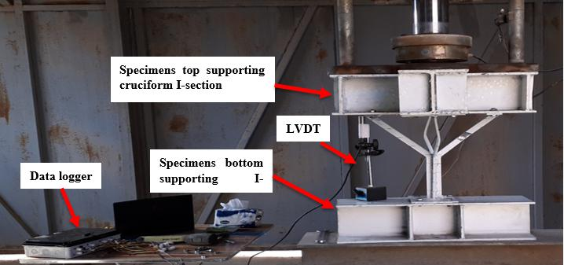
Fig. 2, Specimens Testing Setup.

Tree-Like Steel Column FE Model
A three-dimensional FE model was created using software ABAQUS/CAE Version 6.12-3. The model consisted of three components: steel tree-like column, one lower base plate, and upper cruciform shape rigid member, as shown in Fig. ‎5. The tree-like-steel column, rigid member, and fixing plates were modeled using ten-node general-purpose quadratic tetrahedron with improved surface stress visualization (H.Alsayed 1995). The lower base plate and the upper rigid member were attached to the tree-like column using tie constraints. In the horizontal direction, the upper rigid member was restricted to restrict the load to the vertical direction. The lower base plate was set at the bottom. By using the upper cruciform rigid member, the load was uniformly applied.

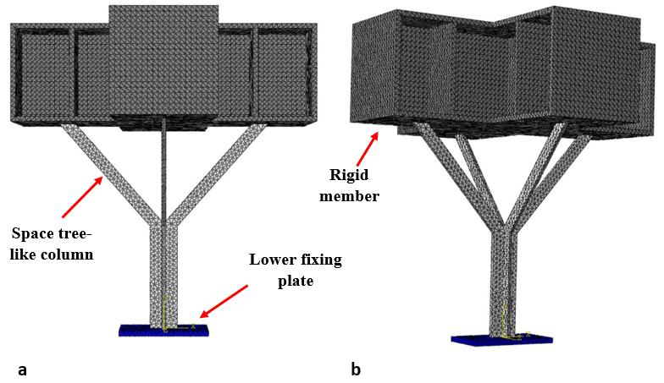
Fig. ‎5, FE Model, (a)Front view, (b) 3D view.

Materials Properties and Meshing
The properties of the defined materials must be in exact conformity with the tested specimens to obtain close results. The stress-strain curve of materials is defined, as shown in Fig. ‎6. The steel modulus of elasticity was taken 195 GPa for a tree-like steel column, and 198 GPa for a rigid member. Furthermore, Poisson’s Ratio was taken 0.3 for all steel materials. Meshing is one of the essential parts of the model, as it has a significant impact on the accuracy of the results, the shape of failure, and the general behavior of the model. The number of elements in this study was adjusted in order to achieve the same behavior in the failure mode for the models and tested specimens. The element size was taken 8 for models. Also, C3D10HS: A 10-node general-purpose quadratic tetrahedron with improved surface stress visualization is adopted as an element type.

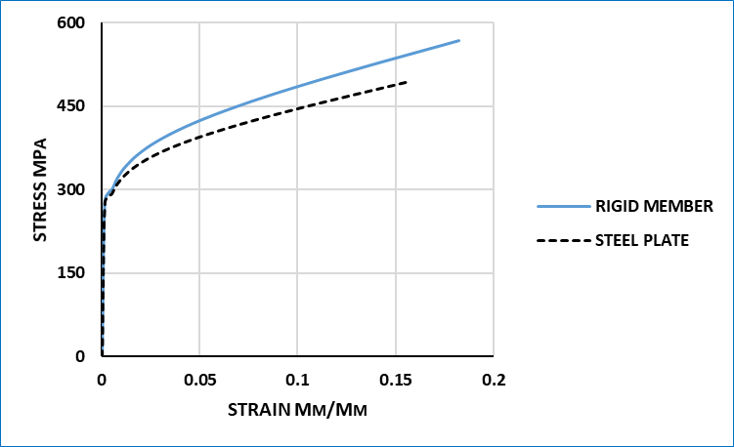
Fig. 6, Stress Versus Strain Curves Used in the FE Models.

Experimental Results and Discussion

Load- Displacement Response
The load-displacement curve for specimens is generally two types. The first type consists of two stages, where the first stage is linear, meaning that an increase in displacement offsets the increase in load, and it represents the elasticity stage. As for the second stage, it represents the plastic stage, and the increase in displacement is significant compared to the load. The second type of load-displacement curve consists of one stage, where it represents the elasticity stage of the specimen. In this type, there is no plastic stage, so it is not preferred since the specimens fail suddenly without warning. The slope of the load-displacement curve decreases when increasing the HB/HT ratio from 25 to 50%; then, it increases when changing the HB/HT ratio from 50 to 75 or 100%. The slope of the load-displacement curve significantly decreases when increasing the (W/WT) ratio. For the specimens with two branching levels, the shape of the load-displacement curve change from the second type to the first type.
The slope of the load-displacement curve increases when reducing the section non-prismatic ratio from 100 to 75%. Furthermore, when reducing it to 50 and 25% respectively, the slope does not change, but the shape changes from the second type to the first type. The load-displacement curves of all tested specimens are shown in Fig. ‎7.

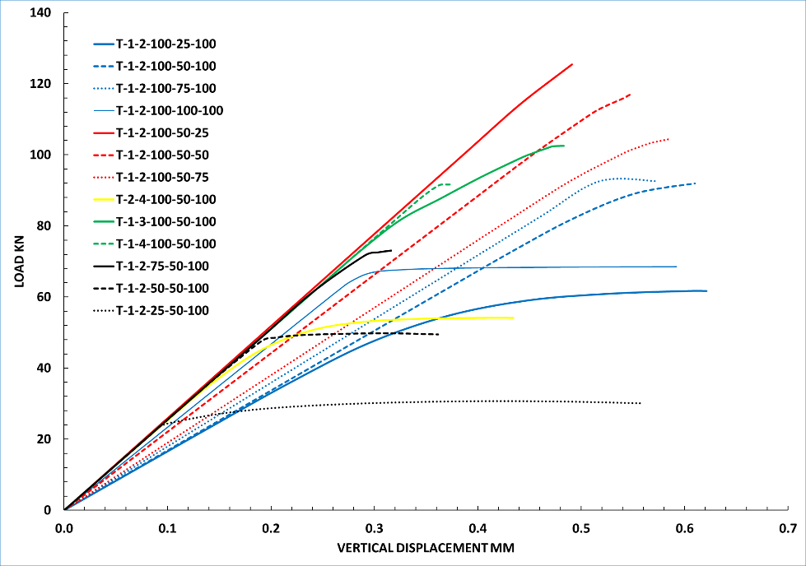
Fig. 7, Specimens’ Load –Vertical Displacement Response.

Failure Load and Failure Displacement
Table 4 below shows the failure load, failure displacement, and failure mode of all tested specimens. It can be noticed that the failure load increases between (11.2 – 50.0) % when increasing the ratio of the branch’s height to total height (HB/HT). In order to explain this result, it must be divided the failure load in the specimen into two parts, the first is the failure load of the branch and the second is the failure load of the trunk. Whichever is less, it is the governing of the specimen’s failure. So, this increase may be because decreasing the trunk’s critical length, so the failure load increases depending on Euler formula, as shown in Eq.1, but when this ratio reach (100 %), the governing failure became the branch’s failure. Also, the failure load decreases between (6.4 – 25.6) % when the specimen’s width to overall width ratio (W/WT) increases; this decrease maybe because of the same reasons above. The failure load increases by about 10.8 % when changing the number of branches from two to three, but it decreases by about 1.1 % when changing the number of branches from two to four. This indicates that the increase in branch numbers not sufficient after three branches. The failure load decreases by about 40.1 % when increasing the branching level from one to two. The decrease maybe because of the failure of the second-level branches. In this type, the second level branches must strengthen against the failure. Furthermore, it was found that the failure load decreases significantly between (21.5 – 66.7) % when decreasing the section non-prismatic ratio, where it decreases about a quarter of its value at each reducing percent.
The failure displacement decreases between (1.8 – 7.7) % when the branch’s height to the total height ratio (HB/HT) increased. Moreover, it increases between (11.4 – 24.2) % when the ratio of the specimen’s width to the overall width (W/WT) increases. This increase in the vertical displacement is due to the increase in the lengths of the branches. Also, the failure displacement decreases about 20.8 and 38.5 %, respectively, when increasing the number of branches (BN) from two to three and four. The failure displacement decreases about 28.8 % when increasing the branching level from one to two; moreover, it decreases between (8.2 – 48.2) % when reducing the section non-prismatic ratio. The decrease maybe because of the reduction in failure load where the specimens fail in stage one (elastic stage).
$Pcr=\frac{π2 EI}{KL2}$ ………………………………………………Eq.1

Mode and Mechanism of Failure
Failure mode was generally buckling for all specimens; therefore, it can be divided into compound buckling and branch’s buckling, as shown in Fig. 8. Most specimens failed with branch’s buckling, as the buckling begins at the bottom of the branch, and then develops until the specimen fails, and the trunk remains without any kind of visible effect. For two-branching level specimens’, buckling occurs in second-level branches and does not extend to first level branches as in the failure of the specimen T-2-4-100-50-100. The second type is compound buckling, where branches begin to fail, and then it develops to the trunk until the specimen fails. This type of failure takes total strength of the branches and trunk. The 2nd level branches in this type of column are the key to failure and must be strengthened to get the maximum failure capacity.

Table 4, Max. Failure Load, Failure Vertical Displacement, and Failure Mode of Specimens.

Specimen Designations | Failure Load, kN | Changing Percent for Failure Load, % | Vertical Displacement, mm | Changing Percent for Failure Displacement, % | Notes | Mode of Failure
T-1-2-100-25-100 | 62 | R1 | 0.621 | R1 | These percentages were calculated depending on the value of R1. | Branch’s buckling
T-1-2-100-50-100 | 93 | + 50.0 | 0.610 | - 1.8 |  | Branch’s buckling
T-1-2-100-75-100 | 92 | + 48.8 | 0.573 | - 7.7 |  | Branch’s buckling
T-1-2-100-100-100 | 69 | + 11.2 | 0.592 | - 4.7 |  | Branch’s buckling
T-1-2-100-50-25 | 125 | R2 | 0.491 | R2 | These percentages were calculated depending on the value of R2. | Compound buckling
T-1-2-100-50-50 | 117 | - 6.4 | 0.547 | + 11.4 |  | Compound buckling
T-1-2-100-50-75 | 105 | - 16.0 | 0.587 | + 19.6 |  | Branch’s buckling
T-1-3-100-50-100 | 103 | + 10.8 | 0.483 | - 20.8 | These percentages were calculated depending on the value of T-1-2-100-50-100 specimen. | Branch’s buckling
T-1-4-100-50-100 | 92 | - 1.1 | 0.375 | - 38.5 |  | Branch’s buckling
T-2-4-100-50-100 | 55 | - 40.1 | 0.434 | - 28.8 | This percentage was calculated depending on the value of T-1-2-100-50-100 specimen. | Branch’s buckling
T-1-2-75-50-100 | 73 | -21.5 | 0.316 | - 48.2 | These percentages were calculated depending on the value of T-1-2-100-50-100 specimen. | Branch’s buckling
T-1-2-50-50-100 | 50 | - 46.2 | 0.361 | - 40.8 |  | Branch’s buckling
T-1-2-25-50-100 | 31 | - 66.7 | 0.560 | - 8.2 |  | Branch’s buckling

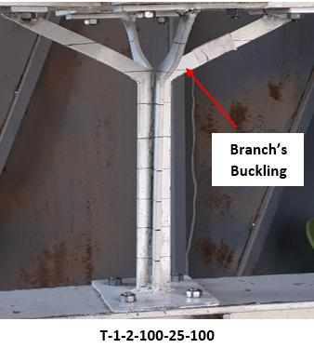 | 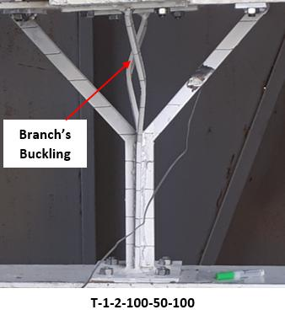 | 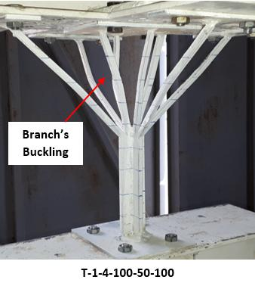
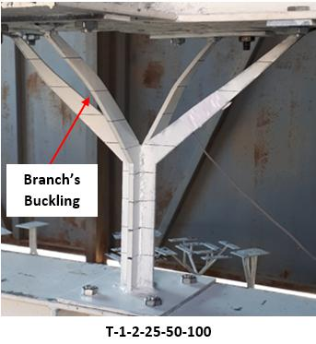 | 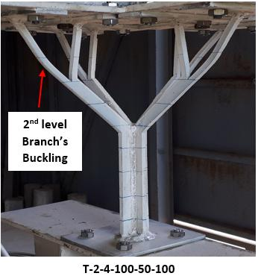 | 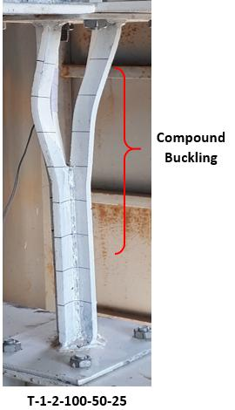

Fig. 8, Specimens’ Failure Mode.

Finite Element Results and Discussions

Calibration of Models
The calibration of the finite element model was done by using the results of seven tree-like column specimens with two branches, in terms of load-deflection response, ultimate load capacity, and failure mode. Specimens with the ratio of branch’s height to the total height (HB/HT) equal to 25, 25, 75, and 100% and the specimens with the ratio of specimen’s width to overall width (W/WT) equal to 25, 50, 75, and 100% were simulated only. To calibrating the load-displacement response of the tree-like steel column model, a tensile strength parameter was considered. According to previous research (Zhao, Liang, and Liu 2018), this parameter and steel module has the greatest effect on FE’s results. A good agreement was reached between the experimental and FE results after several tests, since the specimens showed the same deflection response, as shown in the F. 9. The same mode of failure was observed in both the experiments and in the corresponding FE simulation, as shown in Fig.10. Both the tested and simulated tree-like column experienced a buckling failure that started at the branches and then developed to the trunk. Furthermore, the ultimate strengths of the calibrated specimens were compared to those experimentally tested. The results were summarized in Table ‎5. As can be seen, the difference between the experimental and FE ultimate load ranged from (– 6.1 to + 3.9) %, making the FE model more conservative than the experiment.

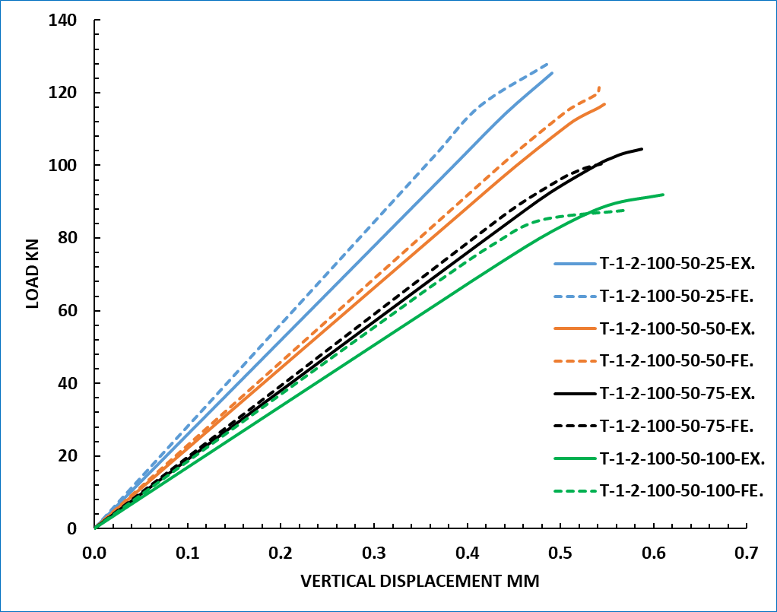 | 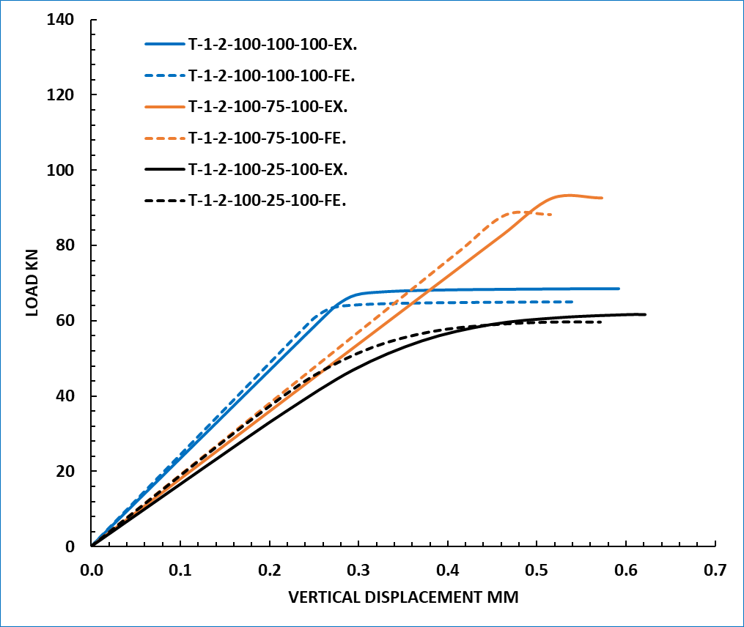

Fig. 9, Load-deflection Responses of Experimental Versus Calibrated FE Models.
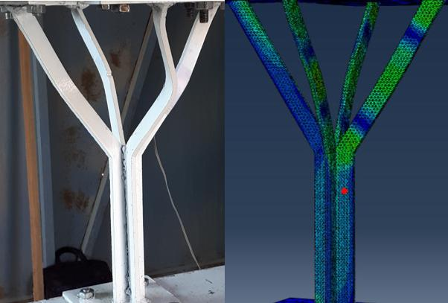 | 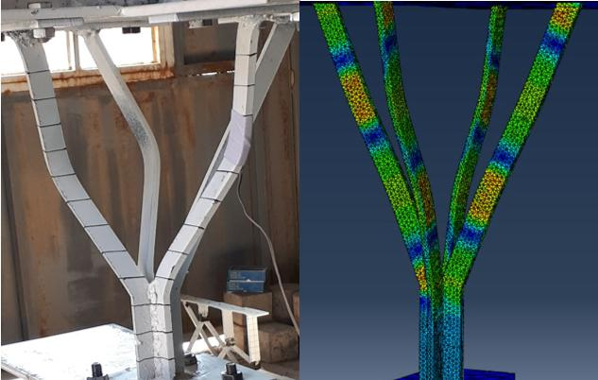
T-1-2-100-50-50 | T-1-2-100-75-100
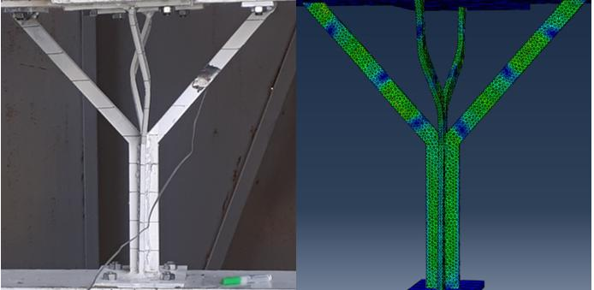
T-1-2-100-50-100
Fig. 10, Mode Failure of Experimental Versus Calibrated FE Models.

Table 5, Ultimate Load of Experimental Versus Calibrated FE Models.

Specimen’s Designation | Experimental Ultimate Load, kN | FE Ultimate Load, kN | Error, %
T-1-2-100-25-100 | 62 | 59.6 | - 3.9
T-1-2-100-50-100 | 93 | 87.9 | - 5.6
T-1-2-100-75-100 | 92 | 88.1 | - 4.3
T-1-2-100-100-100 | 69 | 64.9 | - 6.1
T-1-2-100-50-25 | 125 | 127.9 | + 2.3
T-1-2-100-50-50 | 117 | 121.5 | + 3.9
T-1-2-100-50-75 | 105 | 100.4 | - 4.4

Models Validation
The calibrated models were validated using the experimental results of multi branches, multi-branching level, and section non-prismatic specimens. The calibrated models were validated in terms of load-deflection response and ultimate load capacity. A good agreement was observed between experimental and finite element load-deflection responses observed in elastic and plastic stages, as shown in Fig.11. Moreover, the ultimate load of finite element models was compared to the corresponding experimental results and summarized in Table 6.

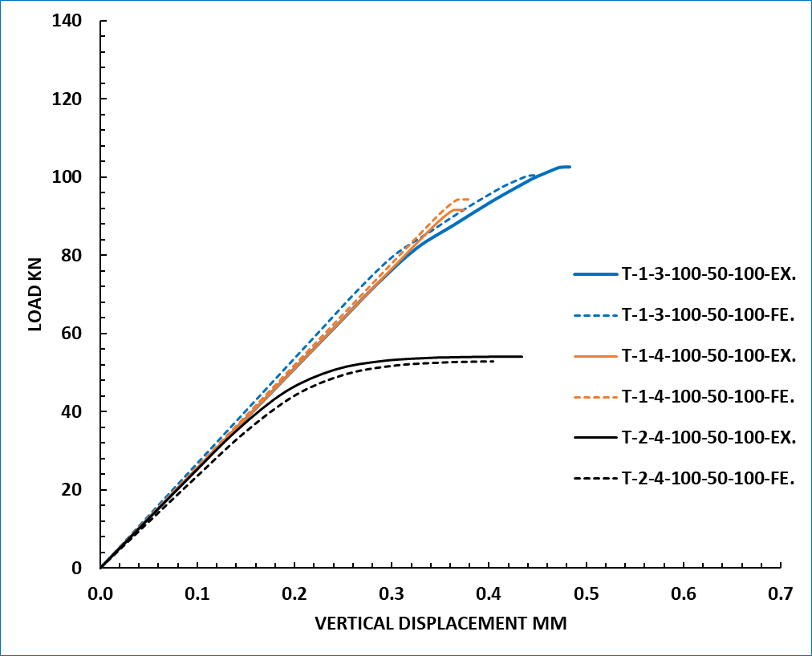 | 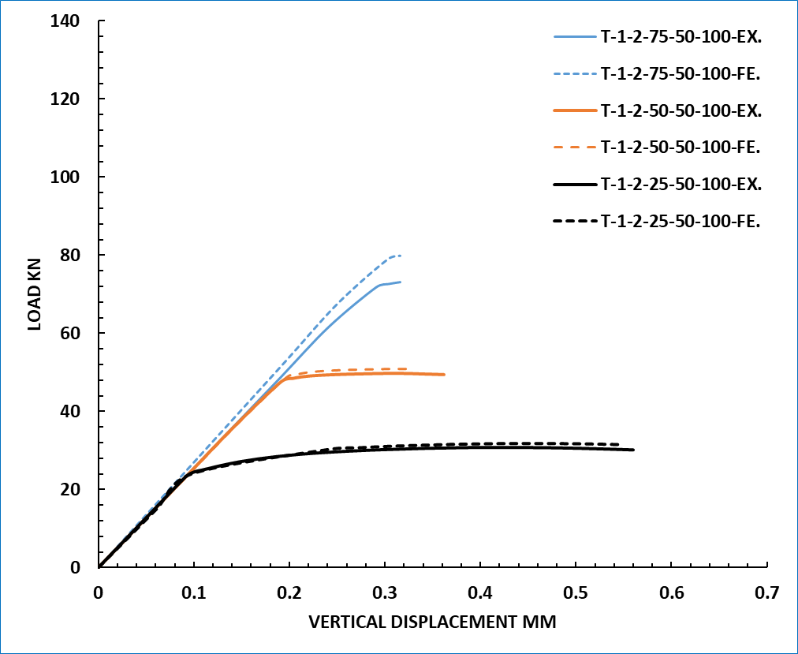
Fig. 11, Load-deflection Responses of Experimental Versus Validated FE Models.

Table 6, Ultimate Load of Experimental Versus Validated FE Models.
Specimen’s Designation | Experimental Ultimate Load, kN | FE Ultimate Load, kN | Difference, %
T-1-3-100-50-100 | 103 | 100.4 | - 2.5
T-1-4-100-50-100 | 92 | 94.4 | + 2.6
T-2-4-100-50-100 | 55 | 53.0 | - 3.7
T-1-2-75-50-100 | 73 | 79.8 | + 9.3
T-1-2-50-50-100 | 50 | 50.9 | + 1.8
T-1-2-25-50-100 | 31 | 31.5 | + 1.6

Parametric Study
To studying other factors affecting the behavior of tree-like steel columns, models with different sequences of cross-section areas were simulated to determine the ultimate strength. This parametric study was conducted for models with one and two branching levels.
Special designations were given to the models to be distinguished from each other. Models whose labile consists of three symbols are one-branching level models, where the first symbol refers to the type of the model, the second symbol refers to the trunk’s area, and the third refers to the area of the first branching level as a percentage from the trunk area. Models that have labile with four symbols are models with a two-branching level, where the first symbol refers to the type of model, the second symbol refers to the trunk’s area, the third symbol refers to the area of the first-branching level as a percentage from the trunk area, and the fourth refers to the area of the second branching level as a percentage from the trunk area. The parametric study results are shown in Table ‎7.

Table 7, Results of Parametric Study.
Specimen’s Designation | Ultimate Load , kN | Changing in Ultimate Load, % | Branching level
T-1-1 | 87.9 | RS1 | One
T-1-1.2 | 117.9 | + 34.1 | One
T-1-1.4 | 121.4 | + 38.1 | One
T-1-1.6 | 144.2 | + 64.1 | One
T-1-1.8 | 144.6 | + 64.5 | One
T-1-2 | 146.1 | + 66.2 | One
T-1-0.8 | 73.6 | - 16.3 | One
T-1-0.6 | 57.2 | - 35.1 | One
T-1-0.4 | 34.6 | - 61.7 | One
T-1-0.2 | 12.8 | - 86.5 | One
T-1-1-1 | 53.0 | RS2 | Two
T-1-1.2-1.44 | 82.1 | + 54.9 | Two
T-1-1.4-1.96 | 85.5 | + 61.3 | Two
T-1-1.6-2.56 | 89.3 | + 68.5 | Two
T-1-1.8-3.24 | 102.6 | + 93.6 | Two
T-1-2-4 | 123.5 | + 133.0 | Two
T-1-0.8-0.64 | 42.3 | - 21.2 | Two
T-1-0.6-0.8 | 27.9 | - 47.4 | Two
T-1-0.4-0.16 | 14.8 | - 73.1 | Two
RS1: one-branching-level reference model. RS2: two-branching-level reference model.

The sequence of the area has a significant impact on the ultimate strength of the tree-like steel column models. As for the models with a one-branching level, the ultimate strength significantly increases when increasing the ratio of the first branching level area from 1 to 1.2 % and 1.4 %, respectively, but this increase became unclear when increasing the area ratio greater than 1.4 %. However, when the ratio of the first branching level area is reduced, the ultimate strength decreases significantly.
For models with two- branching levels, ultimate strength increases significantly when the area ratio for the first and second levels increase. This increase shows the large impact of the second-branching level area on the ultimate strength of the models, where it is the key to the failure.

Conclusion
The following conclusions can be drawn in the scope of this study, based on results obtained from the experimental analysis and finite - element simulation with an ABACUS system for tree-like steel column models subject to uniform load:
- When the ratio of the branch’s height to total height (HB/HT) increases from 25 to 50, 75, and 100% respectively, the specimens’ ultimate strength increases about of (+ 50.4, + 48.4 and + 11.2) % for the case of specimens with two branches and the ratio of specimen’s width to the overall width (W/WT) equal to 100%.
- When the ratio of specimen’s width to the overall width (W/WT) increases from 25 to 50, 75, and 100% respectively, the specimens’ ultimate strength decreases about of (6.4, 16.0 and 25.6) % respectively for the case of specimens with two branches and the ratio of the branch’s height to total height (HB/HT) equal to 50%.
- When the number of branches increases from two to three and four, respectively, the failure load of specimens changes about of (+ 10.8 and – 1.0) % respectively, for the case of specimens with the ratio of specimen’s width to the overall width (W/WT) equal to 100%.
- When changing the branching level from one to two, the ultimate strength decreases about 40.9 % for specimens with a ratio of specimen’s width to the overall width (W/WT) equal to 100 %.
- The ultimate strength of specimens decreases about 21.5, 46.2, and 66.7 %, respectively, when the ratio of section non-prismatic (NP) reduces from 100 to 75, 50, and 25%, respectively.
- Generally, the failure of the specimens occurs suddenly, especially for specimens with two branches and one branching level.
- The critical points of the tree-like steel column are branches of first-level for the case of specimens with one branching level, and branches of second-level for the case of specimens with two branching levels
- The mode of failure is generally buckling for all specimens.
- The sequence of the cross-sectional area has a significant impact on the ultimate strength of the tree-like steel column models. The ultimate strength increases when the area of the upper branching level is greater than the area of the previous branching level, and vice versa.
- The 3D finite element model used in the present study can simulate the tree-like steel column, and it has a good agreement in terms of load-deflection response, failure mode, and ultimate load capacity. The comparison between the numerical and the experimental results showed good validity of the numerical analysis, where the maximum difference ratio based on the ultimate load was less than 9.3 % for all analyzed models.
- It is preferable to construct the tree-like steel column with:
- The ratio of the branch’s height to total height (HB/HT) equal or less than 75 % to improve the stiffness and reduce the vertical failure displacement.
- The ratio of specimen’s width to the overall width (W/WT) equal or less than 50 % to reduce the decrease in stiffness because it has a major impact on the behavior of the tree-like columns.
- More than two branches to improve the ultimate strength, especially for specimens with a ratio of specimen’s width to the overall width (W/WT) more than 50 %.
- More than one branching level to change the behavior of specimens from brittle failure to ductile failure; furthermore, the 2nd level branches’ must be strengthened to improve the ultimate strength.
- The ratio of section non-prismatic (NP) equals or more than 75% to reduce the decrease in the ultimate strength and weight of the column.
- The area of each branching level is greater than the area of the previous branching level.

Conflict of interest statement
The authors declare that there is no conflict of interest.

References
Ahmeti, Flamur. 2007. “Efficiency of Lightweight Structural Forms: The Case of Treelike Structures-A Comparative Structural Analysis.”
Black, R Gary, and Abolhassan Astaneh-Asl. 2014. “Design of Seismically Resistant Tree-Branching Steel Frames Using Theory and Design Guides for Eccentrically Braced Frames.” International Journal of Civil and Environmental Engineering 8 (2): 206–13.
Buelow, Peter von. 2007. “A Geometric Comparison of Branching Structures in Tension and in Compression versus Minimal Paths.”
Buelow, Peter Von. 2006. “Following a Thread: A Tree Column for a Tree House.” In Proc. IASS Symposium, Beijing.
Cui, C Y, B S Jiang, and G Y Cui. 2013. “The Sensitivity-Based Morphogenesis Method for Framed Structures.” China Civil Engineering Journal 46: 1–8.
Gawell, Ewelina. 2013. “Non-Euclidean Geometry in the Modeling of Contemporary Architectural Forms.” Journal Biuletyn of Polish Society for Geometry and Engineering Graphics 24.
Glaeser, Ludwig, Frei Otto, and New York Museum of Modern Art. 1972. The Work of Frei Otto:[The Exhibition Shown at The Museum of Modern Art, New York from July 7 to October 4, 1971]. Museum of modern art.
H.Alsayed, Saleh. 1995. “Non-Linear Finite Element Analysis for RC Elements Subjected to In-Plane Loads.” Journal of King Saud University - Engineering Sciences 8 (1): 1–15.
Hui, Cui Changyu1 Yan. 2006. “An Advanced Structural Morphosis Technique——Extended Evolutionary Structural Optimization Method and Its Engineering Applications [J].” China Civil Engineering Journal 10.
Hunt, Jeffrey, Walter Haase, and Werner Sobek. 2009. “A Design Tool for Spatial Tree Structures.” Journal of the International Association for Shell and Spatial Structures 50 (1): 3–10.
Li, R. 2014. “Research on Branching Structures Based on Fractal Theory.” Barbin Institute of Technology, Harbin In Chinese.
Peng, Xirong. 2016. “Structural Topology Optimization Method for Morphogenesis of Dendriforms.” Open Journal of Civil Engineering 6 (04): 526.
Sasaki, Mutsurō, Toyoo Itō, and Arata Isozaki. 2007. Morphogenesis of Flux Structure. Aa Publications.
Wu, Yue, Jianliang Zhang, and Zhenggang Cao. 2011. “Form-Finding Analysis and Engineering Application of Branching Structures.” Jianzhu Jiegou Xuebao(Journal of Building Structures) 32 (11): 162–68.
Zhang, Q, Z Chen, X Wang, and H Liu. 2015. “Form-Finding of Tree Structures Based on Sliding Cable Element.” J Tianjin Univ 48 (4): 362–72.
Zhao, Zhongwei, Bing Liang, and Haiqing Liu. 2018. “Topology Establishment, Form Finding, and Mechanical Optimization of Branching Structures.” Journal of the Brazilian Society of Mechanical Sciences and Engineering 40 (11): 539.

